

VIRGINIA COMMONWEALTH UNIVERSITY

**Statistical analysis and modelling (SCMA 632)**

**A5a-: Visualisation – Perceptual Mapping for Business (AP)**

**Azim Ziyan A**

**V01102412**

**Date of Submission: 15-07-2024**

|  |  |  |
| --- | --- | --- |
|  |  |  |
| 1 | INTRODUCTION | 3 |
| 2 | OBJECTIVES | 3 |
| 3 | BUSINESS SIGNIFICANCE | 3 |
| 4 | RESULTS AND INTERPRETATION | 3-6 |
|  |  |  |
|  |  |  |
|  |  |  |

TABLE OF CONTENTS

INTRODUCTION

The focus of this study is on the state of Andhra Pradesh, using data from the National Sample Survey Office (NSSO) to analyze district-wise consumption patterns. We aim to visualize the distribution of total consumption across districts with a histogram and provide a detailed view of consumption per district using a barplot. The NSSO68 dataset includes comprehensive consumption-related data for both rural and urban sectors. The analysis involves handling missing values, identifying and removing outliers, and standardizing district and sector names. By summarizing the consumption data regionally and district-wise, we aim to provide valuable insights into consumption patterns within Andhra Pradesh. These visualizations will help policymakers and stakeholders understand how consumption varies across different districts, facilitating targeted interventions and promoting equitable development across the state.

OBJECTIVES

Histogram and Barplot to indicate the consumption district-wise for Andhra Pradesh

- Visualize Consumption Distribution

- Detailed District-wise Analysis

- Identify Consumption Patterns

BUSINESS SIGNIFICANCE

The barplot and histogram tasks showcasing consumption patterns across districts in Andhra pradesh hold significant business implications. They provide critical insights for resource allocation, enabling efficient planning of food supplies and infrastructure development based on district-specific consumption needs. Businesses can leverage this data to tailor marketing strategies and product offerings, effectively targeting consumer preferences across different districts. Additionally, understanding consumption disparities supports optimized supply chain management, ensuring products are distributed efficiently to meet varying demand levels. Policymakers benefit by formulating targeted interventions aimed at promoting balanced consumption and improving public health outcomes. These visualizations also facilitate competitive analysis, helping businesses identify market opportunities and gaps for strategic market entry and positioning. Overall, the analysis of consumption patterns aids in socioeconomic impact assessment and supports initiatives aimed at fostering healthier eating habits and lifestyle choices across Andhra pradesh.

. RESULTS AND INTERPRETATIONS

* Python

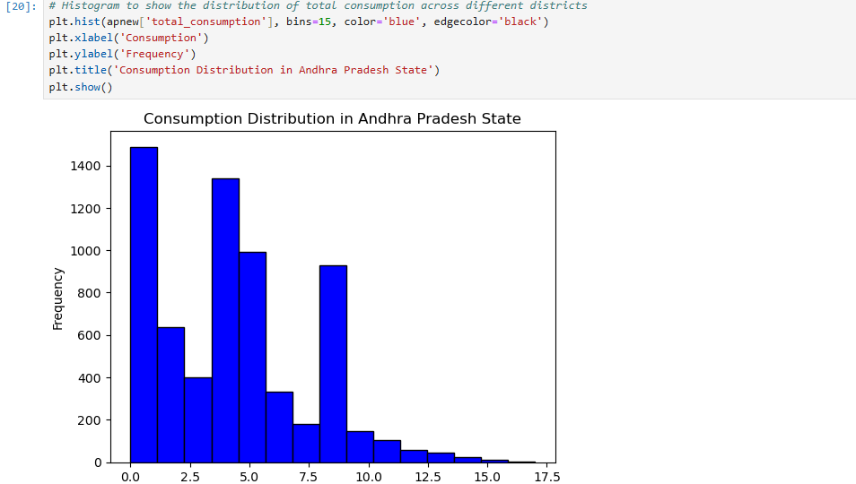

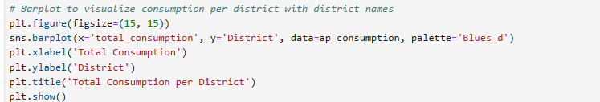

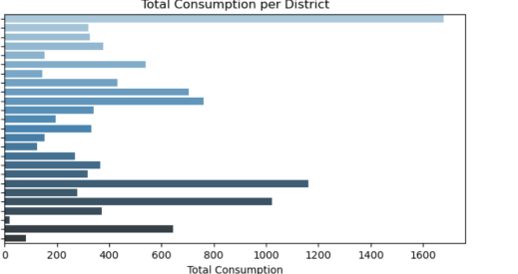

* R

# histogram to show the distribution of total consumption across different districts

hist(apnew$total_consumption, breaks = 15, col = 'blue', border = 'black',

xlab = "Consumption", ylab = "Frequency", main = "Consumption Distribution in Andhra Pradesh State")

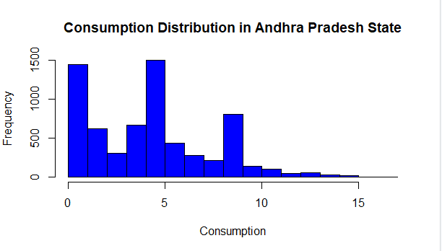

# barplot to visualize consumption per district with district names

??barplot

barplot(ap_consumption$total_consumption,

names.arg = ap_consumption$District,

las = 2, # Makes the district names vertical

col = 'blue',

border = 'black',

xlab = "District",

ylab = "Total Consumption",

main = "Total Consumption per District",

cex.names = 0.7)

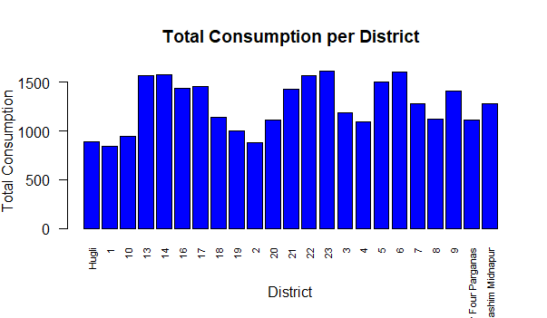

INTERPRETATION

The barplot illustrates significant variations in consumption levels across districts in Andhra pradesh based on the NSSO68 dataset. Districts such as Medak,Nalgonda,Krishna emerge as top consumers, showing notably higher levels of total consumption compared to other districts. This suggests that urban centers and industrial hubs might exhibit greater consumption patterns, likely influenced by higher population densities and economic activities. Conversely, districts like East Godavari exhibit lower consumption levels, possibly indicating rural areas or those with specific dietary preferences impacting overall consumption rates. Such insights are crucial for policymakers and businesses alike, highlighting opportunities for targeted interventions in areas where consumption levels are lower, and optimizing resource allocation in high-consumption regions to meet demand effectively