

VIRGINIA COMMONWEALTH UNIVERSITY

Statistical analysis and modelling (SCMA 632)

**A6b – VAR/VECM**

**Azim Ziyan A**

**V01102412**

**Date of Submission: 25-07-2024**

**TABLE OF CONENTS**

|  |  |  |
| --- | --- | --- |
|  |  |  |
| 1 | **INTRODUCTION** | **3** |
|  |  |  |
| 2 | **OBJECTIVES** | **3** |
|  |  |  |
| 3 | **BUSINESS SIGNIFICANCE** | **3** |
|  |  |  |
| 4 | **CODES** | **4** |
|  |  |  |
| 5 | **RESULTS** | **5** |
|  |  |  |
| 6 | **INTERPRETATION** | **9** |

**INTRODUCTION**

The focus of this study is on analyzing the stationarity and co-integration of various commodity prices using a dataset of monthly prices from January 2000 to July 2024. The dataset comprises attributes such as crude oil (Brent, WTI, Dubai), coal (Australian, South African), natural gas (US, Europe, Japan), agricultural products (cocoa, coffee, tea, palm oil, soybean, maize, rice, wheat), metals (gold, platinum, silver, aluminum, copper), and many others. This analysis aims to investigate the time series properties of these commodities by applying the Augmented Dickey-Fuller (ADF) test for stationarity and Johansen's co-integration test to uncover long-term equilibrium relationships among the variables. In the process of this analysis, the dataset underwent preprocessing steps, including renaming columns, converting date formats, and selecting relevant commodity columns. The ADF test was applied to each series to determine its stationarity, followed by Johansen's co-integration test to identify potential co-integrated relationships. Based on the presence of co-integration, either a Vector Error Correction Model (VECM) or a Vector Autoregression (VAR) model was fitted to the data. The analysis concluded with forecasting future commodity prices using the fitted model and visualizing these forecasts, providing insights into the potential future behavior of the commodity prices, aiding stakeholders in making informed decisions based on anticipated trends.

**OBJECTIVES**

- Analyze the stationarity of various commodity prices using the Augmented Dickey Fuller (ADF) test.

- Identify potential co-integration relationships among the selected commodities.

- Preprocess the dataset by renaming columns, converting date formats, and selecting

relevant commodity columns.

- Determine the appropriate lag length for the VAR model using the Akaike

Information Criterion (AIC).

- Fit either a Vector Error Correction Model (VECM) for co-integrated series or a

Vector Autoregression (VAR) model for non-co-integrated series.

- Forecast future commodity prices using the fitted model

**BUSINESS SIGNIFICANCE**

Analyzing the stationarity and co-integration of various commodity prices provides critical insights into the long-term relationships and trends within the commodity market. By applying the Augmented Dickey-Fuller (ADF) test and Johansen's cointegration test, businesses and financial analysts can understand the stability and interconnectedness of commodity prices. This understanding is essential for making informed decisions about procurement, inventory management, and strategic planning. Identifying co-integrated commodities helps in predicting price movements and managing risks associated with price volatility, enabling stakeholders to optimize their operational and financial strategies. Forecasting future commodity prices using Vector Error Correction Models (VECM) or Vector Autoregression (VAR) models provides valuable forward-looking information that can guide investment and trading strategies. Accurate forecasts help businesses anticipate market trends and adjust their strategies to mitigate potential risks. Investors can use these forecasts to optimize their portfolios and hedge against unfavorable price movements. This predictive capability enhances financial planning, supports proactive management of commodity-related investments, and contributes to more robust risk management frameworks in a dynamic market environment.

**CODES**

* **R**

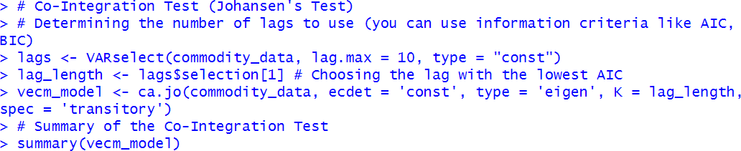

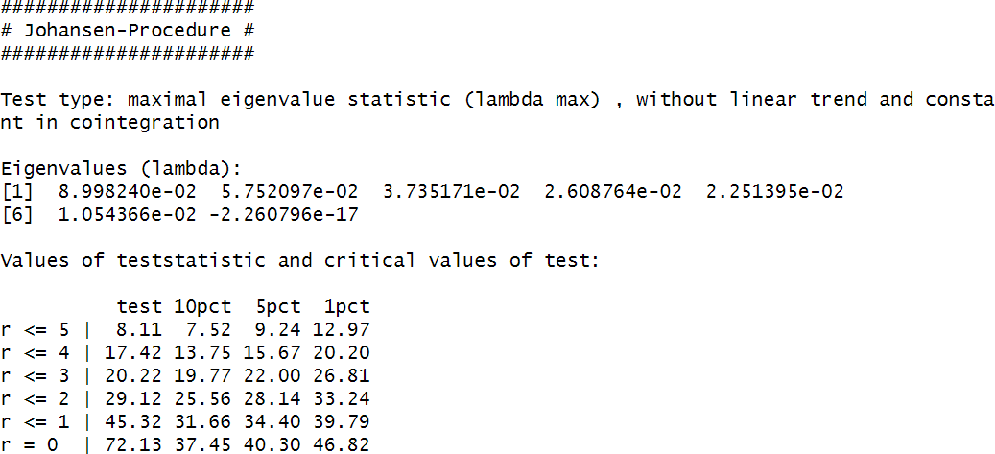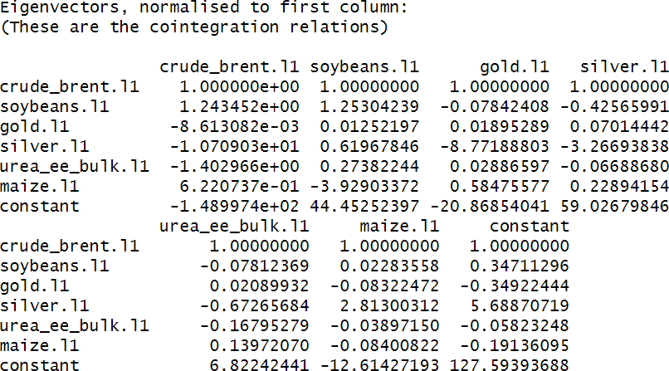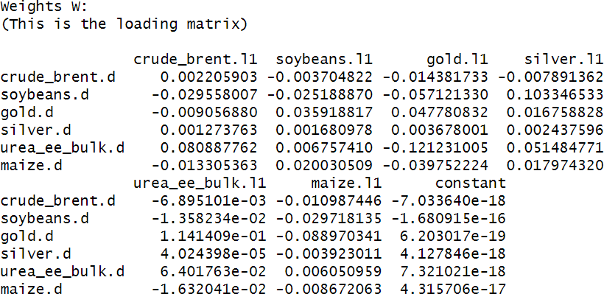

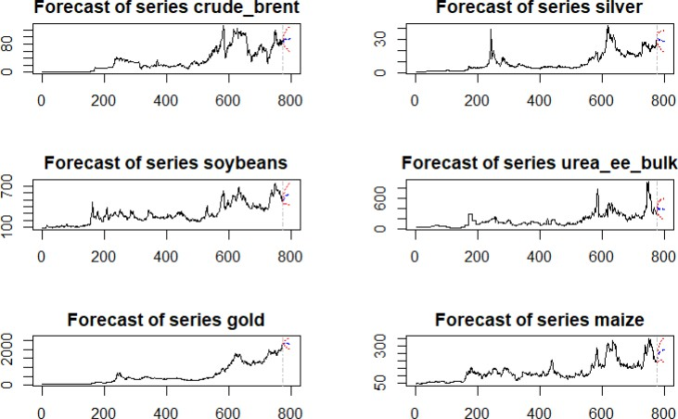

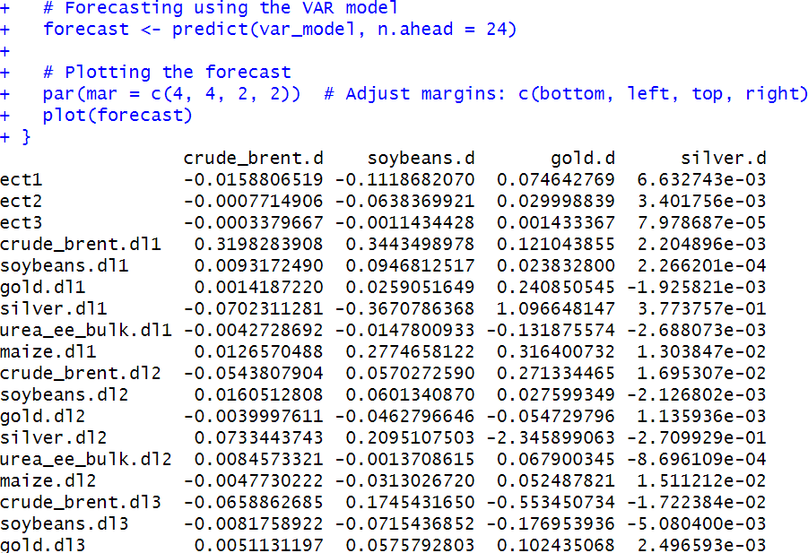

* **PYTHON**

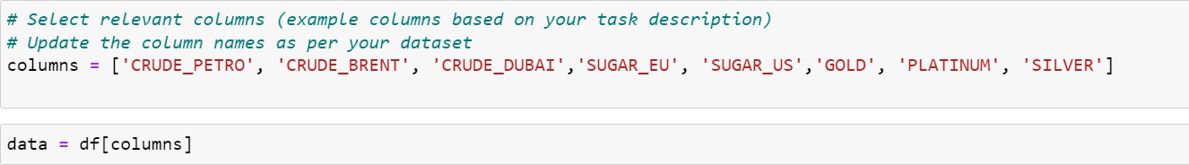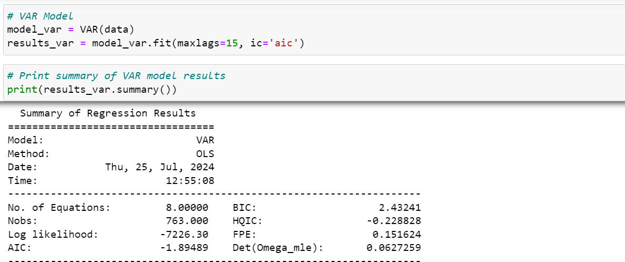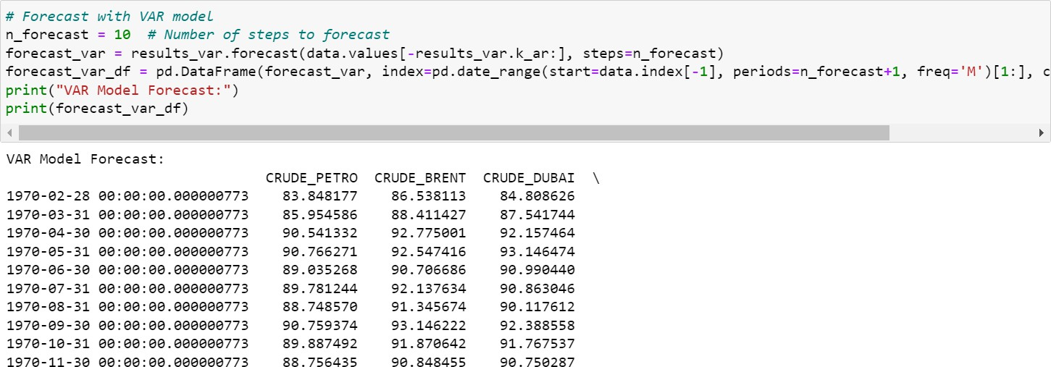

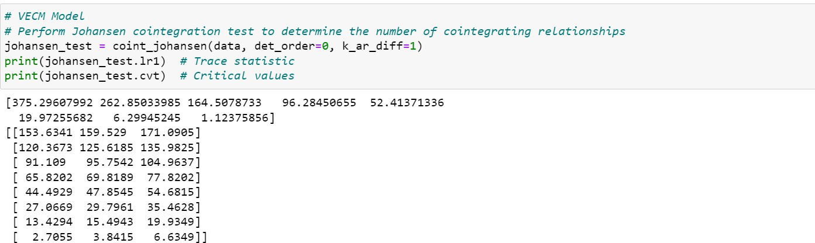

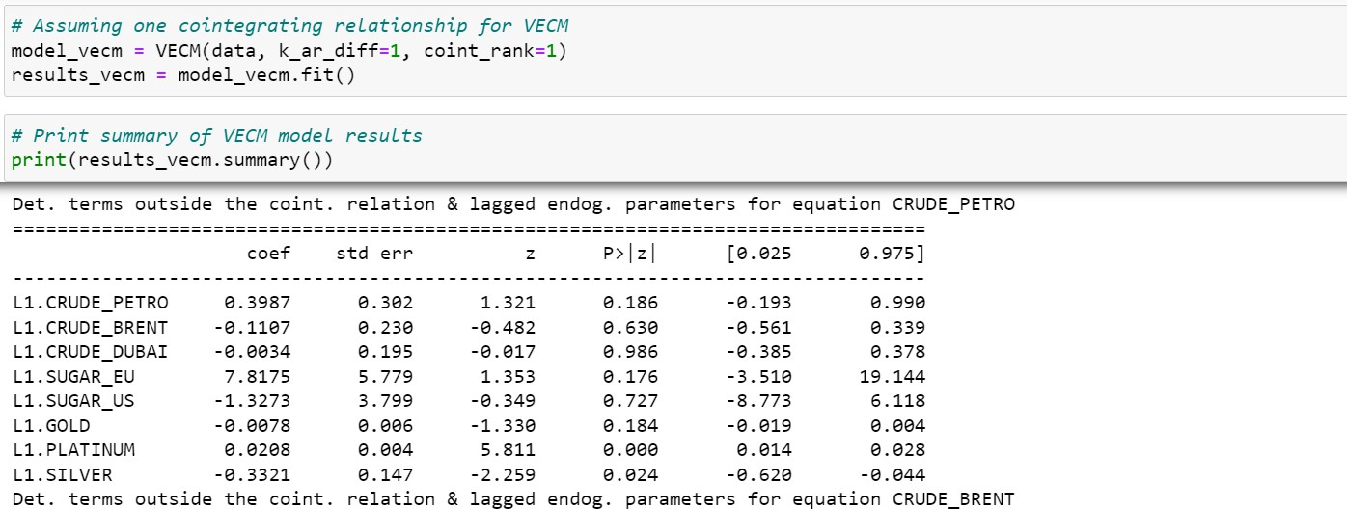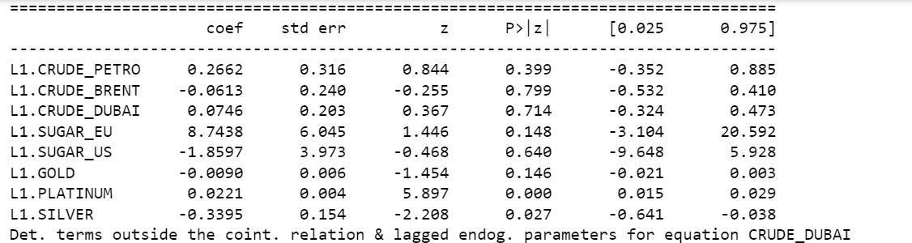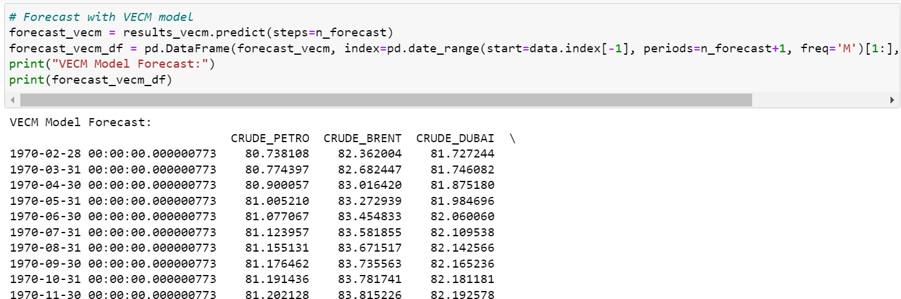

**RESULTS AND INTERPRETATION**

The Augmented Dickey-Fuller (ADF) Test results reveal that out of the six commodities analyzed, Gold and Urea EE Bulk were found to be stationary with p-values of 0.0102 and 0.0264, respectively. This indicates that their price levels do not follow a unit root process and are mean-reverting. In contrast, Crude Brent, Soybeans, Silver, and Maize were identified as non-stationary, with p-values of 0.266, 0.649, 0.256, and 0.453, respectively, suggesting that their prices follow a random walk and exhibit persistent shocks over time.

The Johansen's Co-Integration Test indicates the presence of three co-integrating relationships among the commodities, suggesting that despite being non-stationary individually, certain linear combinations of these commodity prices are stationary, implying long-term equilibrium relationships. The Vector Error Correction Model (VECM) further elucidates these relationships by capturing both the long-term equilibrium and short-term dynamics. The error correction term (ECT) coefficients reveal how quickly the variables adjust back to equilibrium after a shock. For instance, the coefficient for crude_brent.d is -0.0159, indicating a slow speed of adjustment to equilibrium. This comprehensive analysis of stationarity, co-integration, and error correction helps in understanding the interconnectedness and dynamic adjustments among these commodities, which is crucial for making informed decisions in financial markets and risk management.