Software Requirements Specification
for
Canteen Automation System
Version 1.0 approved
Prepared by GROUP 4
CMSE201, EMU, Cyprus.
December 15, 2020
Table of Contents
Table of Contents ii
Revision History ii
1. Introduction 1
1.1 Purpose 1
1.2 Document Conventions 1
1.3 Intended Audience and Reading Suggestions 1
1.4 Product Scope 1
1.5 References 1
2. Overall Description 2
2.1 Product Perspective 2
2.2 Product Functions 2
2.3 User Classes and Characteristics 2
2.4 Operating Environment 2
2.5 Design and Implementation Constraints 2
2.6 User Documentation 2
2.7 Assumptions and Dependencies 3
3. External Interface Requirements 3
3.1 User Interfaces 3
3.2 Hardware Interfaces 3
3.3 Software Interfaces 3
3.4 Communications Interfaces 3
4. System Features 4
4.1 Customre Feature 4
4.2 Administration System Feature 4
5. Other Nonfunctional Requirements 4
5.1 Performance Requirements 4
5.2 Safety Requirements 5
5.3 Security Requirements 5
5.4 Software Quality Attributes 5
5.5 Business Rules 5
6. Other Requirements 5
Appendix A: Glossary 5
Appendix B: Analysis Models 5
Appendix C: To Be Determined List 6

Revision History
Name | Date | Reason For Changes | Version

Introduction

Purpose
Canteen Automation System is the system where customers order their food and receive food in the canteen without any delay as they can directly go and collect what they ordered without waiting for a turn or waiting time. This system aims to accelerate customer orders and customer order system used by employees to accept customer order. The purpose of the system is to develop a simple Canteen Automation System and implement it, which later will be used for a web-based application.

Document Conventions
This document conforms to the Software Requirements Specification IEEE standard. The MLA format is implemented by the document. For emphasizing divisions and sub-section headings of the project, bold face and indentation are used. The remainder of the document would be written using New Times Roman, the traditional font.

Intended Audience and Reading Suggestions
The project manager, development team, testers, documenters, and even the customers can read this report. In order of priority, the SRS was arranged. The audience stated is to become closely acquainted with the SRS so that they can make improvements with few or no errors with the product.

Product Scope
The product is an online application that will allow its users to position orders from different firms for different kinds of food. This would have a simpler and quicker means of purchasing food. As consumers and managers will relate and transact very easily and without much effort, the commodity can improve the economy of most food sales canteens. There might also be an improvement in the rate of buying food from the canteens.

References
- EMU’s Interactive Google Map, EMU. Retrieved 15 December, from https://ww1.emu.edu.tr/campusmap?design=empty
- Google Drive, Google. Retrieved 15 December, from
https://www.google.com/drive/
- Patel, Mayur Kumar, "Online Food Order System for Restaurants" (2015). Technical Library. Paper 219. http://scholarworks.gvsu.edu/cistechlib/219

Overall Description

Product Perspective
Our canteen automation system is developed with a primary aim of 'Saving Time. The customer can order the food and it is also efficient for canteen workers because this system takes lesser time as compared to phone based or manually based system. The system will be developed using PHP, HTML, CSS and other Web tools.

Figure 1 context diagram

Canteen Automation System
Customer
Canteen
Order
Send order info

Response
Accept/Reject Order

Product Functions
The product developed will provide an easy access to the user to manage and alter the canteen automation according to the need. Some proposed functionalities of the application as following:

- Create an account
- Manage your account
- Delete account
- Login/logout
- Ask for help
- Search for nearby canteens
- View menu
- Search for an item from the menu
- View item price
- Select item from the menu
- Add item to current order
- Remove item from current order
- Cancel current order
- Create custom food
- Place an order
- Online payment
- View placed order
- Leave reviews and ratings
- adding categories to the menu
- adding new items to the menu
- deleting items from the menu
- updating the price of items
- adding additional information (e.g., descriptions, images) to the menu
- tracking placed orders
- receive reviews and ratings

User Classes and Characteristics
- Customer: The customer interface is less technical than the administrator interface. Adjustments made affect the user’s account exclusively. Customers can navigate the menu, place orders, edit their preferences, etc.

- Administrator: The administrator interface is a more complex interface accessible by the management. It offers more technical options, allowing alterations to be made to the system including the customer user class.

Operating Environment
The system requires the following software and hardware platforms to run optimally:
- Operating System: Windows 7 and above, Android version 7.0 and above, iOS 8 and above.
- Web Browser: Safari, Google Chrome or any other latest web page supporting browser.

Design and Implementation Constraints
- Hardware Limitations: The minimum hardware requirement for the system is 256 MB of RAM and 20 GB HDD.

- Others: The application should be built using Java and JavaScript inscribed in HTML, and it should initially, be accessible through the eclipse IDE and later published on a server.

User Documentation
For first-time users, the program will come with a hands-on demonstration, driven by the systems' features. A support guide for clearing out questions for later reference will also be available.

Assumptions and Dependencies
Assumptions:
- The system will support all browsers.
- The processor must be at least Dual cored and can be any other latest ones etc.
The project is hugely dependent on the compatibility of the system with hardware device and web browser.

External Interface Requirements

User Interfaces
<Describe the logical characteristics of each interface between the software product and the users. This may include sample screen images, any GUI standards or product family style guides that are to be followed, screen layout constraints, standard buttons and functions (e.g., help) that will appear on every screen, keyboard shortcuts, error message display standards, and so on. Define the software components for which a user interface is needed. Details of the user interface design should be documented in a separate user interface specification.>

Hardware Interfaces
<Describe the logical and physical characteristics of each interface between the software product and the hardware components of the system. This may include the supported device types, the nature of the data and control interactions between the software and the hardware, and communication protocols to be used.>

Software Interfaces
<Describe the connections between this product and other specific software components (name and version), including databases, operating systems, tools, libraries, and integrated commercial components. Identify the data items or messages coming into the system and going out and describe the purpose of each. Describe the services needed and the nature of communications. Refer to documents that describe detailed application programming interface protocols. Identify data that will be shared across software components. If the data sharing mechanism must be implemented in a specific way (for example, use of a global data area in a multitasking operating system), specify this as an implementation constraint.>

Communications Interfaces
<Describe the requirements associated with any communications functions required by this product, including e-mail, web browser, network server communications protocols, electronic forms, and so on. Define any pertinent message formatting. Identify any communication standards that will be used, such as FTP or HTTP. Specify any communication security or encryption issues, data transfer rates, and synchronization mechanisms.>

System Features
<This template illustrates organizing the functional requirements for the product by system features, the major services provided by the product. You may prefer to organize this section by use case, mode of operation, user class, object class, functional hierarchy, or combinations of these, whatever makes the most logical sense for your product.>

System Feature 1
<Don’t really say “System Feature 1.” State the feature name in just a few words.>
4.1.1 Description and Priority
<Provide a short description of the feature and indicate whether it is of High, Medium, or Low priority. You could also include specific priority component ratings, such as benefit, penalty, cost, and risk (each rated on a relative scale from a low of 1 to a high of 9).>
4.1.2 Stimulus/Response Sequences
<List the sequences of user actions and system responses that stimulate the behavior defined for this feature. These will correspond to the dialog elements associated with use cases.>
4.1.3 Functional Requirements
<Itemize the detailed functional requirements associated with this feature. These are the software capabilities that must be present in order for the user to carry out the services provided by the feature, or to execute the use case. Include how the product should respond to anticipated error conditions or invalid inputs. Requirements should be concise, complete, unambiguous, verifiable, and necessary. Use “TBD” as a placeholder to indicate when necessary information is not yet available.>

<Each requirement should be uniquely identified with a sequence number or a meaningful tag of some kind.>

REQ-1:
REQ-2:

System Feature 2 (and so on)

Other Nonfunctional Requirements

Performance Requirements
<If there are performance requirements for the product under various circumstances, state them here and explain their rationale, to help the developers understand the intent and make suitable design choices. Specify the timing relationships for real time systems. Make such requirements as specific as possible. You may need to state performance requirements for individual functional requirements or features.>

Safety Requirements
<Specify those requirements that are concerned with possible loss, damage, or harm that could result from the use of the product. Define any safeguards or actions that must be taken, as well as actions that must be prevented. Refer to any external policies or regulations that state safety issues that affect the product’s design or use. Define any safety certifications that must be satisfied.>

Security Requirements
<Specify any requirements regarding security or privacy issues surrounding use of the product or protection of the data used or created by the product. Define any user identity authentication requirements. Refer to any external policies or regulations containing security issues that affect the product. Define any security or privacy certifications that must be satisfied.>

Software Quality Attributes
<Specify any additional quality characteristics for the product that will be important to either the customers or the developers. Some to consider are: adaptability, availability, correctness, flexibility, interoperability, maintainability, portability, reliability, reusability, robustness, testability, and usability. Write these to be specific, quantitative, and verifiable when possible. At the least, clarify the relative preferences for various attributes, such as ease of use over ease of learning.>

Business Rules
<List any operating principles about the product, such as which individuals or roles can perform which functions under specific circumstances. These are not functional requirements in themselves, but they may imply certain functional requirements to enforce the rules.>

Other Requirements
Use Case - 1 | Register
Actor | Admin, Customer
Goal | To create an account
Preconditions | The system displays the register page
Stimulus | The user wishes to create a new account
Scenario | 1) The user selects ‘Register’ from the homepage menu  2) The system prompts the user for information (Name, Email, Password, Confirm Password)  3)The user fills in the data fields  4) The system analyzes the user’s data for validity  5) A security confirmation link is sent to the user’s email  6) The user confirms their identity by clicking on the link
Exceptions | Invalid information is inputted by the user

Use Case - 2 | Login
Actor | Admin, Customer
Goal | Enable user access to the system
Stimulus | The user requests access to the system
Preconditions | 1) The user already has a valid username and password  2) The user is not already logged in
Scenario | 1) The user selects ‘login’ from the menu  2) The system prompts the user for their username and password  3) The user enters their username and password  4) The system grants access to the user
Exceptions | The user enters invalid username or password

Use Case - 3 | Logout
Actor | Admin, customer
Goal | Disable user access to the system
Preconditions | The user is already logged in
Stimulus | The user no longer requires access to the system
Scenario | 1) The user selects ‘logout’ from the menu  2) The system disables access
Exceptions

Use Case - 4 | Add menu item
Actor | Admin
Goal | The restaurant wants to add an item to their menu
Preconditions | The user is already logged in
Stimulus | The restaurant requests more items on their menu
Scenario | 1)The user clicks on ‘menu’ from the main menu  2) The system opens the current available items on the menu  3) The user selects ‘edit menu’  4) The system enables the editing features on the menu  5) The user selects ‘add item’  6) The system enables more editing features  7) The user clicks finish when done  8) The system displays new changes made by the user
Exceptions

Use Case - 5 | Delete menu item
Actor | Admin
Goal | The restaurant wants to remove an item from their menu
Preconditions | The user is already logged in
Stimulus | The restaurant wishes to delete an item off their menu
Scenario | 1)The user clicks on ‘menu’ from the main menu  2) The system opens the current available items on the menu  3) The user selects ‘edit menu’  4) The system enables the editing features on the menu  5) The user selects ‘delete item’  6) The system asks for confirmation: ‘Do you wish to delete this item?’  7) The user clicks ‘yes’
Exceptions

Use Case - 6 | Accept Order
Actor | Admin
Goal | The restaurant chooses to accept a customer’s order
Preconditions | A customer has already placed an order
Stimulus | The restaurant wants to serve the customer
Scenario | 1)The user selects ‘Manage Orders’ from the table menu  2) The system displays more subcategories  3) The user selects ‘View current orders’  4) The system displays the current pending orders of customers  5) The user clicks on a customer’s name  6) The system displays the details of the customer’s orders  7) The user clicks ‘Accept Order’
Exceptions

Use Case - 7 | Reject Order
Actor | Admin
Goal | The restaurant chooses to reject a customer’s order
Preconditions | A customer has already placed an order
Stimulus | The restaurant does not wish to serve the customer
Scenario | 1)The user selects ‘Manage Orders’ from the table menu  2) The system displays more subcategories  3) The user selects ‘View current orders’  4) The system displays the current pending orders of customers  5) The user clicks on a customer’s name  6) The system displays the details of the customer’s orders  7) The user clicks ‘Reject Order’
Exceptions

Use Case - 8 | Process Credit Card Payment
Actor | Admin
Goal | Charge a customer for their meal using a credit card
Preconditions | A meal has been assigned to the customer’s credit card payment bill
Stimulus | The restaurant wants to finalize a customer’s bill
Scenario | 1)The user selects ‘Bill Table’ from the main menu  2) The user selects ‘Pending Payment’  3) The user selects a customer’s name to process payment for from a list of customers with meals assigned to their credit card payment bill  4) The user swipes the customer’s bankcard through a POS device  5) The system interfaces with the register system to process the payment  6) The customer’s name disappears from the ‘Pending Payment’ list
Exceptions | The transaction is rejected by the register system

Use Case - 9 | Process Cash Payment
Actor | Admin
Goal | Charge a customer for their meal using a cash
Preconditions | A meal has been assigned to the customer’s credit card payment bill
Stimulus | The restaurant wants to finalize a customer’s bill
Scenario | 1)The user selects ‘Bill Table’ from the main menu  2) The user selects ‘Pending Payment’  3) The user selects a customer’s name to process payment for from a list of customers with meals assigned to their cash payment bill  4) The user collects cash from the customer  5) The user processes payment through the payment system  6) The customer’s name disappears from the ‘Pending Payment’ list
Exceptions | Insufficient cash is provided by the customers

Use Case – 10 | View Menu
Actor | Customer
Goal | To view items on the menu
Preconditions | User must be logged in
Stimulus | The customer wishes to see what is available on the menu
Scenario | 1) The customer clicks ‘View Menu’ from the main menu  2) All the items on the menu are displayed
Exceptions | An item is deactivated by user preferences

Use Case - 11 | Search Menu
Actor | Customer
Goal | To view a specific item on the menu
Preconditions | Customer must be logged in
Stimulus | The user must be logged in
Scenario | 1)The customer selects ‘View Menu’ from the main menu  2) The customer clicks on the search field  3) The customer types in the name of an item  4) The system displays result
Exceptions | The item is unavailable on the menu

Use Case - 12 | Place Order
Actor | Customer
Goal | Place an order for menu items from the restaurant
Preconditions | The customer is logged in
Stimulus | The customer wants to order one or more menu items
Scenario | 1) The customer selects ‘View Menu’ from the main menu  2)The customer selects ‘Select’  3)The customer taps on any items they wish to have  4)The customer selects ‘Finish’  5) The system displays a menu of options  6) The customer selects ‘Place Order’  7) The admin is notified of the customer’s order
Exceptions | The customer cancels the order by selecting ‘Cancel’

Use Case - 13 | Pay Bill
Actor | Customer
Goal | A customer wants to pay their bill
Preconditions | An order has been placed
Stimulus | A customer wants to finalize their order
Scenario | 1) The customer has selected items they wish to order  2) The customer selects their payment method  3) The customer finalizes the process and an alert is sent to the admin  4)The admin processes the payment
Exceptions | The customer cancels the process

Use Case - 14 | Indicate item ready
Actor | Admin
Goal | To notify the customer that their order has been prepared and is being delivered
Preconditions | The order was accepted
Stimulus | Order preparation is complete
Scenario | 1) The user selects a customer’s name from a list of pending orders  2) The user selects ‘Ready’  3) An alert is sent to the customer to notify them
Exceptions | None

Use Case - 15 | Track Delivery
Actor | Customer
Goal | To view the progress of customer’s order
Preconditions | Order has been placed and order is ready
Stimulus | The order is being delivered
Scenario | 1)The user selects ‘Track Delivery’ from the main menu  2) The system displays the location of the delivery driver
Exceptions | None

Use Case - 16 | Seek Customer Service
Actor | Customer
Goal | To seek for help from the admin
Preconditions | None
Stimulus | The customer is having trouble with the system
Scenario | 1)The user selects ‘Customer Services’ from the main menu  2) The user selects what kind of help they need  3) The user writes their queries and selects ‘Send’  4) The message is sent to the admin with an alert to notify them
Exceptions | None

Appendix A: Glossary
- SRS Document: Software requirements specification document.
- IEEE: Institute of Electrical and Electronics Engineers.
- HDD: Hard disk drive is an electro-mechanical data storage device.
- Google Drive: A file storage and synchronization service developed by Google.

Appendix B: Analysis Models
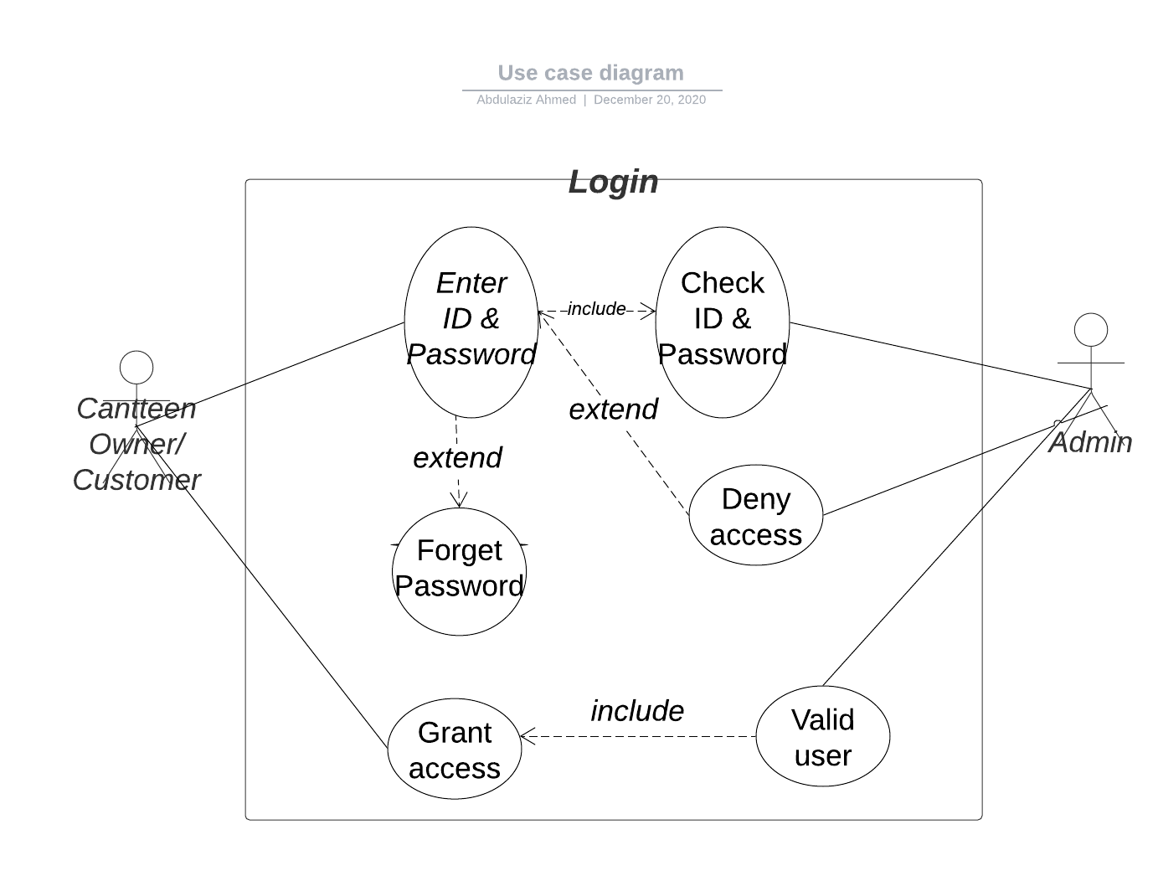

Appendix C: To Be Determined List
<Collect a numbered list of the TBD (to be determined) references that remain in the SRS so they can be tracked to closure.>

Source: http://www.frontiernet.net/~kwiegers/process_assets/srs_template.doc

