Freight Rate Prediction
Machine Learning Assessment Report
Development data: January-October 2025 | Prediction period: November-December 2025

1. Objective
The objective is to predict posted_rate for every load in data/validation.csv and produce a positive predicted rate for each of the 12,000 validation loads. The final model is trained using data/train_test.csv, with the supplied December chart inputs used to produce the required fixed-route forecast.

2. Data Exploration and Quality
The development data contains 48,000 labeled rows from January through October 2025. The validation data contains 12,000 unlabeled rows from November and December 2025. The target is posted_rate.
- 292 negative weights were identified as sign errors. Their absolute values matched normal load weights, so they were converted to positive values.
- 300 training weights and 165 validation weights were missing. Missing weights were imputed with the training median, 31,496 lb, and a weight_missing indicator was retained.
- 677 posted_rate values, approximately 1.4% of the labeled data, were identified as corrupted labels using a robust log-rate relationship and excluded from model fitting.
- market_index and quote_signal were not used as model features because the December chart input does not provide them.
- Eight cities appear only in validation. City and lane identifiers were therefore avoided; geographic coordinates provide a more robust representation for unseen cities.
All cleaning operations preserve validation rows. The cleaned training data contains 47,323 rows, and all 12,000 validation rows remain available for prediction.

3. Validation Strategy and Data Split
Because the real task predicts future months, random cross-validation was not used as the primary evaluation method. The development data was evaluated with expanding time windows, where each test period occurs strictly after its training period.
Fold | Training period | Test period
A | January-April | May-June
B | January-June | July-August
C | January-August | September-October
Feature selection was based on folds A and B. Fold C was retained as the main recent holdout and was not used to choose the final feature group. For every fold, imputation parameters and the robust label-outlier rule were fitted using historical training rows only.

4. Feature Engineering
- distance and log_distance
- cleaned weight and weight_missing
- one-hot equipment indicators for Dry Van, Flatbed, and Reefer
- day of week
- pickup and delivery latitude and longitude
The model does not use load_id. Pickup and delivery city names were not included as categorical features because validation contains unseen cities. Coordinates preserve geographic information and generalize better to those locations. Numerical normalization was not required because the selected model is LightGBM, a tree-based algorithm.

5. Model
The selected model is LightGBM using L1 regression on log(posted_rate). Training on the logarithm of the target reduces the effect of very large rates and guarantees positive predictions after exponentiating the model output. The final model is refit on all 47,323 clean January-October rows before generating the submission predictions.

6. Evaluation Results
The following results are calculated on clean labels in the internal time-based folds. The naive baseline is the median dollars-per-mile rate by equipment multiplied by distance.
Evaluation | MAE | MAPE | Bias
Naive baseline, Fold C | $175.1 | 8.1% | -1.7%
Selected model, Fold C | $44.7 | 2.0% | -0.7%
Selected model, mean folds A-C | $81.9 | 3.4% | approximately -2.4%
Fold performance varies with the market level: Fold A has MAE $146.6 and MAPE 5.9%, while folds B and C are substantially better. This indicates that the main remaining risk is a market-wide price shift, not route geography. When the known corrupted labels are included in the recent holdout, MAE rises to approximately $100.7 and RMSE to approximately $630.9; these rows are not predictable from the available features.

7. December Prediction Chart
The provided scorer validated the December prediction file and generated the required chart for the fixed Lexington-to-Fort Wayne route, with distance 360 miles, Dry Van equipment, and 32,000 lb weight. Only the date changes across the 31 December rows.
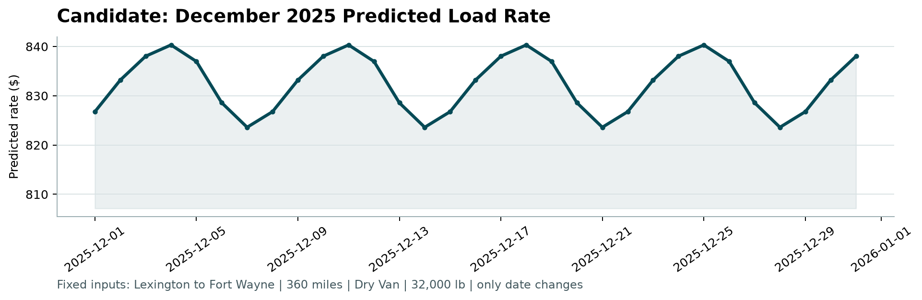
Figure 1. Candidate December 2025 predicted load rate.

8. Final Deliverables and Reproducibility
- validation_predictions.csv contains exactly 12,000 rows with columns load_id,predicted_rate.
- december_predictions.csv contains the seven required original columns plus predicted_rate.
- The provided scorer validated both output files successfully.
- The final model can be reproduced with: .\.venv\Scripts\python.exe -m src.train_predict
- The output files can be checked with: .\.venv\Scripts\python.exe scorer\score.py --predictions validation_predictions.csv --december-predictions december_predictions.csv

9. Limitations
The final November-December labels are hidden, so true submission performance cannot be calculated locally. Internal metrics are estimates based on earlier months. The model deliberately does not use market_index or quote_signal, and therefore may underpredict or overpredict if the overall freight market moves sharply after October.

