**Ideation Camp**

**3 Fundamental principles:**

- Desirability (Of the market/ actors)

- Feasibility (Technical and organizational)

- Viability (Economic)

**Tim Brown** (Inspiration/ Ideation/ Implementation)

1. **Inspiration (Problematic)**

* **Task 1:**
* Discuss in the team a problem you would to address
* Why is it important?
* **Task 2:**
* Causes: What are the leading causes of your prob?
* Effects: What are the main effects of your prob?
* Root: What is the main root of the prob?
* SDGs

1. **Ideation**

* **Task 3:**
* Dominant solutions for the problem
* Define the key elements of the value proposition
* **Task 4:**
* Mind Mapping
* Try to find a solution
* **Task 5: Market Analysis**
* SWOT
* Descriptive Research (=Quantitative DATA)
* Exploratory Research (=Qualitative DATA)
* **Task 6:**
* Benchmarking
* **Task 7:**
* BMC
* **Task 8: Pilot**
* Identify the scope of activities to be tested
* Identify the scale and duration of the test
* Identify the segment of the target audience that will be included in the pilot
* Identify the main tasks to be undertaken (Team Alignment Map)
* **Task 9:**
* Resource mobilization

**Tools for collecting information**

1. Research on the internet
2. Sharing expertise through:

* individual interviews with experts
* Group interviews with experts

1. In-depth interviews with users or people concerned by the topic in question
2. Observation

**Benchmarking**

| Brand | Description | Strengths | Price | Communication | Distribution channels | Types of technologies |
| --- | --- | --- | --- | --- | --- | --- |
|  |  |  |  |  |  |  |

**Team Alignment Map**

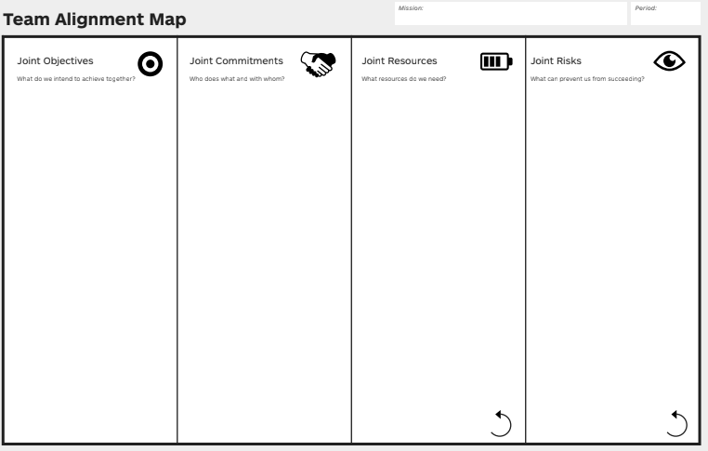

**BMC**

