How to Add managed oacore in Oracle Apps R12.2.x

#### Adding a new managed server

To increase the Weblogic performance, we might need to add up more JVMs by doubling managed servers.  Please follow below steps to add extra oacore managed server to Oracle E-Business Suite R12.2.x.  You can follow same procedure to add extra oafm, forms, forms-c4ws servers.

Addition of managed servers needs to be done on the run file system when there is no active ADOP cycle. During the next adop prepare, the Configuration Change Detector identifies that the addition has been made and the managed servers are automatically synced up from the run file system to the patch file system. The synchronization also gets done when fs_clone is executed.

To add a new managed server of a specific service type, perform the following steps on the run file system:

• Execute the following command to add a new managed server. This will create a managed server and add a new entry to the context file for starting and stopping the new managed server via the adstrtal and adstpall scripts:

$ perl <AD_TOP>/patch/115/bin/adProvisionEBS.pl \  
ebs-create-managedserver -contextfile=<CONTEXT_FILE> \  
-managedsrvname=<MANAGED_SERVER_NAME> -servicetype=<SERVICE_TYPE> \  
-managedsrvport=<MANAGED_SERVER_PORT> -logfile=<LOGFILE>

http://erp.appsdba.info:7007/console

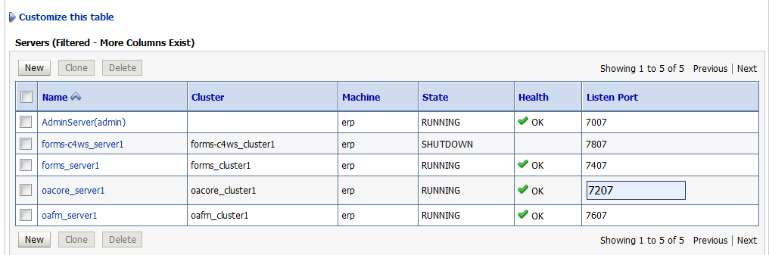

perl $AD_TOP/patch/115/bin/adProvisionEBS.pl \  
ebs-create-managedserver -contextfile=/d01/oracle/PROD/fs2/inst/apps/PROD_erp/appl/admin/PROD_erp.xml \  
-managedsrvname=oacore_server2 -servicetype=oacore \  
-managedsrvport=**7208** -logfile=/d01/oracle/PROD/TXK/addMS_oacoreserver2.log

perl $AD_TOP/patch/115/bin/adProvisionEBS.pl \

> ebs-create-managedserver -contextfile= /d01/oracle/PROD/fs2/inst/apps/PROD_erp/appl/admin/PROD_erp.xml \

> -managedsrvname=oacore_server2 -servicetype=oacore \

> -managedsrvport=7208 -logfile=/d01/oracle/PROD/TXK/addMS_oacoreserver2.log

Context file has not been passed.

-bash-4.1$ perl $AD_TOP/patch/115/bin/adProvisionEBS.pl ebs-create-managedserver -contextfile=/d01/oracle/PROD/fs2/inst/apps/PROD_erp/appl/admin/PROD_erp.xml -managedsrvname=oacore_server2 -servicetype=oacore -managedsrvport=7208 -logfile=/d01/oracle/PROD/TXK/addMS_oacoreserver2.log

Enter the APPS Schema password:

Enter the WebLogic AdminServer password:

The logfile for this session is located at /d01/oracle/PROD/TXK/addMS_oacoreserver2.log

ManagedServer oacore_server2 created successfully.

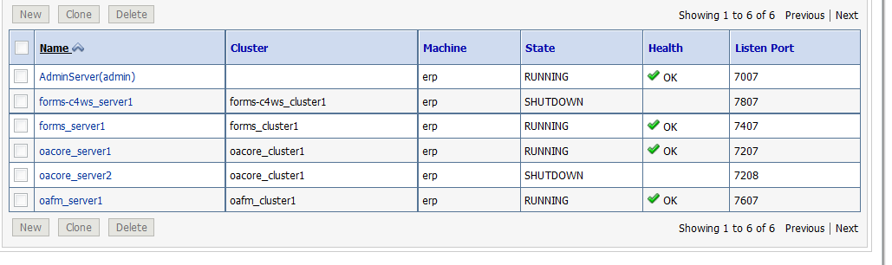

• Startup the managed server as follows:

sh admanagedsrvctl.sh start oacore_server2

Perform the following steps on all application tier nodes participating in the same cluster where this managed server is added:

Execute the following command to add details of the newly added managed servers into the OHS configuration files mod_wl_ohs.conf and apps.conf on the current node:

perl <FND_TOP>/patch/115/bin/txkSetAppsConf.pl -contextfile=<CONTEXT_FILE> \  
-configoption=addMS -oacore=testserver.example.com:7205

perl $FND_TOP/patch/115/bin/txkSetAppsConf.pl -contextfile=/d01/oracle/PROD/fs2/inst/apps/PROD_erp/appl/admin/PROD_erp.xml \

-configoption=addMS -oacore=erp.appsdba.info:7208

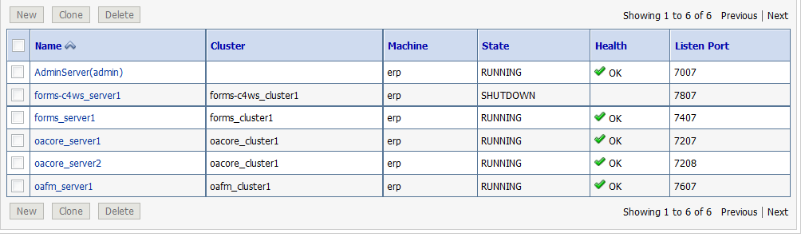

If Oracle HTTP Server is enabled on the node, restart it as follows:

sh <ADMIN_SCRIPTS_HOME>/adapcctl.sh stop

sh <ADMIN_SCRIPTS_HOME>/adapcctl.sh start

References:

**Managing Configuration of Oracle HTTP Server and Web Application Services in Oracle E-Business Suite Release 12.2 (Doc ID 1905593.1)**