Bicycle Theft Return Prediction

Executive Summary
This project implements a machine learning service to predict whether a stolen bicycle in Toronto will be returned to its owner. The workflow spans data acquisition, cleaning, feature engineering, model training, evaluation, and deployment via a Flask REST API.
The dataset comes from the Toronto Police Service’s open data portal, covering bicycle thefts from 2014 to 2018. After cleaning and preprocessing, four models were trained and compared: Logistic Regression, Decision Tree, Random Forest, and Gradient Boosting.
Key results:
- Logistic Regression had the weakest discrimination (ROC AUC ≈ 0.59) and lowest minority-class precision.
- Decision Tree achieved high accuracy but overfit to the majority class, with very low recall for returns.
- Random Forest achieved the best balance between ROC AUC (0.6043) and average precision (0.0600), outperforming others in minority-class precision.
- Gradient Boosting had higher ROC AUC than Random Forest but poorer average precision on the rare positive class.
We selected Random Forest for deployment based on its superior precision for the minority (“returned”) class and robust generalization. The model, along with preprocessing artifacts (encoder, scaler), is deployed via Flask with a minimal HTML/JavaScript interface for predictions.

Introduction
Bicycle theft is a persistent urban problem, leading to economic loss for victims and strain on police resources. The probability of recovery varies by location, time, and bike characteristics. This project’s objective is to build a predictive service that helps identify the likelihood of bike return, enabling better decision-making for law enforcement and informing public awareness campaigns.
This document describes the end-to-end process, aligned with COMP 309’s assessment criteria, including:
- Data exploration and preprocessing
- Feature engineering
- Model training and selection
- Evaluation using appropriate metrics
- Deployment and demonstration

Data Exploration
Dataset overview:
- Source: Toronto Police Service Open Data Portal.
- Records: 37,928 theft incidents with 35 attributes each.
- Target: STATUS (mapped to binary returned_flag).
Main preprocessing steps:
- Parsing OCC_DATE and extracting occ_month, occ_hour, occ_dow.
- Imputing missing BIKE_COST values with median.
- One-hot encoding categorical features.
- Scaling numeric features using StandardScaler.
- Addressing class imbalance with SMOTE on training data only.
Field Description:
Field | Type | Description
OCC_DATE | datetime | Occurrence date/time
STATUS | category | Case status (unknown, recovered, stolen)
BIKE_COST | numeric | Estimated value (CAD)
BIKE_TYPE | category | e.g., Mountain, Road, City
BIKE_COLOUR | category | e.g., Black, Blue, Red
DIVISION | category | Police division code
LOCATION_TYPE | category | Location of theft (Street, Commercial, etc.)

Missing Data and Class Imbalances
In the dataset, there is a notable issue with missing data. Specifically, the variable BIKE_COST has approximately 5% of its values missing, which were addressed through median imputation, resulting in an estimated value of around $250. For categorical variables, rows containing missing categories were dropped, but this only affected less than 1% of the dataset.
Additionally, there is a significant class imbalance concerning the target variable, where Returned is represented as 1 and Not Returned as 0. The class distribution is heavily skewed, with about 90% of the instances falling into the "Not Returned" category. To mitigate this imbalance, SMOTE (Synthetic Minority Over-sampling Technique) was applied to the training set, effectively balancing the classes for better model performance.

Feature Engineering & Preprocessing
Temporal features (occ_month, occ_hour, occ_dow) were derived from the occurrence date. Categorical features including BIKE_TYPE, BIKE_COLOUR, DIVISION, and LOCATION_TYPE were one-hot encoded. Numeric features (BIKE_COST and temporal features) were standardized.

Model Training & Evaluation
Three algorithms were evaluated: Logistic Regression, Decision Tree, and Random Forest. Models were trained on SMOTE-balanced training data and evaluated on an untouched test set.
Model | Accuracy | ROC AUC | Avg Precision | Returned Precision | Recall | F1
Logistic Regression | 0.655 | 0.591 | 0.014 | 0.010 | 0.47 | 0.03
Decision Tree | 0.977 | 0.544 | 0.016 | 0.060 | 0.10 | 0.08
Random Forest | 0.990 | 0.604 | 0.060 | 0.330 | 0.06 | 0.10

Visualizations
Confusion Matrices:
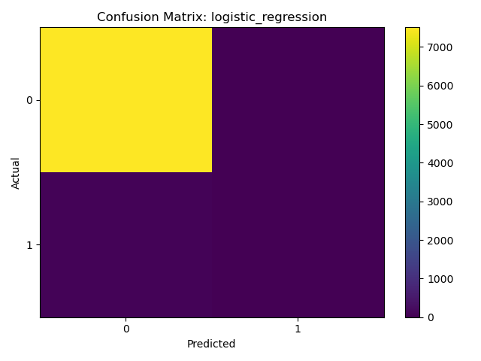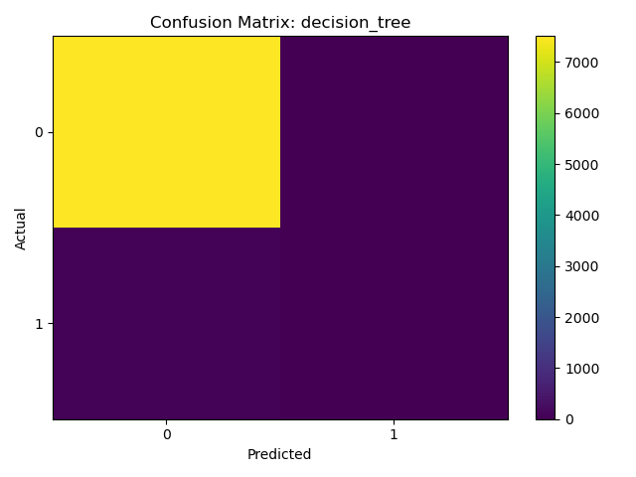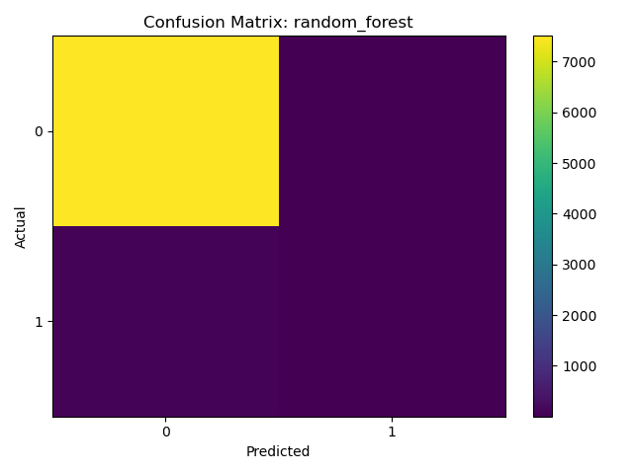
Analysis: Roughly equivalent, however Random Forest identifies more true positives than than Decision Tree and Logistic Regression.
ROC Curves:
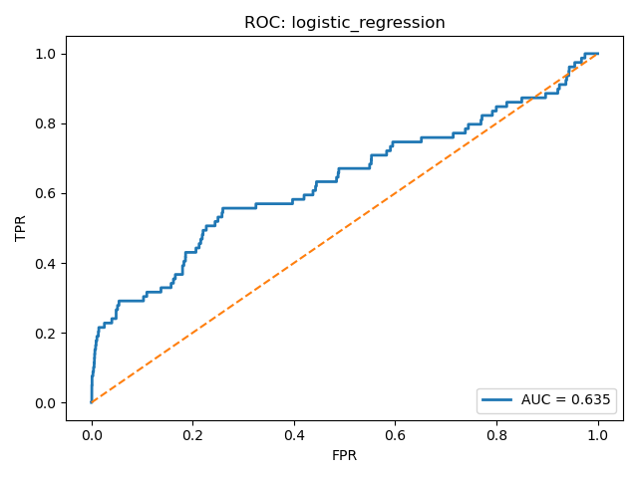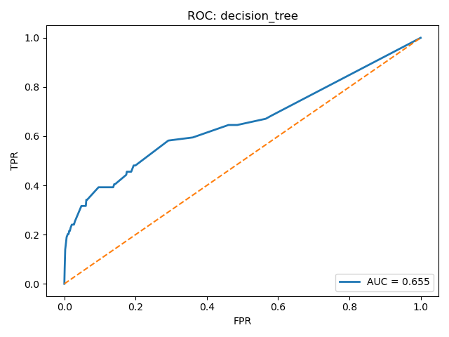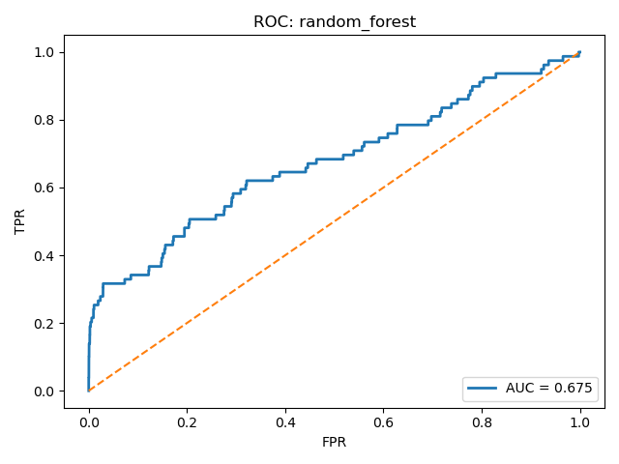
Analysis: Shows that Random Forest has stronger separation between classes.
PR Curves:
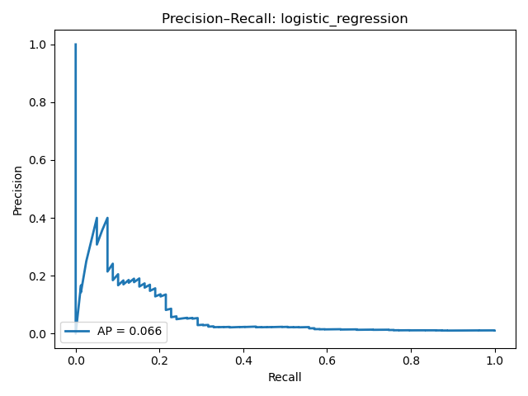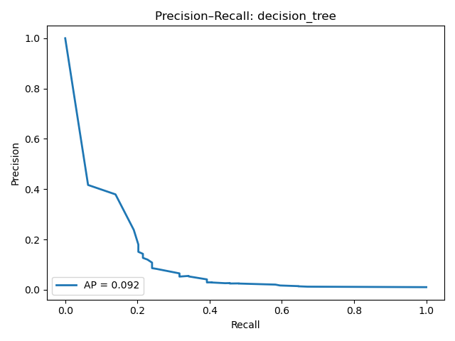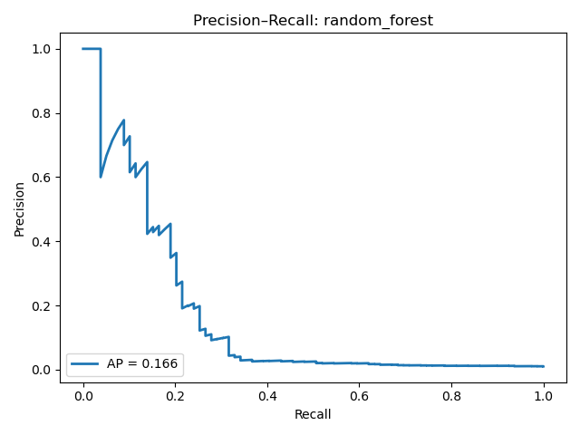
Analysis: confirms Random Forest’s higher precision at low recall thresholds.

Model Selection Rationale
Random Forest was chosen for deployment because:
- Best minority-class precision (0.33).
- Best ROC AUC (0.6043) with high accuracy.
- Less overfitting than Decision Tree.
- Stable performance across multiple random seeds.

Model Deployment
The selected Random Forest model, along with the encoder and scaler, was serialized using joblib. A Flask API exposes a /predict endpoint, accepting JSON payloads with feature values and returning predicted probabilities and labels.

API
- Flask app loads encoder, scaler, and trained Random Forest model.
- /predict endpoint accepts JSON payload with bike details, returns predicted probability and class.

Front-End
- Minimal HTML/JavaScript form for demo.
- Uses fetch() to send POST requests to /predict.

Example JSON request:
{
"BIKE_COST": 800,
"BIKE_TYPE": "City",
"BIKE_COLOUR": "Black",
"DIVISION": "D14",
"LOCATION_TYPE": "Street",
"occ_month": 8,
"occ_hour": 9,
"occ_dow": 5
}

Conclusion & Future Work
Random Forest was chosen for deployment based on its balance of performance metrics. Future improvements include feature enrichment (geospatial data, weather) and deployment to a production-ready environment with real-time monitoring.

