Autonomous AI Agent for Blockchain Anomaly & Crypto Fraud Detection

Author: Abdul Aziz Abbasi
Category: Blockchain Security & Cloud Data Pipelines
Environment: AWS, Alchemy (Ethereum API), Python, Streamlit

Project Overview
This project details the deployment of a real-time blockchain threat intelligence architecture designed to flag fraudulent transactions. By connecting a 24/7 lightweight memepool streaming script to a scalable cloud ingestion engine, the platform feeds active transaction data through serverless logic to isolate financial anomalies and visualize high-risk activity on an interactive operational dashboard.

- Created account on Alchemy:
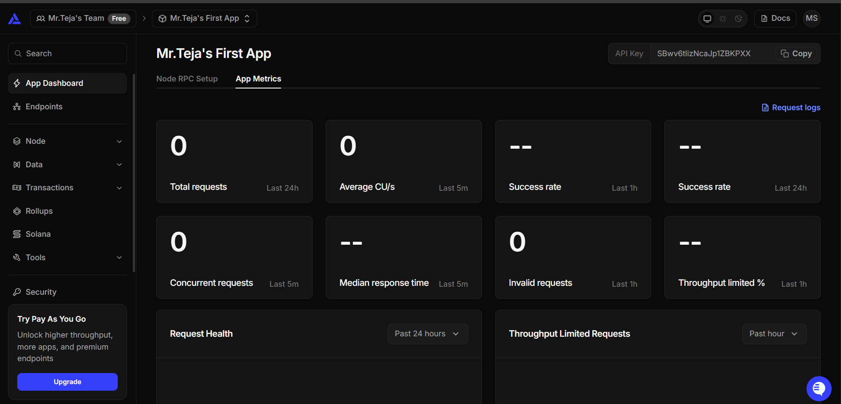

- Created etherium memepool and tested directly on local machine:
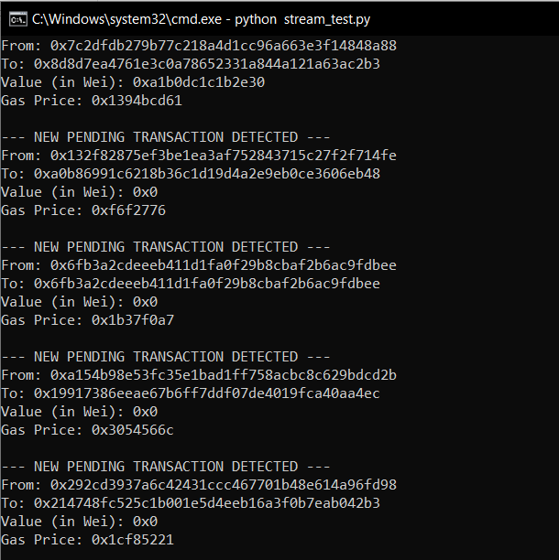

- Blueprint:

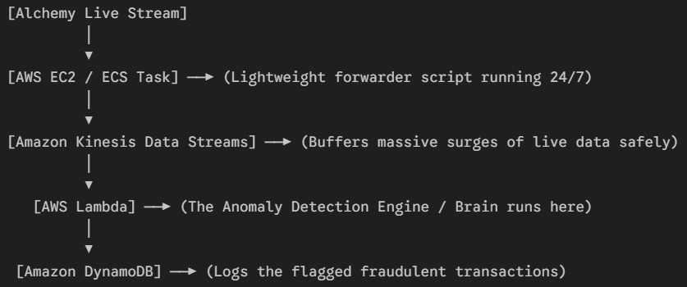

- Creating the DynamoDB Table:
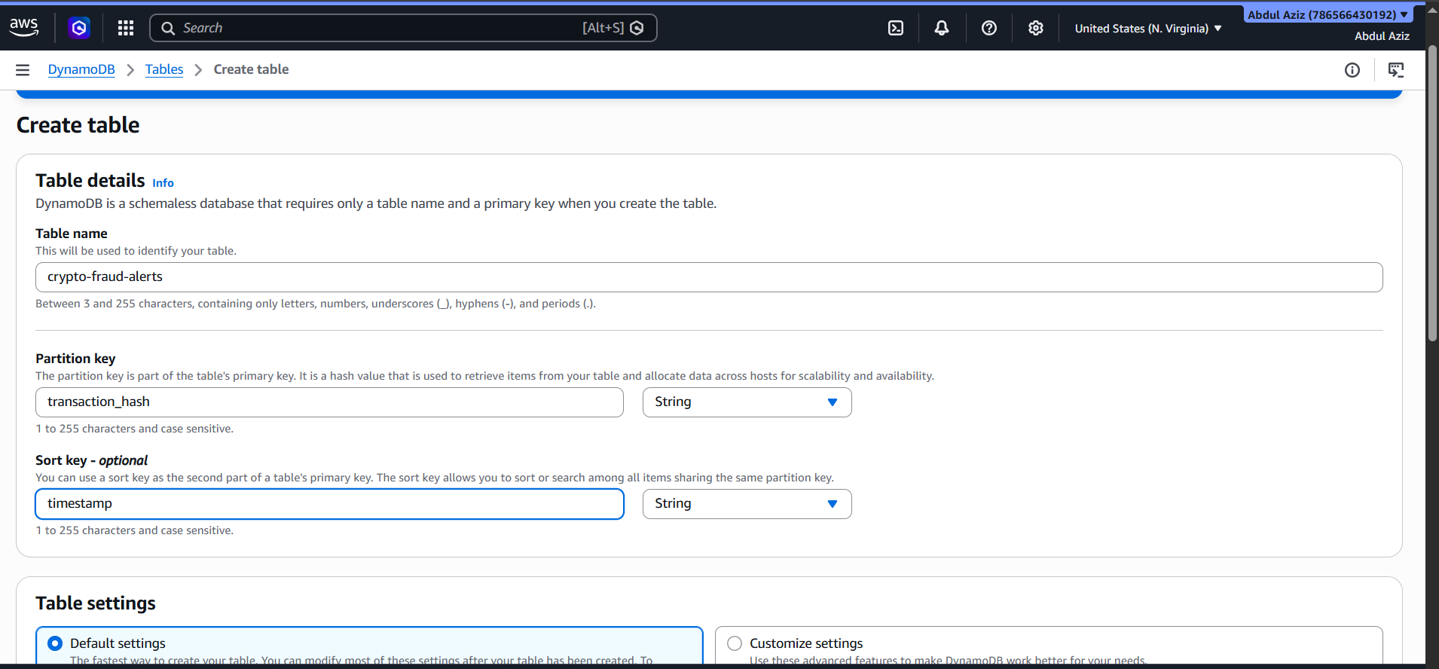

- Created:
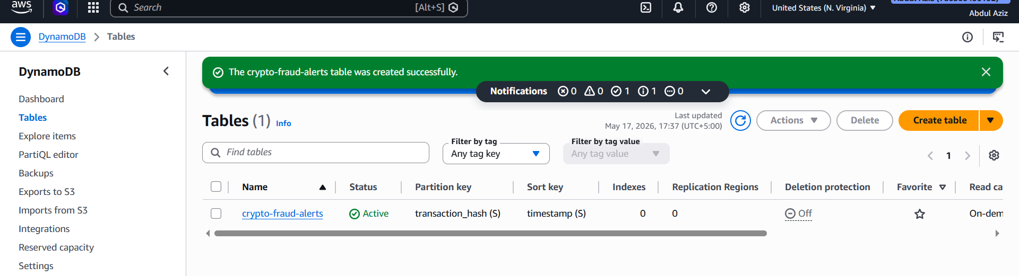

- Created Amazon Kinesis Data Stream:
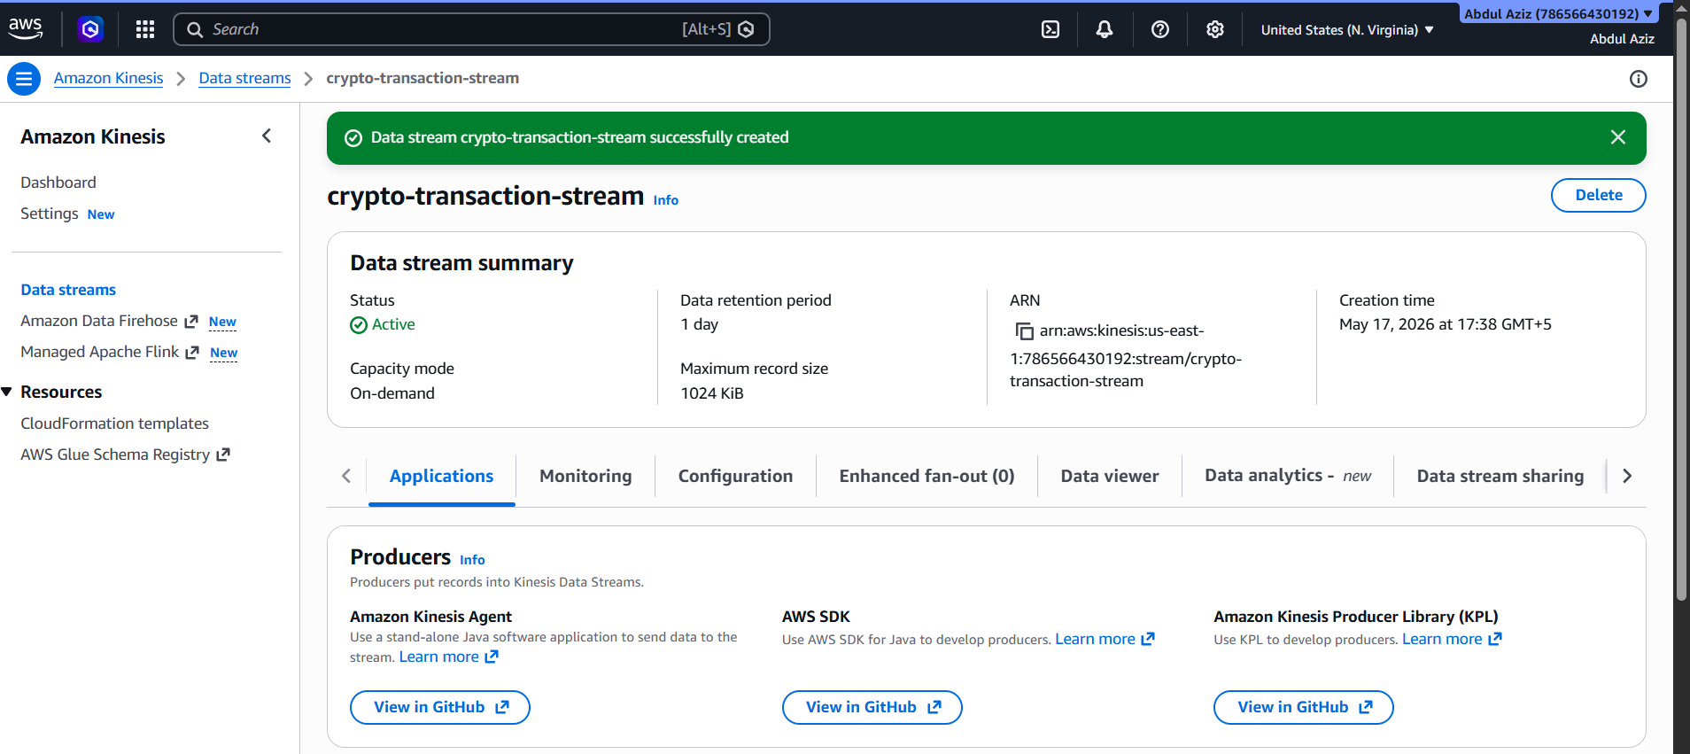

- Installing BOTO3:

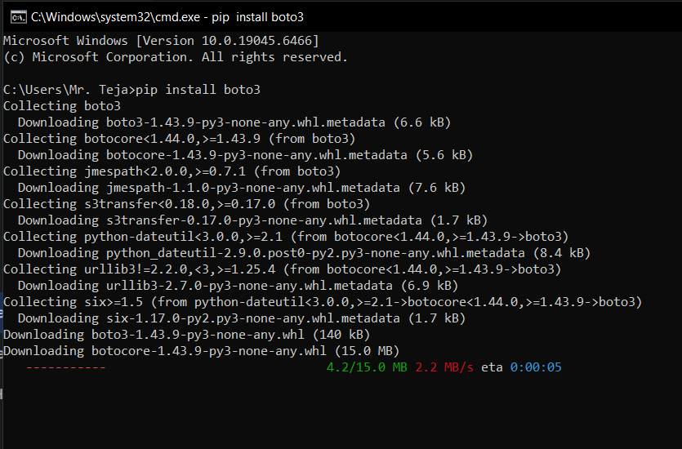

- Established connection between blockchain and cloud:
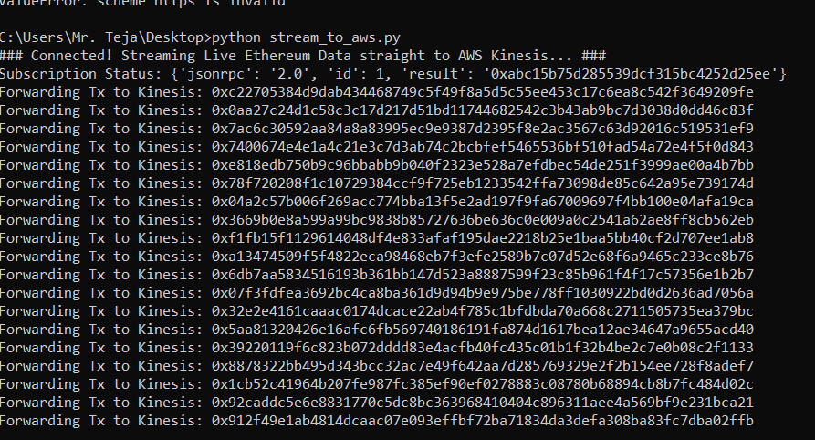

- Creating lambda function:
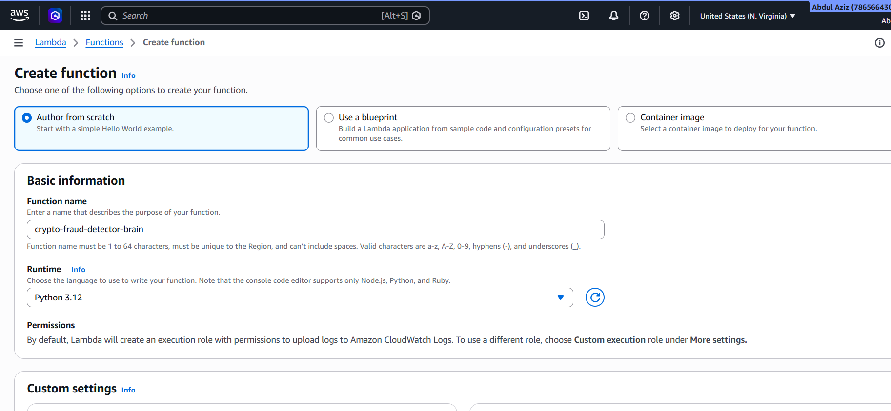

- Created:
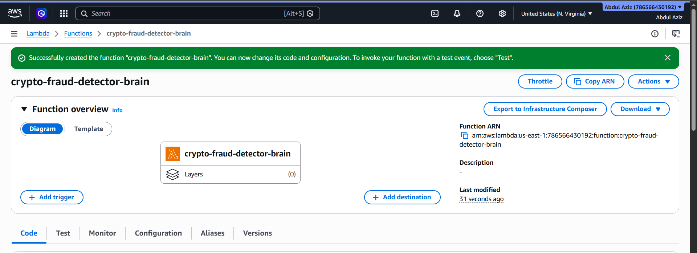

- Attached 2 policies to role:
1. AmazonKinesisReadOnlyAccess
2. AmazonDynamoDBFullAccess

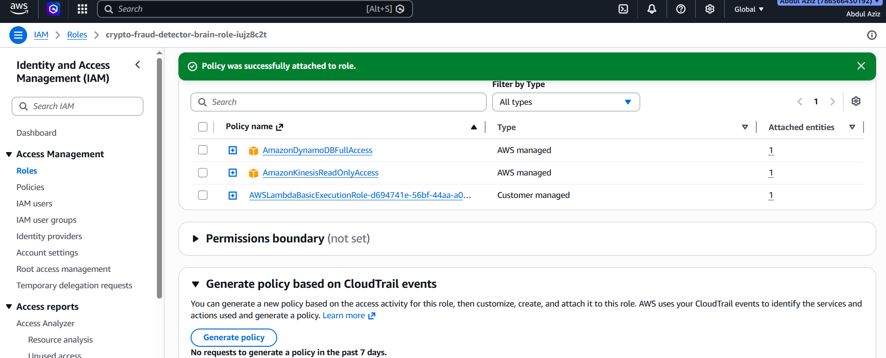

- Adding Trigger:
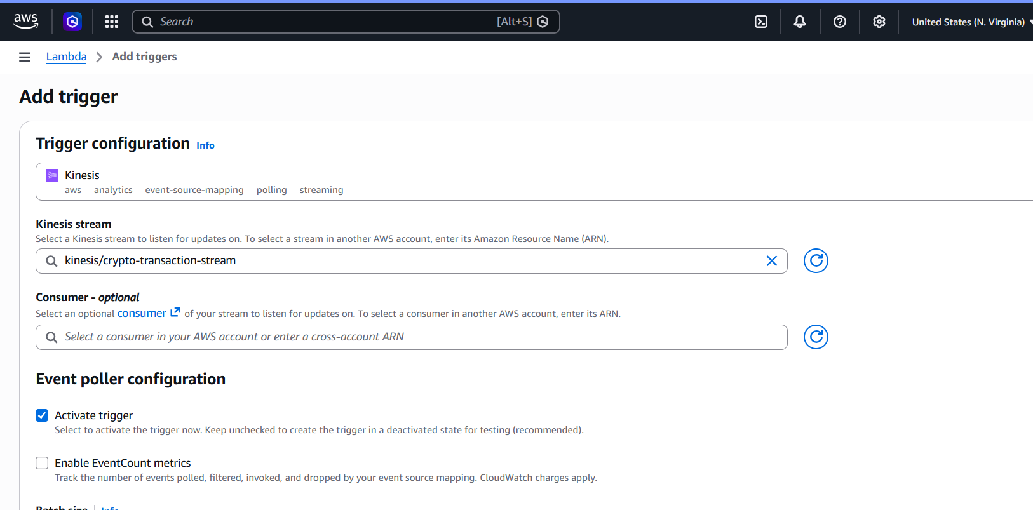

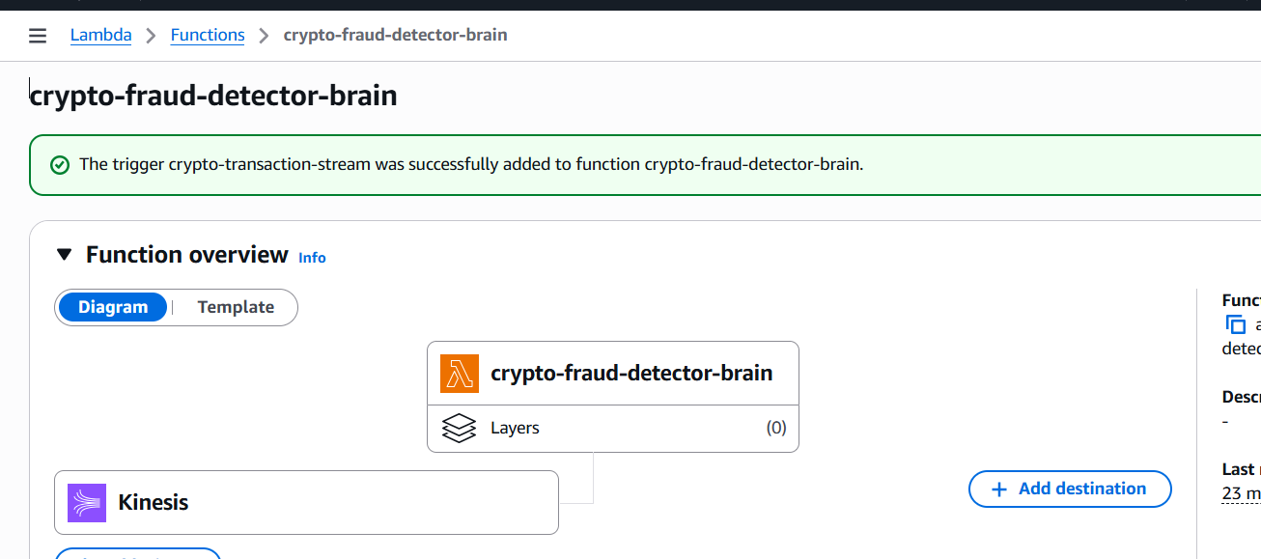

- Updated the function code:
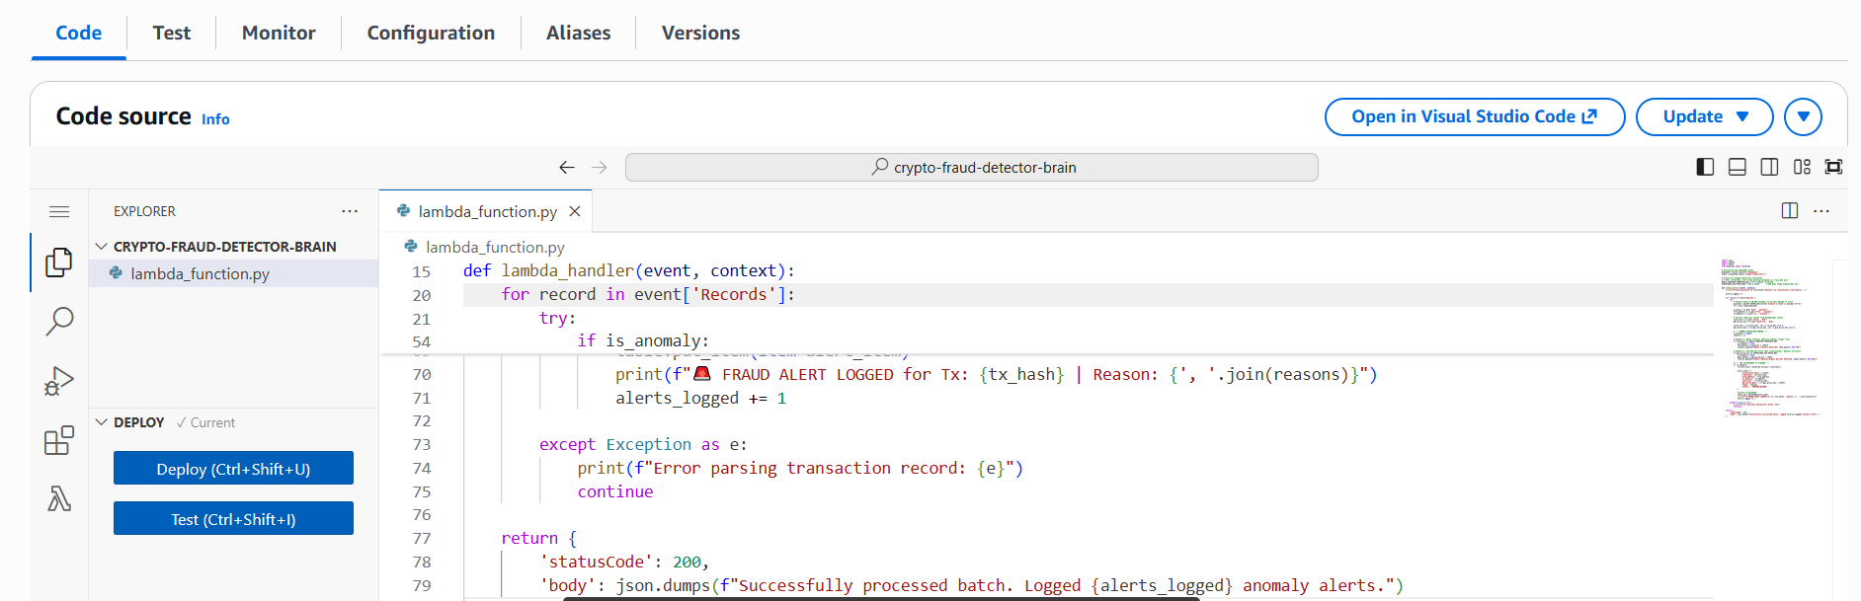

- Monitoring alerts:

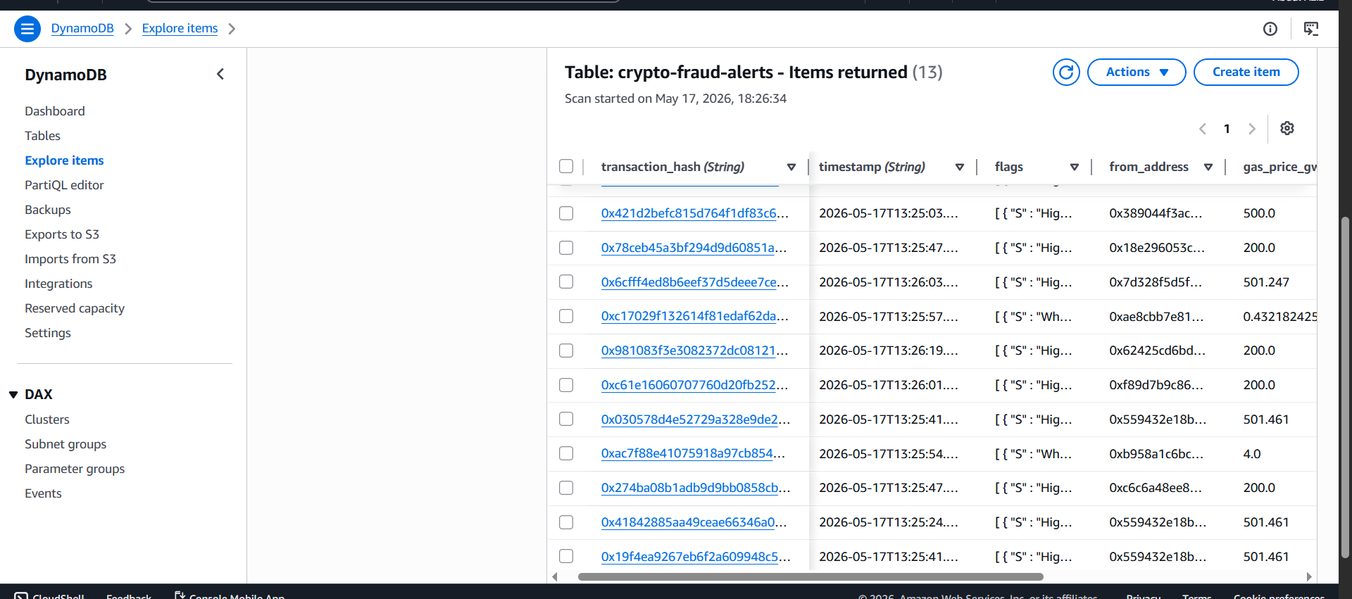

- Setting stream limit to 10 for kinesis:
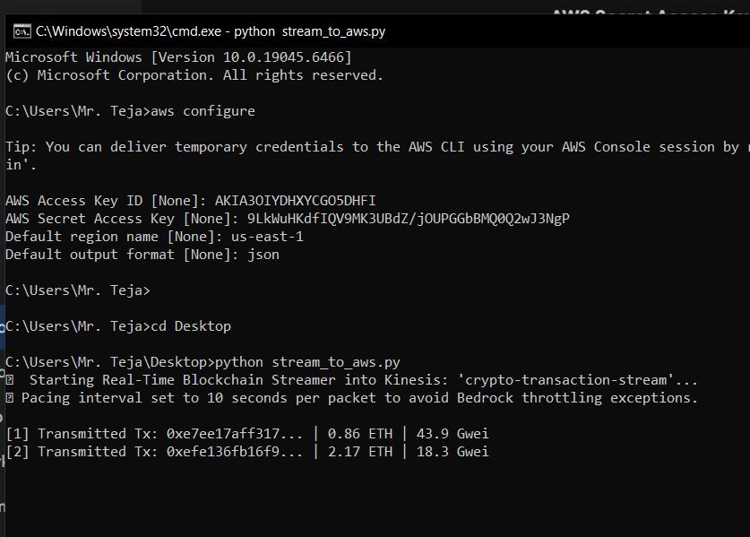

- Installed streamlit:
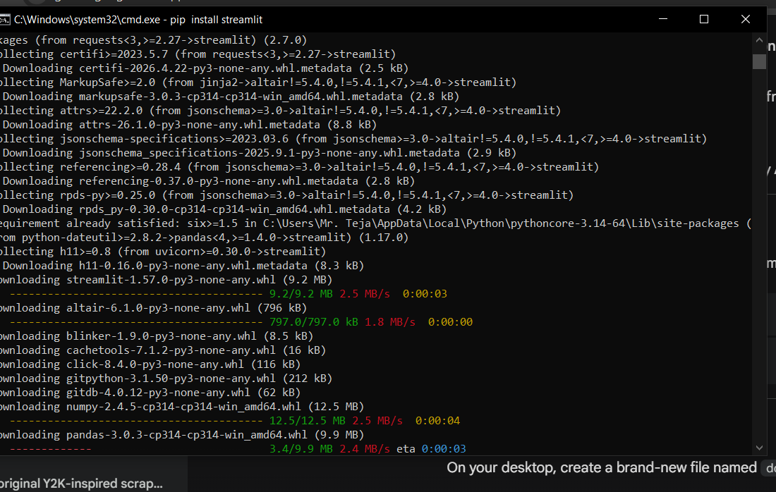

- Created dashboard for detection:
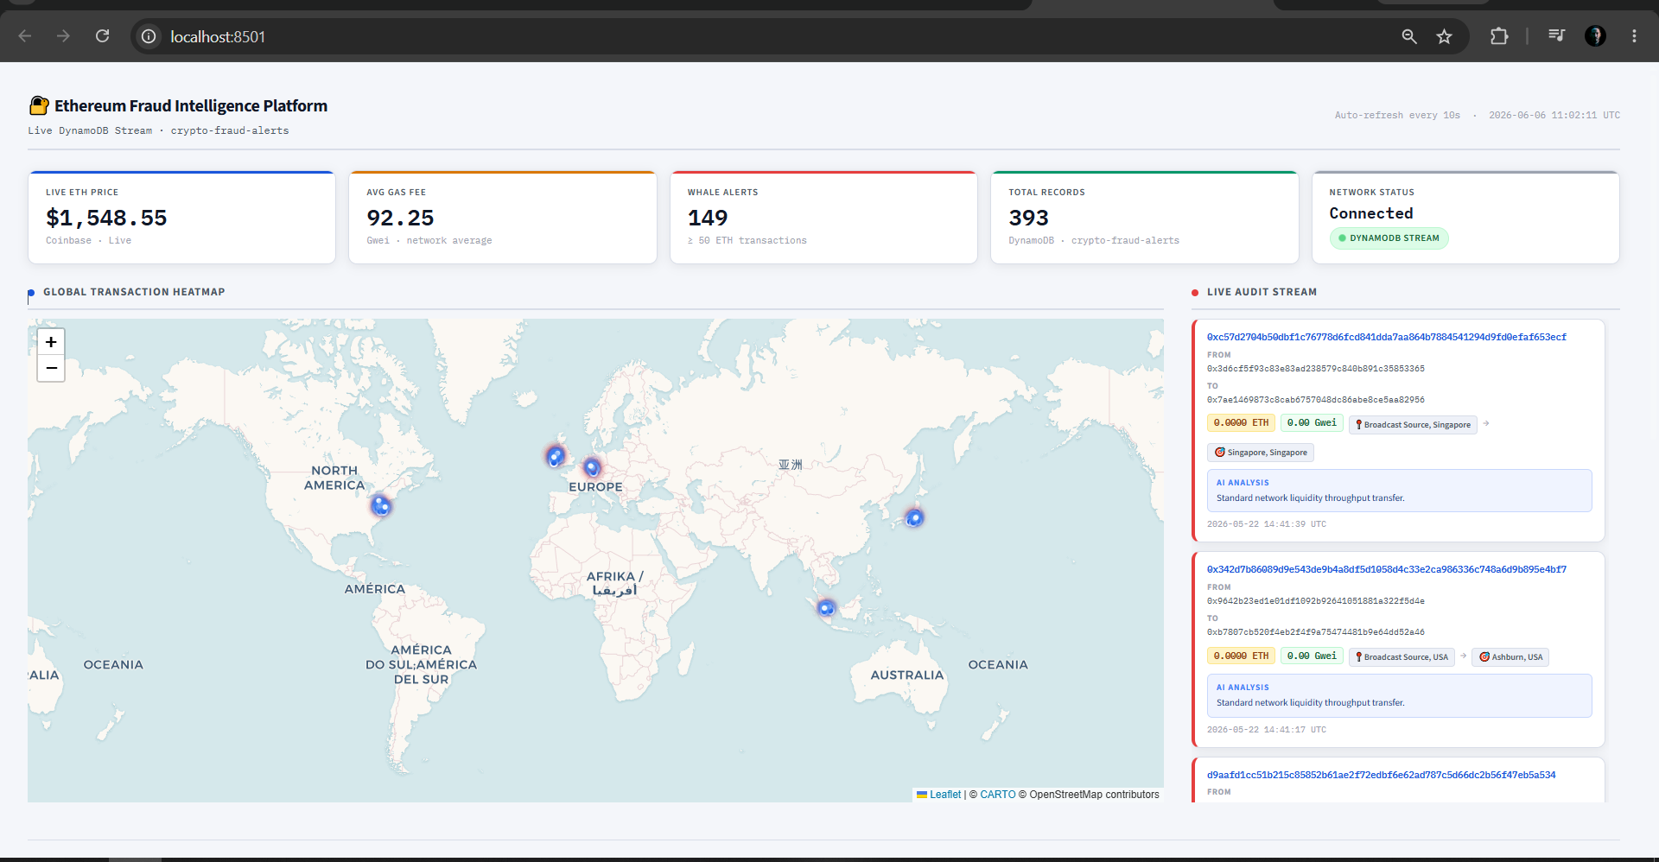

- The results:
