Name: Abdul Aziz Abbasi
1. Title

Forensic Investigation and Data Recovery: Analyzing E01 Disk Images using FTK Imager and Autopsy.

2. Background / Theory
Digital forensics involves the preservation and recovery of data that has been intentionally or accidentally deleted. Unlike simple file deletion, which often only removes the pointer to the data, forensic imaging allows for the recovery of actual file content from "unallocated space." This project utilizes the E01 (EnCase Evidence) format, a standard in the industry that supports compression and metadata storage, ensuring data integrity through cryptographic hashing.

3. Objective
The objectives of this Open Ended Lab are:
- To create a forensically sound E01 disk image using FTK Imager.

- To simulate data loss by deleting various file types (Excel, Word, Images) and emptying the drive.
- To perform data recovery and analysis using the Autopsy Digital Forensics Platform.

- To verify evidence integrity using MD5/SHA1 hash values.
- To understand limitations of logical folder-based forensic acquisition

4. Tools and Environment
The following tools and environment were used:
• FTK Imager: Used for creating the E01 physical/logical disk image.
• Autopsy: Used for disk image analysis, file recovery, and timeline building.
• Hardware: External/Thumb Drive used as the evidence source.
• File Types: Excel (.xlsx), Word (.docx), and Images (.jpg/png).

5. Flowchart / Block Diagram
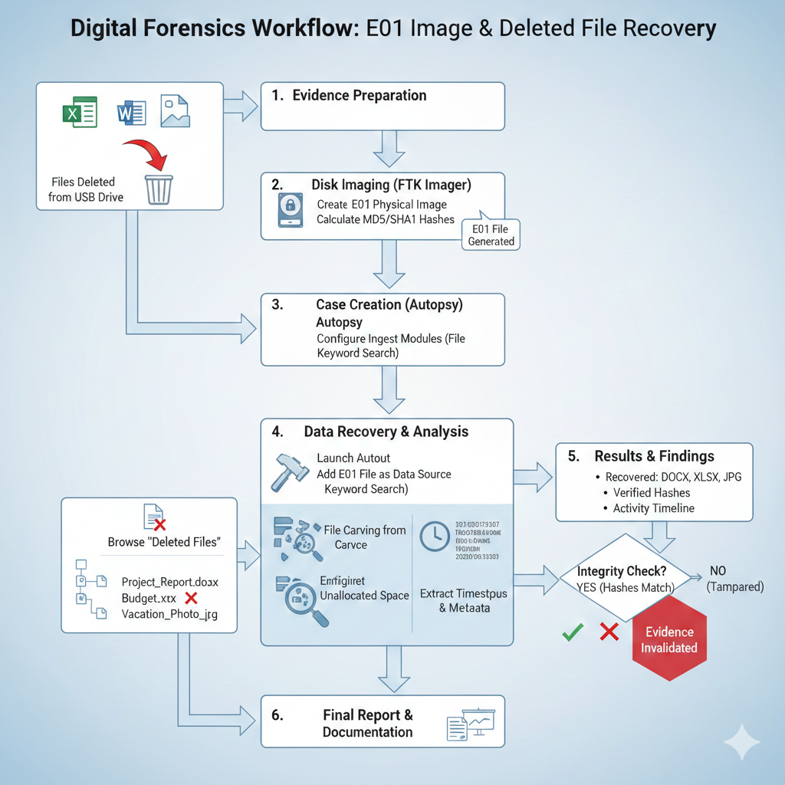

6. Procedure / Methodology

Files (Excel, Word, Images) were copied into a clean, empty drive.
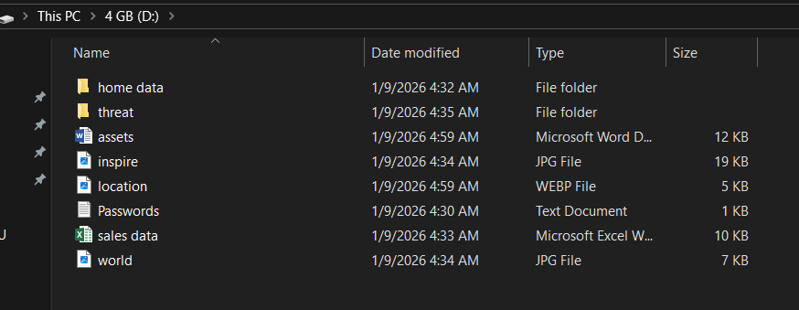

- Disk Imaging (FTK Imager)
The drive was connected to the forensic workstation.
Action: Selected "Create Disk Image" -> "Physical Drive."

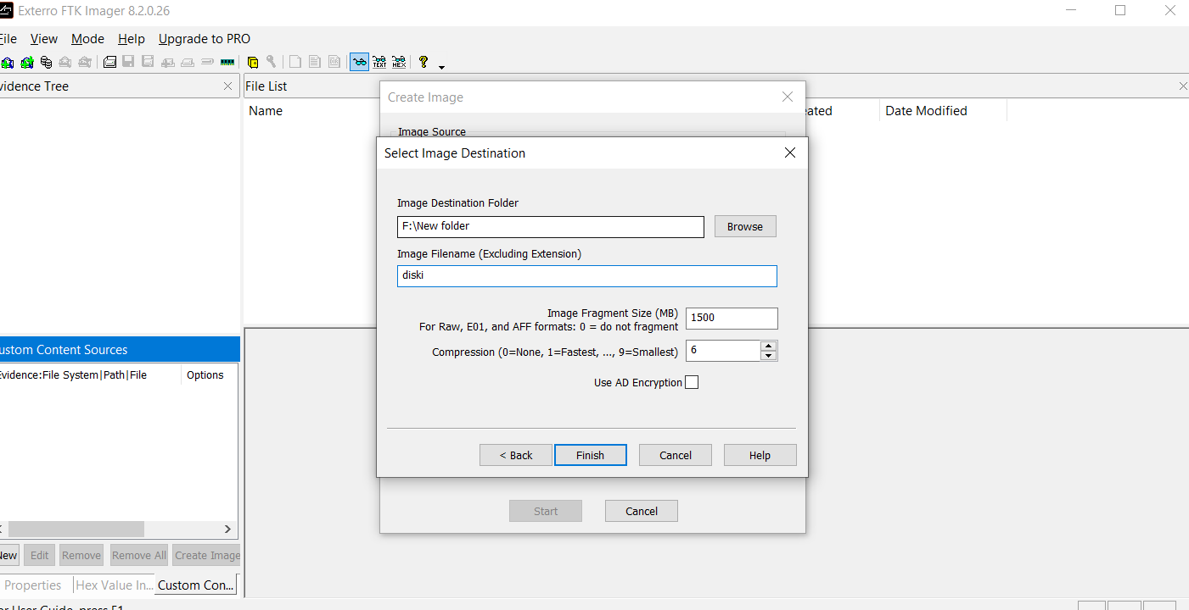

Chose the E01 format, added case details, and set a destination.

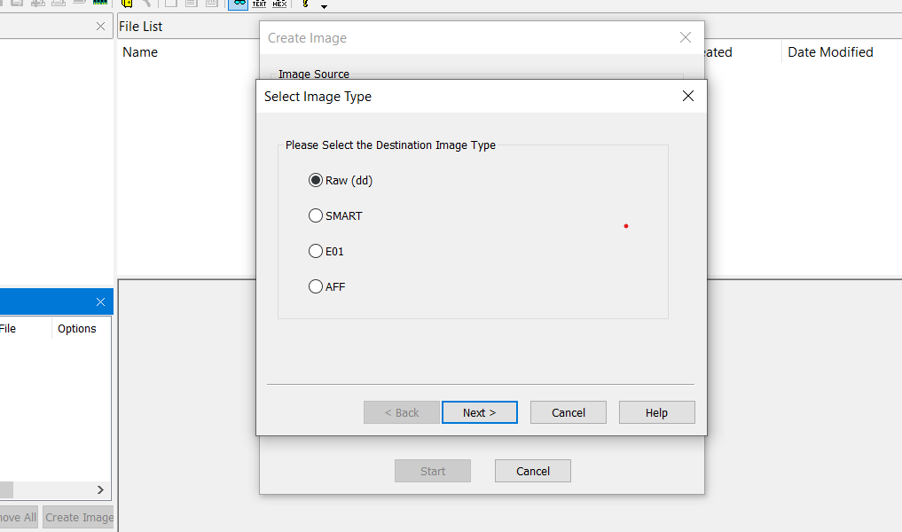

Created the E01 file:

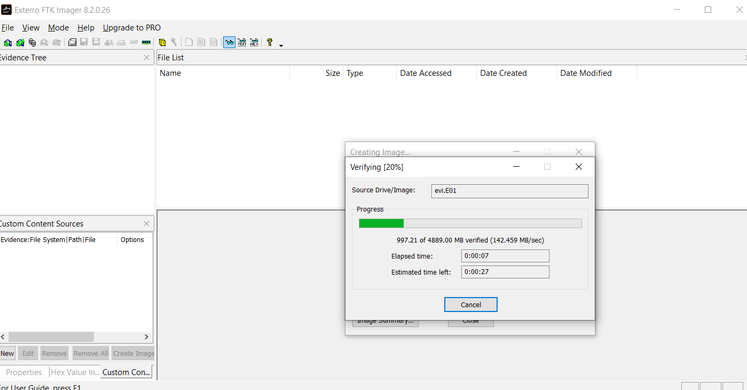

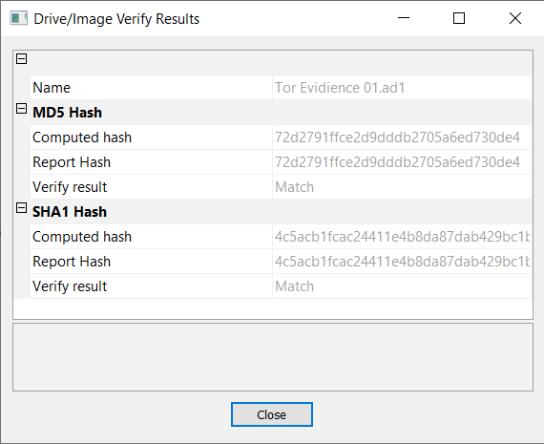

- Case Creation in Autopsy

Launched Autopsy and created a "New Case.

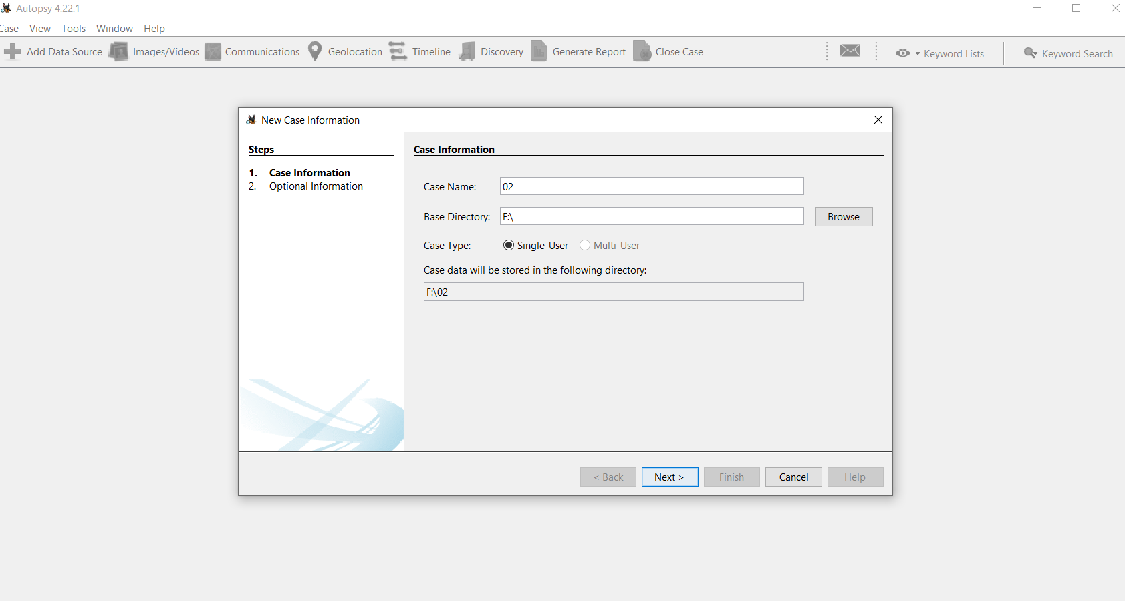
- Configured Ingest Modules (File Type Identification, Keyword Search):

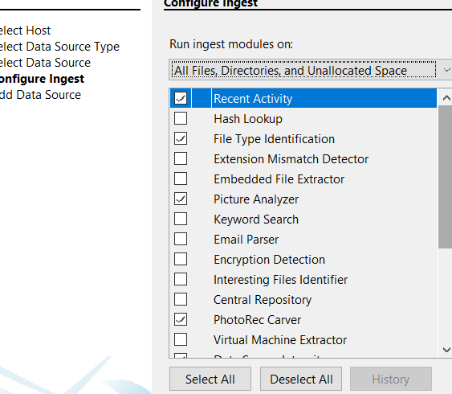

Data Recovery and Analysis
- Navigated to the "File Analysis" or "Deleted Files" section in Autopsy:

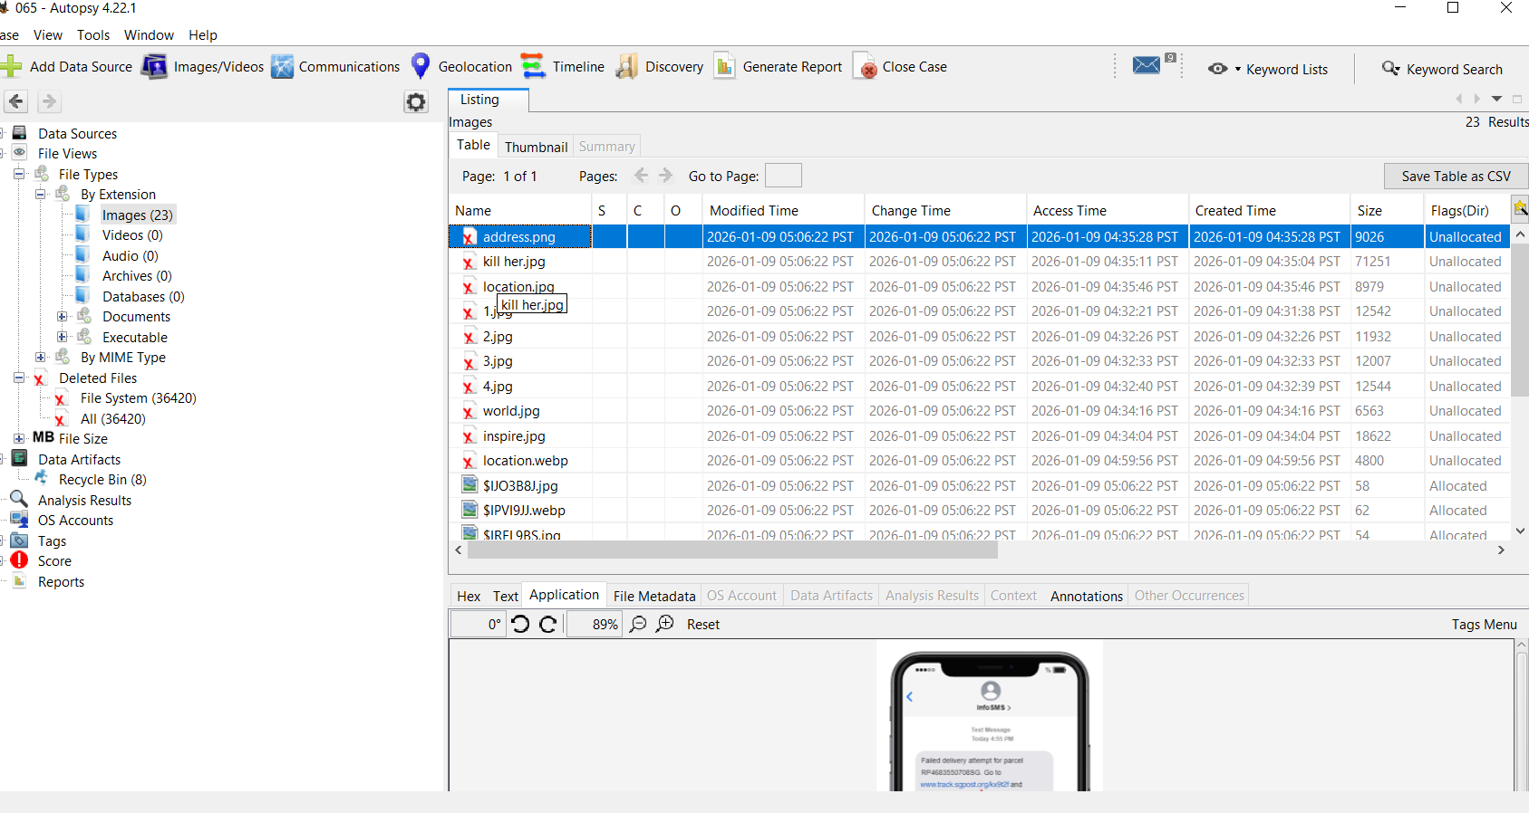

- Autopsy identified the deleted Excel, Word, and Image files:

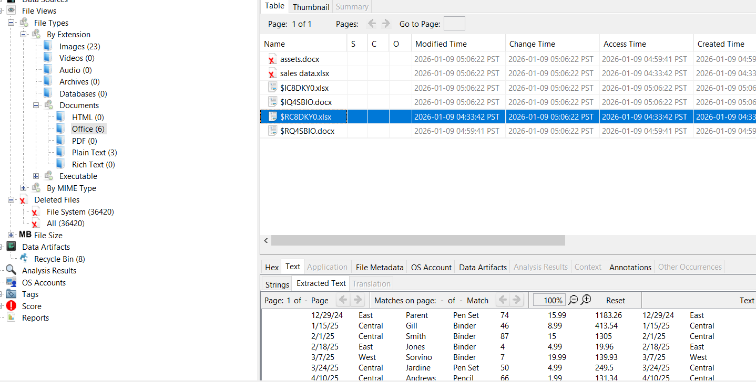

- Extracted the recovered files for verification:

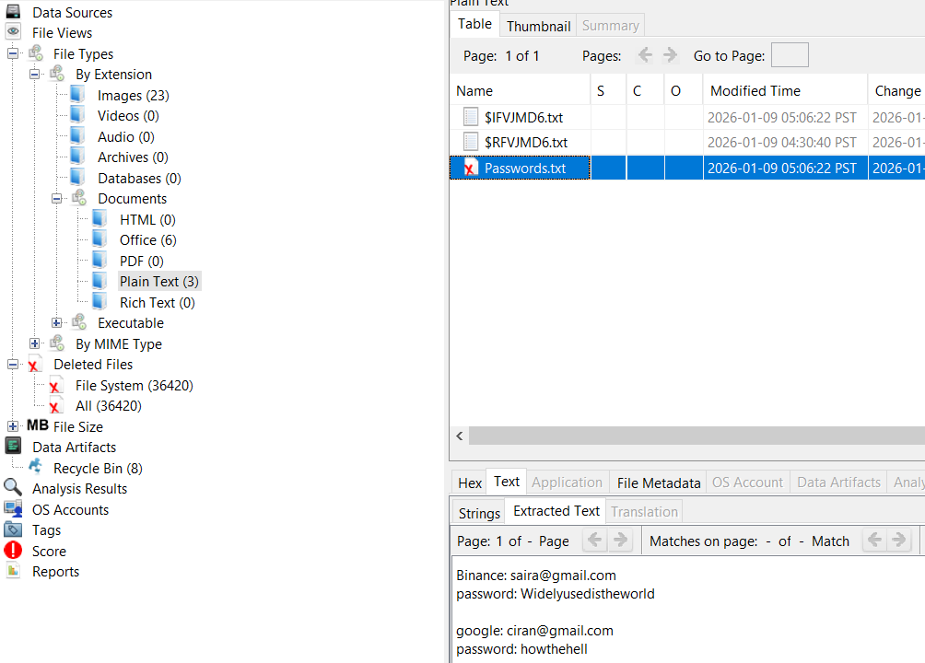
- All deleted files (Word, Excel, Images) were successfully identified:

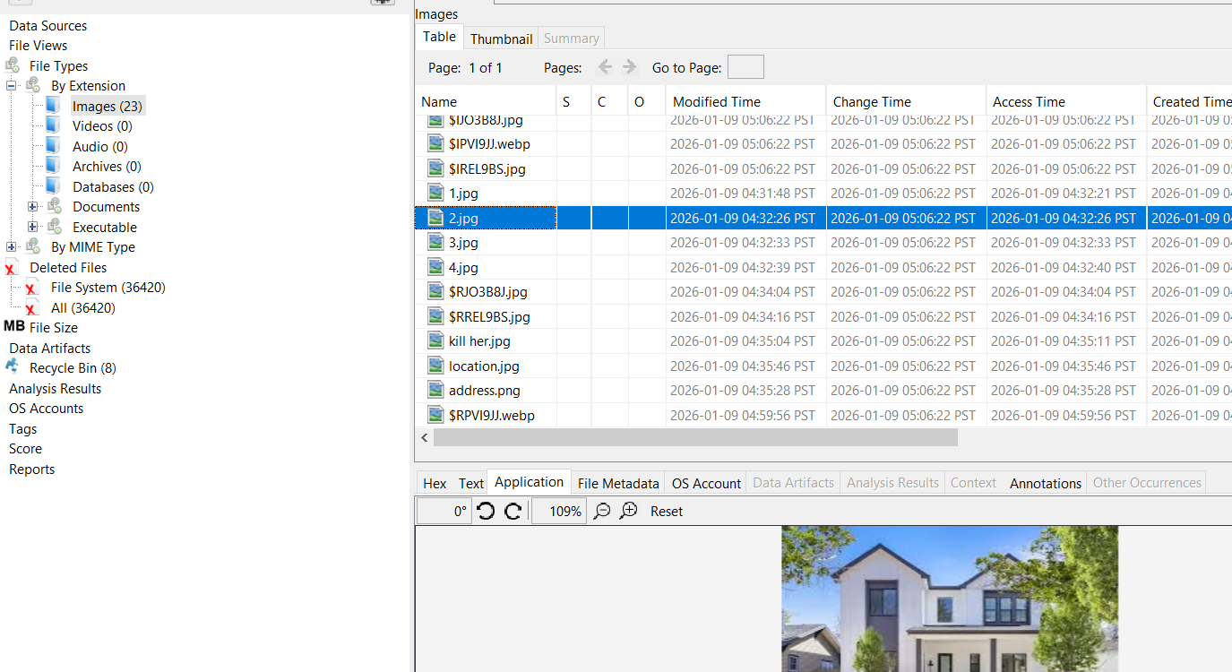

7. Evidence Preservation and Rule of Three:
To maintain forensic integrity during this project, the Rule of Three was strictly applied during evidence handling. Three identical copies of the digital evidence (the E01 forensic image) were maintained throughout the investigation:
- Original (Master) Copy: This was the primary E01 image file generated immediately after disk acquisition. It was stored in a secure location and remained untouched to serve as the "gold standard."
- Working Copy: This copy was used exclusively for active examination and analysis within the Autopsy Digital Forensics Platform. This ensured that any metadata changes made by the analysis software did not affect the original evidence.
- Backup Copy: A third copy was retained on a separate storage medium to ensure evidence availability in the event of data loss or hardware failure.
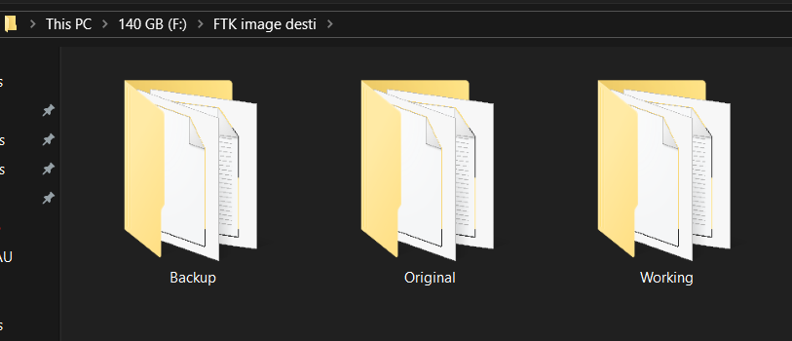

8. Results
The following results were obtained:
• Successful Acquisition: Created a bit-stream E01 image of the drive, successfully capturing all sectors including unallocated space.
• Data Recovery: Identified and recovered deleted Excel (.xlsx), Word (.docx), and Image files that were no longer visible to the OS.
• Integrity Verification: Verified that the MD5/SHA1 hashes generated during acquisition matched the analysis phase, ensuring evidence was not altered.
• Artifact Extraction: Extracted metadata including original file names, creation dates, and deletion timestamps to reconstruct user activity.

9. Discussion

This project proves that "deleting" a file does not erase it from the physical disk. When Word, Excel, or Image files were deleted, only their pointers were removed. Using FTK Imager to create an E01 physical image allowed us to access the unallocated space. Through Autopsy, we successfully performed file carving to recover the data. This highlights the advantage of Physical Acquisition over logical methods: it captures everything, even hidden or deleted artifacts.

10. Conclusion

This investigation successfully demonstrated the power of forensic imaging. Even though files were deleted and the drive appeared empty to the OS, the use of FTK Imager and Autopsy allowed for full recovery. This reinforces the principle that "deleted" data remains on the physical media until overwritten.

11. References (IEEE Format)
[1] AccessData, "FTK Imager User Guide," 2024. [Online]. Available: https://accessdata.com/product-download/ftk-imager-version-4-5
[2] Basis Technology, "Autopsy Digital Forensics Platform Documentation: Data Sources and Ingest Modules," 2024. [Online]. Available: https://www.autopsy.com/documentation
[3] Guidance Software, "EnCase Forensic Evidence File Format (E01) Specifications," 2023. [Online]. Available: https://www.guidancesoftware.com/encase-forensic

