COURSEWORK SUBMISSION FORM
STUDENT USE |  | STAFF USE
Module Name | Database Systems Development | First Marker’s  (acts as signature)
Module Code | 5BUIS009C-n | Second Marker’s  (acts as signature)
Lecturer Name | Dmitriy Pochitaev | Agreed Mark
UoW Student IDs |  | For Registrar’s office use only (hard copy submission)
WIUT Student IDs | 00013836  00014725  00014896
Deadline date | 29.03.2024
Assignment Type | Group

SUBMISSION INSTRUCTIONS

COURSEWORKS must be submitted in both HARD COPY (to the Registrar’s Office) and ELECTRONIC unless instructed otherwise.
For hardcopy submission instructions refer to: http://intranet.wiut.uz/Shared%20Documents/Forms/AllItems.aspx - Coursework hard copy submission instructions.doc
For online submission instructions refer to: http://intranet.wiut.uz/Shared%20Documents/Forms/AllItems.aspx - Coursework online submission instructions.doc

MARKERS FEEDBACK (Continued on the next page)

Table of Contents
Introduction 2
Relational DB diagram 3
User Interface of the application 4
Testing 10
Test Case 1: Create New Employee 10
Test Case 2: Filter Employees by Last Name 10
Test Case 3: Delete Employee 10
Test Case 4: Delete Employee - Cancel Confirmation 11
Test Case 5: View Ingredients List 11
Test Case 6: Create new Ingredient 11
Test Case 7: Export Orders to JSON 12
Test Case 8: Removing an ingredient from the meal 12
Test Case 9: Custom Access Control Trigger - Disallowing CRUD Operations on Menu and Employee Tables During Weekends 12
Test Case 10: Trigger Validation for Business Rule - Limiting Ingredients in Menu Item 13
Test Case 11: Triggers for Data Logging 13

Word Count: 1509

Introduction

The paper describes the details of Web Application was developed for a fast food establishment. Through a user-friendly interface, the application offers features for managing the company’s data. It makes use of a relational database that has five linked tables. The web application enables authorized users to efficiently handle the Fast Food company's data by implementing CRUD (create, read, update, delete) activities for the tables. Further exploration of the system's architecture, database design, implementation specifics, and testing protocols will be provided in the following report. Additionally, it will demonstrate features like data filtering, sorting and exporting as well as importing the data.
Project can be found on GitHub https://github.com/AzizbekStudent/DBMS_FastFood_2024.git

Relational DB diagram

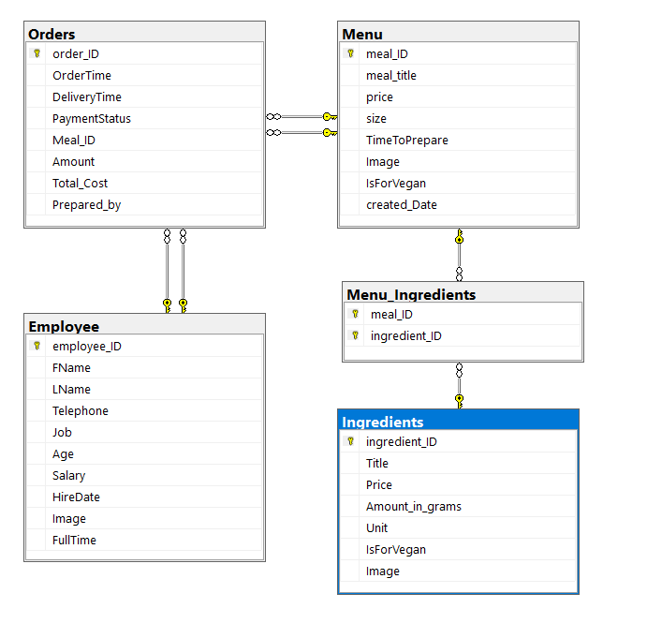

Order table has by two connection to table Employee and to table Menu: First one is actual relationship, where order table has reference to foreign key from these tables; Other relationship is because of setting null value if that record in particular table is removed

Four key tables make up the complexly organized restaurant menu database: Orders, Menu, Ingredients, and Employee. Important information about customer orders is carefully maintained in the Orders table. This includes order IDs, order times, delivery times, payment status, and meal IDs, amounts, total cost, preparation information, and creation dates. In the meanwhile, the menu table serves as a source for information about individual menu items. It contains important information such as the meal ID, meal title, price, size variants, preparation time, and visual aids like photographs. It also has a

marker that indicates whether the meal is appropriate for vegan eaters. An essential function of the Ingredients table is to catalog the ingredients that are used to create menu items and create relationships between meal IDs and corresponding ingredient IDs. The Employee table, on the other hand, contains detailed employee profiles, including employee IDs, first and last names, contact information, job titles, age, salary information, and dates of hire. Additional information includes images, indicators of full-time status, and dietary preferences, such as being vegan. In the diagram, it is displayed that foreign key relationships link the Ingredients table to the Menu table and the Orders table to the Menu table, facilitating easy data management and retrieval within the database structure.

User Interface of the application

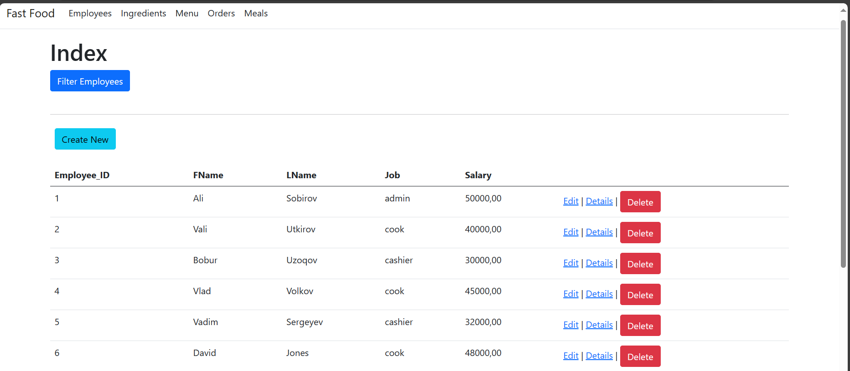
This is landing page of the web application
Navigation Menu (Employees, Ingredients, Menu, Orders, Meals each of them has its own table from where it takes data)
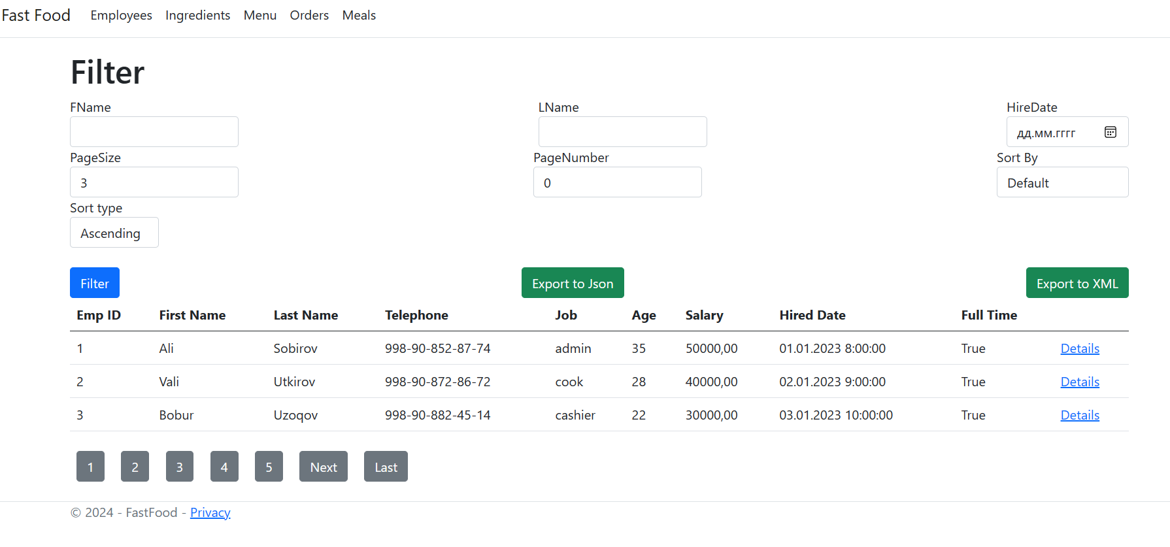
Task 4 was requiring to implement Filtering functionality in one of the table, and user should be able to do filtration by three properties. We implemented this functionality in Employee table. Now users are able to filter Employees table by three properties by indicating filter direction (asc or desc) as well as by specifiying sorting column.
In addition this page contains two buttons for exporting the data in two different formats. One exports data in json structured format, other exports in xml structured format. (Task 6 Exporting data)
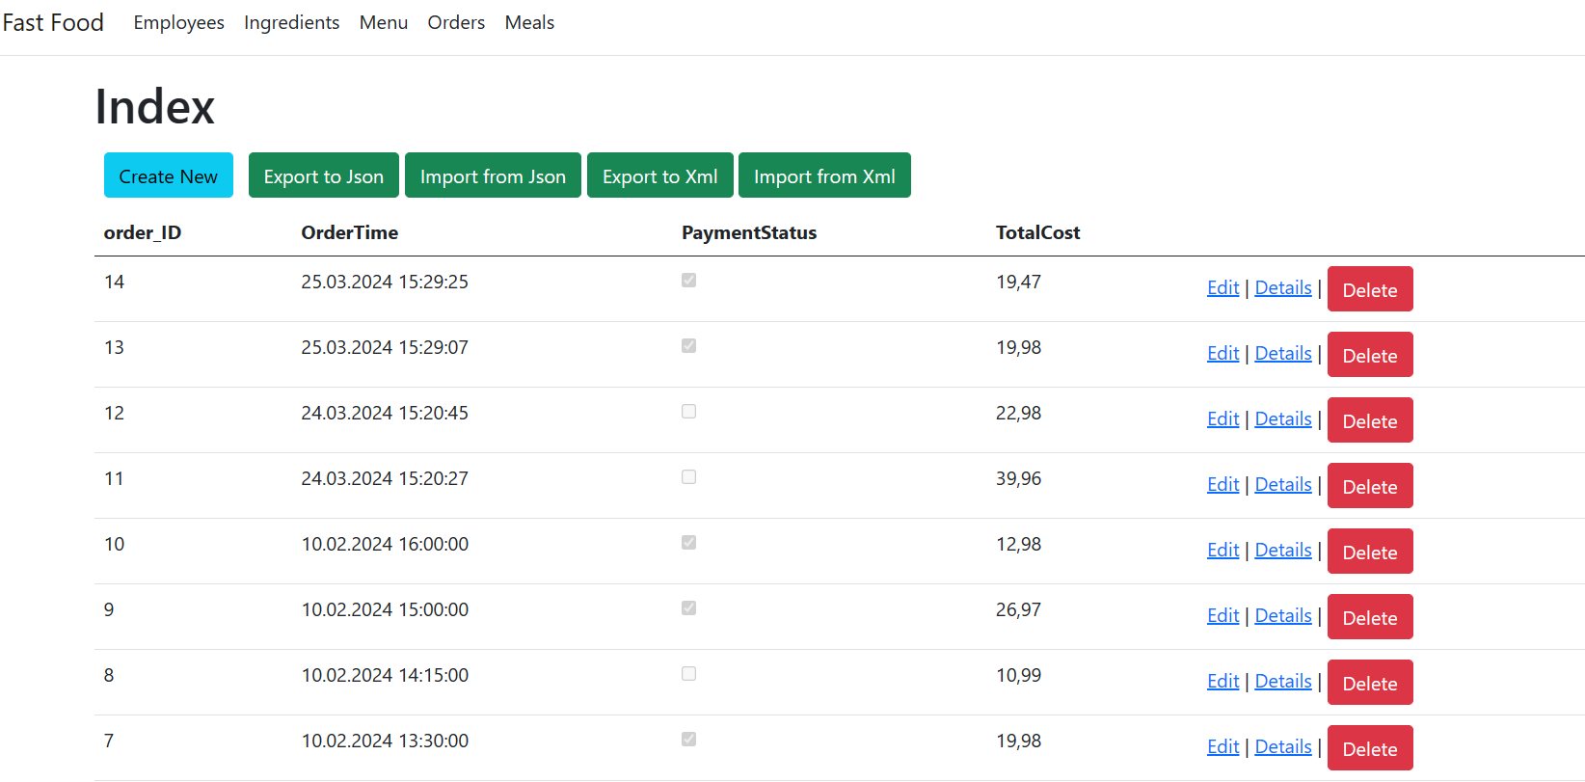
Task 7 was requiring to do data import to table which has foreign keys or in the other word 2 linked tables
But in our case we have Order table which has foreign keys for two other tables (Employee and Menu)

First of all, we created data export functionalityv for both xml and json structure, then we created importing function (Note that import function depends on structure that was created on export function for both xml and json file).

These function scripts can be found inside of the project in folder SQL_/import
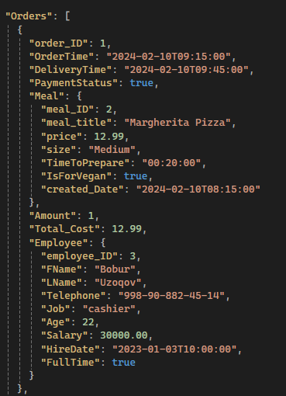 | 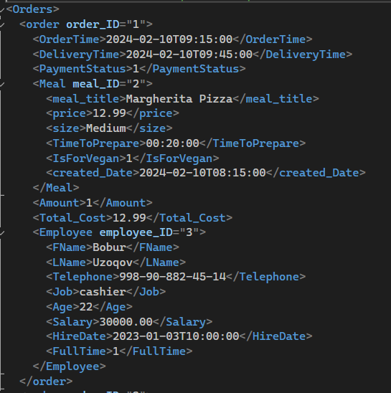
These are examples of the structure of xml and json file. These files can be found inside of the project
TempFiles/ (CheckXML_File.xml) and (CheckJSON_File.json)
For checking import functionality we are providing four file
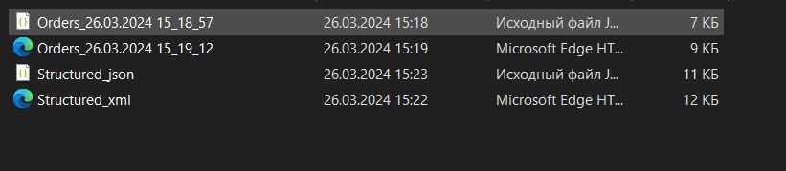
We recommend to use files with name “Orders_%” in the beginning other two files is the same , but it is changed into block view from line view
One Specific action
For table Menu_Ingredients we created this page
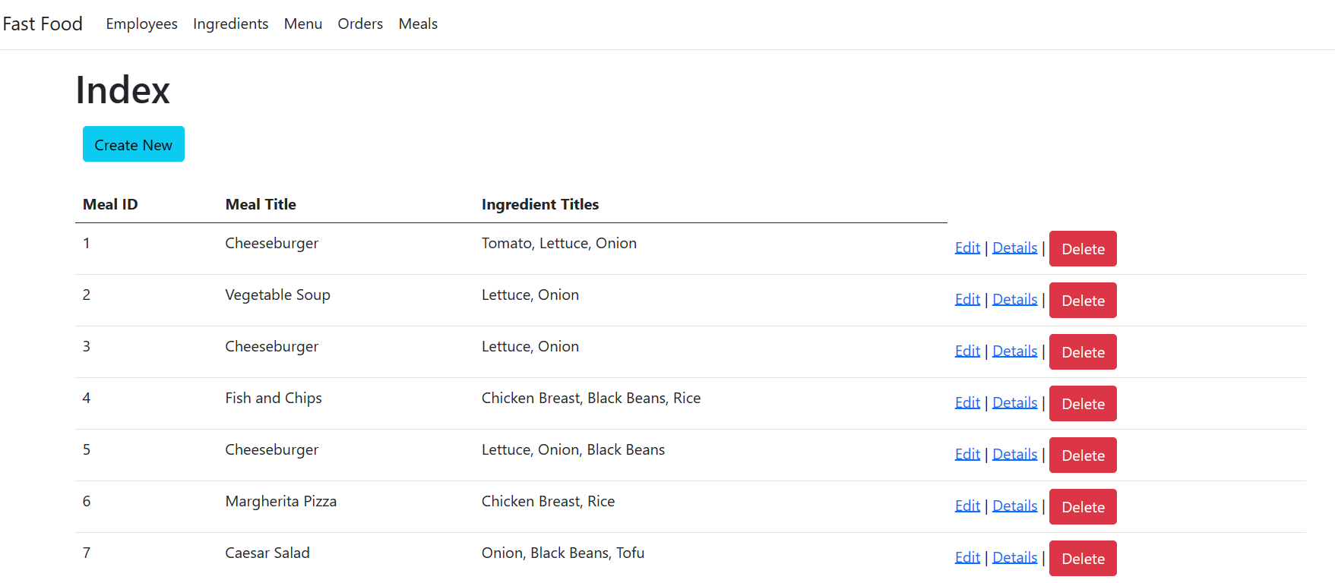
After clicking create or Edit buttons
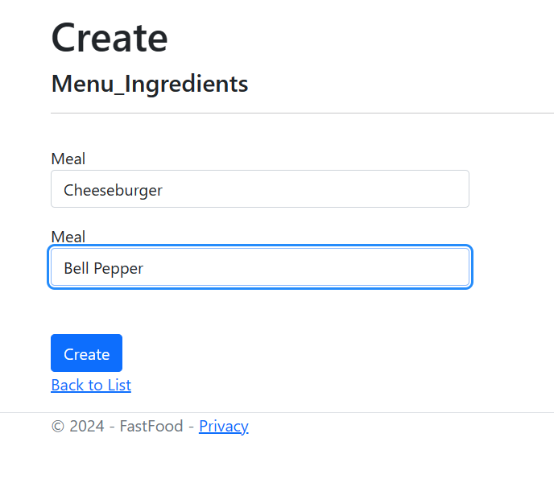
Or this will show up
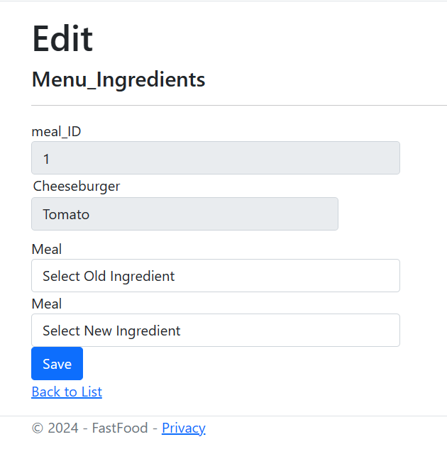
We could not implement submitting multiple records at the same time
So to add ingredient or change ingredient in particular record, user should do multiple times
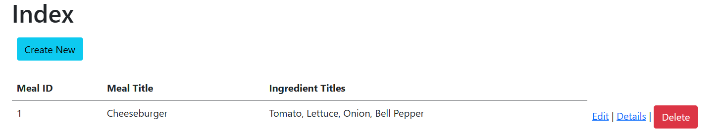

Testing

Test Case 1: Create New Employee

Test description | Expected results | Actual results | Comments
The user accesses the "Create New Employee" page and fills out all required fields (such as first and last names, job title, and salary) with accurate information. | The user is either taken back to the employee list or to a confirmation page once a new employee record has been created in the database. | Employee successfully created

Test Case 2: Filter Employees by Last Name

Test description | Expected results | Actual results | Comments
The user clicks "Filter" after entering their last name, either fully or partially, in the "LName" filter field. | Only those workers whose last names fully or partially match the entered word will be shown in the employee list. The filtered results should be reflected in the number of employees listed. | Inserted value successfully found.

Test Case 3: Delete Employee

Test description | Expected results | Actual results | Comments
User selects an employee from the list and clicks “Delete” button, | The selected employee record is permanently deleted from the database. The employee is no longer displayed in the list. | The selected employee successfully removed from the employees list.

Test Case 4: Delete Employee - Cancel Confirmation

Test description | Expected results | Actual results | Comments
User tries to remove an employee and clicks "Back to List" button. | The deletion is not performed, and the employee remains in the list. | Deletion process cancelled.

Test Case 5: View Ingredients List

Test description | Expected results | Actual results | Comments
User moves to the  “Ingredients” page | The database's entire ingredient list is shown. The ID, title, and cost of each ingredient should be listed. | The list of the ingredient list is displayed.

Test Case 6: Create new Ingredient

Test description | Expected results | Actual results | Comments
User clicks “Create New” button in order to add new ingredient and fills the form. | The new created ingredient will be added to the ingredients list and it automatically back to the ingredients main page. | Created new ingredient will be added successfully and displayed in the list.

Test Case 7: Export Orders to JSON

Test description | Expected results | Actual results | Comments
In the Orders page user can export the order list to the JSON file by clicking “Export to JSON” file. | A Json file including all order data is created and downloaded to the user’s device. | Json file created and downloaded to the device.

Test Case 8: Removing an ingredient from the meal

Test description | Expected results | Actual results | Comments
In the Meals page user can choose the meal and remove unwanted ingredient from it by accessing to the “Delete” button. | The chosen ingredient is taken out of the dish. The ingredient listing for that dish shouldn't contain the component anymore. The database stores the most recent meal details. | The removed ingredient no longer will be in the list and the meal is updated.

Test Case 9: Custom Access Control Trigger - Disallowing CRUD Operations on Menu and Employee Tables During Weekends

Test description | Expected results | Actual results | Comments
On Saturday and Sunday, the custom access control trigger is used to prevent inserting, updating, and deleting data from the Menu and Employee tables | It is not permitted to insert, update, or delete data on the Menu and Employee tables on weekends. | CRUD operations on the Menu and Employee tables are blocked during weekends.

Test Case 10: Trigger Validation for Business Rule - Limiting Ingredients in Menu Item

Test description | Expected results | Actual results | Comments
Trigger is used to verify a business rule that states that a particular menu item can only have ten ingredients. | The trigger need to stop the insert action when someone tries to insert a menu item with more than ten ingredients. | Error message alerting the user to the violation of the business rule is displayed when an item on the menu is added with more than ten ingredients.

Test Case 11: Triggers for Data Logging

Test description | Expected results | Actual results | Comments
The triggers is used to keep track of all modifications (data population, updates, removes) made to the tables. The Log_(Menu, Employee, Ingredients, Menu_Ingredients, Orders) tables are where the log should be kept, along with extra entries for Log_ID, OperationType, LogDateTime | In order to provide a thorough audit trail for data alterations, the trigger should precisely record any changes made to the particular tables. | The trigger provides data logging and auditability by reliably recording modifications made to the tables.

