Supplementary Material
Supplementary Table 1 : Overview of Key Research in ESG Data Processing Domain.

Author(s) | Year | Application Area | Methodology | Key Findings
Bronzini et al. | 2023 | Inter-corporate ESG Action Correlations | NLP, RAG | Extraction of semantically structured ESG information from sustainability reports
Kim et al. | 2023 | Economic Utility of Disclosures | GPT-3.5 | Used GPT-3.5 to analyze and summarize corporate disclosure texts to simplify complex company disclosures while retaining key information
Liu et al. | 2023 | ESG Context Understanding | Latent Dirichlet Allocation (LDA) | Utilized a social media analytics (SMA) framework to analyze public perceptions of ESG in China by examining data from Sina Weibo
Moodaley and Telukdarie | 2023 | Green Claim Detection | Pre-training of LLMs | Enhanced ability to identify green claims and detect "greenwashing"
Ni et al. | 2023 | Corporate Sustainability Reporting | CHATREPORT System | Analysis of 1015 corporate sustainability reports using TCFD framework
Ruberg et al. | 2023 | ESG Reporting | BERTimbau, DistilBERT | Automated classification of ESG report content relevant to GRI standards, enhancing analytical efficiency
Yang et al. | 2023 | Environmental, Social, and Governance Issues | FinGPT | Democratized financial data and stimulated innovation in financial services by offering an accessible and transparent resource for researchers and practitioners
Zhang and Zhang | 2023 | Sustainability Goals Identification | Review of Machine Learning (ML) tools in ESG research | Underscored the transformative potential of ML in ESG research, highlighting its superiority in predictive accuracy and adaptability
Fischbach et al. | 2022 | ESG Score Calculation | ESG-Miner Tool | Automatic extraction of ESG-related information from media headlines
Lee et al. | 2022 | ESG Data Analysis | Light Gradient Boosting Machine (LGBM)  Local Outlier Factors (LOF) | Employed a variety of machine learning and deep learning algorithms to analyze ESG data across five distinct experiments.
Pasch and Ehnes | 2022 | ESG Adaptability | BERT, FinBERT, and RoBERTa | Predicted whether a company's text implies positive or negative ESG behavior
Perazzoli et al. | 2022 | ESG Literature Analysis | Natural Language Processing (NLP) | Extensive analysis of 55,000 publications on ESG-related topics
Lewis et al. | 2020 | Information Retrieval | Retrieval-Augmented Generation (RAG) | Improved response precision with dynamic information retrieval
Luccioni et al. | 2020 | Climate Change Analysis | NLP-based ClimateQA Model | Analysis of climate change-related information in financial reports
Raman et al. | 2020 | ESG Trend Detection | Fine-tuned NLP model | Detection of ESG trends through analysis of corporate earnings call transcripts

Supplementary Table 2 : Indicators of the ESG Metadata Module Based on HKEx Standards.
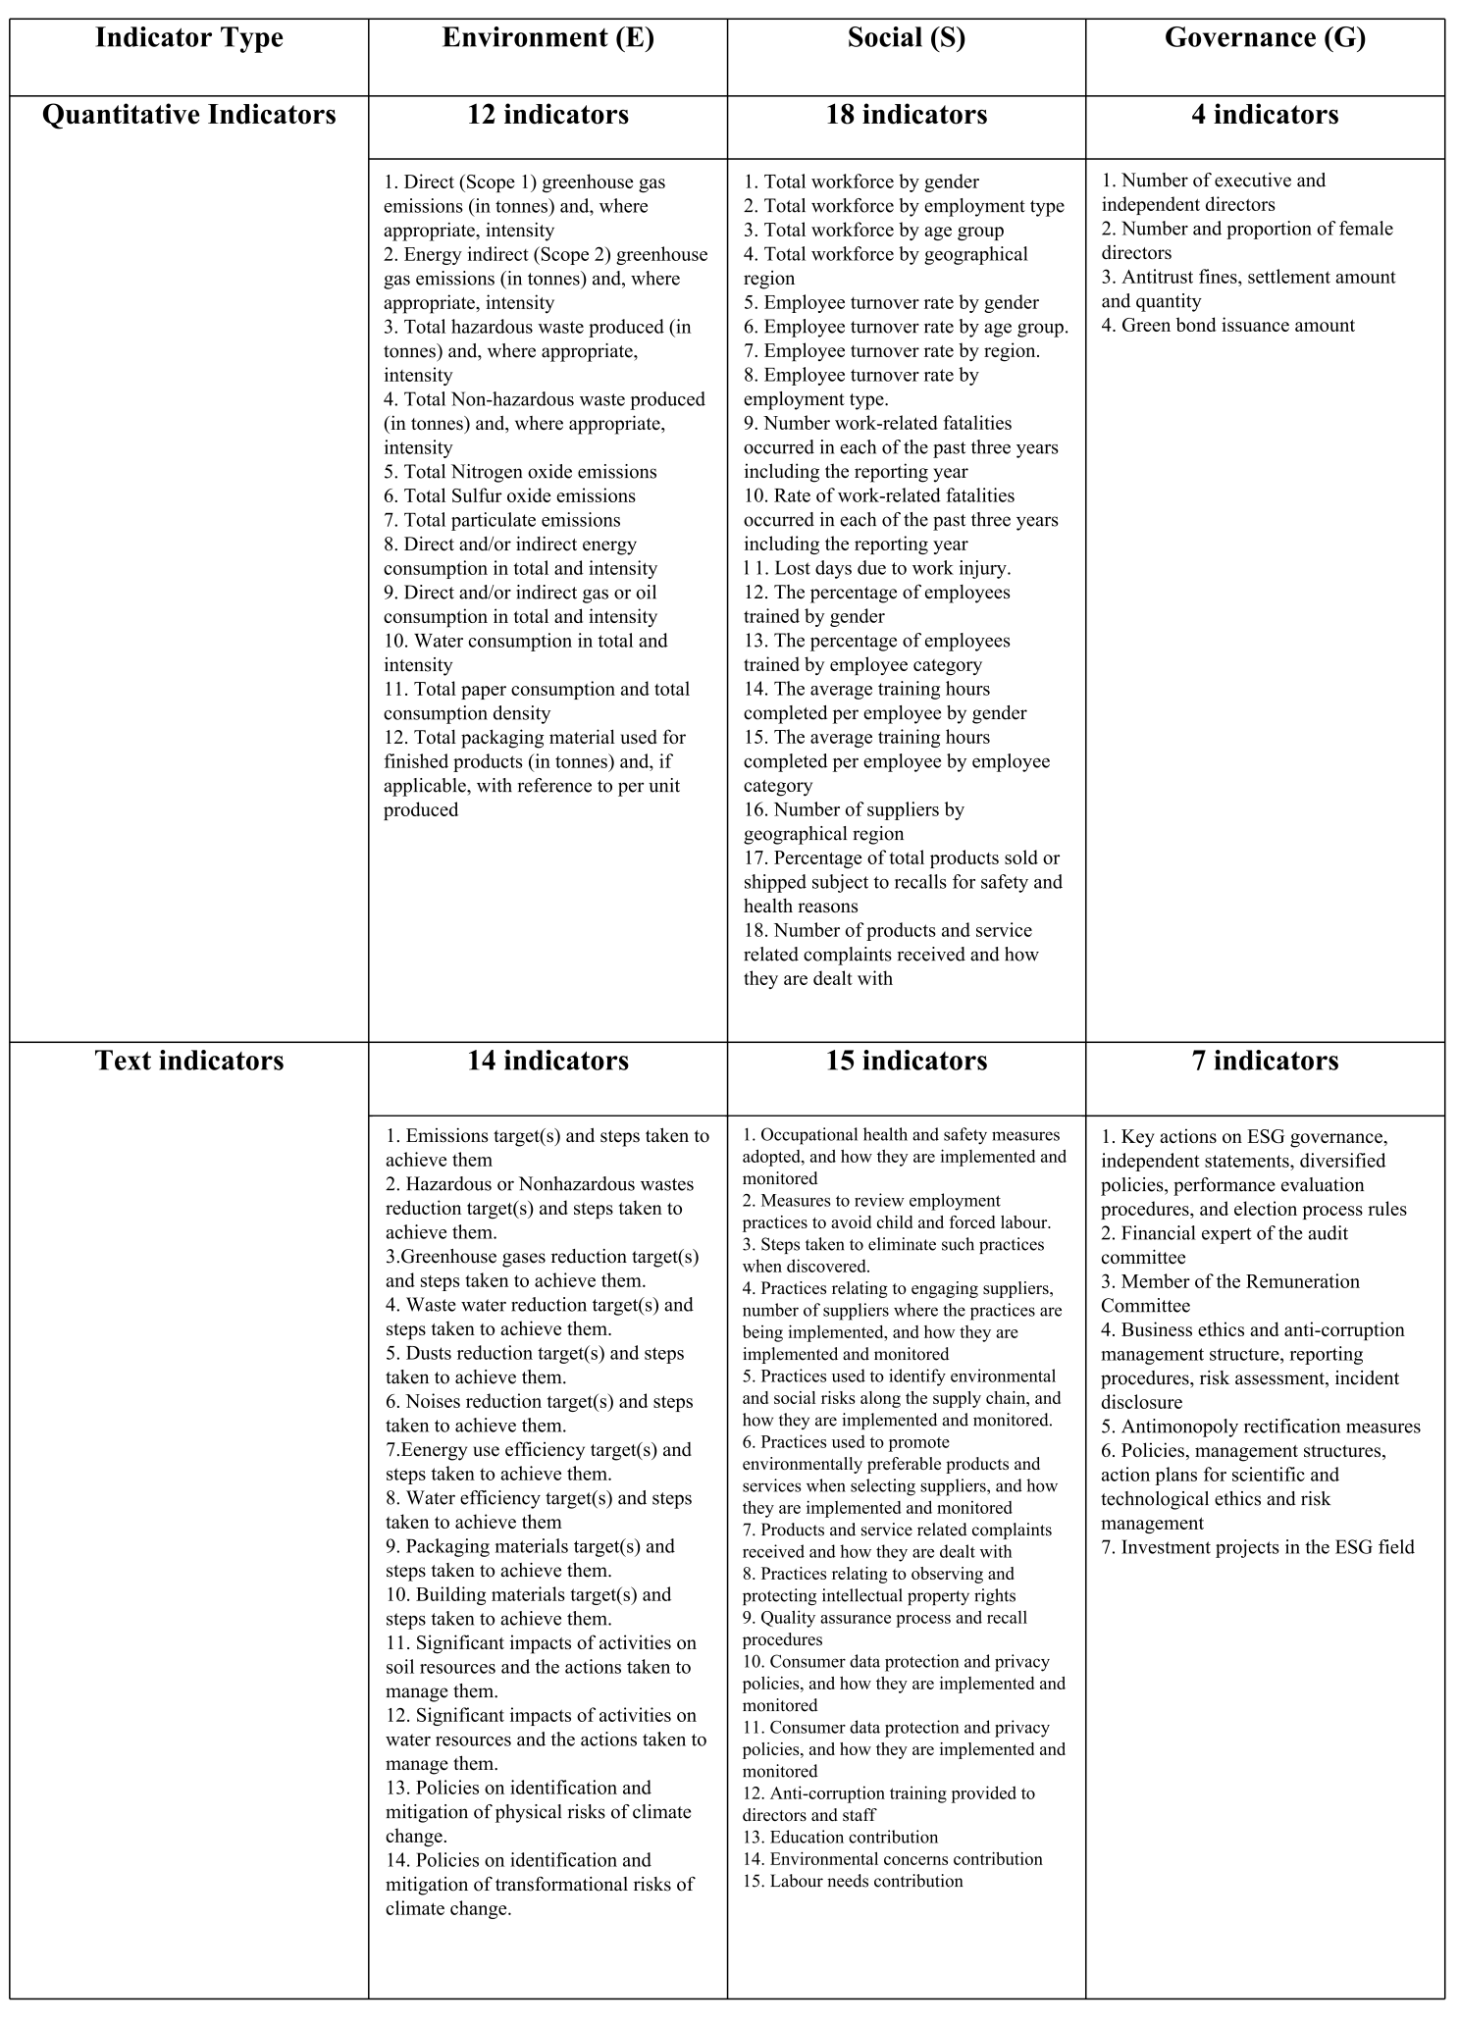

Supplementary Table 3 : Examples of the ESG Metadata Module Based on HKEx Standards.

Supplementary Table 4 : Examples of Prompts and Answers.
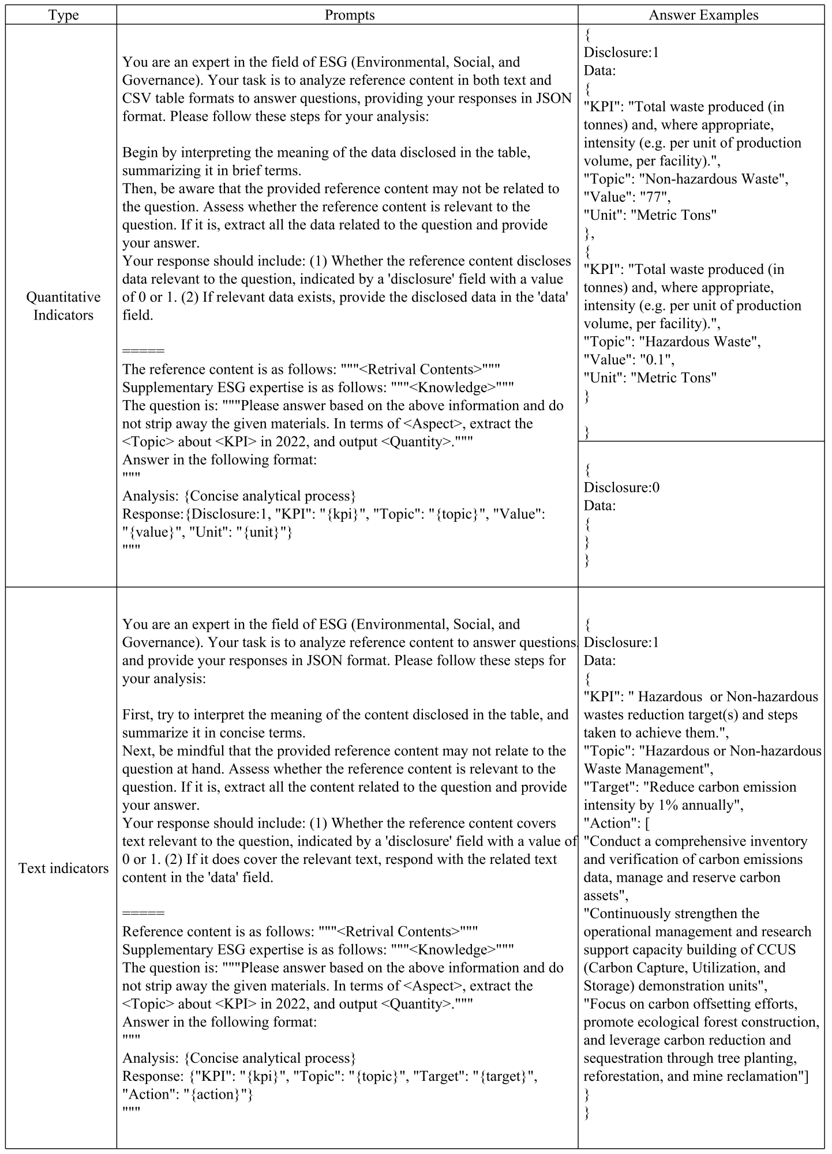

Supplementary Table 5 : Representative Companies in Each Sector According to the Hang Seng Industry Classification System.

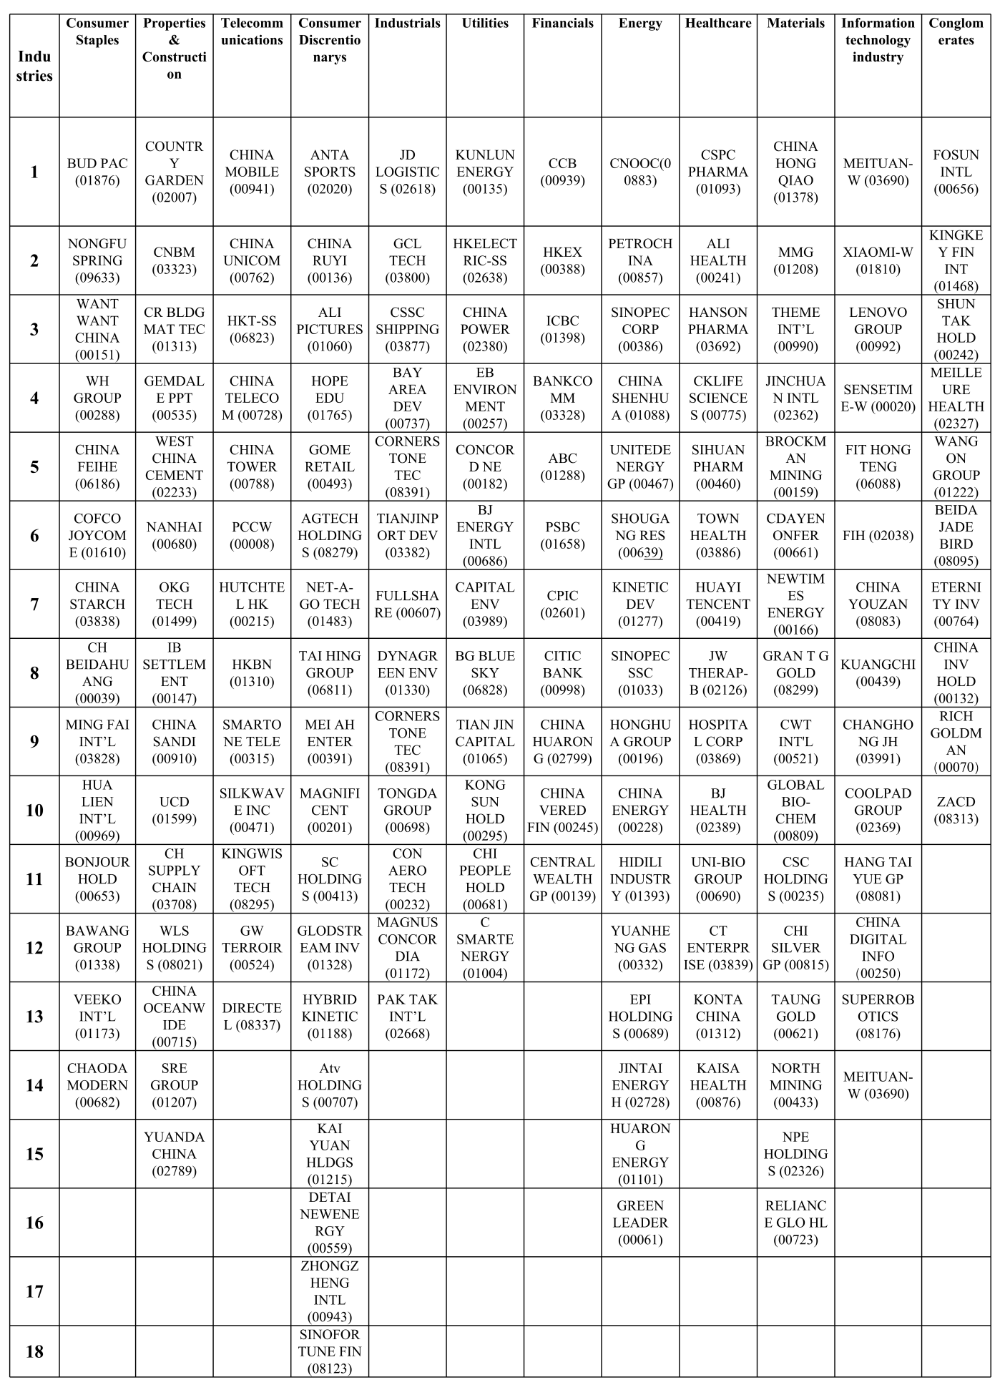

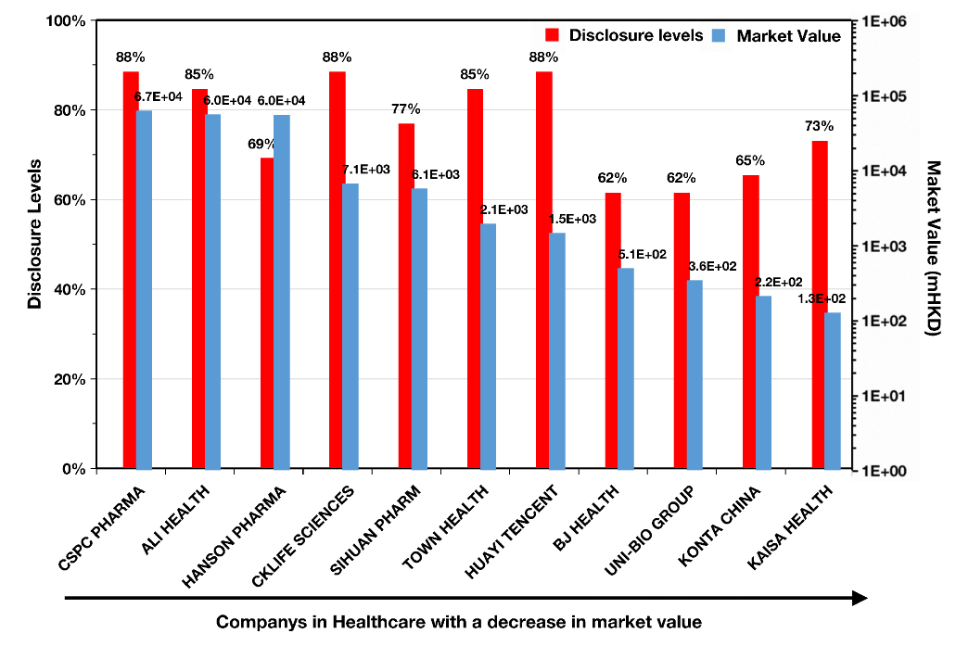

Supplementary Figure 1: Disclosure Levels and Market Value Across Different Companies in Healthcare.

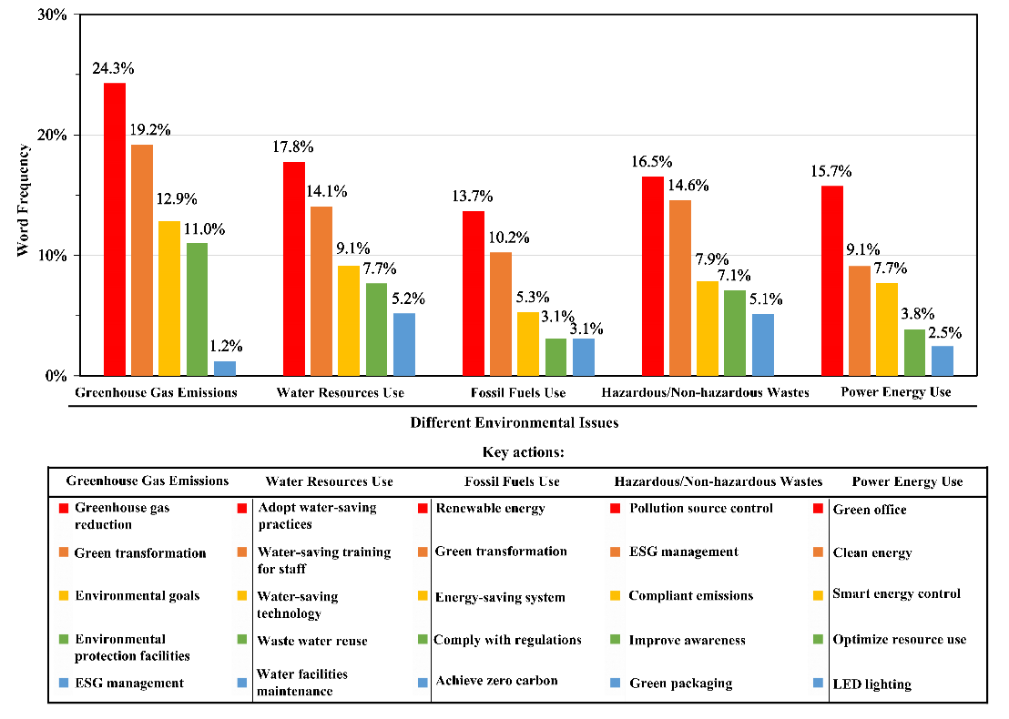

Supplementary Figure 2: Key Actions and Word FrequenciesUnder Different Environmental Issues.

Supplementary Table 6 : Partial Examples of Key Actions by Industries for Different Environmental Issues.

Main actions | Greenhouse Gas  Emission Management | Harmful or Harmless  Waste Management | Water Resources  Management | Power Energy  Management | Fossil Energy  Management
Real estate | [Provide a guarantee for the completion of project development] [Build an energy-saving office space] [Replacement of first-class energy-efficient equipment or energy-efficient equipment] | [Control the source of potentially volatile organic compounds] [Use sprinkler devices to suppress dust] [Entrust qualified third-party units to dispose] [procure and digest industrial waste] | [Regular inspection, maintenance and leakage testing of the water supply system] [water-saving irrigation method promotion] | [New Energy System Solutions] [Preparation of Central Air Conditioning Operation Plan] [Installation of Efficient Equipment to Manage Fuel and Electricity Use | [Friendly and sustainable housing] [Control the impact of construction environment] [Promote collaborative disposal projects] [Reuse of building materials]
Telecommunication | [Design security and environmental protection products] [Improving the green level of communication network infrastructure] [Artificial intelligence and machine learning energy control] | [SmarTone encourages battery recycling] [Use red bags to process sensitive information] | [Full coverage of water conservancy communication and water conservancy video surveillance construction application] [High-level monitoring service pollution prevention and control of iron tower] [Shared communication tower construction video monitoring points and radar monitoring points] | [Installation of sensors in different locations] [Widely used in power generation business] [Indoor air conditioning temperature in summer is maintained at 25℃] | [Cross-departmental procurement of office supplies] [Optimize the use of standby generators] [Build a green supply chain] [Reduce the printing of customer communications and enterprise information]
Healthcare | [Providing high-quality online medical and health services] [DMUlish a hazardous waste management plan] [Reduce the number of round trips of patients] [Use digital medical services to help save energy and reduce emissions] | [Re-examination of the production workflow] [Chemical residues produced by empty salts are mixed, air dried and transported to compost manufacturers] [Closed collection of waste gas, exhaust gas absorption device] | [Implement water-saving measures] [Free medication guidance] [Implement water-saving measures] | [Refrigeration unit with frequency conversion control] [Transformation of power distribution facilities] [Artificial intelligence management system (software and hardware) + Internet of Things technology + energy-saving transformation of computer room equipment] | [Implementation of solar power generation project] [Use natural gas as fuel] [Installation of solar photovoltaic] [Eliminate seriously polluting production lines and related facilities]
Energy | [Strengthen the control of total energy] [Update equipment gas source and technology] [Equipment of natural gas collection device at the wellhead] [Oil well maintenance equipment changed to gas boiler] [Decarbonization in the power generation industry] | [Start the pilot construction of "waste-free group"] [Classified treatment of general industrial solid waste] [Protection and control of oil fences and linoleum] [Facilities to prevent seepage and protect the environment] | [Sewer circulation system and recycling pool management] [Installation of solar reverse osmosis device] [Establishment of drilling fluid transfer station] [Circulation and waste reduction] [Implementation of solar collector system on the roof of the plant] | [Close idle electrical appliances] [Eliminate backward motors] [Examine and evaluate risk management policies] [Continue to promote the modernization of corporate governance system] | [Establish a energy consumption and resource assessment system] [Control combustion emissions] [Vehicle emission reduction measures] [Vigorously develop natural gas business] [Scientific and reasonable adjustment of fresh water and natural gas]
Raw material | [Establishment of Quality, Health, Safety and Environment Committee] [Adopting Forest Certification System] [Regular Monitoring of Air Quality] [Early Discovery and Repair of Emission Sources] | [Develop new technologies with R&D capabilities] [Digital management of environmental protection facilities][Avoid oil leakage and implement remedial action plans] [Adoption blasting mining and recycling production processes] | [Water recycling in the mine] [Monitoring business water consumption] [Strengthen pollutant discharge monitoring] [Mining solid waste classification treatment and recycling] | [Reconstruction into a green energy center] [Set up a monitoring system to track fuel consumption] [Technological innovation and transformation and lean management] [Attract hydrogen energy and other industries] | [Management and control of climate change risks] [Redevelopment and transformation of abandoned factories] [Pre-planning routes to improve fuel consumption efficiency]
Information technology | [Supervision of the implementation of energy-saving measures] [Promotion of natural lighting and energy-saving electrical appliances] [Use risk-based standard methods to assess risks] [Improved three categories of input data] [Pass ISO14001 environmental management system certification] | [Waste toner cartridges and waste ink cartridges are handed over to suppliers for unified treatment] [Optimized disposal method] [Implementation of dynamic induction switch] [Hazardous waste conversion energy] | [Routine inspection of sewage treatment system] [some workplaces, warehouses and service stations] [focus on inspection and regular inspection and maintenance equipment] | [Implementation of Intelligent Management System] [Quantification and Conversion of Energy Usage Indicators] [Regular Audit and Inspection of Resource Usage] [Energy Graded Management Methods] [Purchase Renewable Energy Credit Limit] | [Realizing data center energy saving] [Optimizing the use of resources] [Improving the operation and management strategy of air conditioning] [Regular evaluation of the number of lamps] [Regular evaluation of material consumption]
Financial | [Green Loan] [Carbon Check and Carbon Reduction Plan] [Provide Financial Living Water] [Develop Sustainable Finance] [Listening to Reports and Review Environmental Risk Management Effectiveness] | [Establishment of energy and resource consumption monitoring and diagnosis system] [ Underwriting green bonds] [Specially used for the upgrading and transformation of electrolytic aluminum environmental protection and energy-saving technology] | [Help industrial upgrading] [Serving the protection of the Yellow River ecological basin] [Serving the development of the Yangtze River economic belt] [Support the improvement of saline and alkaline land] | [Obtained Green Power Certificate] [Green Finance Business] [Introduction of Carbon Cost Analysis] [Paperless Office] [Disposal of High Fuel Consumption Official Vehicles] | [Establish key performance indicators for environmental protection] [Priority arrangement of energy-saving transformation projects] [Strengthen cooperation between banks, government, banks and enterprises] [Strengthen carbon footprint identification and management]

