OWERU Foundation

Phase One Outreach Equipment Funding Platform

Software Requirements Specification (SRS) & System Design
Document Control
Field | Value
Document | Phase One Outreach Equipment Funding Platform – SRS & System Design
Client | OWERU Foundation
Prepared by | Azizi Ally
Version | 1.0 – Discussion Draft
Date | 28 August 2026
Purpose | Requirements validation, system design, development quotation and implementation planning
Important Note
This document combines the original Phase One SRS with clarified functional requirements, roles, workflows, use cases, database/ERD design, architecture, security, UI structure, dashboard requirements, acceptance criteria and a phased implementation roadmap. It should be reviewed and approved jointly by OWERU Foundation and the development team before production development begins.

1. Executive Summary
OWERU Foundation requires a transparent digital platform for funding outreach equipment rather than providing cash grants. The system will allow approved outreach requests to be presented publicly, break each request into individually fundable equipment items, record donor contributions, coordinate suppliers, maintain an equipment register, collect post-delivery reports and publish a transparent public ledger.
- No cash transfers to applicants or recipients.
- Every applicant must be endorsed by a recognised church or organisation before Foundation review.
- Donors fund approved equipment items individually using an all-or-nothing model within a 60-day funding window.
- Suppliers invoice the Foundation directly.
- Delivery requires verification, including photographic evidence and serial numbers where applicable.
- Equipment remains owned by the Foundation for 24–36 months before possible transfer.
- Public information must respect privacy and safeguarding controls.
- Public-facing content must support English and Swahili.

2. Business Objectives
- 1. Increase transparency in how outreach equipment funding is requested, funded and delivered.
- 2. Prevent misuse of funds by ensuring the Foundation purchases equipment directly.
- 3. Create a traceable record from request through procurement, delivery and reporting.
- 4. Give donors a clear view of individual funding opportunities and progress.
- 5. Create an operational equipment register for ownership, warranty and status tracking.
- 6. Improve safeguarding and privacy by controlling what applicant information becomes public.
- 7. Provide reliable reports and statistics for Foundation management and board reporting.

3. Scope

3.1 In Scope – Phase One
- Public bilingual website.
- Approved funding requests and individual equipment funding pages.
- Funding request intake and admin review.
- Endorsement tracking.
- Donor funding records and payment-reference tracking.
- Supplier, quotation and invoice records.
- Equipment register.
- Delivery verification.
- 30-day, 90-day and incident reporting.
- Public funding ledger.
- Privacy and safeguarding controls.
- Role-based access control and audit logging.
- Admin dashboard and basic reporting/export.

3.2 Out of Scope – Phase One
- Cash grants, stipends or salaries.
- Funding of buildings or construction.
- Child-focused activities.
- Custom payment-processing engine or holding donor funds inside the platform.
- Full native mobile application.
- Advanced analytics and predictive reporting.
- Large-scale automated procurement.

4. Funded and Non-Funded Categories
Category | Examples
Funded | Sound systems, speakers, amplifiers, microphones, generators, solar kits, Bibles, tracts, tents, chairs, transport via ticket/hire/fuel account
Not Funded | Cash payments, stipends, salaries, buildings, child-focused work, ongoing/recurring operating costs

5. Stakeholders and User Roles
Role | Main Responsibilities | Access Level
Applicant | Submit/track request, choose exposure level, provide supporting information | Own records only
Endorsing Church / Organisation | Verify applicant, endorse request, support follow-up | Endorsements and assigned requests
Foundation Admin | Review, approve, publish, manage donors, suppliers, payments, equipment, reports and ledger | Full administrative access
Donor | Browse approved items, initiate funding, view own donation history | Public + own donor records
Supplier | Provide quotes/invoices, confirm delivery and warranty information | Assigned supplier records
Recipient | Confirm receipt/use, submit required reports and incidents | Assigned equipment/report records

6. Functional Requirements
ID | Area | Requirement
FR-01 | Public Website | System shall provide Home, About, Approved Requests, Funding Details, Public Ledger, Reports/Stories, Safeguarding, Privacy and Complaints pages.
FR-02 | Bilingual Content | Public pages shall support English and Swahili, with a language switcher.
FR-03 | Request Submission | System shall capture funding request details and supporting documents.
FR-04 | Endorsement | A request shall not enter Foundation review as eligible unless the required endorsement is recorded.
FR-05 | Review | Admin shall mark requests Approved, Declined or More Information Needed and record a decision note.
FR-06 | Itemisation | Approved requests shall be broken into individual equipment items with descriptions, prices and funding targets.
FR-07 | Funding Window | Each fundable item shall have a 60-day funding window and all-or-nothing status.
FR-08 | Donation Tracking | System shall record donor, item, amount, date, payment reference and confirmation status.
FR-09 | Supplier Management | System shall maintain suppliers, quotes, invoices, delivery and warranty records.
FR-10 | Direct Supplier Payment | Supplier payment shall be recorded against the Foundation and never as a cash transfer to the applicant.
FR-11 | Delivery Verification | Admin shall verify delivery using required evidence, including photos/serial numbers where applicable.
FR-12 | Equipment Register | System shall maintain register number, item/model, serial number, supplier, invoice, amount, recipient, location, dates and status.
FR-13 | Reporting | System shall support delivery, 30-day, 90-day and incident reports with media attachments.
FR-14 | Privacy | System shall enforce Open, Partial and Protected exposure levels.
FR-15 | Public Ledger | System shall publish approved transparency data while suppressing protected personal information.
FR-16 | Notifications | System shall generate notifications for key workflow events and overdue reports.
FR-17 | Audit | System shall log approvals, payments, edits, status changes and other sensitive actions.
FR-18 | Exports | Admin shall export relevant reports/data for board and operational reporting.

7. Request Status Model
Status | Meaning | Typical Next Action
Draft | Application not yet submitted | Applicant completes and submits
Submitted | Application received | Check endorsement/completeness
Endorsement Pending | Required endorsement not yet confirmed | Church/organisation endorses
Under Review | Admin is assessing request | Approve, decline or request information
More Information Needed | Additional evidence required | Applicant provides information
Approved | Request accepted by Foundation | Create/pricelist items
Published | Approved items are visible for funding | Donors fund items
Funding Closed | Funding window expired or completed | Procurement decision
Procurement | Supplier/order process underway | Delivery
Delivered | Equipment received | Verify evidence and register item
Active / Reporting | Equipment in use and reports being collected | 30/90-day monitoring
Closed | Lifecycle completed | Archive/report

8. Item and Equipment Status Model
Status | Meaning
Pending Funding | Item is published but target not reached
Fully Funded | Target amount reached
Ordered | Procurement/order initiated
Delivered | Supplier delivered item
Verified | Delivery evidence and required checks completed
In Use | Equipment actively used
In Repair | Equipment temporarily unavailable for repair
Returned | Equipment returned to Foundation
Transferred | Ownership transferred after approved period
Lost | Equipment reported lost

9. Donor Funding and Payment Flow
- 1. Donor browses approved requests.
- 2. Donor opens an individual equipment item.
- 3. Donor sees target amount, current progress, remaining amount and funding deadline.
- 4. Donor selects the amount to contribute.
- 5. System provides/redirects to the Foundation's approved payment rail or payment instructions.
- 6. Payment reference is recorded.
- 7. Admin or approved integration confirms payment.
- 8. Donation status becomes Confirmed and the item's progress is updated.
- 9. When the item's target is reached, the item becomes Fully Funded and moves to procurement.
Phase One decision required: confirm whether payment will be (A) external redirect/integration with return reference, or (B) donor payment followed by manual admin confirmation. The choice affects integration scope and cost.

10. Supplier and Procurement Workflow
- 1. Admin creates/selects an approved supplier.
- 2. Supplier quote is attached to the relevant equipment item.
- 3. Admin approves the selected quote.
- 4. Purchase/order is recorded.
- 5. Supplier submits invoice to OWERU Foundation.
- 6. Supplier delivers equipment.
- 7. Admin verifies delivery and required evidence.
- 8. Serial number and equipment details are entered into the register.
- 9. Foundation payment to supplier is recorded.
- 10. Warranty details and warranty expiry are stored.

11. Reporting Workflow
Report | Due/Trigger | Required Information
Delivery Report | After delivery | Date, item, serial number, recipient confirmation, photos/evidence
30-Day Report | 30 days after delivery | Active use confirmation, condition, usage summary, photos if required
90-Day Report | 90 days after delivery | Continued use, impact/outcomes, supporting photos/videos
Incident Report | Whenever loss/theft/damage occurs | Incident date, description, action taken, evidence
Overdue reports should create follow-up tasks/notifications. Repeated non-compliance should be recorded and may affect future eligibility.

12. Privacy and Safeguarding Design
Exposure Level | Public Information | Restricted Information
Open | Name/organisation or approved public identity, broad region/district, request story and funding information as approved | Phone, national ID, exact household/village location and other sensitive data
Partial | Limited name/organisation, region/district and request information | Direct contact details and sensitive identity/location information
Protected | Minimal public identity; project/request information only where approved | All direct personal identifiers and precise locations
Safeguarding rules:
- Phone numbers must never appear on public pages.
- National ID numbers must never appear publicly.
- Exact household/village locations must never appear publicly.
- Public pages should use region/district where location is necessary.
- Uploaded documents must be access-controlled and not publicly exposed by default.
- Admins should only see sensitive information when required for their role.

13. Public Website Structure
Page | Purpose | Key Components
Home | Introduce OWERU and direct visitors to funding opportunities | Mission, impact, CTA, featured requests
About | Explain Foundation and programme | History, mission, principles
Approved Requests | Browse funding opportunities | Filters, categories, progress
Funding Details | Fund an individual equipment item | Target, progress, deadline, description, fund CTA
Public Ledger | Transparency | Supplier, amount, dates, status, approved public fields
Reports & Stories | Show impact | Reports, stories, media
Safeguarding | Explain safeguarding commitments | Policy and reporting route
Privacy Notice | Explain data handling | Privacy policy
Complaints | Receive concerns | Secure complaint form/contact route

14. Authenticated UI Structure
Portal | Pages / Functions
Applicant | Dashboard, New Request, My Requests, Documents, Endorsement Status, Reports, Privacy Settings, Notifications
Donor | Dashboard, Browse Items, Donation History, Payment References, Receipts/Confirmations, Profile
Supplier | Dashboard, Assigned Items, Quotes, Invoices, Delivery Submission, Warranty Records
Recipient | My Equipment, Delivery Confirmation, 30-Day Report, 90-Day Report, Incident Report
Admin | Dashboard, Requests, Endorsements, Items, Donations, Payments, Suppliers, Quotes, Invoices, Equipment, Reports, Ledger, Users, Settings, Audit Logs

15. Admin Dashboard Requirements
- Summary cards: active requests, items awaiting funding, funded items, procurement items, overdue reports and registered equipment.
- Funding analytics: target vs funded, successful/expired items, donor totals.
- Request review queue with filters by status, date, region and category.
- Supplier and procurement management.
- Equipment register with search, filters and lifecycle status.
- Report monitoring with due dates and overdue flags.
- Public ledger management and publication controls.
- User and role management.
- Audit log viewer.
- CSV/Excel export for operational and board reporting.

16. High-Level Use Cases
Use Case | Primary Actor | Outcome
UC-01 Submit Funding Request | Applicant | Request is stored for endorsement/review
UC-02 Endorse Request | Church/Organisation | Endorsement is recorded
UC-03 Review Request | Admin | Request approved, declined or returned
UC-04 Publish Funding Item | Admin | Approved item becomes publicly fundable
UC-05 Fund Item | Donor | Donation/payment reference is recorded
UC-06 Manage Supplier | Admin/Supplier | Quote/invoice and supplier records maintained
UC-07 Confirm Delivery | Admin/Recipient | Equipment delivery verified
UC-08 Register Equipment | Admin | Equipment enters official register
UC-09 Submit Report | Recipient | Required monitoring report stored
UC-10 Publish Ledger | Admin/System | Transparency information becomes public

17. End-to-End Workflow Diagram
The workflow intentionally separates approval, donor funding, procurement, delivery verification and post-delivery monitoring so that the Foundation maintains control over funded equipment.
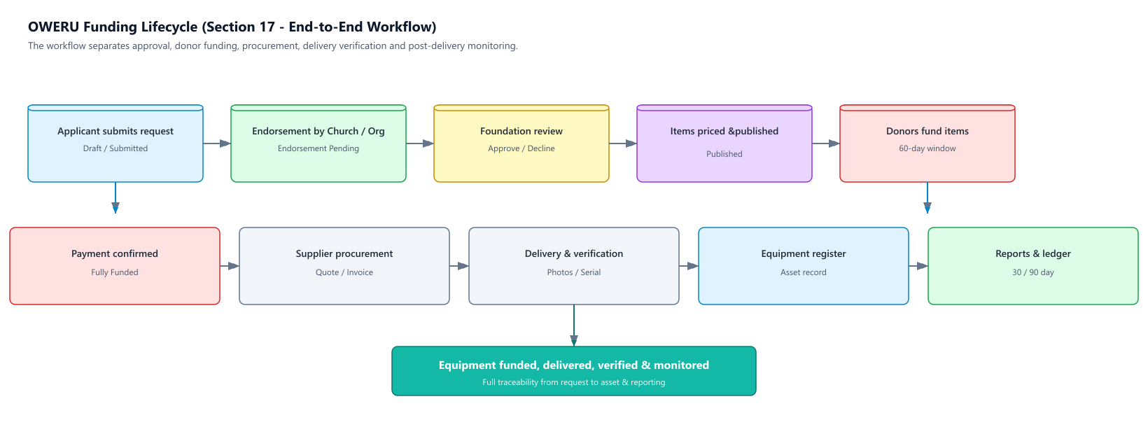

18. System Architecture
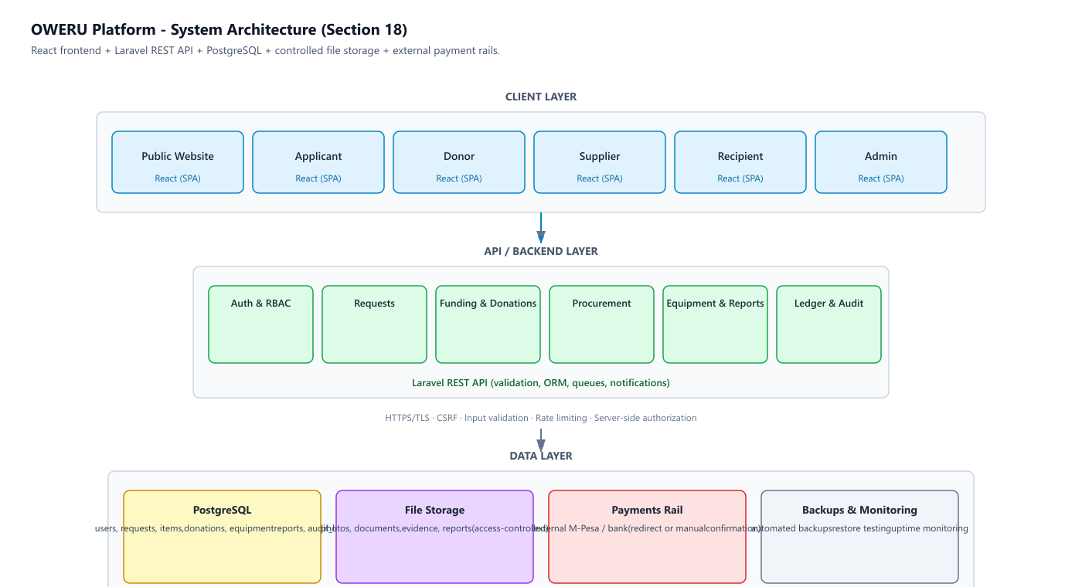
Recommended architecture: React frontend, Laravel API/backend, PostgreSQL database, controlled file storage, cloud hosting and external payment rails.

19. Database / ERD – Logical Design
The following logical entities should be considered for the production database. The final physical schema should be reviewed after the client confirms workflow and payment details.
Entity | Important Fields | Relationships
users | id, name, email/phone, password, role, status | Has requests, donations, reports and audit actions
organizations | id, name, type, region, contact, verification_status | Endorses requests; may be linked to applicants/recipients
requests | id, applicant_id, organization_id, status, region, exposure_level, submitted_at | Has many request_items and documents
endorsements | id, request_id, organization_id, endorser, status, date, notes | Belongs to request and organisation
request_items | id, request_id, description, category, target_amount, funding_deadline, status | Has donations, quote, invoice and equipment record
suppliers | id, name, contact, verification_status | Has quotes/invoices/items
quotes | id, item_id, supplier_id, quote_number, amount, valid_until, document | Belongs to item and supplier
invoices | id, item_id, supplier_id, invoice_number, amount, status, document | Tracks supplier invoice/payment
donations | id, item_id, donor_id, amount, payment_reference, status, donated_at | Belongs to donor and item
payments | id, donation_id/invoice_id, reference, amount, method, status, confirmed_at | Tracks payment confirmations
deliveries | id, item_id, delivered_at, verified_at, evidence, verified_by | Delivery evidence and verification
equipment | id, item_id, register_number, model, serial_number, status, recipient_id, delivery_date, transfer_date | Operational asset record
reports | id, item_id, recipient_id, type, due_date, submitted_at, status, content | Delivery/30-day/90-day/incident
attachments | id, owner_type, owner_id, file_path, type, visibility | Controlled documents/media
privacy_settings | id, user_id, exposure_level, public_fields | Controls public exposure
notifications | id, user_id, type, message, read_at | Workflow alerts
audit_logs | id, user_id, action, entity, entity_id, old_value, new_value, created_at | Immutable audit history

20. Core Relationships (Text ERD)
- User 1—M Requests
- Organization 1—M Endorsements
- Request 1—M Request Items
- Request Item M—1 Supplier (through Quotes/Procurement)
- Request Item 1—M Donations
- Donation 1—1/Many Payment Records as required by the chosen payment model
- Request Item 1—1 Equipment Record after delivery
- Equipment 1—M Reports
- Any major entity 1—M Attachments where applicable
- User 1—M Notifications
- User 1—M Audit Logs

21. Recommended Database Constraints
- Unique user email/phone where used for authentication.
- Unique equipment register number.
- Serial number should be unique where applicable.
- Donation amounts must be positive and validated against item funding rules.
- A funding item cannot accept contributions after closure unless an admin-authorised exception is explicitly defined.
- Sensitive fields should be encrypted or strongly access-controlled where appropriate.
- Audit logs should not be editable by ordinary administrators.
- Foreign-key relationships should prevent deletion of critical financial/equipment history.

22. Security Requirements
- HTTPS/TLS across all production traffic.
- Secure password hashing and session/token management.
- Role-based access control (RBAC).
- Server-side authorization checks for every protected operation.
- CSRF protection where session-based authentication is used.
- Input validation and output encoding.
- Protection against SQL injection through parameterized ORM/database queries.
- File upload restrictions: size, MIME/type validation, secure storage and access control.
- Rate limiting on login, password reset and sensitive endpoints.
- Audit logging for sensitive actions.
- Regular automated backups and tested restoration procedures.
- Least-privilege access for admin and supplier accounts.
- No sensitive personal data in public URLs or public API responses.

23. Non-Functional Requirements
Area | Requirement
Performance | Normal public pages should load quickly under expected Phase One traffic; API operations should normally respond within a few seconds.
Availability | Use reliable cloud hosting with monitoring and backup procedures.
Scalability | Design should allow growth beyond the first 50 equipment records without redesigning core entities.
Usability | Responsive UI for desktop, tablet and mobile browsers.
Accessibility | Readable typography, keyboard-friendly controls, labels and accessible colour contrast.
Maintainability | Modular codebase, documented API and database migrations.
Localization | English and Swahili content architecture should avoid hard-coded text.
Auditability | Financial and asset lifecycle actions must be traceable.
Backup | Regular database and file backups with recovery testing.

24. Notifications
Event | Recipient | Priority
Request submitted | Admin | High
Endorsement required/completed | Applicant/Admin | High
More information requested | Applicant | High
Request approved/declined | Applicant | High
Item published | Donor/Public | Normal
Funding target reached | Admin/Relevant users | High
Delivery due | Supplier/Admin | High
Delivery verified | Admin/Recipient | Normal
30-day report due | Recipient/Admin | High
90-day report due | Recipient/Admin | High
Report overdue | Recipient/Endorsing organisation/Admin | High
Incident submitted | Admin | Critical

25. Reports and Analytics
- Total requests by status.
- Funding target vs actual confirmed funding.
- Funding success rate and expired items.
- Donations by period and item/category.
- Supplier spending and payment status.
- Equipment by status, region and recipient.
- Upcoming and overdue reports.
- Incidents by type and status.
- Equipment approaching 24–36 month ownership/transfer milestone.
- Exportable board-report summary.

26. Phase One Launch Requirements
- Launch with approximately 5–8 already endorsed and priced requests.
- Public bilingual website operational.
- Approved funding pages operational.
- Public ledger operational.
- Basic donor funding flow operational.
- Equipment register can initially be spreadsheet-backed for the first 50 items if the client chooses a lightweight launch.
- Application intake can begin with paper/WhatsApp while the full online workflow is finalised, but the database structure should be ready for later migration.
- Safeguarding, privacy and complaints information must be published before launch.

27. Acceptance Criteria for Phase One
ID | Acceptance Test
AC-01 | Visitor can switch between English and Swahili on public pages.
AC-02 | Only approved requests/items appear as public funding opportunities.
AC-03 | Each item displays target, funded amount, remaining amount and funding status.
AC-04 | An item cannot be treated as approved merely because a donor attempts to fund it.
AC-05 | Admin can record and verify payment references.
AC-06 | Supplier invoices are linked to the Foundation/item and payment status is traceable.
AC-07 | Equipment record contains register number and required lifecycle fields.
AC-08 | Public pages never expose phone numbers, national IDs or exact protected locations.
AC-09 | Delivery, 30-day, 90-day and incident reports can be stored and tracked.
AC-10 | Overdue reports are visible to authorised admin users.
AC-11 | Sensitive admin actions are present in the audit log.
AC-12 | Admin can export operational/board reporting data.

28. Proposed Technology Stack
Layer | Recommended Technology | Reason
Frontend | React | Responsive, component-based UI and strong bilingual architecture
Backend | Laravel (PHP) | Fast development, authentication, validation, ORM, queues and admin/API capabilities
Database | PostgreSQL | Strong relational integrity and scalability
File Storage | Cloud/object storage | Secure media/document storage
Hosting | Cloud VPS/managed cloud | Reliability, backups and scalability
Payments | Existing local payment rails | Avoid custom payment engine in Phase One
Version Control | Git + GitHub/GitLab | Source control and collaboration
Alternative backend options from the original SRS—Node.js or Spring Boot—remain technically possible. Laravel + React is recommended here because it keeps the Phase One stack relatively simple and is well suited to form-heavy workflows, role-based administration and relational data.

29. Development Phases
Phase | Main Deliverables
Phase 1 – Foundation | Project setup, database, authentication, roles, public website, bilingual structure
Phase 2 – Funding | Requests, endorsement, approval, itemisation, funding pages, donation/payment-reference flow
Phase 3 – Operations | Suppliers, quotes, invoices, delivery verification, equipment register
Phase 4 – Reporting | 30/90-day reports, incident reporting, notifications, overdue tracking
Phase 5 – Transparency & Admin | Public ledger, analytics, exports, audit logs, dashboard refinement
Phase 6 – Testing & Launch | Security testing, user acceptance testing, training, deployment and documentation

30. Phased Product Roadmap
Release | Scope
Phase One | Public website, basic funding flow, initial equipment register, public ledger
Phase Two | Full supplier management, structured reports, donor dashboards, notifications
Phase Three | Advanced analytics, mobile app, deeper payment integration, automation

31. Key Client Decisions Required Before Coding
- 1. Confirm the exact legal/operational meaning of the 24–36 month Foundation ownership period.
- 2. Confirm the approved payment rail(s) and whether Phase One uses redirect/integration or manual payment confirmation.
- 3. Confirm whether donors need accounts or may donate as guests.
- 4. Confirm whether anonymous donor display is allowed.
- 5. Confirm exactly what donor receipts/acknowledgements should contain.
- 6. Confirm the official endorsement process and who is authorised to endorse.
- 7. Confirm whether applicants and recipients are always the same person/organisation.
- 8. Confirm the required public ledger fields and publication timing.
- 9. Confirm the exact safeguarding/complaints process and responsible contact.
- 10. Confirm who can approve supplier payments and what approval evidence is required.
- 11. Confirm whether spreadsheet equipment records will be migrated into the platform at launch or later.

32. Risks and Mitigations
Risk | Impact | Mitigation
Unclear payment workflow | High | Decide payment model before integration/development
Sensitive information exposed publicly | Critical | Privacy-by-design, field-level access rules and public DTO/view models
Fake/invalid endorsements | High | Verified organisation records and endorsement audit trail
Unverified supplier/delivery | High | Approved supplier list + delivery evidence + admin verification
Overdue reports | Medium/High | Automated reminders and escalation through endorsing organisation
Data loss | Critical | Automated backups + restore testing
Scope creep | High | Freeze Phase One requirements and use roadmap for later features

33. Final System Workflow Summary
Applicant submits → endorsement confirmed → Foundation review → request approved → items priced → funding page published → donors fund items → payment confirmed → item fully funded → supplier procurement → delivery → verification → equipment register → 30-day report → 90-day report → incident handling where necessary → public ledger and board reporting.

34. Conclusion
The proposed OWERU Foundation Phase One platform is designed as a controlled, transparent equipment-funding system rather than a cash-disbursement platform. Its core value is the traceability of each funded item from application and endorsement through donor funding, supplier procurement, delivery, asset registration and post-delivery reporting. The system should be implemented incrementally, beginning with a focused public website and essential operational workflows, while keeping the database and architecture ready for later automation.

35. Approval and Sign-Off
This document is a discussion draft. The final scope should be agreed jointly before development and quotation are considered final.
Party | Name | Signature | Date
OWERU Foundation Representative
Development Lead – Azizi Ally

