**Lab 08.01 – Tic-Tac-Toe**

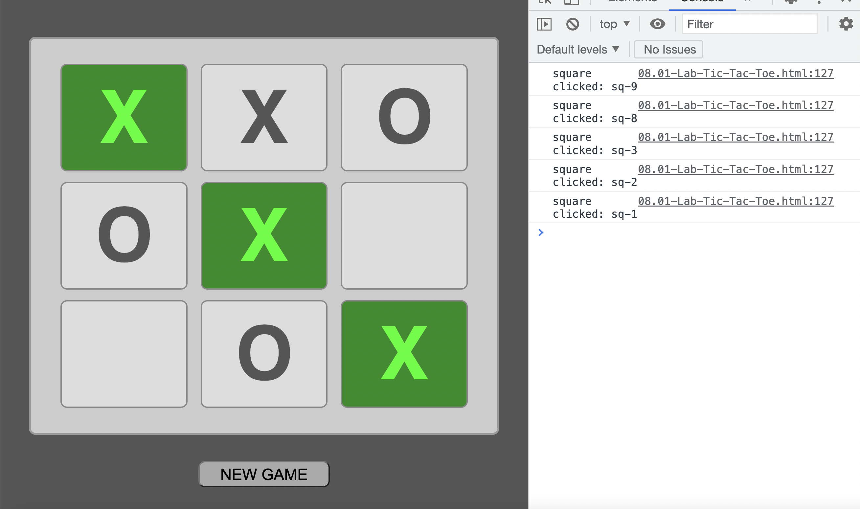

**Get the necessary DOM elements and make them call functions**

1. In the **08-setInterval-setTimeout** folder, open the **lab** folder,   
   and then open the **Lab-08.01–Tic-Tac-Toe.html**
2. Import the JS file.
3. Write JS to get all the X and O squares into JS. One line of code can bring them all in as an array of DOM elements (**querySelectorAll**).
4. Loop through the array, making each item call the **evalChosenSq** function when clicked (**addEventListener**)
5. Define the function **evalChosenSq**. For starters, just have the function log the id of the clicked square to the console (see above)
6. Get the **button** and have it run the **playNewGame** function when clicked.
7. Define the function **playNewGame**. For starters, just have the function clear all the hard-coded X’s and O’x, leaving an empty tic-tac-toe board.

**The Game Play**

Write an algorithm explaining the logical flow of the game.

* What needs to happen first, then next, then next.
* What variables do we need
* What function(s) de we need—what does the function(s) do?
* How do we alternate / keep track of whose turn it is and what squares were clicked?
* How do we determine a legal vs. illegal move (square already occupied)
* Determine winner

with each player choice of a square,

store the choice as an object in an array.

so if X chooses the middle square:

* the numeric part of "sq-5" gets pushed along w "X" into the array: usedSqs.push({ char: "X", sq: 5 } );
* the letter "X" appears in the middle square
* the square becomes disabled so that it cannot be clicked again..
* the tic-tax-toe board should not be directly editable.. the player clicks a square to add "X" or "O".. the player does NOT type into the squares
* in the

output the correct letter

disable the

check if clicked (chosen) tic-tac-toe square is available or taken. do this by checking if the usedSqs array contains the number corresponding to the numeric suffix of the id of the chosen square. if the numver is already in the array the square is taken , so tell the user