Private Higher School of Engineering and Technology



CBL Project

***Maintaining Healthy Skin and Preventing Skin Disorders***

**By**

**Turki Khaled**

**Mohamed Aziz Omezzine**

**Walid Jlassi**

**Tijani Boujdaria**

**Souhail Foudhaili**

**Aya Omezzine**

# 2022-2

**Table of content**

1. STUDY OF CBL PROJECT 3

INTRODUCTION 3

HEALTH CARE 3

BIG IDEA 3

4

GUIDING QUESTIONS 4

Challenge 4

1. Main Idea And Goals

INTRODUCTION 5

MAIN IDEA 5

Goals 5

SDG …………………………………………………………………………...5

**3. Partnership**

Dr Chaffik Jarraya………………………………………………………….......6

Dr Riadh Jelassi………………………………………………………………....6

Dr talel Badri………………………………………………………………....6

Menara Fm ………………………………………………………………....6

**4. Investigate**

Generating Guiding Questions………………………………………………… 7

Guiding Activities……………………………………………………………..8

Guiding Resources……………………………………………………………….13

Investigation Synthesis………………………………………………………………14

**5. ACT**

Act Definition………………………………………………… 7

DataBase……………………………………………………………..8

CNN……………………………………………………………….13

Deployment………………………………………………………………14

# Chapter 1: Study of CBL Project

1. **Introduction**

Challenge Based Learning (CBL) is an educational approach that involves students in solving real-world problems or addressing complex issues through collaboration and critical thinking. It is similar to project-based learning, but with a focus on addressing a specific challenge or problem.

# BIG IDEA: Health Care

Healthcare is an ever-evolving field that relies on cutting-edge technology to deliver the best possible care to patients. In recent years, the combination of dermatology and AI technology has emerged as a powerful tool that offers new and innovative ways to improve patient outcomes and streamline operations.

Essential Question : How can we maintain healthy skin and prevent skin disorders?

# Challenge

Dermatology is the branch of medicine that deals with the diagnosis and treatment of skin-related disorders , is a complex field that requires a high degree of accuracy and precision.

AI technology is able to analyze vast amounts of dermatological data, including images, symptoms, and medical history, in a fraction of the time it would take a human dermatologist. This technology can be used to identify and diagnose skin diseases, including skin cancer, with a high degree of accuracy. AI algorithms can also be used to recommend treatment options and monitor the effectiveness of treatments over time.

# Guiding Question

1. What does it mean to be healthy?
2. What do we need to do to be healthy?
3. Why should I take care of my health?
4. What are the barriers to being healthy?
5. What behaviors positively and negatively impact our health?
6. What are long-term consequences of being unhealthy?
7. How does skin health relate to overall health and well-being?
8. What is the importance of skin health?
9. What is dermatology?
10. What are common skin disorders and how are they treated?
11. Etc...

# Slogan

For he who has health has hope ,and he who has hope, has everything!

# Chapter 2: Main Idea and Goals

# Main Idea

The main idea is to utilize the power of advanced machine learning algorithms to improve the accuracy and efficiency of diagnosing skin conditions. By analyzing large amounts of data in the form of skin images, deep learning models can learn to accurately identify skin conditions, including common skin diseases, rare conditions, and skin cancers. Deep learning models can identify subtle patterns and features that may be difficult for human dermatologists to detect, and can provide a quick and accurate diagnosis, potentially leading to earlier treatment and better outcomes for patients. The ultimate goal of a deep learning project in dermatology is to improve the speed and accuracy of diagnosis, which can ultimately lead to better patient outcomes and potentially save lives

# 2. Goals

1. Improved accuracy of diagnosis: The primary goal of a deep learning project in dermatology is to improve the accuracy of diagnosis of skin conditions. By utilizing advanced machine learning algorithms, deep learning models can identify subtle patterns and features in skin images that may be difficult for human dermatologists to detect, leading to more accurate diagnoses.
2. Earlier detection and treatment: Deep learning models can quickly analyze large amounts of data, potentially leading to earlier detection and treatment of skin conditions. This can result in better patient outcomes and potentially save lives.
3. Development of user-friendly software: Another goal of a deep learning project in dermatology may be the development of a user-friendly software tool that can assist dermatologists in their diagnoses. Such a tool can potentially improve efficiency and accuracy in clinical settings.
4. Identification of new skin conditions: Deep learning models can potentially identify new skin conditions that may have been missed or misdiagnosed with traditional diagnostic methods. This can lead to new discoveries and insights in the field of dermatology
5. Creation of a large database of skin images: Deep learning projects can create a large database of skin images that can be used for future research and training of deep learning models. This can facilitate the development of more accurate and efficient models, ultimately leading to better patient outcomes

**3. SDG**

1) Good Health and Well-being (SDG 3): This goal aims to ensure healthy lives and well-being for all. Developing more accurate and efficient methods for diagnosing and treating skin diseases can contribute to improving health outcomes and reducing the burden of disease.

2) Partnerships for the Goals (SDG 17): The development and implementation of this technology require collaboration between healthcare professionals, technology experts, and policymakers to build partnerships to achieve SDGs.

3)Reduced Inequalities (SDG 10) - By developing accurate and efficient deep learning models for diagnosing skin diseases, we can reduce the disparities in healthcare access and treatment between different regions and demographics.

# Chapter 3: Partnership

1. **Dr Chaffik Jarraya**

Dr. Chafik JARRAYA is a highly experienced and renowned dermatologist in his profession. He received his medical training at the University of Tunis El Manar before specializing in dermatology at the Habib Thameur Hospital in Tunis. Since then, he has worked in many hospitals and clinics in Tunisia, France, and Switzerland, gaining valuable experience in the treatment of a wide range of skin problems. In addition to his clinical practice, Dr. JARRAYA is also a passionate teacher, sharing his expertise with medical students and residents in dermatology training programs. With his in-depth knowledge of dermatology and caring approach to his patients,

1. **Dr Riadh Jlassi**

Dr. Riadh Jelassi is a general practitioner in Mahdia, Tunisia. According to this website, Dr. Jelassi received his general medical degree from the Faculty of Medicine in Tunis in 1992. He also received training in occupational medicine and is a member of the Tunisian Society of General Medicine.

1. **Dr Talel Badri**

Dr. Talel Badri is a dermatologist practicing in Tunis, Tunisia. He specializes in the diagnosis and treatment of skin, hair, and nail diseases, as well as cosmetic procedures and dermatological surgical interventions. He obtained his medical degree from the Faculty of Medicine in Tunis and pursued his specialized training in dermatology and venereology at the Charles Nicolle Hospital in Tunis. He is a member of the Tunisian Association of Dermatology and the French Society of Dermatology.

1. **Menara FM**

Menara FM is a Tunisian radio station broadcasting on the frequency 100.7 FM. It is based in Monastir, a coastal city located in eastern Tunisia. The station began broadcasting in 2011 and offers a diverse program, including news, entertainment, sports, culture, as well as music of different genres.

**Chapter 4 : Investigate**

1. **Generating Guiding Questions**

Aim at identifying the knowledge existing and required to solve the problem.

Using the question set “what – where - why – how” can help you guide your students through the process. Make sure that your Students develop an extensive list of guiding questions, and do not hesitate to involve stakeholders in case students face difficulties.

* What are the common skin disorders and diseases, and what are their causes and symptoms?
* How can skin health be affected by lifestyle choices, such as diet, exercise, and sleep?
* What are the risk factors for developing skin cancer, and how can it be prevented?
* What are the current diagnostic and treatment methods for skin disorders, and what are their limitations?
* How can technology, such as AI and machine learning, be used to improve the diagnosis and treatment of skin disorders?
* How can healthcare systems be improved to provide better access to dermatological care, particularly in underserved communities?

1. **Guiding Activities**

The Guiding Activities are dedicated to acquire the knowledge needed to answer the guiding questions and to develop an innovative, insightful, and realistic solution. Students start by looking for resources before engaging activities and collecting data.

* What are the common skin disorders and diseases, and what are their causes and symptoms?
* Research and compile a list of common skin disorders and diseases, along with their causes and symptoms.
* Healthline: This website has a series of articles that feature interviews with dermatologists and patients who share their experiences with different skin conditions, such as eczema, psoriasis, and acne. <https://www.healthline.com/health/skin-disorders>

<https://www.youtube.com/watch?v=Ijae4iURrDI>

<https://www.mayoclinic.org/diseases-conditions/skin-cancer/symptoms-causes/syc-20377605>

* Website’s, to help understand the information more easily.
* Dermnet Skin Disease Atlas: This website provides a comprehensive collection of images depicting various skin diseases and conditions, including the ones you mentioned. The images are arranged alphabetically, making it easy to find the specific condition you are looking for.

<https://www.dermnetnz.org/topics/>

* American Academy of Dermatology: This website has a section dedicated to patient education, which includes visual aids such as infographics and videos that explain different skin conditions and their causes and symptoms.

<https://www.aad.org/public/diseases>

* How can skin health be affected by lifestyle choices, such as diet, exercise, and sleep?
* Conduct research on the effects of diet, exercise, and sleep on skin health.
* Diet:

Eating a diet high in fruits, vegetables, whole grains, and omega-3 fatty acids may have a protective effect against skin aging and skin cancer.

Conversely, consuming a diet high in sugar, saturated fat, and processed foods may have negative effects on skin health.

Certain nutrients, such as vitamins A, C, and E, as well as zinc and selenium, may play a role in maintaining healthy skin.

A low-glycemic diet may reduce acne severity.

<https://www.youtube.com/watch?v=aeAmktAGSGI>

* Exercise:

Regular exercise can improve circulation, which can deliver more nutrients and oxygen to the skin.

Exercise can also reduce stress, which can have a positive effect on skin health.

Moderate exercise has been shown to improve skin thickness, elasticity, and collagen production.

<https://www.youtube.com/watch?v=pCd7QpIW4xQ>

* Sleep:

Lack of sleep can lead to increased inflammation and oxidative stress in the body, which can have negative effects on skin health.

Chronic sleep deprivation can lead to premature skin aging and a decrease in skin barrier function.

Adequate sleep has been linked to improved skin hydration and a reduction in the appearance of wrinkles and fine lines.

<https://www.youtube.com/watch?v=l3-X84VQxIc>

[**https://www.mayoclinic.org/healthy-lifestyle/adult-health/in-depth/skin-care/art-20048237#:~:text=Eat%20a%20healthy%20diet&text=Eat%20plenty%20of%20fruits%2C%20vegetables,might%20promote%20younger%20looking%20skin**](https://www.mayoclinic.org/healthy-lifestyle/adult-health/in-depth/skin-care/art-20048237#:~:text=Eat%20a%20healthy%20diet&text=Eat%20plenty%20of%20fruits%2C%20vegetables,might%20promote%20younger%20looking%20skin)

* What are the risk factors for developing skin cancer, and how can it be prevented?
* Research the risk factors for skin cancer and compile a list of preventive measures.

Skin cancer is a type of cancer that forms in the skin cells. There are three main types of skin cancer: basal cell carcinoma, squamous cell carcinoma, and melanoma.

* The risk factors for skin cancer include:

1. Exposure to UV radiation: Exposure to UV radiation from the sun or tanning beds is a major risk factor for skin cancer.
2. Fair skin: People with fair skin, hair, and eyes are more likely to develop skin cancer than those with darker skin.
3. History of sunburns: People who have had multiple severe sunburns, especially during childhood, are at higher risk of developing skin cancer.
4. Family history: People with a family history of skin cancer have a higher risk of developing the disease.
5. Weakened immune system: People with weakened immune systems, such as those with HIV or those taking immunosuppressive drugs, are at higher risk of developing skin cancer.

* Preventive measures to reduce the risk of skin cancer include:

1. Use sunscreen: Use a broad-spectrum sunscreen with an SPF of 30 or higher every day, even on cloudy days.
2. Seek shade: Stay in the shade during peak sun hours, typically between 10 am and 4 pm.
3. Wear protective clothing: Wear protective clothing, such as long-sleeved shirts and hats, when outside.
4. Avoid tanning beds: Tanning beds emit UV radiation and can increase the risk of skin cancer.
5. Conduct self-examinations: Check your skin regularly for changes, such as new moles or changes in the color or shape of existing moles.
6. Get regular checkups: See a dermatologist for a skin exam at least once a year, especially if you have a family history of skin cancer or have had skin cancer in the past.

<https://www.skincancer.org/skin-cancer-prevention/>

* interviews with dermatologists and cancer survivors to gain personal perspectives on the subject.

<https://youtu.be/kIL2wGCqPzg>

* What are the current diagnostic and treatment methods for skin disorders, and what are their limitations?
* Research and compile a list of current diagnostic and treatment methods for skin disorders.

There are various diagnostic and treatment methods for skin disorders depending on the type of skin condition. Here is a general list of some current diagnostic and treatment methods for skin disorders:

* Diagnostic methods:

1. Physical examination: A visual inspection of the skin by a healthcare provider to assess the appearance, texture, and color of the skin.
2. Biopsy: A small sample of the affected skin is removed and sent to a laboratory for analysis to determine the underlying cause of the skin disorder.
3. Blood tests: Certain skin disorders may have associated blood abnormalities, which can be detected through blood tests.
4. Imaging tests: Imaging tests such as ultrasound or CT scan may be used to assess the extent of the skin disorder and its impact on surrounding tissues.

* Treatment methods:
* Topical medications: Creams, ointments, lotions, and gels containing active ingredients such as corticosteroids, retinoids, antibiotics, antifungals, or immune suppressants can be applied directly to the affected area.
* Oral medications: Pills or capsules containing active ingredients such as antibiotics, antihistamines, antifungals, or immune suppressants can be prescribed to treat skin disorders.
* Phototherapy: Exposure to ultraviolet light (UVA or UVB) can be used to treat certain skin disorders, such as psoriasis or eczema.
* Laser therapy: High-intensity light beams can be used to remove or reduce the appearance of skin disorders, such as scars or birthmarks.
* Surgery: Skin disorders such as skin cancer may require surgical removal of the affected tissue.
* Cryotherapy: Freezing of the affected skin cells can be used to treat skin disorders such as warts or precancerous skin lesions.

[**https://www.webmd.com/skin-problems-and-treatments/features/advances-skin-body-issues**](https://www.webmd.com/skin-problems-and-treatments/features/advances-skin-body-issues)

* interviews with dermatologists to gain insight into the limitations of current methods.

<https://youtu.be/b7KwLjmGMYM>

* Develop a list of recommendations for improving the current methods.

Here are some recommendations for improving the current diagnostic methods for skin disorders:

* Integration of digital imaging technologies: Digital imaging technologies, such as dermoscopy and reflectance confocal microscopy, can enhance the accuracy of skin disorder diagnosis by providing a more detailed visualization of skin lesions.
* Multidisciplinary approach: A multidisciplinary approach involving dermatologists, pathologists, radiologists, and other healthcare providers can improve the accuracy and speed of skin disorder diagnosis.
* Integration of artificial intelligence (AI) and machine learning (ML) technologies: AI and ML technologies can help automate the diagnostic process and improve the accuracy and speed of skin disorder diagnosis.
* How can technology, such as AI and machine learning, be used to improve the diagnosis and treatment of skin disorders?
* Research the current state of AI and machine learning in dermatology.
* AI and machine learning are increasingly being used in dermatology to improve the accuracy and efficiency of skin disorder diagnosis and treatment. Here are some current developments in this field:

1. Automated skin cancer diagnosis: AI algorithms can analyze images of skin lesions and provide a diagnosis based on pattern recognition. Several studies have demonstrated the effectiveness of these algorithms in identifying skin cancers with high accuracy, which could potentially reduce the need for invasive biopsies.

<https://www.bccrc.ca/dept/ccr/projects/automated-skin-cancer-detection-systems>

1. Predictive modeling: Machine learning algorithms can be trained on large datasets of skin disorder images and patient data to predict disease progression and treatment outcomes. This could help healthcare providers develop personalized treatment plans and improve patient outcomes.

<https://www.frontiersin.org/articles/10.3389/fonc.2022.893972/full>

1. Differential diagnosis: AI algorithms can be trained to differentiate between different skin disorders with similar symptoms, which could improve the accuracy of diagnosis and reduce the need for unnecessary biopsies.

<https://emedicine.medscape.com/article/1100753-differential>

1. Teledermatology: AI-powered mobile apps and platforms can allow patients to take images of their skin lesions and receive a diagnosis remotely. This could improve access to dermatology services, particularly in underserved areas.

<https://www.skincancer.org/blog/five-tips-to-prepare-for-a-teledermatology-appointment/>

1. Drug development: Machine learning algorithms can be used to identify potential drug targets and predict the efficacy of new drugs in treating skin disorders.

<https://www.researchgate.net/profile/Prashansa-Agrawal-5/publication/324986571_Artificial_Intelligence_in_Drug_Discovery_and_Development/links/5c1f9d23a6fdccfc7064a671/Artificial-Intelligence-in-Drug-Discovery-and-Development.pdf>

* interviews with technologists and dermatologists to gain insight into the potential benefits and limitations of using AI and machine learning.

<https://youtu.be/b7KwLjmGMYM?t=1767>

* Develop a proposal for integrating AI and machine learning into dermatological practice.

<https://docs.google.com/document/d/1JztUciVgfxRhOVTGNFPFLfAdsSNpNJbn/edit?usp=sharing&ouid=103757302966954602874&rtpof=true&sd=true>

* What are the ethical considerations of using AI and machine learning in dermatology, and how can they be addressed?
* Research the ethical considerations surrounding the use of AI and machine learning in dermatology.
* The use of AI and machine learning in dermatology raises several ethical considerations that need to be addressed. Here are some of the key issues:

1. Algorithm bias: Machine learning algorithms are only as good as the data they are trained on. If the data used to train the algorithms is biased, then the algorithms themselves will be biased, potentially leading to inaccurate or unfair diagnoses. This could lead to disparities in healthcare outcomes for certain patient groups, such as those with different skin types or ethnicities. Therefore, it is important to ensure that the data used to train these algorithms is diverse and representative of the patient population.
2. Privacy and security: The use of AI and machine learning in dermatology involves the collection and storage of large amounts of sensitive patient data. This raises concerns around privacy and security, particularly with regard to the potential for data breaches or misuse of patient information. Healthcare providers must take steps to ensure that patient data is stored securely and in compliance with relevant regulations.
3. Accountability and transparency: Patients have the right to know how their data is being used and should be able to hold healthcare providers accountable for the decisions made based on that data. Therefore, healthcare providers using AI and machine learning in dermatology must be transparent about how the technology is being used and provide patients with the opportunity to opt out of data collection and analysis.
4. Medical liability: If an AI algorithm or machine learning model is used to make a diagnosis or treatment decision that results in harm to a patient, who is responsible? This raises questions around medical liability and the need for clear guidelines and regulations to determine responsibility in these cases.
5. Impact on healthcare workforce: The use of AI and machine learning in dermatology has the potential to change the roles and responsibilities of healthcare providers. While these technologies can improve the accuracy and efficiency of diagnoses and treatments, they may also lead to job displacement for some healthcare workers. Therefore, it is important to consider the impact of these technologies on the healthcare workforce and develop strategies to mitigate any negative effects.

<https://www.mdpi.com/2076-3417/12/20/10228>

**4 . Guiding Resources**

Dermatology image classification from Kaggle <https://www.kaggle.com/code/frankyaul/dermatology-image-classification>

Harvard Data Base :

<https://dataverse.harvard.edu/dataset.xhtml?persistentId=doi%3A10.7910%2FDVN%2FDBW86T>

This article discusses various aspects of dermatology, including what dermatologists do, how they diagnose and treat skin conditions, and what patients can expect during a dermatology visit :

<https://www.medicalnewstoday.com/articles/323006>

The AAD website also offers resources for dermatology residents and medical students, including educational materials, career advice, and research opportunities. Additionally, the site features news and updates on the latest developments in dermatology research and treatment.

<https://www.aad.org/>

DermNet NZ is a comprehensive online resource about dermatology, developed and maintained by a team of dermatologists in New Zealand. Their website provides information about a wide range of skin conditions, as well as photographs and videos to help with diagnosis and treatment.

<https://dermnetnz.org>

Mayo Clinic is a healthcare organization that provides expert care to patients with various conditions, including skin conditions. Their website offers information about common skin conditions, such as rashes, as well as advice on how to manage symptoms

<https://www.mayoclinic.org/diseases-conditions/ganglion-cyst/diagnosis-treatment/drc-20351160>

Wiley Online Library :

<https://onlinelibrary.wiley.com/doi/full/10.1002/ski2.81>  
  
Cleveland Clinic:  
<https://my.clevelandclinic.org/health/diseases/21573-skin-diseases>

**3.Investigation Synthesis:**

A written document aiming to demonstrate students’ ability to address all the Guiding Questions and to develop clear conclusions that will set the foundation for the solution. It should meet three objectives:

• To accurately report the results from answering the guiding questions.

• To compare and contrast findings as well as to identify patterns.

• To draw conclusions forming the foundation for the recommended solution.

* What are the common skin disorders and diseases, and what are their causes and symptoms?
* Common skin disorders and diseases, their causes, and symptoms include:
* Actinic keratoses and intraepithelial carcinoma/Bowen's disease (akiec): These are both types of skin cancer that can develop from long-term sun exposure. Symptoms include scaly, rough patches on the skin that may be red, brown, or flesh-colored.
* Basal cell carcinoma (bcc): This is a type of skin cancer that usually develops on sun-exposed areas of the skin, such as the face, head, and neck. Symptoms include a pearly or waxy bump, a flat, flesh-colored or brown scar-like lesion, or a bleeding or scabbing sore that heals and then returns.
* Benign keratosis-like lesions (solar lentigines/seborrheic keratoses and lichen-planus like keratoses, bkl): These are non-cancerous growths on the skin that can be caused by sun exposure, genetics, and aging. Symptoms include small, raised, and wart-like growths on the skin that can be black, brown, or flesh-colored.
* Dermatofibroma (df): This is a benign skin growth that can be caused by insect bites, trauma, or genetics. Symptoms include a small, hard bump that may be pink, brown, or red.
* Melanoma (mel): This is a type of skin cancer that can develop from sun exposure or genetics. Symptoms include a mole or new growth on the skin that changes in size, shape, or color.
* Melanocytic nevi (nv): These are commonly known as moles, and they are usually benign growths on the skin that can be caused by genetics or sun exposure. Symptoms include small, raised growths on the skin that are usually brown or black.

Vascular lesions (angiomas, angiokeratomas, pyogenic granulomas, and hemorrhage, vasc): These are non-cancerous growths on the skin that are caused by abnormalities in blood vessels. Symptoms include red or purple bumps on the skin that may bleed or become tender

* How can skin health be affected by lifestyle choices, such as diet, exercise, and sleep?
* Skin health can be influenced by various lifestyle choices, including diet, exercise, and sleep. Here is more information on how each of these factors can affect skin health:
* Diet: What you eat can have a significant impact on the health of your skin. A diet that is high in sugar and processed foods can contribute to inflammation in the body, which can exacerbate skin conditions like acne and rosacea. On the other hand, a diet that is rich in antioxidants, vitamins, and minerals can help to nourish the skin and promote healthy cell growth. Some foods that are particularly beneficial for skin health include leafy greens, fatty fish, nuts and seeds, and colorful fruits and vegetables.
* Exercise: Regular exercise can have numerous benefits for skin health. It can help to increase blood flow and circulation, which can promote the delivery of oxygen and nutrients to the skin. Exercise can also help to reduce stress, which can be a trigger for skin conditions like eczema and psoriasis. However, it is important to keep in mind that excessive sweating during exercise can also exacerbate certain skin conditions, so it is important to keep the skin clean and dry after working out.

Sleep: Getting enough sleep is crucial for maintaining healthy skin. During sleep, the body goes through a process of cellular repair and regeneration, which is important for maintaining the health of skin cells. Lack of sleep can contribute to increased levels of stress hormones, which can lead to inflammation and exacerbation of skin conditions. Additionally, lack of sleep can cause dark circles under the eyes and a dull complexion

* What are the risk factors for developing skin cancer, and how can it be prevented?
* Skin cancer is one of the most common types of cancer, but it is also one of the most preventable. Here are some of the risk factors for developing skin cancer and how it can be prevented:
  + Sun exposure: Exposure to ultraviolet (UV) radiation from the sun or tanning beds is the most significant risk factor for developing skin cancer. To reduce your risk of skin cancer, it is important to protect your skin from the sun by wearing protective clothing, such as hats and long-sleeved shirts, using sunscreen with an SPF of at least 30, and avoiding the sun during peak hours (10 a.m. to 4 p.m.).
  + Skin type: People with fair skin, light eyes, and red or blonde hair are at a higher risk of developing skin cancer than those with darker skin. However, anyone can develop skin cancer, regardless of skin color.
  + Family history: If you have a family history of skin cancer, you may be at a higher risk of developing the disease. Be sure to talk to your doctor about any family history of skin cancer.
  + Age: The risk of developing skin cancer increases as you get older, with most cases occurring in people over the age of 50.
  + Immune system suppression: People with weakened immune systems, such as those who have had an organ transplant or are living with HIV/AIDS, are at a higher risk of developing skin cancer.
* To prevent skin cancer, it is important to protect your skin from the sun, avoid tanning beds, and perform regular self-exams to check for any changes in moles or other spots on your skin. You should also see a dermatologist for regular skin cancer screenings, particularly if you have a family history of skin cancer or have previously been diagnosed with the disease.
* What are the current diagnostic and treatment methods for skin disorders, and what are their limitations?
* The diagnostic and treatment methods for skin disorders depend on the specific condition. Here are some of the current diagnostic and treatment methods for common skin disorders and their limitations:
  + Diagnostic methods: The diagnosis of a skin disorder typically involves a physical exam and a review of the patient's medical history. In some cases, a biopsy or other diagnostic test may be necessary to confirm the diagnosis. However, not all skin disorders can be definitively diagnosed through these methods, and misdiagnosis can occur.
  + Topical treatments: Many skin disorders can be treated with topical medications, such as creams, lotions, and ointments. These medications are typically applied directly to the affected area and can help to reduce inflammation, itching, and other symptoms. However, some topical medications can be irritating to the skin or may not be effective for all patients.
  + Oral medications: In some cases, oral medications may be prescribed to treat skin disorders. These medications may include antibiotics, antifungals, or immunosuppressants, depending on the specific condition. However, oral medications can have side effects and may not be appropriate for all patients.
  + Light therapy: Light therapy, or phototherapy, involves the use of ultraviolet light to treat certain skin disorders. This treatment can be effective for conditions such as psoriasis and eczema, but it may not be appropriate for all patients and can increase the risk of skin cancer with long-term use.
  + Surgery: In some cases, surgical removal of the affected area may be necessary to treat a skin disorder, particularly if it is cancerous. However, surgery can be invasive and may result in scarring or other cosmetic concerns.
  + Laser therapy: Laser therapy can be used to treat certain skin conditions, such as acne scars and birthmarks. However, this treatment can be expensive and may not be covered by insurance.
* The limitations of these diagnostic and treatment methods vary depending on the specific condition and the individual patient. In general, some of the limitations include the potential for side effects, the need for ongoing treatment, the risk of misdiagnosis or incomplete treatment, and the potential for scarring or other cosmetic concerns. It is important for patients to work closely with their dermatologist to find the best treatment approach for their specific skin condition.
* How can technology, such as AI and machine learning, be used to improve the diagnosis and treatment of skin disorders?
* Artificial intelligence (AI) and machine learning (ML) have the potential to revolutionize the field of dermatology by improving the accuracy and speed of diagnosis and treatment. Here are some ways in which AI and ML can be used to improve the diagnosis and treatment of skin disorders:
  + Image analysis: AI and ML algorithms can analyze images of skin lesions and identify potential signs of cancer or other skin disorders. This can help dermatologists to quickly and accurately diagnose skin conditions, and can also help to identify lesions that may be missed by the human eye.
  + Decision support: AI and ML algorithms can provide decision support to dermatologists by suggesting treatment options based on the patient's medical history, skin type, and other factors. This can help to improve treatment outcomes and reduce the risk of complications.
  + Patient triage: AI and ML algorithms can be used to triage patients based on the severity of their skin condition. This can help to ensure that patients with more serious skin conditions receive priority for treatment.
  + Personalized treatment: AI and ML algorithms can analyze a patient's medical history, skin type, and other factors to create personalized treatment plans. This can help to ensure that patients receive the most effective treatment for their specific skin condition.
  + Telemedicine: AI and ML algorithms can be integrated into telemedicine platforms, allowing patients to receive virtual dermatology consultations from anywhere in the world. This can improve access to dermatological care for patients who live in remote or underserved areas.
* How can healthcare systems be improved to provide better access to dermatological care, particularly in underserved communities?
* Improving access to dermatological care in underserved communities can help to reduce health disparities and ensure that everyone has access to high-quality skin care. Here are some ways in which healthcare systems can be improved to provide better access to dermatological care:
  + Telemedicine: Telemedicine platforms can be used to connect patients in underserved communities with dermatologists who may be located in other areas. This can help to overcome geographic barriers to care and ensure that patients receive timely and effective treatment.
  + Community outreach: Healthcare providers can partner with community organizations to provide free or low-cost skin cancer screenings and educational materials in underserved areas. This can help to increase awareness of skin cancer and other skin conditions and encourage patients to seek medical care when needed.
  + Training and education: Healthcare providers and medical students can receive training and education on the unique dermatological needs of underserved communities, including patients with darker skin tones and those with limited access to care. This can help to ensure that providers have the knowledge and skills needed to provide high-quality care to all patients.
  + Mobile clinics: Mobile dermatology clinics can be used to provide on-site care in underserved communities. These clinics can provide a range of services, including skin cancer screenings, education, and treatment.

**Chapter 5 : ACT**

**1.Definition :**

1. Authenticity: Authenticity in CBL emphasizes the use of real-world challenges or problems that are relevant and meaningful to students. The challenges should be authentic, representing real-world issues that require critical thinking and problem-solving skills to address. Authenticity helps students connect their learning to real-life situations and encourages them to develop solutions that have real-world impact.
2. Connection: Connection in CBL focuses on interdisciplinary and collaborative learning. It encourages students to work collaboratively, drawing on the strengths of different disciplines to address challenges. CBL often involves students working in teams, connecting with experts and stakeholders in the field, and making connections between different subject areas to gain a holistic understanding of the challenge at hand.
3. Transformation: Transformation in CBL emphasizes the goal of empowering students to become active learners and agents of change. CBL aims to go beyond rote memorization of facts and instead fosters critical thinking, problem-solving, and innovation skills. It encourages students to transform their understanding and skills through inquiry, reflection, and action, ultimately leading to personal growth and meaningful outcomes.

ACT serves as a framework for designing CBL experiences that are authentic, connected, and transformative, allowing students to engage in deep and meaningful learning experiences while addressing real-world challenges.

**2.Database :**

### Context

The data consists of images of 23 types of skin diseases taken from <http://www.dermnet.com/dermatology-pictures-skin-disease-pictures>. The total number of images are around 19,500, out of which approximately 15,500 have been split in the training set and the remaining in the test set.

### Content

The images are in JPEG format, consisting of 3 channels, i.e. RGB. The resolutions vary from image to image, and from category to category, but overall these are not extremely high resolution imagery.

The categories include acne, melanoma, Eczema, Seborrheic Keratoses, Tinea Ringworm, Bullous disease, Poison Ivy, Psoriasis, Vascular Tumors, etc.

* **Acne and Rosacea Photos**
* **Actinic Keratosis Basal Cell Carcinoma and other Malignant Lesions**
* **Atopic Dermatitis Photos**
* **Bullous Disease Photos**
* **Cellulitis Impetigo and other Bacterial Infections**
* **Eczema Photos**
* **Exanthems and Drug Eruptions**
* **Hair Loss Photos Alopecia and other Hair Diseases**
* **Herpes HPV and other STDs Photos**
* **Light Diseases and Disorders of Pigmentation**
* **Lupus and other Connective Tissue diseases**
* **Melanoma Skin Cancer Nevi and Moles**
* **Nail Fungus and other Nail Disease**
* **Poison Ivy Photos and other Contact Dermatitis**
* **Psoriasis pictures Lichen Planus and related diseases**
* **Scabies Lyme Disease and other Infestations and Bites**
* **Seborrheic Keratoses and other Benign Tumors**
* **Systemic Disease**
* **Tinea Ringworm Candidiasis and other Fungal Infections**
* **Urticria Hives**
* **Vascular Tumors**
* **Vasculitis Photos**
* **Warts Molluscum and**

**3.CNN : C**[**onvolutional Neural Network**](https://datascientest.com/convolutional-neural-network)

**3.1/ Data Collection**

Collect a large dataset of images that contain examples of the disease we want to detect. For example, if we want to detect skin cancer, we would need to collect a dataset of images of skin lesions that have been labeled as either cancerous or non-cancerous.

-Diviser DataSet on two folders : Test / Train

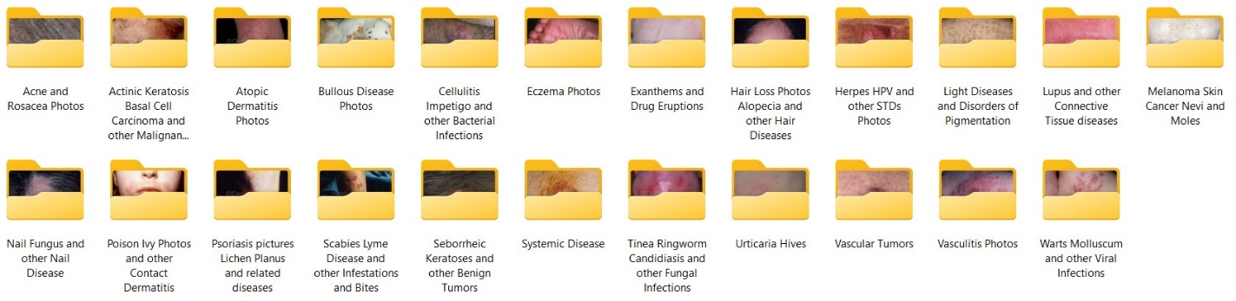

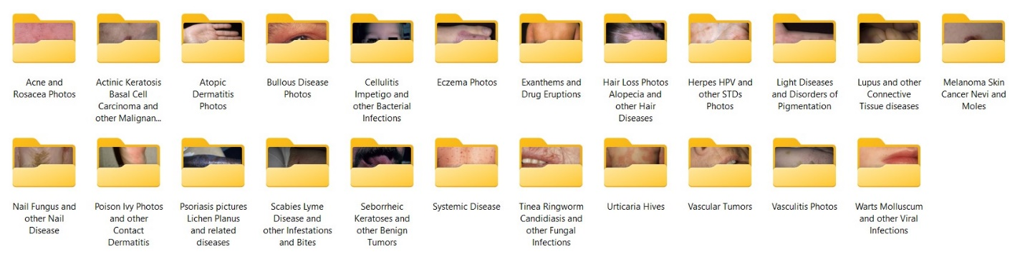

**3.2/ Data Preprocessing :**

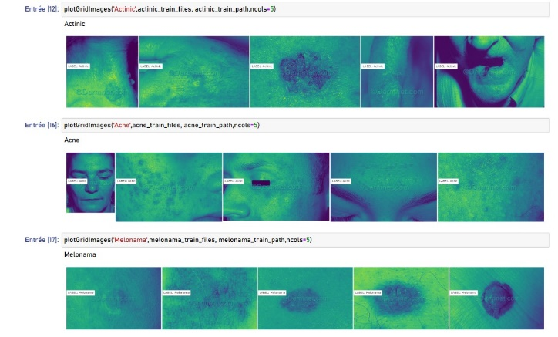Preprocess the images to prepare them for input into the CNN. This may include resizing the images to a consistent size, normalizing the pixel values, and augmenting the data by applying random transformations such as rotations or translations to create additional training examples.

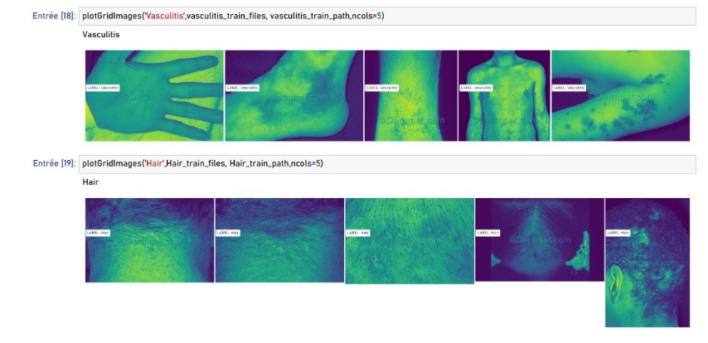

**3.3/ Training the CNN :**

Train the CNN on the labeled dataset using a suitable loss function and optimization algorithm. During training, the network learns to recognize the patterns and features that are associated with the disease we want to detect.

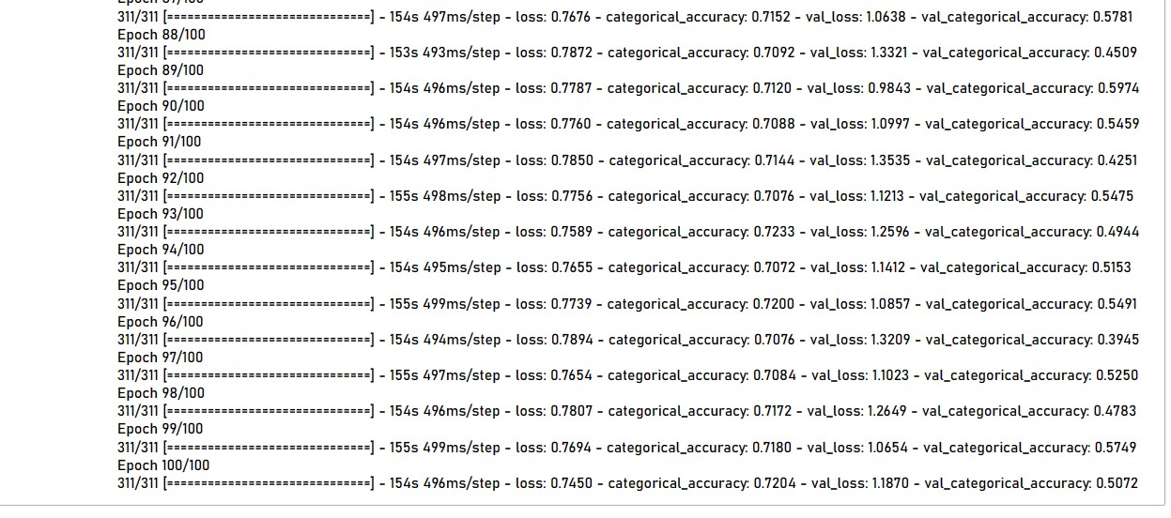

**3.4/ Vlidation :**

Validate the performance of the trained CNN on a separate validation dataset to ensure that it is generalizing well and not overfitting to the training data.

**3.5/ Training :**

Test the performance of the trained CNN on a separate test dataset to evaluate its accuracy in detecting the disease

