**Flip Coin Game**

**Submitted To**

**Susmita kor**

**Department of CSE**

**Submitted By**

**Group A**

**Md.Azizur Rahman- 14153203054**

**Md.Mirajur Rahman-14153203053**

**Md.Nazmul Hoque- 14153203061**

**Mst.moarium Akter- 14153203059**

Contents

Project Name: Flip Coin Game. 2

Flip Coin Game Rules 3

Flip Coin Software Process Models 3

Incremental Model: 4

Flip Coin Game Algorithm 5

Flip Coin Games Tree Diagram 6

Calculating probability 7

Flip Coin Game System View 8

Game Instruction 9

Authorizetion Form 10

Registration Form 11

Registration procedures 12

Login Form 13

Login procedures 14

Deshbaord 15

Play Games 16

Random selection /Toss 17

Adding Game Fund 18

Adding Game Fund Procedure 19

Buy Coin 20

Convert Coin 21

Cash Out 22

Admin Login 23

Table View of Admin Panel 24

Delete user 25

Update User 26

Search User 27

User request 28

Admin Response 29

User gets Feedback 30

Dashboard Control Views Code 31

Admin Controller Views Code 33



[**Bangladesh University of Business and Technology (BUBT)**](https://www.bubt.edu.bd/)

Department of Computer science engineering

### Project Name: Flip Coin Game.

**Objective**: Coin flipping, coin tossing, or heads or tails is the practice of throwing a [coin](https://en.wikipedia.org/wiki/Coin) in the air or using program checking [which side is showing](https://en.wikipedia.org/wiki/Obverse_and_reverse) when it lands to choose between two alternatives, sometimes to resolve a dispute between two parties. It is a form of [sortation](https://en.wikipedia.org/wiki/Sortition) which inherently has only two possible and [equally likely outcomes](https://en.wikipedia.org/wiki/Equally_likely_outcomes) Head or Tails.

**Overview:**

The programming assignments during the semester will comprise parts of a single application a Game Project. The Game Project is to be done in teams of from one to four people per team .Over the course of the semester each team will implement a complete game with capabilities as outlined below. At the end of the semester we will have a “Game Party” where each team demonstrates its game and has a chance to see and play those of other teams.

**Language:**

**Java**

**Java Fx**

### Flip Coin Game Rules

1. A user must have authorization to play game.
2. A player must have an Account.
3. A user needs Valid Email address.
4. An email address user can use only once.
5. User can change password by sending request to admin.
6. Minimum bet are 25 coins.

Maximum bet are 5000 coins.

1. For withdrawal user must have minimum balance 10k$.
2. Winner will get amount 200% included 5% Vat.
3. Loser wills loss Total investment.

### Flip Coin Software Process Models

**Incremental Development**

* In incremental model the whole requirement is divided into various builds. Multiple development cycles take place here, making the life cycle a [“multi-waterfall” cycle](http://istqbexamcertification.com/what-is-waterfall-model-advantages-disadvantages-and-when-to-use-it/).
* Cycles are divided up into smaller, more easily managed modules.  Each module passes through the requirements, design, implementation and [testing](http://istqbexamcertification.com/what-is-a-software-testing/) phases.
* A working version of software is produced during the first module, so you have working software early on during the [software life cycle](http://istqbexamcertification.com/what-are-the-software-development-life-cycle-phases/).
* Each subsequent release of the module adds function to the previous release. The process continues till the complete system is achieved.
* For example:

### Incremental Model:

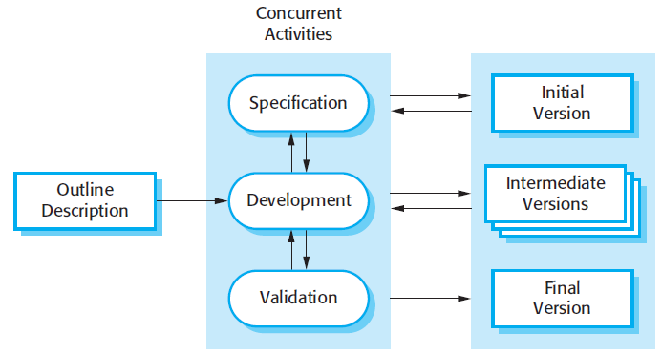

**How does it work?**

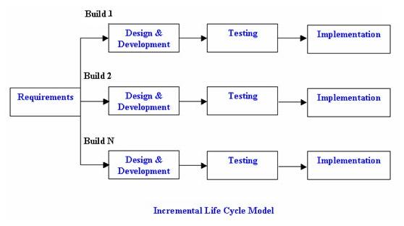

### Flip Coin Game Algorithm

Is new user?

**No**

Login

**Yes**

Registration

Increment Coin

Input Guess from user

Head or Tails

Decrement Coin

Is guess Correct?

**Yes**

Win

**No**

Is guess Correct?

**No**

Lose

**Yes**

Play Again?

**No**

### Flip Coin Games Tree Diagram

Clare tossed a coin three times.

a) Draw a tree diagram to show all the possible outcomes.   
b) Find the probability of getting:   
(i) Three tails.   
(ii) Exactly two heads.   
(iii) At least two heads.

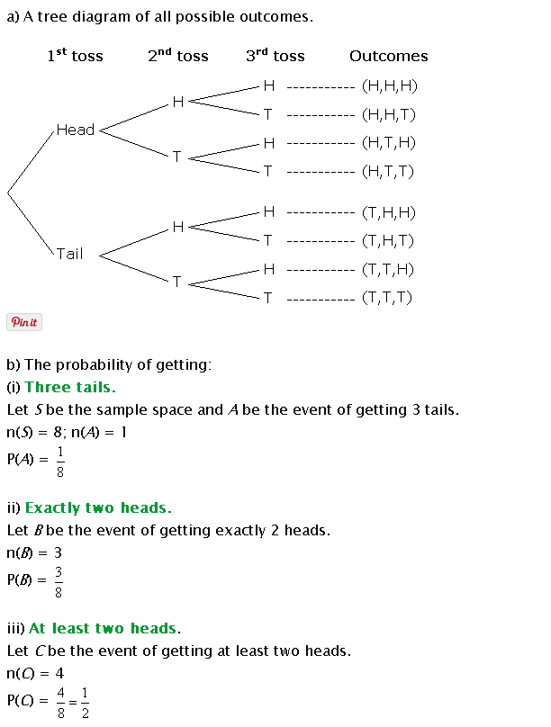

### Calculating probability

A simple diagram like the one below can be used to calculate the probability of any outcome. The sum of the probabilities of all possible outcomes for a random event must always add to 1. For a coin flip, there are two possible outcomes, either heads or tails. So if the coin is unbiased, and the coin flipping technique is also unbiased, then the probabilities are exactly half and half (½ or 0.5 or 50%).

So, using the diagram, there are four possible outcomes on the second flip. The probability of getting HH on the second flip is ¼ (or 0.25). The probability of HT, TH, or TT are all also ¼. The probability of HHH on the third flip is 1/8 (or 0.125) and HHHH on the fourth is 1/16 (or 0.0625).

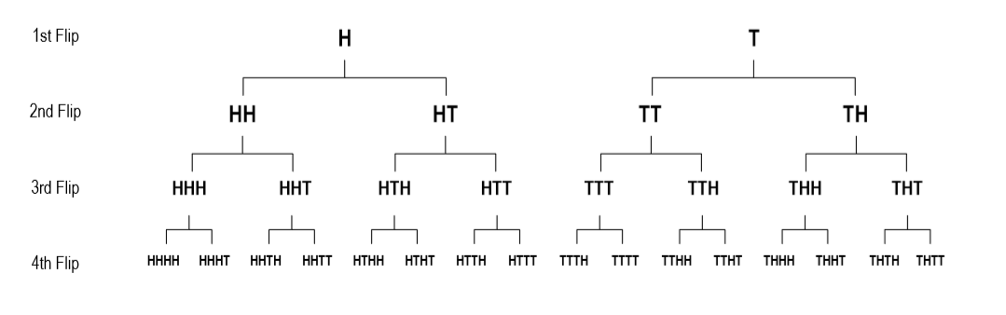

A faster way to calculate the probability of an outcome after any number of flips is to multiply the probabilities of all the outcomes together. So the probability of HH is ½ × ½ = ¼. The probability of HHH is ½ × ½ × ½ = 1/8 and of HHHH is ½ × ½ × ½ × ½ = 1/16.

Calculating the probabilities and expected frequencies of clusters is beyond the scope of primary school mathematics but students should be able to grasp the concept of their expected frequency and notice that their combined results match these predictions almost perfectly.

The expected frequencies for each cluster size are provided in Table 5 in the Student Worksheet. Each frequency in the table represents the average number of times you would expect to see these clusters in a large number of sets of results from one hundred coin flips.

### Flip Coin Game System View

**Game Instruction**

**TableView**

**UserAcc.**

**Tails**

**Head**

**Search**

**Update**

**Delete**

**Admin**

**Buy Coin**

**Add Fund**

**withdrawal**

**Covert Coin**

**Play**

**Massage**

**Login**

**Failed**

**Dashboard**

**Home**

**Registration**

**Play Game**

**Start**

Yes

**Confirm**

**Adminid**

**NOs**

**NOs**

**Success**

**Yess**

**Bet**

### Game Instruction

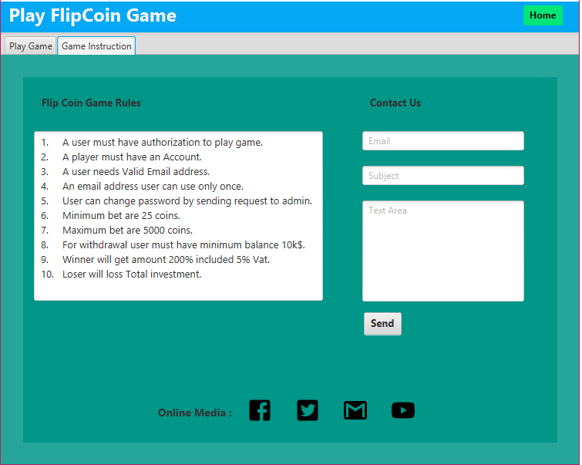

Flip Coin Game Rules

1. A user must have authorization to play game.

2. A player must have an Account.

3. A user needs Valid Email address.

4. An email address user can use only once.

5. User can change password by sending request to admin.

6. Minimum bet is 25$.

7. Maximum bet is 5000$.

8. For withdrawal user must have minimum balance 10k$.

9. Winner will get amount 200% included 5% Vat.

10. Loser will loss Total investment.

Above those rules must followed by a user of Flipcoin Games.

### Authorizetion Form

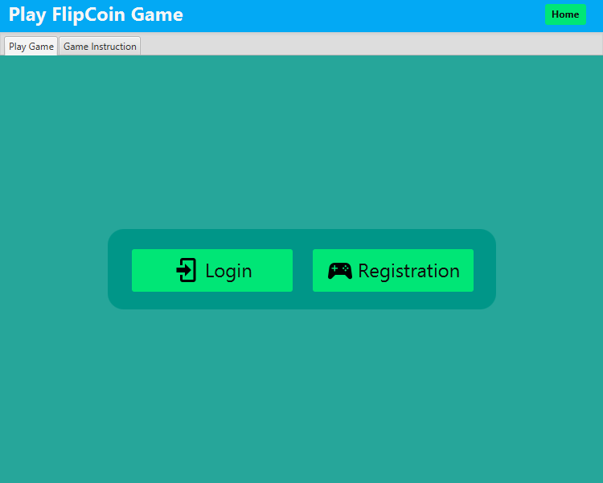

After a Welcome Screen a user will get a screen where have two options

1. Login

2. Registration

If a user be a new person in this game, user must registration first, after the user can login into the Game without registration a user can’t access main form where user can play the Flip Coin Game.

### Registration Form

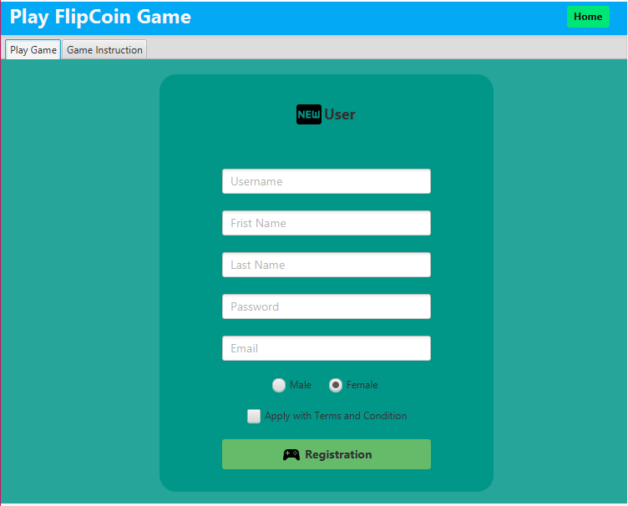

In the registration form a user must have fill 5 information such as

1.Username

2.First name

3.Last name

4. Password

5.Email

And also Two clickable checked point one is Radio Button another is CheckBox

Then press Registration.

### [Registration procedures](http://www.kalliasandassociates.com/EN/registration-procedures.html)

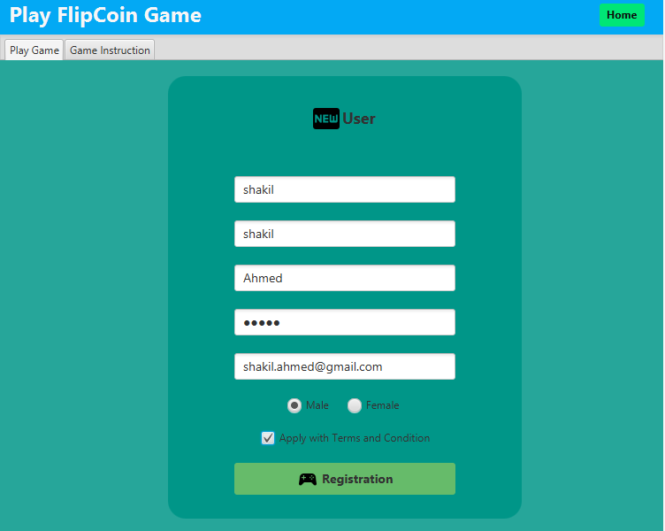

Male or

Female

Email address used only once.

Username less than 12 Characters

LastName less than 12 Characters

Password less than 12 Characters

FirstName less than 12 Characters

1.Username: User can gives as a user name text and number.

2.First name: user sur name

3.Last name : last name of user

4. Password: Number or text combination

5.Email: User should use valid Email address. One more thing is that a user can’t able to open two Flip Coin Game id by One email Address.

** Click Male or Female Button according to your Gender.

** Check above all terms and condition that is given by a user.

### Login Form

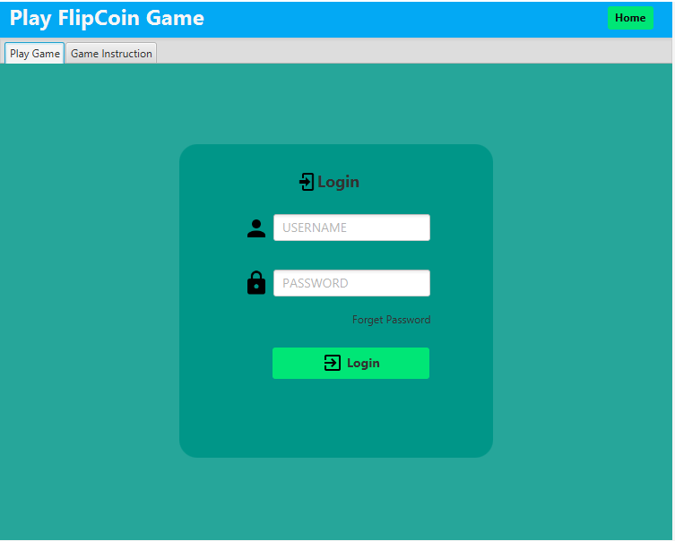

Username less than 12 Characters

Password less than 12 Characters

In login form has username and password

1. Username: user name will be less than 12 characters.

2. Password: password will be less than 12 characters.

### Login procedures

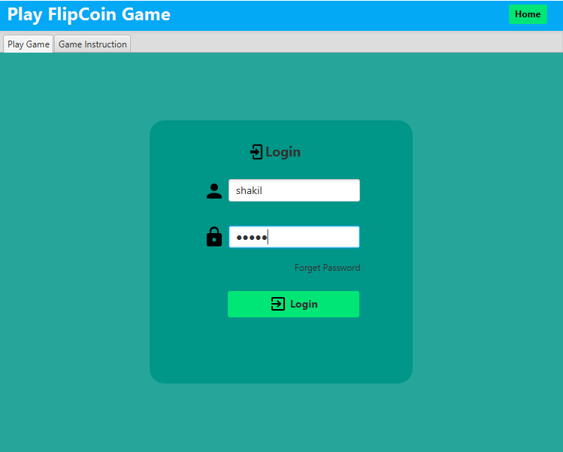

Valid Username

Valid Password

In Login Form

Only a registered user can login, a registered user will give valid username and password that is gave by user when user got registration.

After that a user can successfully Login.

### Deshbaord

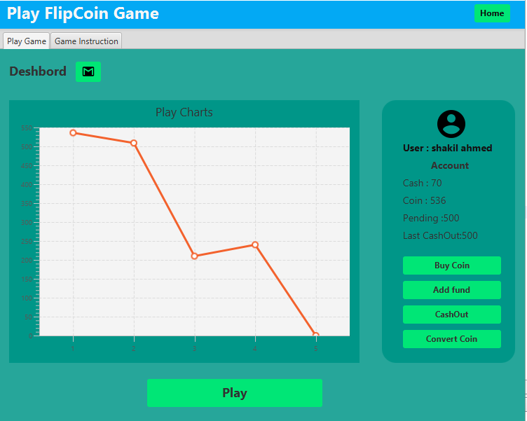

Dashboard, it will show five new user and their coins. In X axis it shows last Five individual user. In Y axis it shows amount of Coin last five individual users.

### Play Games

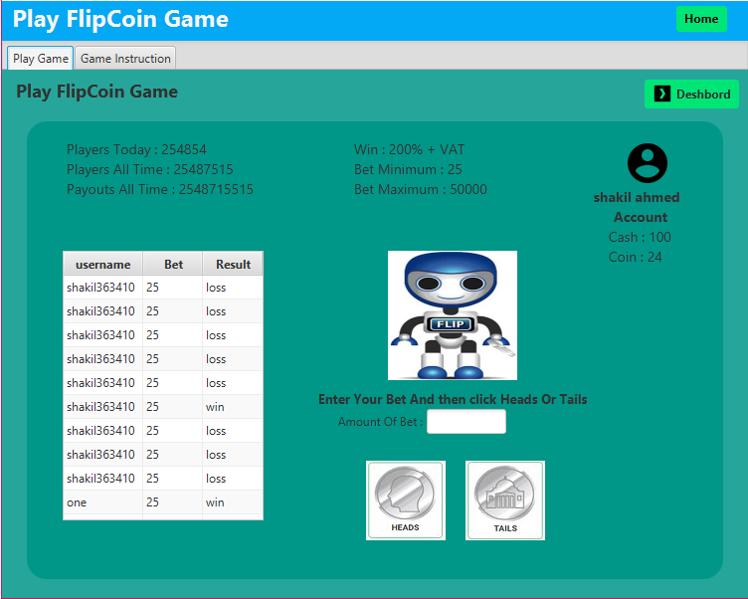

This surface is for the user to playing game. User can randomly choose heads or tails option accordingly user opinion .here guess pattern is more important things for playing game. User must choose right one for earn money.

### Random selection /Toss

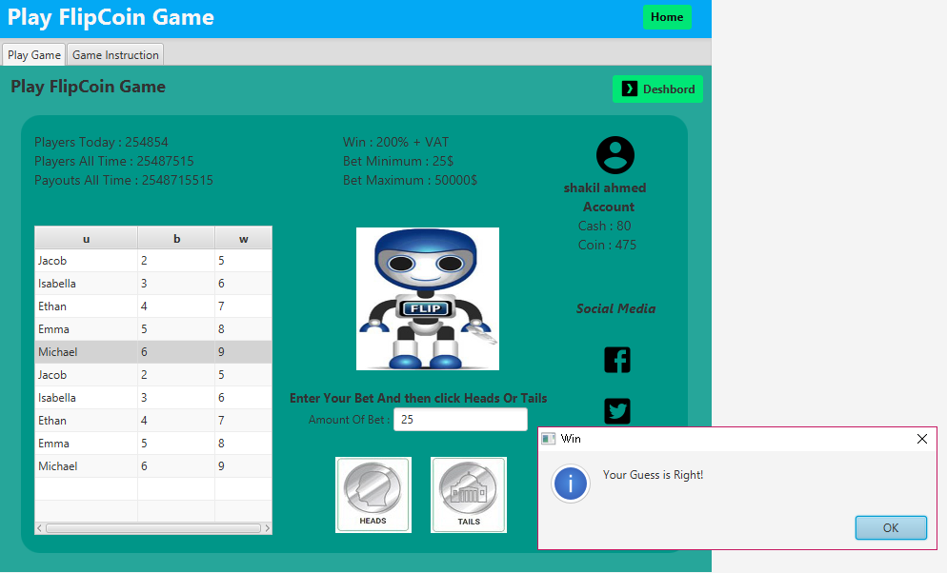

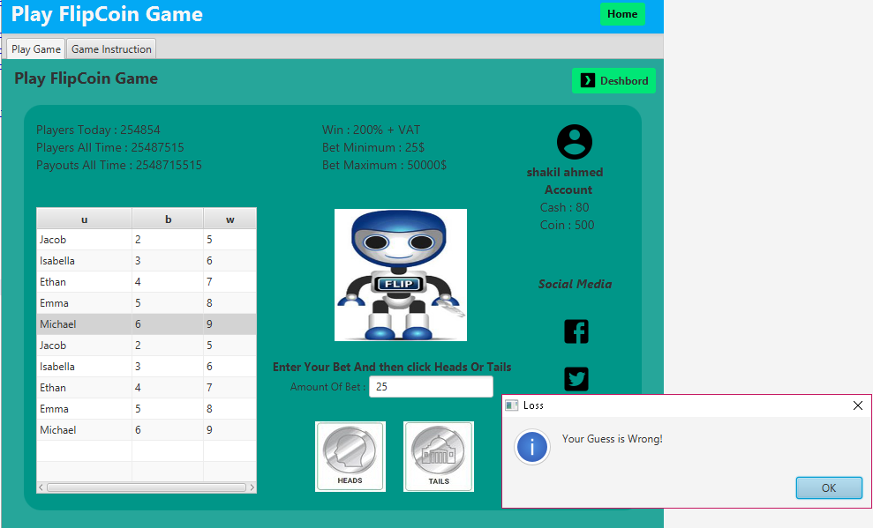

A user can choose only one option head or tails.

If user guess is correct then user will get 200% Bonus but user will gives 5% VAT to service provider of Game.

On the other hand if user lose the toss .user will lose the toss money that user bet.

### Adding Game Fund

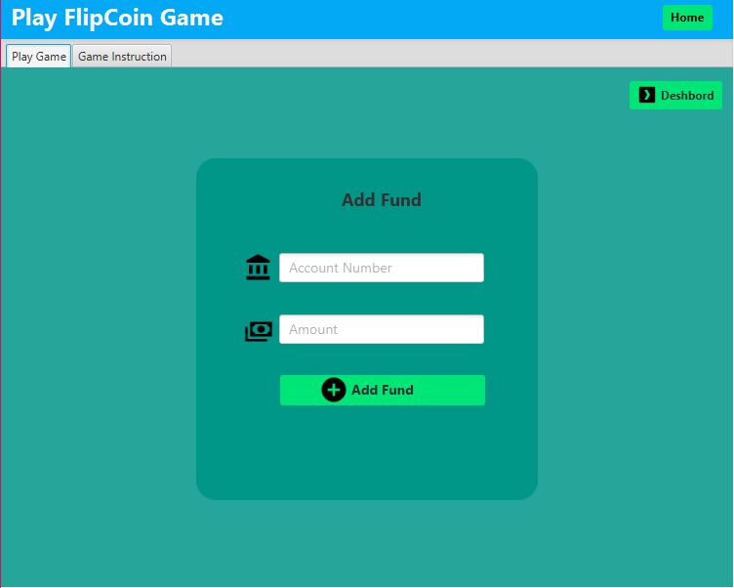

Sometimes a user need amount to paly game. But user doesn’t have money on his/her account to play game.

At that time user can transfer money to Flip coin games account from his/her valid Bank Account number.

This is the easy and quickest way to transfer money and play game.

User also can use his/her bKash account number. This is upcoming process. Flip coin game developer team working on it .user will access bkash account very soon…………………….

### Adding Game Fund Procedure

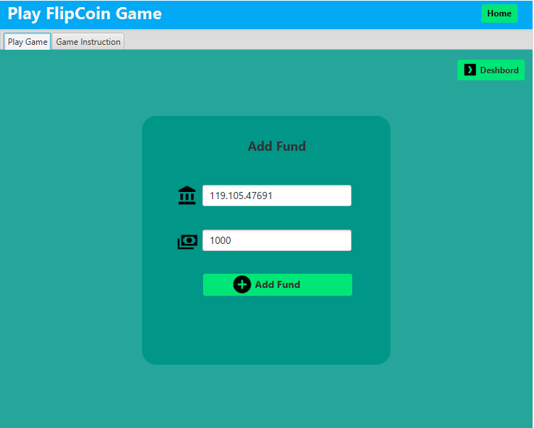

This is the procedure how to Transfer money from the Bank account. There is two options one gives valid 11 digits account number and another one is gives how much amount wants to transfer from account.

### Buy Coin

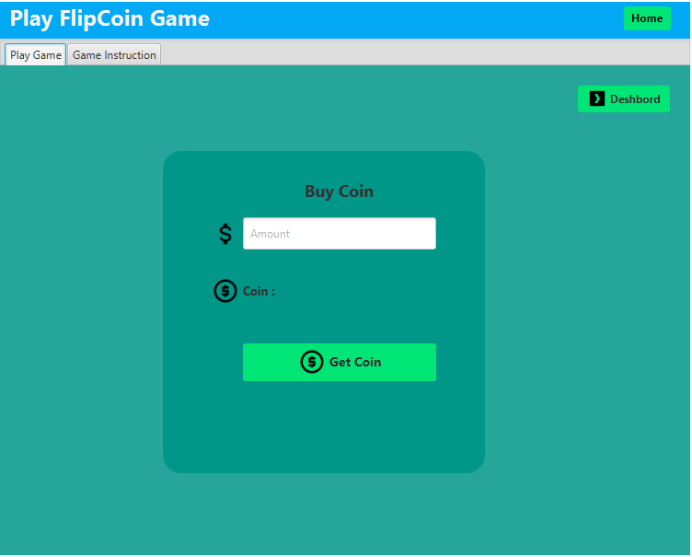

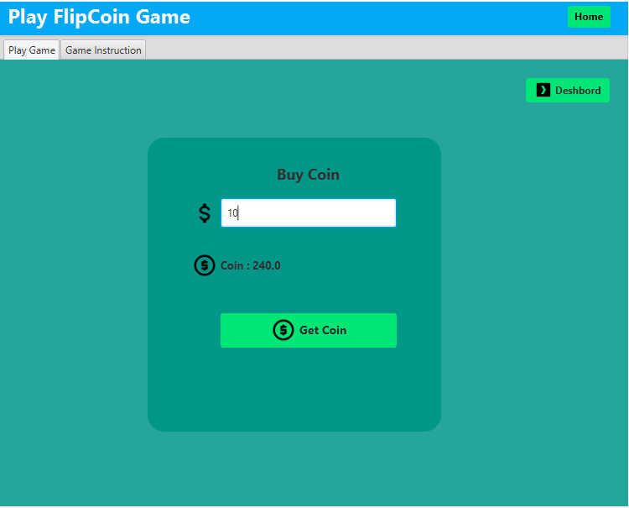

Buy coin is the process by following this process a user can buy coin to play game.

A user will get 24 coins by one dollar. Ten dollar user will get 240 coins.

At first a user should buy two dollar coin because of user must have minimum 25 coins to play game.

### Convert Coin

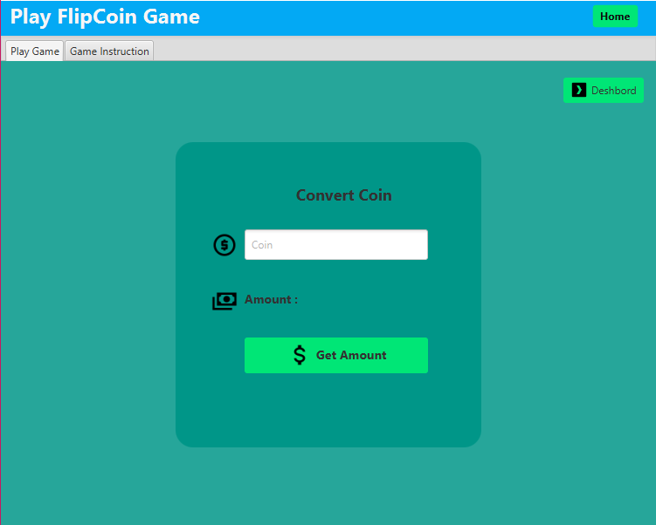

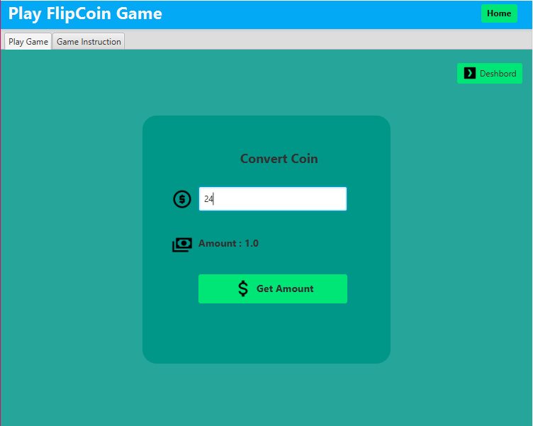

After playing games user will wish to get money from flip coin game account.

At first user must convert amount to dollar. Following this procedure a user can convert whole coins to dollar. It’s depending on user how much he/she wants to convert.

### Cash Out

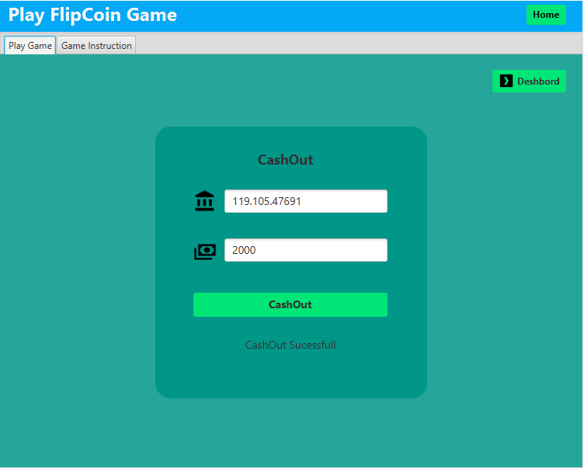

After playing games user will wish to get money from flip coin game account. After converting coin into dollar user can send money to his /her valid Bank account .money will send after confirmation of flip coin game authority.

### Admin Login

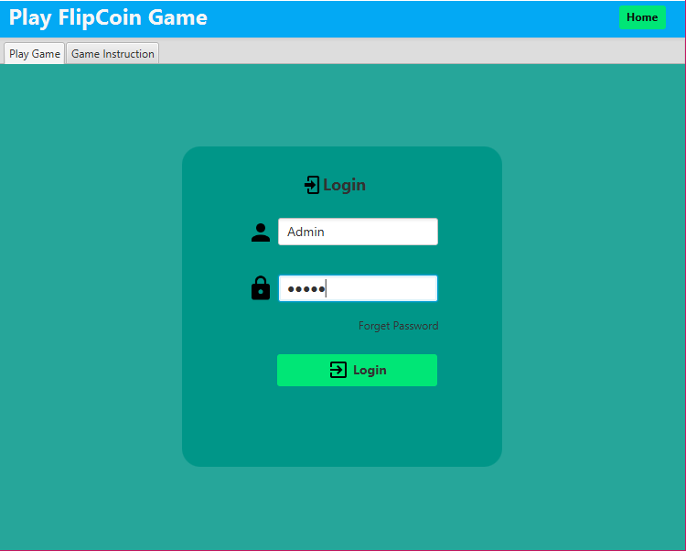

Admin user has whole power of the games. Admin can delete any users who are not abiding by rules and regulations of flip Coin game. Admin can update user information according to user valid request, find out by searching by the username of a user.

### Table View of Admin Panel

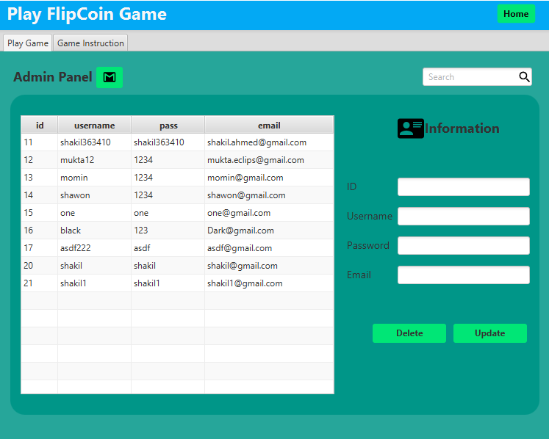

After admin login view of a admin panel. There is a table view where has all of the information of every single user. Delete, update, search options available.

### Delete user

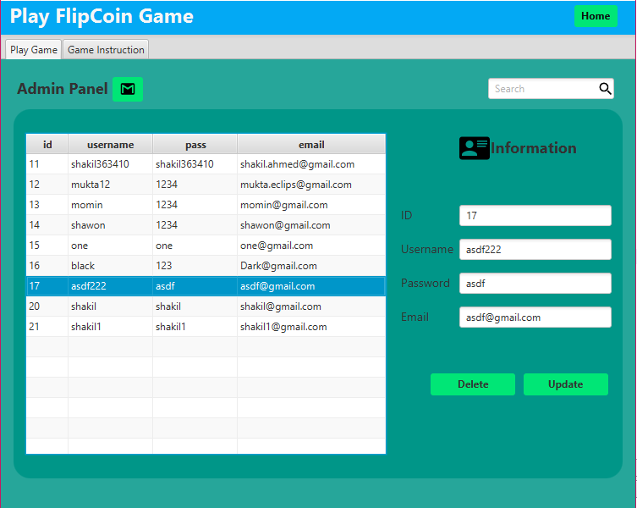

Before deleting id 17 view of admin table. In the right-bottom side of the table has delete button.

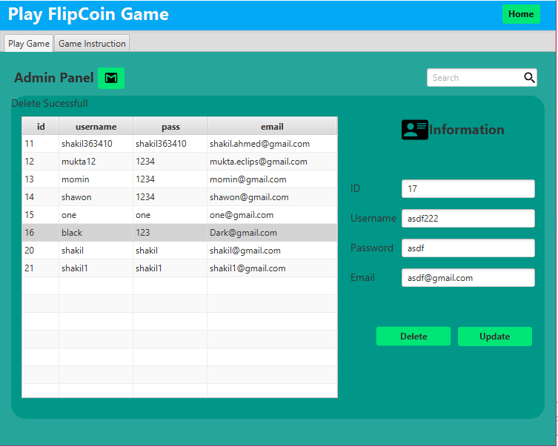

After deleting id 17 is gone. Others id’s are same as like as before was.

### Update User

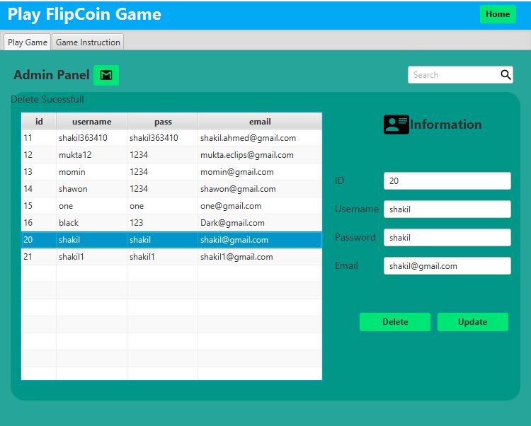

For updating id, admin selected id was 20.

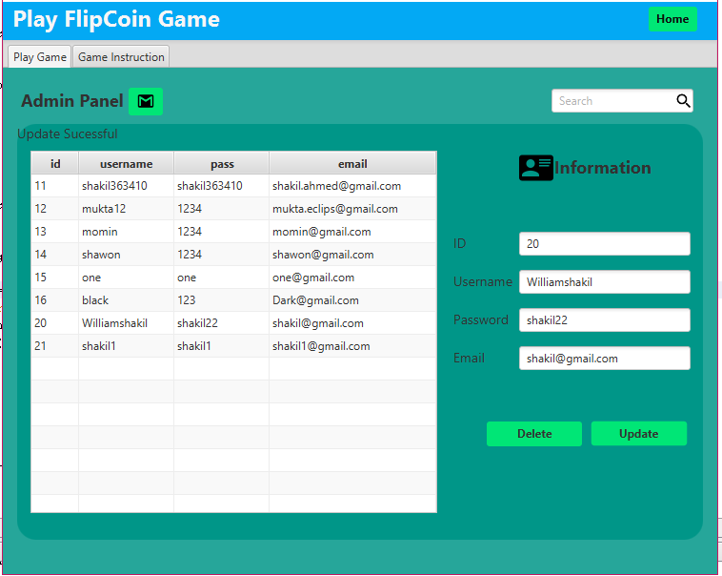

After updating here we find that admin change username from **shakil to Williamshakil**, password **shakil to shakil22** and others thinks kept same as like before.

### Search User

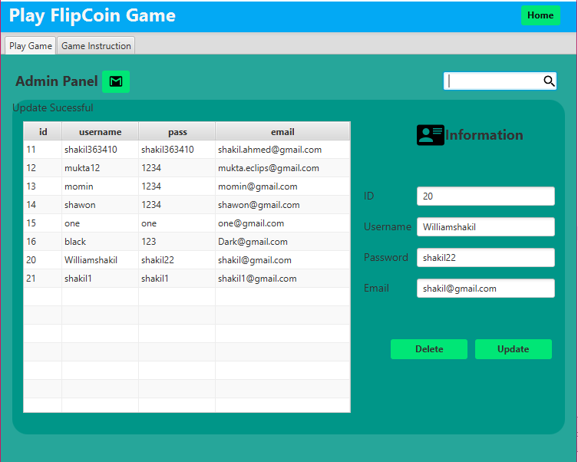

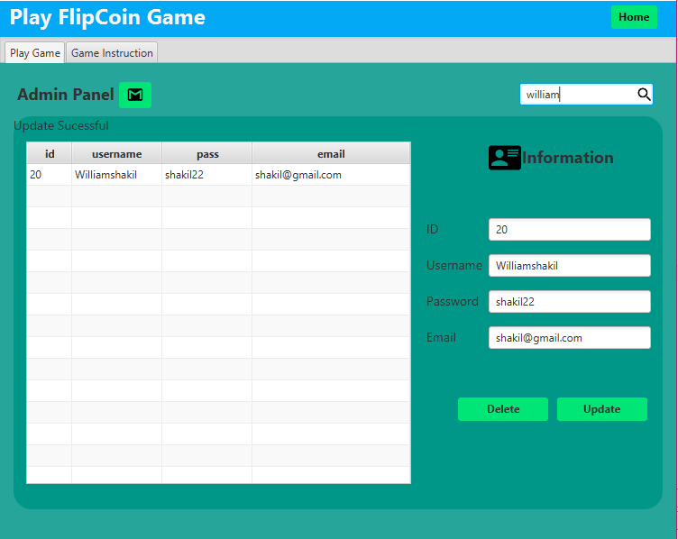

Admin searching for username williamshakil. in the first image where this id position is 20.in the second image view admin only write down William in the search box of image view two. In the table view it’s shown that id 20, username, pass and email.

### User request

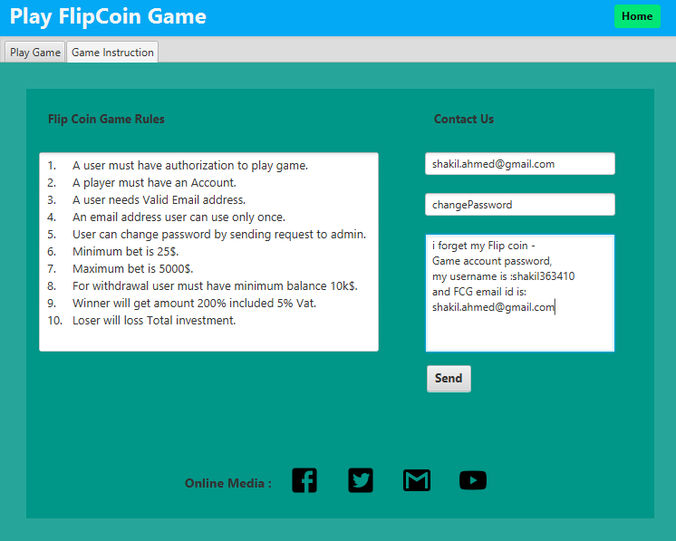

For Forget password user sending text request

I forget my Flip coin-Games account password

My username is : shakil363410

And FCG email id is :

[Shakil.ahmed@gmail.com](mailto:Shakil.ahmed@gmail.com)

### Admin Response

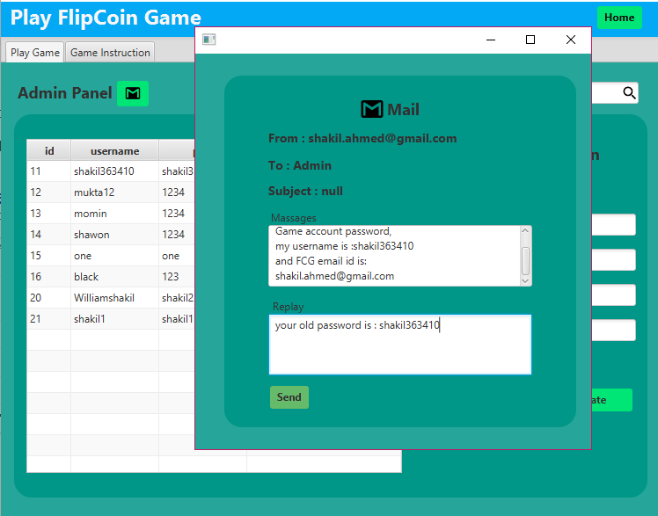

Admin gives response to user that your old password is :shakil363410

And sending to user via email address.

### User gets Feedback

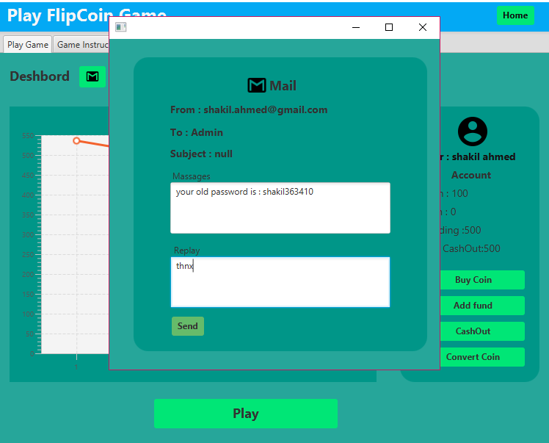

User gets feedback from admin that user old password is :shakil363410

### Dashboard Control Views Code

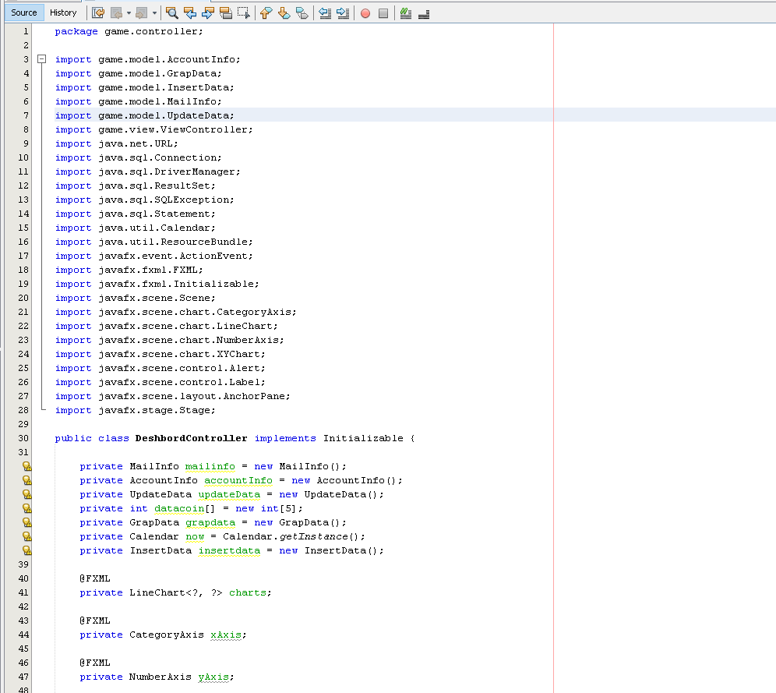

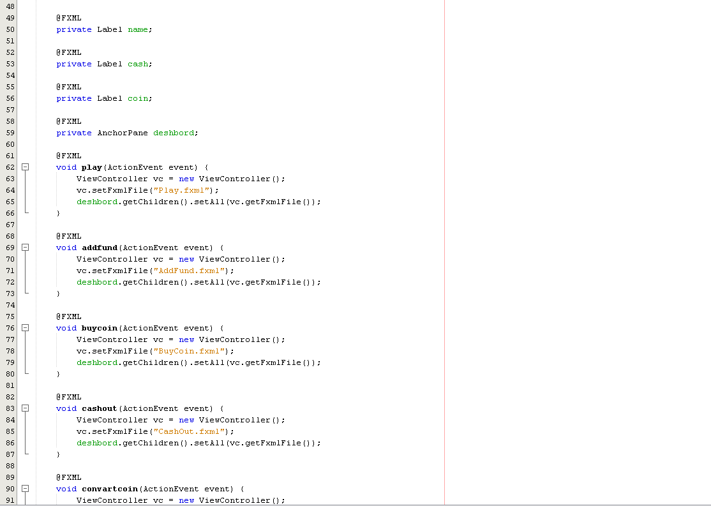

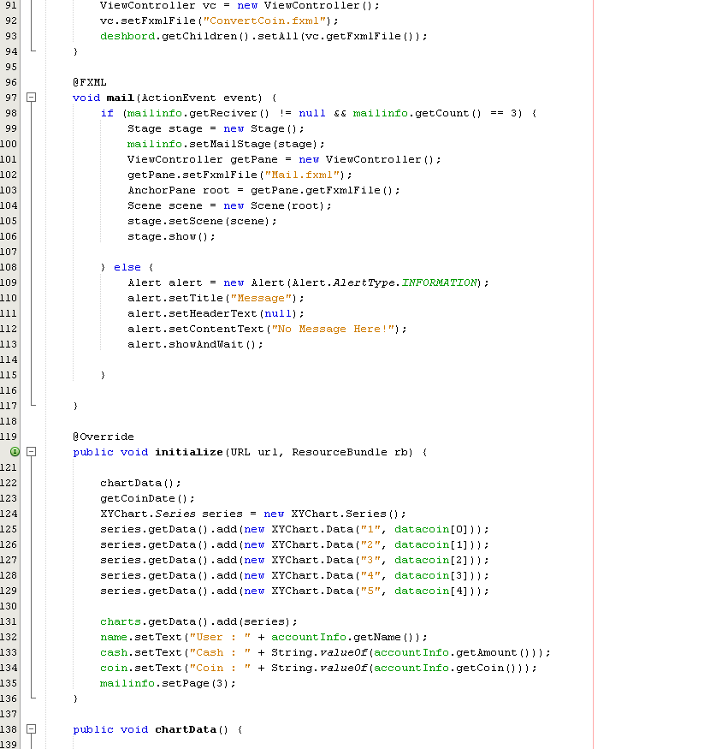

### Admin Controller Views Code

