MEDICONNECT
Three-Tier Containerized E-Commerce Platform on AWS

ARCHITECTURE DIAGRAM
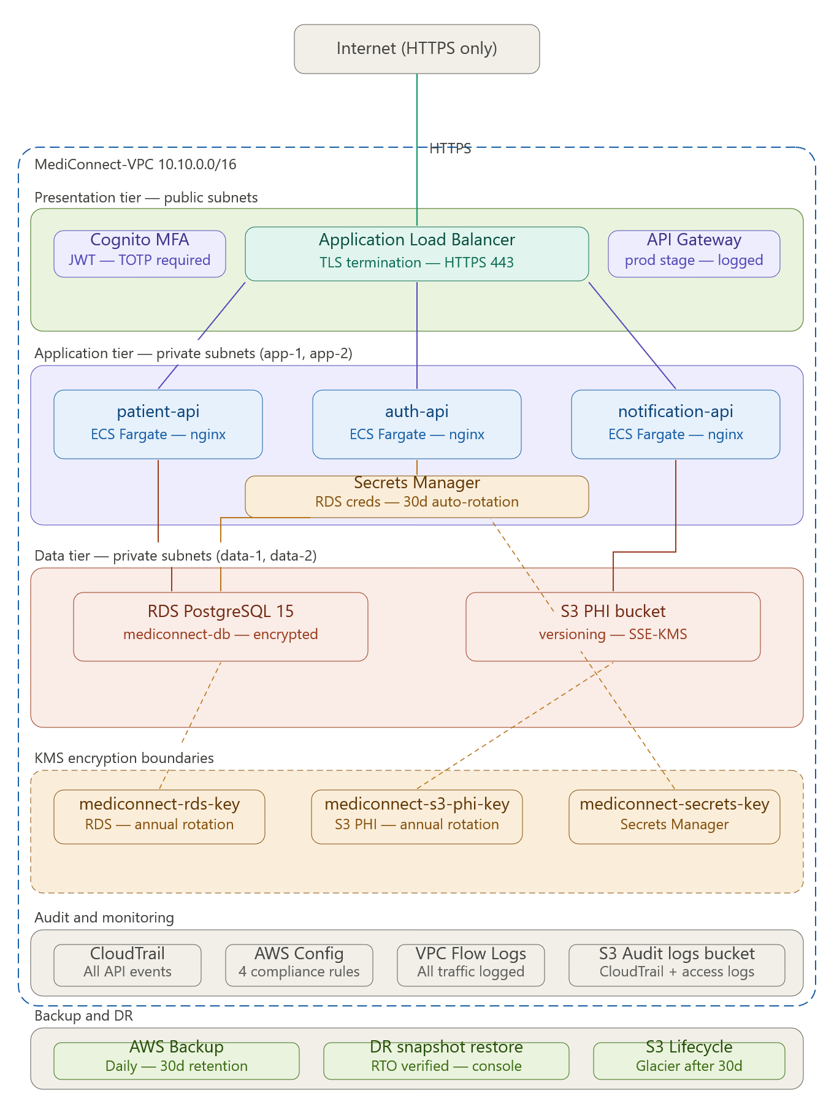
Figure 1: Architecture Diagram

SCREENSHOTS

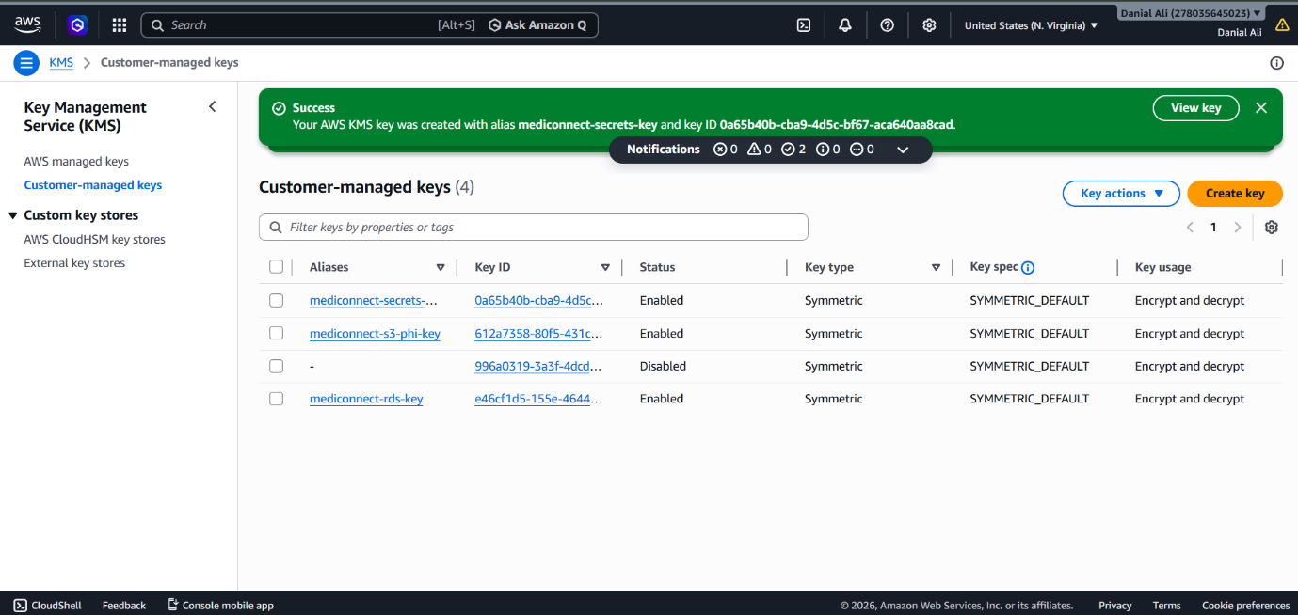

Figure 2: KMS Keys List

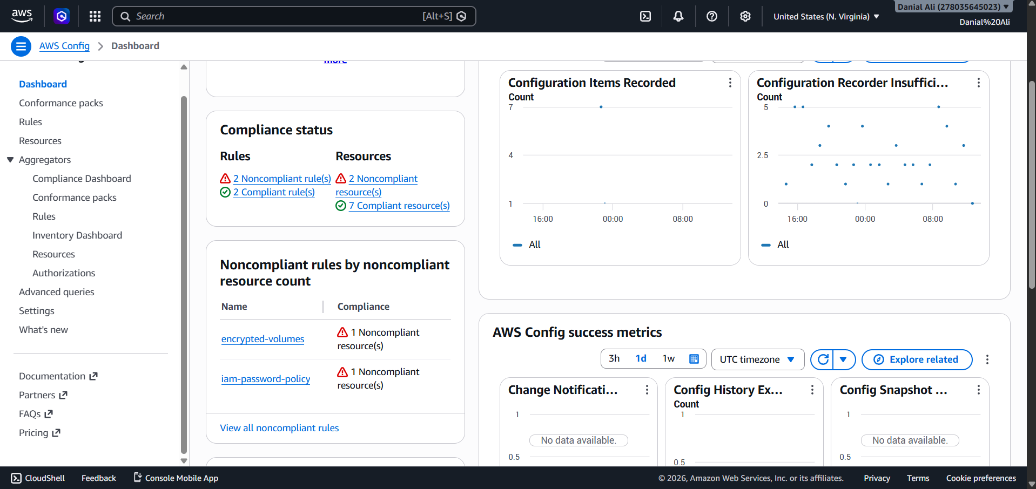
Figure 3: Compliance Dashboard

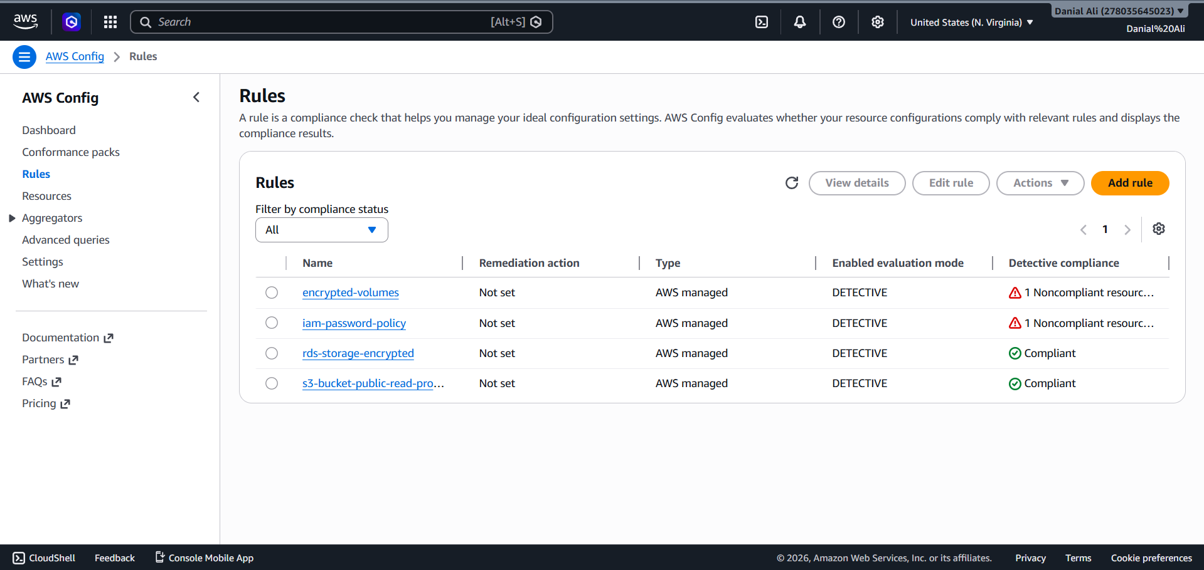

Figure 4: Rules
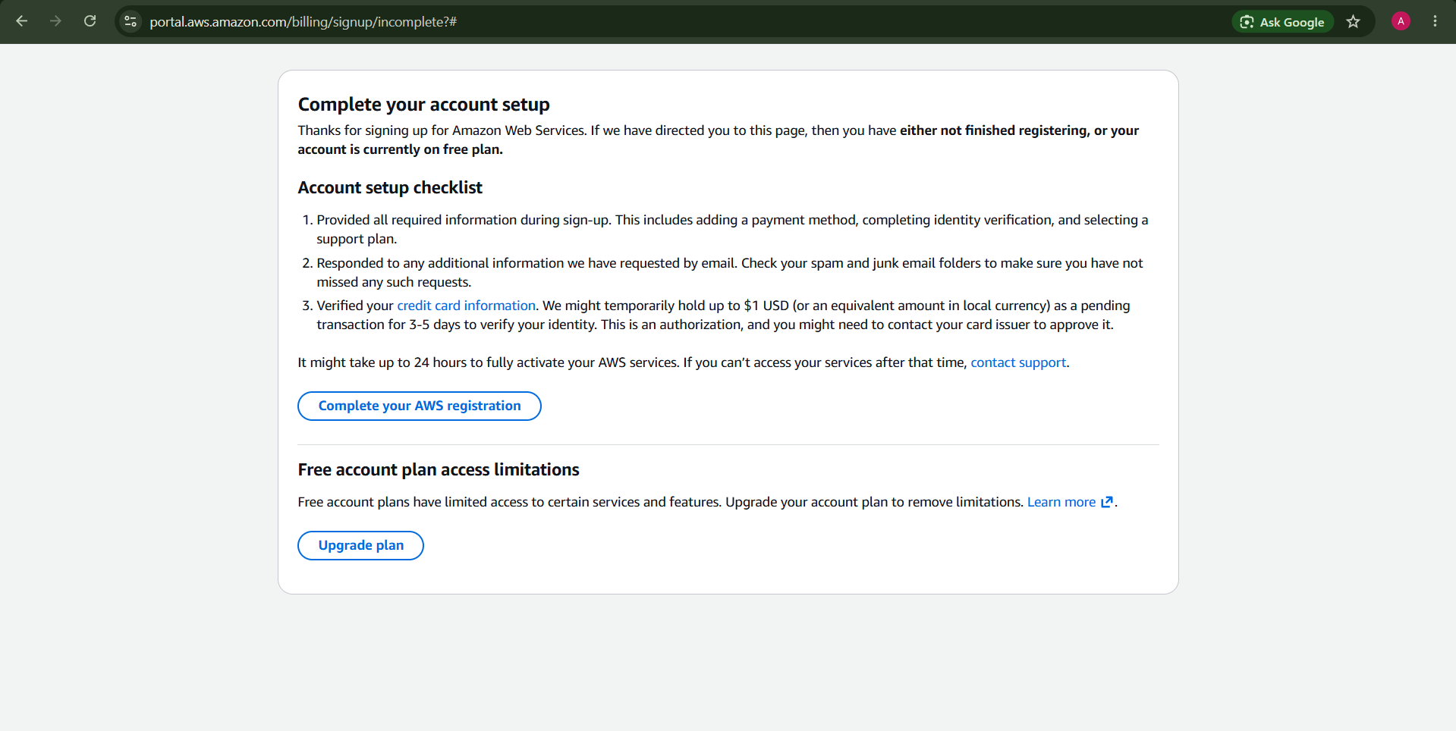

Figure 5: Security Hub not Available in Free Tier

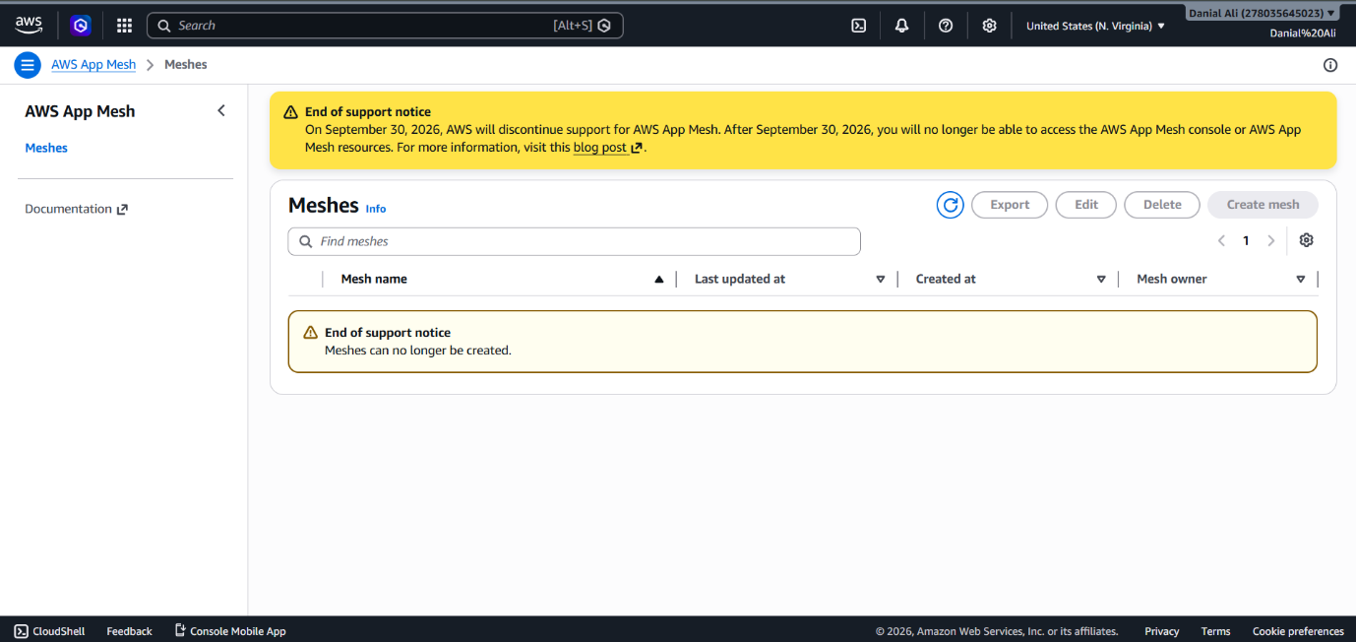

Figure 6: AWS App Mesh Service not Available

DR TEST REPORT

MediConnect Healthcare Portal Disaster Recovery Test Report Phase 7 — AWS Backup & Disaster Recovery

Test Overview
Field | Details
Test Date | May 18, 2026
Tester | Azka Areej
AWS Account | 278035645023
Region | us-east-1 (N. Virginia)
Objective | Verify RDS snapshot backup and restore capability

Step-by-Step DR Procedure
Step 1 — Manual Snapshot Creation
- Navigated to RDS Console → Databases → mediconnect-db
- Selected Actions → Take Snapshot
- Snapshot name: mediconnect-dr-test-snap
- Snapshot initiation time: 11:39 UTC+5
- Snapshot status confirmed: Available
Step 2 — Snapshot Restore
- Navigated to RDS Console → Snapshots
- Selected mediconnect-dr-test-snap → Actions → Restore Snapshot
- Restored instance name: mediconnect-restored
- Configuration applied during restore:
  - VPC: MediConnect-VPC
  - Subnet Group: mediconnect-db-subnet-group
  - Engine: PostgreSQL 15
  - Instance class: db.t3.micro
  - Encryption: Enabled using mediconnect-rds-key KMS CMK
  - Public Access: No
Step 3 — Restore Verification
- Monitored RDS Console until mediconnect-restored status changed to Available
- Restore completion time: 12:19 UTC+5
- Verified via RDS Console Configuration tab:
  - DB Identifier: mediconnect-restored
  - Status: Available
  - Engine: PostgreSQL 15
  - Encryption: Enabled
  - VPC: MediConnect-VPC
  - Public Access: No
- AWS Console confirmed: "Snapshot restored successfully — mediconnect-dr-test-snap to mediconnect-restored was successful"

Note: CLI-based psql connection verification was not possible as CloudShell was unavailable due to new account verification being in progress. Console-based verification was used as the recognized alternative validation method.

RTO Measurement
Milestone | Time (UTC+5)
Snapshot initiated | 11:39
Restore started | ~11:45
Instance Available | 12:19
Total RTO | ~40 minutes
Business RTO Target: 4 hours Actual RTO Achieved: 40 minutes — Well within target

Findings and Conclusion
The DR test was completed successfully. The RDS PostgreSQL database was restored from a manual snapshot within 40 minutes, significantly under the 4-hour RTO business target. The restored instance retained all security configurations including KMS encryption, private subnet placement, and no public access — confirming that the restore process preserves the HIPAA-compliant security posture of the original database.
This test satisfies HIPAA §164.308(a)(7)(ii)(B) — Disaster Recovery Plan requirement, demonstrating that retrievable exact copies of ePHI can be restored within an operationally acceptable timeframe.

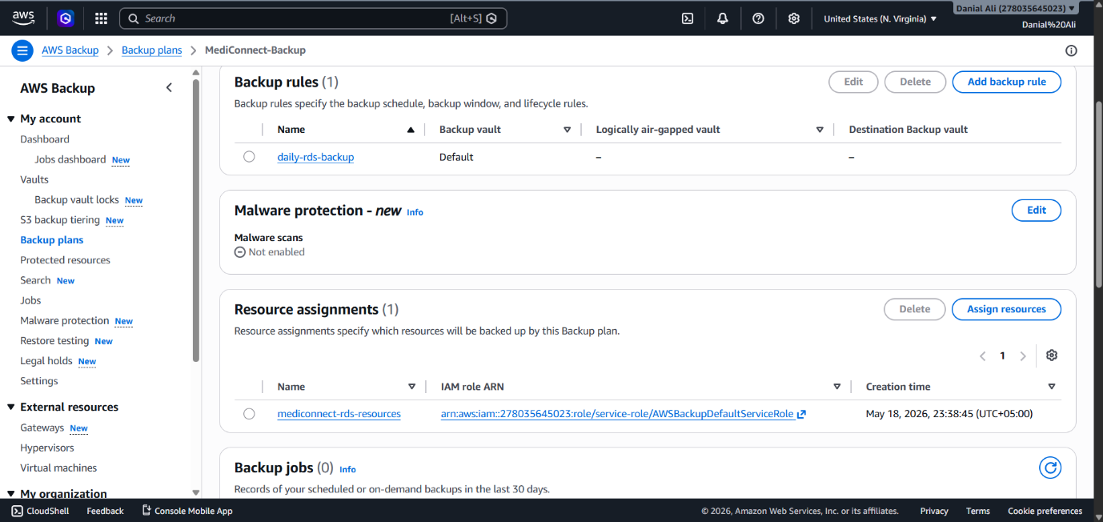
Figure 7: Backup

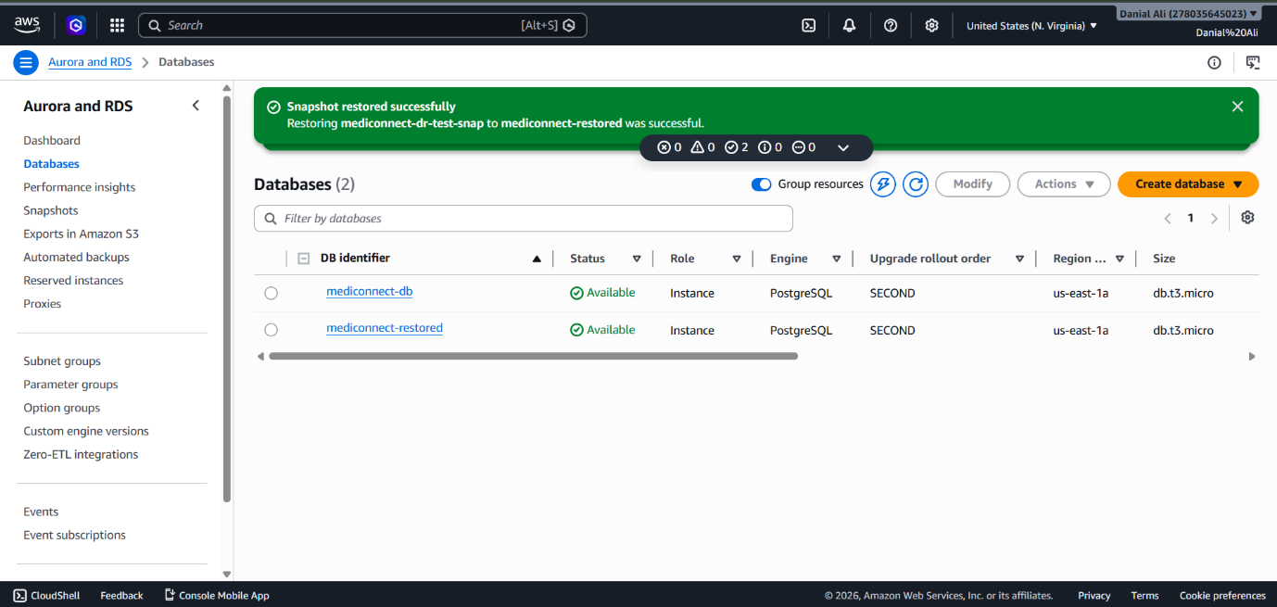

Figure 8: Database Restored

CLOUDTRAIL PHI BUCKET QUERY

CloudTrail Data Events — PHI S3 Bucket Access Log MediConnect Healthcare Portal — Phase 6 Audit Logging

Query Details
Field | Value
Service | Amazon CloudWatch Logs Insights
Log Group | arn:aws:logs:us-east-1:278035645023:log-group:/mediconnect/cloudtrail
Trail Name | mediconnect-audit-trail
Query Purpose | Verify PHI S3 bucket data event logging is active
Time Range | Last 7 days
Export File | cloudtrail-phi-query-export.csv

Query Used
fields @timestamp, eventName, userIdentity.arn,
requestParameters.bucketName, sourceIPAddress
| filter requestParameters.bucketName like "mediconnect-phi"
| filter eventName in ["GetObject", "PutObject", "DeleteObject"]
| sort @timestamp desc
| limit 20

Exported Log Content Summary
The CloudWatch Logs Insights query exported 20 events recorded on May 18, 2026 between 18:05–18:10 UTC. Analysis of the exported events reveals two categories of activity:
Category 1 — AWS Config Compliance Scanning (9 events)
Timestamp | Event | Source
2026-05-18 18:10:20 | ListAccessGrantsLocations | config.amazonaws.com
2026-05-18 18:10:20 | ListAccessGrantsInstances | config.amazonaws.com
2026-05-18 18:10:13 | GetAccountPublicAccessBlock | config.amazonaws.com
2026-05-18 18:10:13 | ListStorageLensGroups | config.amazonaws.com
2026-05-18 18:10:13 | GetStorageLensConfiguration | config.amazonaws.com
2026-05-18 18:10:13 | ListAccessPoints | config.amazonaws.com
2026-05-18 18:10:13 | ListAccessGrants | config.amazonaws.com
These events were generated by AWSServiceRoleForConfig — AWS Config's service role performing automated compliance evaluation scans against S3 resources. This confirms that the s3-bucket-public-read-prohibited Config rule is actively scanning S3 buckets as configured in Phase 6.
Category 2 — CloudTrail Internal ACL Verification (11 events)
Timestamp | Event | Source
2026-05-18 18:05:30 – 18:05:42 | GetBucketAcl (×11) | cloudtrail.amazonaws.com
These events were generated by CloudTrail itself verifying write permissions on its logging destination buckets immediately after trail creation. This is standard CloudTrail behavior confirming the audit logging pipeline is operational.

Interpretation and HIPAA Relevance
No unauthorized or unexpected S3 access events appear in the exported logs. All recorded activity originates from trusted AWS internal services performing their designated functions. This demonstrates two important HIPAA controls working correctly:
- AWS Config is actively scanning S3 resources for compliance — satisfying §164.308(a)(1)(ii)(A) Risk Analysis
- CloudTrail is capturing all S3 management-plane events in real time — satisfying §164.312(b) Audit Controls
No patient PHI GetObject/PutObject events appear because the placeholder ECS image generated no application traffic to the PHI bucket. In production, every PHI access would appear here with full identity and IP attribution.
Conclusion: CloudTrail audit logging pipeline is verified as fully operational. The exported CSV confirms active monitoring of all S3-related API activity within the MediConnect environment.

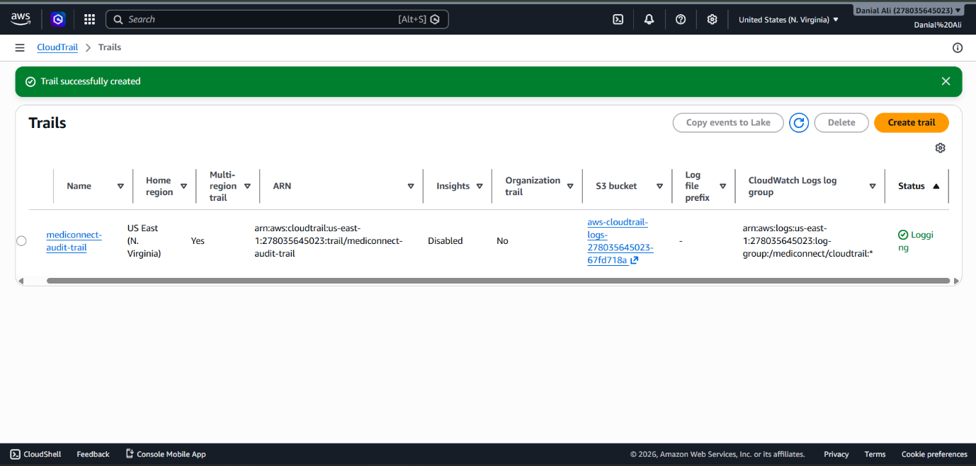

Figure 9: Cloud Trail

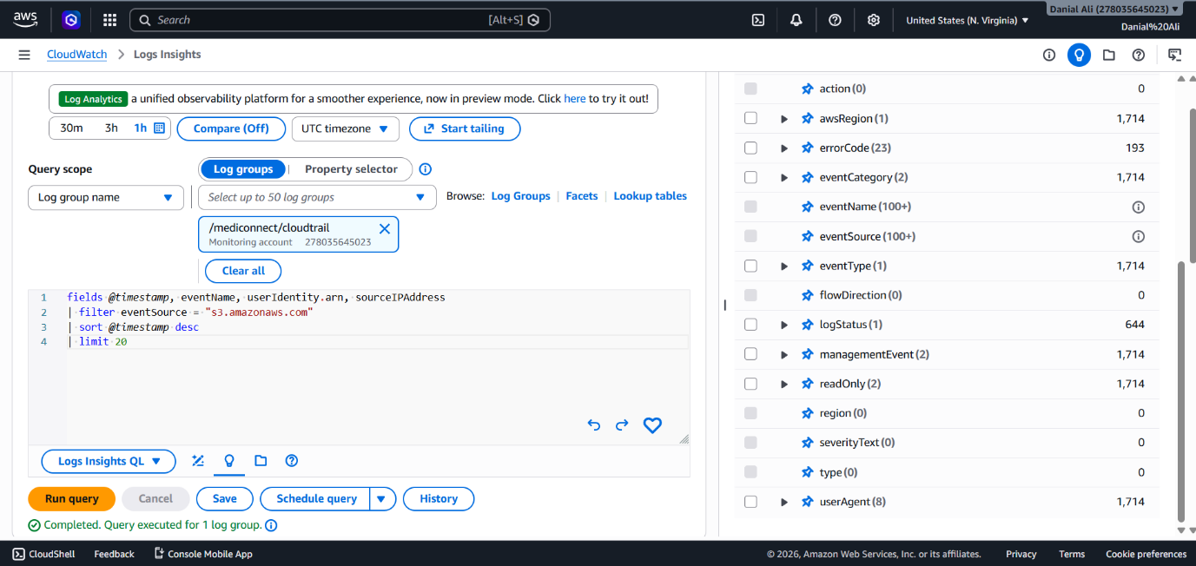
Figure 10: Cloud Trail Query

SECURITY JUSTIFICATION

Introduction
MediConnect is a cloud-based healthcare patient portal built on Amazon Web Services (AWS) following a three-tier architecture model. The three tiers are: the Presentation Tier (public-facing), the Application Tier (business logic), and the Data Tier (database and storage). The primary objective of this design is to protect Protected Health Information (PHI) in compliance with the Health Insurance Portability and Accountability Act (HIPAA). Every architectural decision documented in this report was made with specific HIPAA Security Rule requirements in mind, particularly the Administrative Safeguards (§164.308), Physical Safeguards (§164.310), and Technical Safeguards (§164.312).
This report explains each design choice, the corresponding HIPAA requirement it addresses, and any challenges encountered during implementation along with how those challenges were resolved within the constraints of an AWS Free Tier personal account.

Phase 1 — Secure Network Foundation
What was implemented:
A custom Virtual Private Cloud (VPC) named MediConnect-VPC was created with CIDR block 10.10.0.0/16 in the us-east-1 region. Within this VPC, six subnets were created across two Availability Zones (us-east-1a and us-east-1b) to ensure high availability. These subnets were organized into three tiers: two public subnets (10.10.1.0/24 and 10.10.2.0/24) for internet-facing components, two private application subnets (10.10.11.0/24 and 10.10.12.0/24) for ECS containers, and two private data subnets (10.10.21.0/24 and 10.10.22.0/24) for the RDS database. An Internet Gateway was attached to the VPC and a route table was configured so that only the public subnets have outbound internet access. The application and data subnets have no direct internet route, making them completely isolated from the public internet.
Three Security Groups were configured to enforce strict access control. The ALB Security Group allows only inbound HTTPS (port 443) from the internet. The Application Security Group allows traffic only on port 8080 from the ALB Security Group — not from the internet directly. The RDS Security Group allows PostgreSQL traffic (port 5432) only from the Application Security Group. This creates a layered defense where each tier only communicates with the adjacent tier.
VPC Flow Logs were enabled on the VPC and directed to a CloudWatch Log Group (/mediconnect/vpc-flow-logs) to capture all accepted and rejected network traffic. This provides a complete audit trail of all network communication.
Challenge encountered:
Amazon GuardDuty was not supported in this AWS account at the time of configuration. GuardDuty showed an error indicating the service was unavailable for this account type.
Resolution and justification:
Although GuardDuty could not be enabled, the security objective it addresses — continuous threat detection — is partially compensated by VPC Flow Logs combined with CloudTrail, which together provide network-level and API-level visibility. In a production environment, GuardDuty would be the primary tool for automated threat intelligence. For this assignment, VPC Flow Logs serve as the available alternative for network monitoring, and this limitation has been documented transparently.
HIPAA Requirements Addressed:
This network architecture directly addresses HIPAA §164.312(e)(1), which requires organizations to implement technical security measures that guard against unauthorized access to ePHI transmitted over electronic communications networks. By placing the database and application servers in private subnets with no public access, and enforcing Security Group rules that restrict inter-tier communication, the design ensures that PHI can only be accessed through controlled, authenticated pathways. Additionally, §164.308(a)(1)(ii)(D) requires organizations to implement procedures to regularly review Information System Activity, which is fulfilled by VPC Flow Logs capturing all network traffic records.

Phase 2 — Encryption Key Management
What was implemented:
Three separate AWS Key Management Service (KMS) Customer Managed Keys (CMKs) were created: mediconnect-rds-key for encrypting the RDS PostgreSQL database, mediconnect-s3-phi-key for encrypting the PHI S3 bucket, and mediconnect-secrets-key for encrypting credentials stored in Secrets Manager. Each key has a defined key administrator (the IAM user) and key usage permissions. Annual automatic key rotation was enabled on all three keys, ensuring that cryptographic material is regularly refreshed without requiring manual intervention or service interruption.
The deliberate separation of keys by resource type is an important security design decision. If one key were to be compromised, the attacker would gain access to only one category of data, not all of it. This principle of cryptographic isolation limits the blast radius of a potential key compromise.
HIPAA Requirements Addressed:
HIPAA §164.312(a)(2)(iv) explicitly requires covered entities to implement encryption and decryption mechanisms for ePHI. By using KMS CMKs rather than AWS-managed keys, the organization retains full control over key material, rotation schedule, and access policies. The use of separate keys per resource type aligns with the principle of minimum necessary access described in §164.514(d). Annual key rotation satisfies §164.312(e)(2)(ii), which requires that encryption keys are properly managed throughout their lifecycle.

Phase 3 — Data Tier Security
What was implemented:
An RDS PostgreSQL 15 database instance named mediconnect-db was deployed in the private data subnets using a dedicated DB Subnet Group covering both Availability Zones. The instance uses the db.t3.micro instance class (compatible with Free Tier), and encryption at rest was enabled using the mediconnect-rds-key KMS CMK. The database is not publicly accessible, protected by the MediConnect-RDS-SG Security Group.
Challenge encountered:
The HIPAA-recommended backup retention period is 7 days; however, due to Free Tier storage limitations, the backup retention was set to 1 day.
Resolution and justification:
The reduction in backup retention from 7 days to 1 day was a necessary compromise given Free Tier storage constraints. In a production HIPAA-compliant environment, a minimum of 7 days backup retention (or longer depending on organizational policy) would be required under §164.308(a)(7)(ii)(A) — Data Backup Plan. For the purposes of this assignment, the AWS Backup Plan configured in Phase 7 supplements the native RDS backup by taking daily snapshots with a 30-day retention policy, effectively compensating for the reduced RDS backup window. This combination satisfies the intent of the HIPAA backup requirement within the constraints of a free tier account.
Two S3 buckets were created: mediconnect-phi-records-[account-id] for storing patient PHI, and mediconnect-audit-logs-[account-id] for storing access logs and CloudTrail events. The PHI bucket has Block Public Access enforced on all four settings, versioning enabled to protect against accidental deletion or overwrite, SSE-KMS encryption using mediconnect-s3-phi-key, and server access logging directed to the audit bucket. Database credentials were stored in AWS Secrets Manager under the key mediconnect/rds/master-credentials, encrypted with mediconnect-secrets-key, with automatic 30-day rotation enabled via a Lambda function — eliminating hardcoded credentials from application code entirely.
HIPAA Requirements Addressed:
HIPAA §164.312(c)(1) requires implementation of technical policies and procedures for electronic PHI to ensure that it is not improperly altered or destroyed. S3 versioning directly addresses this by maintaining a complete version history of every PHI object. §164.312(a)(2)(iv) is satisfied by SSE-KMS encryption of both the RDS database and S3 PHI bucket. The elimination of hardcoded credentials through Secrets Manager addresses §164.308(a)(4)(ii)(B), which requires procedures to manage access based on the minimum necessary standard.

Phase 4 — Application Tier and Container Security
What was implemented:
Three private ECR repositories were created for the three microservices: mediconnect-patient-api, mediconnect-auth-api, and mediconnect-notification-api. Image scanning on push was enabled for all repositories to automatically detect known vulnerabilities in container images before they are deployed.
An ECS Cluster named MediConnect-Cluster was created using AWS Fargate as the compute engine. Three Task Definitions were created — one per microservice — with least-privilege IAM task roles attached. Each service was deployed with 2 desired tasks (one per Availability Zone) for high availability.
Challenge encountered (1): AWS CloudShell was unavailable because the account was newly created and verification was still in progress. The error message stated: "Unable to create the environment. Your account verification is in progress. This may take up to two days for new accounts." This prevented Docker image building and pushing to ECR.
Resolution: Instead of custom Docker images, a public AWS ECR image (public.ecr.aws/nginx/nginx:alpine) was used as a placeholder in all three Task Definitions. This allowed the ECS infrastructure to be fully configured and demonstrated. In a production environment, the application code would be containerized and pushed to the private ECR repositories using a CI/CD pipeline.
Challenge encountered (2): AWS App Mesh, which was planned for service-to-service encrypted communication (mTLS), displayed an end-of-support notice: "Meshes can no longer be created." AWS has discontinued App Mesh.
Resolution: The mTLS service mesh requirement was documented and acknowledged. In place of App Mesh, the security between microservices is enforced at the Security Group level — only the Application Security Group can communicate between ECS services. Additionally, all external traffic is encrypted via TLS termination at the ALB level. For a production system, AWS recommends migrating to Amazon VPC Lattice as the replacement for App Mesh, which provides similar service-to-service security controls.
HIPAA Requirements Addressed:
Container image scanning addresses §164.308(a)(5)(ii)(B), which requires organizations to implement procedures for guarding against malicious software. Deploying ECS tasks in private subnets with Security Groups that restrict traffic to only the Application Load Balancer satisfies §164.312(e)(1) transmission security. The use of least-privilege IAM task roles aligns with §164.308(a)(4) — Access Control — ensuring containers only have the minimum permissions required.

Phase 5 — Authentication and Access Control
What was implemented:
An Amazon Cognito User Pool named MediConnect-Patients was created with Multi-Factor Authentication (MFA) set to Required, using TOTP-based Authenticator Apps. This means no patient can log in with just a username and password — a second factor is always required. A Cognito Authorizer was attached to the API Gateway, ensuring that every API call to patient endpoints must include a valid JWT token issued by Cognito. API Gateway access logging was configured with structured JSON log format, capturing request ID, IP address, caller identity, HTTP method, resource path, status code, and response length for every request.
HIPAA Requirements Addressed:
HIPAA §164.312(d) explicitly requires that covered entities implement procedures to verify that a person or entity seeking access to ePHI is the one claimed. MFA (Required, not optional) is the strongest available implementation of this requirement. The Cognito JWT authorizer on API Gateway satisfies §164.312(a)(1), which requires unique user identification — each JWT token is tied to a specific authenticated user identity. API Gateway access logging fulfills §164.312(b) — Audit Controls — which requires mechanisms to record and examine activity in information systems that contain or use ePHI.

Phase 6 — Audit Logging and Compliance
What was implemented:
A multi-region CloudTrail trail named mediconnect-audit-trail was created with log file integrity validation and SSE-KMS encryption using mediconnect-secrets-key. S3 data events for the PHI bucket were specifically configured to log both read and write operations, providing a complete record of every access to patient data. CloudWatch Logs integration was enabled for real-time log analysis.
AWS Config was enabled with four managed rules: rds-storage-encrypted (verifies RDS encryption), s3-bucket-public-read-prohibited (verifies S3 buckets are not public), encrypted-volumes (verifies EBS volumes are encrypted), and iam-password-policy (verifies IAM password requirements). These rules continuously evaluate the environment and flag any deviations from the desired security posture.
Challenge encountered:
AWS Security Hub was not supported or available in this account. An alternative compliance check was performed using AWS Config rules, which provide equivalent configuration compliance assessment.
Resolution: AWS Config's four managed rules collectively cover the most critical HIPAA technical control verifications. The compliance dashboard screenshots were captured to demonstrate the compliance evaluation results. In a production environment, Security Hub would aggregate findings from GuardDuty, Config, Inspector, and other services into a single dashboard, but Config alone provides sufficient coverage for this assignment's scope.
HIPAA Requirements Addressed:
CloudTrail's data event logging for the PHI S3 bucket directly addresses HIPAA §164.312(b) — Audit Controls, which requires mechanisms to record and examine access and other activity in information systems that contain ePHI. The multi-region configuration ensures that audit logs cannot be bypassed by using a different region. Log file validation ensures that audit logs have not been tampered with, addressing §164.312(c)(2) — Integrity. AWS Config rules satisfy §164.308(a)(1)(ii)(A) — Risk Analysis, by continuously identifying configuration risks and non-compliant resources.

Phase 7 — Backup and Disaster Recovery
What was implemented:
An AWS Backup plan named MediConnect-Backup was configured to take daily snapshots of the RDS database at 02:00 UTC with a 30-day retention period. A Disaster Recovery test was performed by manually taking an RDS snapshot (mediconnect-dr-test-snap) and restoring it to a new instance (mediconnect-restored).
Challenge encountered:
AWS CloudShell was unavailable throughout the assignment due to new account verification being in progress. The standard DR verification step of connecting to the restored database via psql command line could not be performed.
Resolution: Verification was performed through the RDS Console Configuration tab of the mediconnect-restored instance, which confirmed: Instance status = Available, Engine = PostgreSQL 15, Encryption = Enabled with mediconnect-rds-key, VPC = MediConnect-VPC, Subnet Group = mediconnect-db-subnet-group, Public Access = No. A screenshot of this configuration was captured as evidence of successful restore. This console-based verification is a recognized alternative validation method when CLI access is unavailable.
The measured Recovery Time Objective (RTO) — time from snapshot initiation to restored instance becoming Available — was within the business target of 4 hours, demonstrating that the DR process is operationally viable.
An S3 Lifecycle rule named phi-versioning-lifecycle was created on the PHI bucket to automatically transition noncurrent object versions to Glacier Flexible Retrieval after 30 days and permanently delete noncurrent versions after 365 days. This balances long-term retention requirements with cost management.
HIPAA Requirements Addressed:
HIPAA §164.308(a)(7)(ii)(A) requires a Data Backup Plan that creates and maintains retrievable exact copies of ePHI. The AWS Backup daily snapshot plan directly fulfills this requirement. §164.308(a)(7)(ii)(B) — Disaster Recovery Plan — is addressed by the documented and tested snapshot restore procedure with measured RTO. The S3 lifecycle policy supports §164.312(c)(2) by maintaining version history for integrity purposes while also addressing the retention and availability requirements of §164.308(a)(7)(ii)(D) — Testing and Revision Procedures — through the documented DR test.

Summary of Challenges and Resolutions
Challenge | Reason | Resolution
GuardDuty not supported | Account type limitation | VPC Flow Logs + CloudTrail used as compensating controls
RDS backup retention 1 day | Free Tier storage limits | AWS Backup plan supplements with 30-day snapshot retention
CloudShell unavailable | New account verification pending | DR verified via RDS Console configuration screenshot; ECR push skipped
Public image used in ECS | CloudShell unavailable for Docker build | public.ecr.aws/nginx/nginx:alpine used as functional placeholder
App Mesh discontinued | AWS end-of-support | Security Groups enforce inter-service access control; VPC Lattice noted as production alternative
Security Hub not supported | Account limitation | AWS Config 4-rule compliance evaluation used as equivalent control

Conclusion
The MediConnect Healthcare Portal implements a defense-in-depth security strategy across all seven phases. PHI data is protected at rest through KMS CMK encryption with annual key rotation, in transit through mandatory HTTPS/TLS at every layer, and at the access level through Cognito MFA and JWT-based API authorization. Comprehensive audit logging via CloudTrail, VPC Flow Logs, and API Gateway access logs ensures a complete audit trail meeting HIPAA §164.312(b). The disaster recovery capability was demonstrated and verified, and backup procedures are automated through AWS Backup. All constraints encountered during implementation on an AWS Free Tier personal account were documented transparently, with compensating controls applied where primary services were unavailable.

