ALI IBRAHIM
24F-3009
AZKA FAISAL
24F-3068
MISBAH IRFAN
24F-3003

2
AMAL-NAMA
SLDC

Table of Contents
SECTION 1: REQUIREMENTS 4
1.1 INTRODUCTION 4
1.1.1 PURPOSE 4
1.1.2 SCOPE 4
1.1.3 Definitions, Acronyms, and Abbreviations 6
1.1.4 References 7
1.1.5 Overview 7
1.2 User Roles 8
1.2.1 Student 8
1.2.2 Teacher 8
1.2.3 Administrator 8
1.3. FUNCTIONAL REQUIREMENTS 9
1.3.1 Authentication 9
1.3.2 Attendance 9
1.3.3 Results 9
1.3.4 Dashboard 9
1.3.5 Notifications 10
1.3.6 Reporting 10
1.3.7 Admin 10
1.4. NON-FUNCTIONAL REQUIREMENTS 10
1.4.1 Performance 10
1.4.2 Security 10
1.4.3 Reliability 10
1.4.4 Usability 11
1.4.5 Other 11
1.5 USECASES 12
1.5.1 USE CASE DIAGRAM 12
1.5.1 Usecase codes: 12
1.5.2 Detailed Descriptions of Four Usecases 13
SECTION 2: SYSTEM DESIGN 16
2.1 System Architecture 16
2.1.1 Tiers: 16
2.1.2 Diagram: 17
2.1.3 Justification 18
2.2 Data Design 18
2.3 User-Interface Design 21
Figure 2.3.1: Login Portal 21
Figure 2.3.2: Teacher Dashboard 22
Figure 2.3.3: Student Dashboard 23
Figure 2.3.4: Admin Dashboard 24
2.4 Dynamic System Modelling 24
2.4.1 Sequence Diagram 24
Figure 2.4.2 The Student State Diagram 27
Section 3: Implementation 28
3.1 Technology Stack 28
3.2 Project Structure 28
3.3 Core Algorithms 28
3.4 Key Code Implementation 29
SECTION 4: TESTING 31
4.1 Testing Strategy: 31
4.2 Key Testcases 31
4.3 Requirements Traceability Matrix (RTM) 33

SECTION 1: REQUIREMENTS

1.1 INTRODUCTION

1.1.1 PURPOSE

This Software Requirements Specification (SRS) describes the functional and non-functional requirements for AMAL-NAMA, a University Attendance & Results Management System. The purpose of this SRS is to provide a complete, consistent, and verifiable description of the software to be built so that all stakeholders (students, teachers, parents, administrators, developers, and the course instructor) share a single authoritative reference for system scope, behavior, constraints, and acceptance criteria.

Primary readers: course instructor, development team, testers, university administrators, and project stakeholders.

1.1.2 SCOPE

AMAL-NAMA is a web-based application that digitizes attendance tracking and result management, so students, teachers and administrators always have accurate, up-to-date information.

1.1.2.1 High-Level Capabilities :
- Student account and profile management (view attendance, grades, and calculation breakdowns).
- Digital attendance marking (individual or bulk) with automatic attendance percentage calculation and threshold alerts.
- Assessment management and automatic grade calculation from weighted assessments.
- Dashboards and reports for students, teachers and administrators.
- Notifications via email and in-app alerts (for low attendance, new grades, teacher broadcasts etc.).
- Administrative features: user/course management, audit logs, configuration.

1.1.2.2 TASKS IN-SCOPE:

User Management
- Separate logins for Admin, Teacher, and Student
- Each role can only access what they're allowed to see.
- Secure passwords
- Forgot password feature.

Attendance Features
- Teachers mark attendance digitally.
- Mark individual students or entire class at once
- System automatically calculates attendance percentage.
- Students see their attendance anytime
- Email alerts at 90%, 87%, and 85% thresholds
- Teachers can add notes like "medical leave."
- View attendance history by date

Result Features
- Teachers create assessments with weightages
- Enter marks for quizzes, assignments, midterms, finals
- System automatically calculates total marks and letter grades
- Students see detailed breakdown of all marks
- Show how final grade is calculated
- Display class average, highest, and lowest marks

Dashboards
- Student dashboard: attendance percentage, all grades, CGPA, alerts
- Teacher dashboard: assigned courses, pending work, at-risk students
- Admin dashboard: system stats, policy violations

Notifications
- Email alerts for low attendance
- Email when new grades are posted
- In-app notification center

Reports
- Generate transcripts, attendance sheets, grade sheets
- Download as PDF or Excel
- Print-friendly format

Admin Functions
- Create and manage user accounts
- Add courses and assign teachers
- Configure system settings
- View audit logs
- Backup database

1.1.2.3 TASKS OUT-OF-SCOPE:
- Fee payments or financial stuff
- Online exams or quizzes
- Assignment submission
- Course registration
- Timetable scheduling
- Library management
- Hostel booking
- Mobile apps (web only, works on phone browsers)
- Offline mode
- Biometric attendance

1.1.3 Definitions, Acronyms, and Abbreviations

Abbreviations
FR: Functional Requirement
NFR: Non-Functional Requirement
SRS: Software Requirements Specification
RBAC: Role-Based Access Control
SLA: Service Level Agreement
CSV: Comma-Separated Values
PDF: Portable Document Format
API: Application Programming Interface
UI: User Interface
DB: Database
ID: Identifier

Definitions
Acceptance criteria: concrete tests showing a feature meets its requirements.
Activity diagram: a flowchart showing actions, decisions, and parallel steps for a process.
Admin: user role with full system privileges and ability to unlock/approve edits.
Admin alert: notification sent to admin when the system detects suspicious activity.
Audit entry: a logged record of who changed what and when.
Audit Log: persistent storage for audit entries.
Attendance record: one database row showing a student’s status for a session.
Attendance Service: backend module that saves attendance, recalculates stats, and triggers actions.
Attendance status: Present, Absent, or Late for a session.
Attendance threshold: configured percentage (default 75%) used to trigger alerts.
Authentication: verifying a user’s identity (login or SSO).
Authorization: checking whether a user is allowed to perform an action.
Broadcast announcement: teacher-initiated email sent to a group (no dashboard entry).
CSV import: uploading a CSV file to bulk-add marks or data.
Dashboard / Inbox: UI area where users see system-generated notifications.
Delivery status: result of an email send attempt (queued, sent, failed).
Email Service: external service or API used to send emails.
Enrollment: the record that links a student to a course instance.
Finalize / Lock: state that prevents ordinary edits to a session or result.
Flagged student: student marked for admin review due to threshold or suspicious activity.
Generate Reports: action to produce attendance or result reports, optionally as PDF.
Grading schem: the set of weights and rules used to compute final grades.
Notification: a system message delivered by dashboard and/or email.
Notification Worker: background process that creates dashboard entries and enqueues emails.
Notification logs: records of notification creation and email delivery attempts.
PDF Service: external service used to render reports to PDF.
Pending publish: marks saved but not yet released to students.
Provisional entry: temporary attendance or mark needing admin verification.
Publish / Published: marking results as officially released to students.
Queue / Enqueue: placing a job (email, report) in a work queue for background processing.
Recalculate percentages: compute updated attendance % after saves.
Roster: list of students enrolled in a course instance.
Scheduler: external trigger that runs jobs like bulk notifications.
Session: a scheduled class meeting (date and time).
Special Audit: detailed audit created when suspicious edits are detected.
Suspicious edit / pattern: heuristics like bulk changes or many edits in short time.
Student: user role that can view their own attendance, marks, and notifications.
Teacher: user role that can mark attendance and manage results for assigned courses.
Versioning: keeping previous copies of marks or grades when updates happen.
View Results: use case where a student sees their marks and grades.

1.1.4 References
- IEEE Std 830 — Software Requirements Specification (general guideline).
- Course assignment outline: Intro to Software Engineering — Requirements Engineering tasks (instructor handout).
- Inception & elicitation artifacts from assignment outline: Problem Statement, Objectives, Stakeholder Table, QFD metrics and other appendices.
- Teaching Assistant’s guidelines and given samples.

1.1.5 Overview
This SRS document is organized as follows:
- Section 2: System overview (product perspective, functions, users, environment, constraints and assumptions).
- Section 3: Functional requirements (IDs, descriptions, priorities).
- Section 4: Non-functional requirements (measurable service and quality requirements).
- Section 5: System features (high-level feature descriptions).
- Section 6: System models and diagrams (use cases, CRC cards, DFD/Activity diagram).
- Section 7: Assumptions, dependencies and constraints (detailed).
- Section 8: Appendices (stakeholder table, QFD, traceability examples).
- Section 9: Index.

1.2 User Roles

The system supports three distinct user roles with specific access privileges:

1.2.1 Student
Access:
Can only access the Student Portal.

Capabilities:
- View personal attendance percentage and history.
- View grades and detailed result breakdowns.
- Receive notifications for low attendance or new grades.
- Download academic transcripts.
Restriction: Cannot view other students' data or edit any records.

1.2.2 Teacher
Access:
Can only access the Teacher Portal.

Capabilities:
- View assigned courses and enrolled students.
- Mark attendance (Present, Absent, Late).
- Enter and update assessment marks (Quizzes, Midterms, Finals).
- View "At-Risk" students (attendance < 85%).
Restriction:
Cannot create new courses or delete users.

1.2.3 Administrator
Access:
Access to the Admin Dashboard (Full System Access).
Capabilities:
- Create, modify, and delete User accounts (Student/Teacher).
- Create and manage Courses and Enrollments.
- View System Statistics and Audit Logs.
- Monitor Policy Violations (students below 80% attendance).

1.3. FUNCTIONAL REQUIREMENTS

The following are the functional requirements for AMAL-NAMA, grouped feature-wise:

1.3.1 Authentication
- FR-001: Separate login for Admin, Teacher, Student
- FR-002: Username and password authentication
- FR-003: Simple password storage
- FR-004: Role-based access control
- FR-005: Forgot password via email

1.3.2 Attendance
- FR-006: Teachers mark attendance for their courses
- FR-007: Support Present, Absent, Late statuses
- FR-008: Bulk mark all present or absent
- FR-009: Auto-calculate attendance percentage
- FR-010: Teachers view student attendance history
- FR-011: Modify past attendance with reason
- FR-012: Show attendance shortage below 85%
- FR-013: Students view their attendance percentage
- FR-014: Students view date-wise attendance details
- FR-015: Teachers add notes to attendance
- FR-016: Prevent marking future dates

1.3.3 Results
- FR-018: Teachers create assessments with weightages
- FR-019: Enter marks for students
- FR-020: Validate marks don't exceed maximum
- FR-021: Auto-calculate total marks from weightages
- FR-022: Assign letter grades based on scale
- FR-023: Calculate CGPA
- FR-024: Students view detailed marks breakdown
- FR-025: Show grade calculation formula
- FR-026: Show class statistics
- FR-027: Teachers modify marks before finalization

1.3.4 Dashboard
- FR-030: Role-specific dashboards
- FR-031: Student dashboard shows attendance and grades
- FR-032: Teacher dashboard shows assigned courses
- FR-033: Teacher dashboard shows pending tasks
- FR-034: Admin dashboard shows system stats
- FR-035: Color-coded alerts

1.3.5 Notifications
- FR-036: Email alert at 90% attendance
- FR-037: Email alert at 87% attendance
- FR-038: Email alert at 85% attendance
- FR-039: Email when grades published
- FR-040: In-app notification center

1.3.6 Reporting
- FR-041: Generate student transcripts
- FR-042: Generate attendance reports
- FR-043: Generate grade sheets
- FR-044: Export to PDF
- FR-045: Export to CSV (opens in excel)

1.3.7 Admin
- FR-046: Create user accounts
- FR-047: Modify user accounts
- FR-048: Create courses and assign teachers
- FR-049: Configure some system settings
- FR-050: View audit logs

1.4. NON-FUNCTIONAL REQUIREMENTS

The following are the non-function requirements for AMAL-NAMA, grouped together quality attribute-wise:

1.4.1 Performance
- NFR-001: Dashboard loads in under 3 seconds
- NFR-002: Database queries complete in under 1 second

1.4.2 Security
- NFR-005: Encrypted data transmission
- NFR-006: Role-based access control
- NFR-007: Log all login attempts
- NFR-008: Lock account after 5 failed logins
- NFR-009: Daily automated backups

1.4.3 Reliability
- NFR-010: 99.5% uptime
- NFR-011: Recover from crashes in 5 minutes
- NFR-012: User-friendly error messages

1.4.4 Usability
- NFR-013: Usable after 30 minutes training
- NFR-014: Clear error messages
- NFR-015: Works on desktop, tablet, mobile
- NFR-016: Consistent design across all pages
- NFR-017: Max 3 clicks to reach any feature

1.4.5 Other
- NFR-018: Compatible with Chrome, Firefox, Safari, Edge
- NFR-019: Can add courses without system downtime
- NFR-020: Follow university policies and standards

- NFR-021: System interface shall maintain consistent color themes across all pages.
- NFR-022: Notification emails shall include the university logo and system name in the header.

1.5 USECASES

1.5.1 USE CASE DIAGRAM
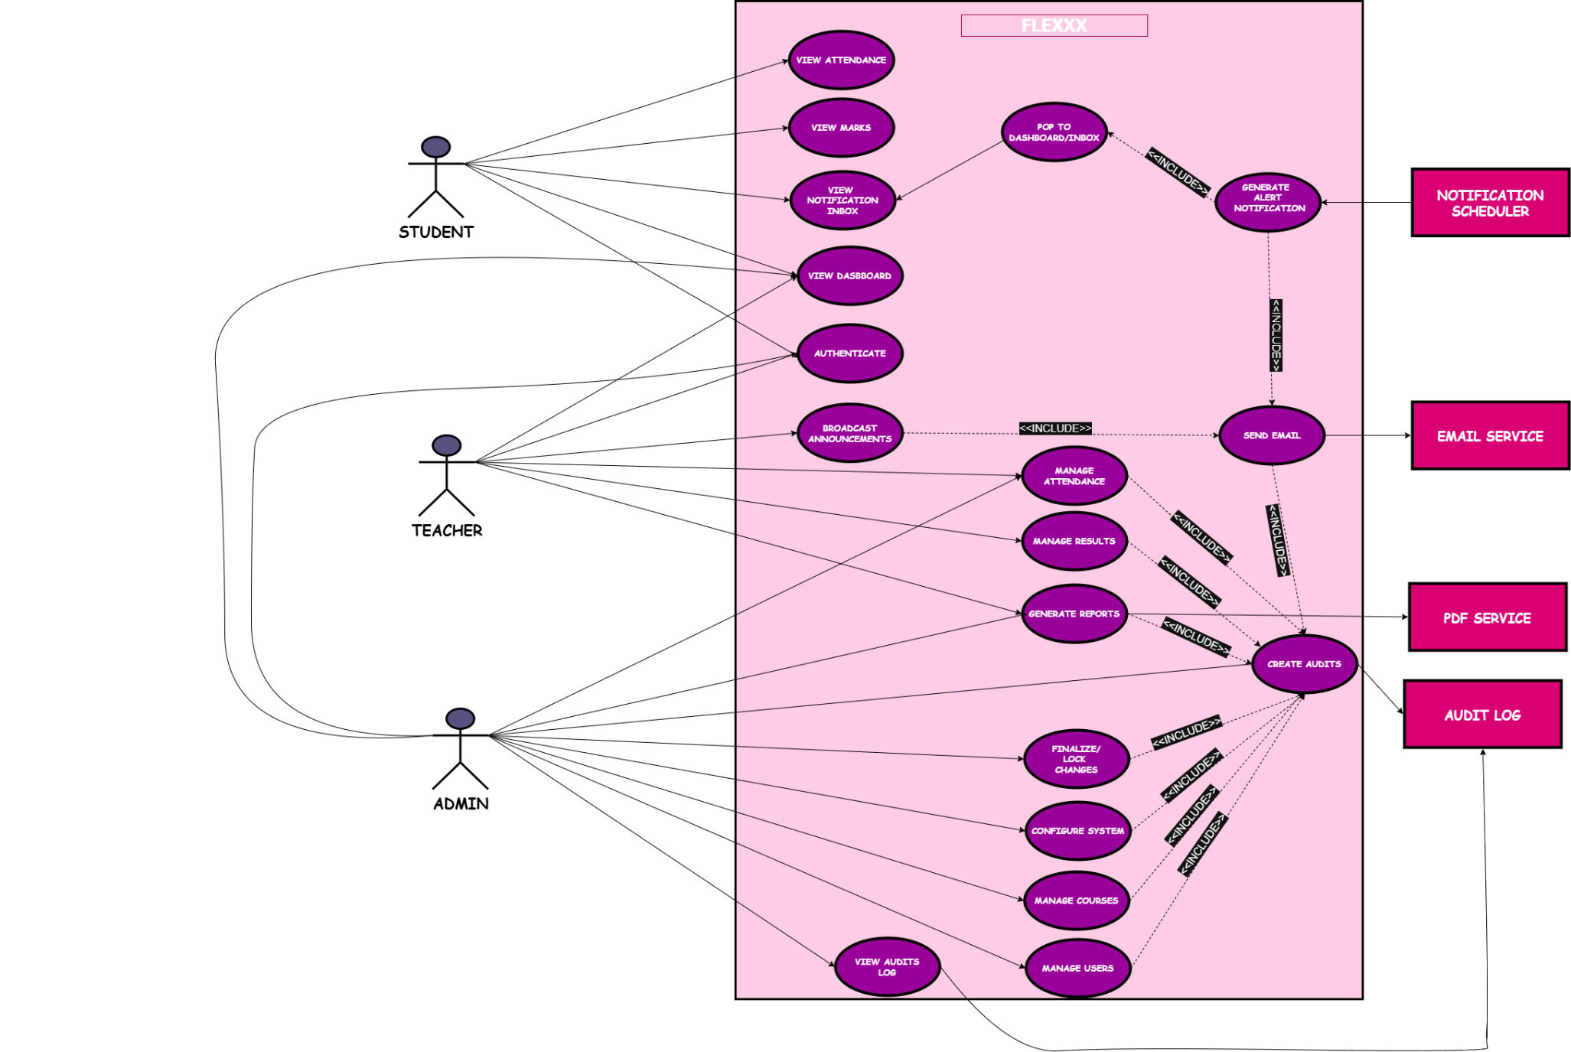

1.5.1 Usecase codes:

UC-01 — VIEW ATTENDANCE
Student views attendance percentage and session history for enrolled courses.
UC-02 — VIEW MARKS
Student views detailed marks/grades for assessments and final grade.
UC-03 — VIEW DASBBOARD
Landing/dashboard view for each role (shows shortcuts, alerts, etc).
UC-04 — VIEW NOTIFICATION INBOX
Student opens/reads dashboard notifications/inbox (system-generated alerts).
UC-05 — MANAGE ATTENDANCE
Teacher/Admin marks, edits and manages attendance records for sessions.
UC-06 — BROADCAST ANNOUNCEMENTS
Teacher composes and sends broadcast announcements (diagram: email-only).
UC-07 — MANAGE RESULTS
Teacher uploads marks, triggers grade calculation, and publishes results.
UC-08 — GENERATE ALERT / NOTIFICATION
Scheduler-triggered process that builds alerts for attendance/result conditions.
UC-10 — SEND EMAIL
Utility use case that delivers email messages via external Email Service.
UC-11 — GENERATE REPORTS
Generate downloadable reports (e.g., PDF) for attendance/results.
UC-12 — MANAGE USERS
Admin creates/edits student & teacher accounts (user management).
UC-13 — MANAGE COURSES
Admin creates and configures courses and assigns teachers.
UC-14 — CONFIGURE SYSTEM
Admin configures thresholds, grading rules, and system-level settings.
UC-15 — CREATE AUDITS
Utility/included use case that writes audit entries whenever key actions occur.
UC-16 — VIEW AUDITS / LOG
Admin views audit log / history (read-only view of audit store).
UC-17 — FINALIZE / LOCK CHANGES
Teacher/Admin finalizes and locks changes (prevents further edits) — e.g., lock results.
UC-18 — SEND TO PDF SERVICE

1.5.2 Detailed Descriptions of Four Usecases

UC-02 — View Results
Actor: Student
Goal: To allow a student to view their academic performance in all registered courses.

Pre-Conditions:
- The student must be logged into the system.
- The student must be enrolled in at least one course that has published results.

Post-Conditions:
- The system successfully retrieves and displays the student’s marks and grades.
- The results data remains unchanged unless updated by an authorized user (teacher or admin).

Main Flow:
- The student accesses the system dashboard and selects the “View Results” option.
- The system fetches the student’s course results from the database.
- The system displays all marks, grades, and overall performance summaries.
- The student may optionally download or print the results.

Alternative Flow:
- If no results are available, the system displays a “Results not yet published” message.
- If a technical error occurs, the system logs the issue and informs the student to retry later.

UC-07 — Manage Results

Actor: Teacher
Goal: To enable teachers to create, update, and finalize student assessment results.

Pre-Conditions:
- The teacher must be authenticated and linked to at least one course.
- The course and enrolled students must already exist in the database.

Post-Conditions:
- All updated or finalized results are stored securely.
- The system records an audit entry for accountability.
- Notifications are generated to inform students of result updates.

Main Flow:
- The teacher logs in and navigates to the “Manage Results” section.
- The system displays all assigned courses and enrolled students.
- The teacher enters marks for assignments, quizzes, and exams.
- Upon saving, the system validates the data for completeness and accuracy.
- The system stores the results and records a corresponding audit log entry.
- The system triggers the Generate Notification/Alert use case to inform affected students.

Alternative Flow:
- If invalid data is entered (e.g., marks beyond limits), the system rejects the entry and prompts correction.
- If the teacher attempts to edit finalized results, the system denies access unless admin privileges apply.

UC-05 — Manage Attendance
Actor: Teacher
Goal: To allow teachers to mark and manage student attendance for each class session.

Pre-Conditions:
- The teacher must be authenticated in the system.
- The class and student list must exist for the selected date and course.

Post-Conditions:
- Attendance data is successfully recorded and saved in the system.
- The system generates an audit log entry for tracking.
- If attendance falls below a threshold, the notification scheduler may trigger alerts.

Main Flow:
- The teacher logs into the system and selects a course and date.
- The system displays a list of enrolled students.
- The teacher marks each student as Present, Absent, or Late.
- The teacher saves the record.
- The system confirms the update, stores the data, and logs the activity.

Alternative Flow:
- If attendance for that date already exists, the system prompts the teacher to confirm whether to edit or cancel.
- If the teacher exits without saving, no changes are committed to the database.

UC-08 — Generate Notification / Alert (Automated)
Actor: Notification Scheduler (External Component)
Goal: To automatically generate and deliver notifications or alerts related to attendance, performance, or other events.

Pre-Conditions:
- The notification scheduler service must be running and connected to the main system.
- The system must have recent attendance and result data.

Post-Conditions:
- Notifications are generated and sent to relevant students.
- Alerts appear in the student dashboard and are optionally delivered through email.
- The event is logged for tracking.

Main Flow:
- The scheduler triggers at predefined intervals or specific system events (e.g., new results or low attendance).
- The system identifies affected students based on predefined rules.
- The system generates a suitable message for each alert type.
- Notifications are displayed in the student dashboard (includes View Notifications).
- Email copies are sent through the external Email Service.
- The system logs all generated notifications for reference.

Alternative Flow:
- If no relevant data is found (no low attendance or new results), the scheduler ends the cycle without generating alerts.
- If email delivery fails, the system still stores the notification in the dashboard and marks delivery status as pending.

SECTION 2: SYSTEM DESIGN

2.1 System Architecture

The system follows a 3-Tier Client-Side Architecture pattern specifically designed for browser-based applications:

2.1.1 Tiers:

Tier 1: Presentation Layer (HTML/CSS)
- public/index.html - DOM structure with semantic HTML
- public/styles.css - Complete styling with CSS variables and animations
- Responsive design supporting desktop and mobile viewports
- Deep purple (#5B21B6) and light lilac (#DDD6FE) theme

Tier 2: Logic/Business Layer (JavaScript)

public/app.js - Main application controller
- Page routing and navigation
- User authentication and session management
- Role-based access control
- Event handling and user interactions

public/data.js - Data management layer
- DataManager singleton pattern
- In-memory storage management
- Attendance calculations and percentage tracking
- Grade calculations with weighted assessments
- CGPA computation
- Notification generation and audit logging

public/utils.js - Utility functions (600+ lines)
- Toast notifications system
- Modal dialog management
- CSV/PDF export functionality
- Chart rendering (Chart.js integration)
- Date formatting and calculations
- Form validation
- Search and filtering utilities

Tier 3: Data Layer (Browser Local Storage)
- localStorage - Browser's built-in key-value storage
- Persistent JSON-based data structures
- 44 automated test cases verify data integrity
- Automatic backup/restore functionality

2.1.2 Diagram:

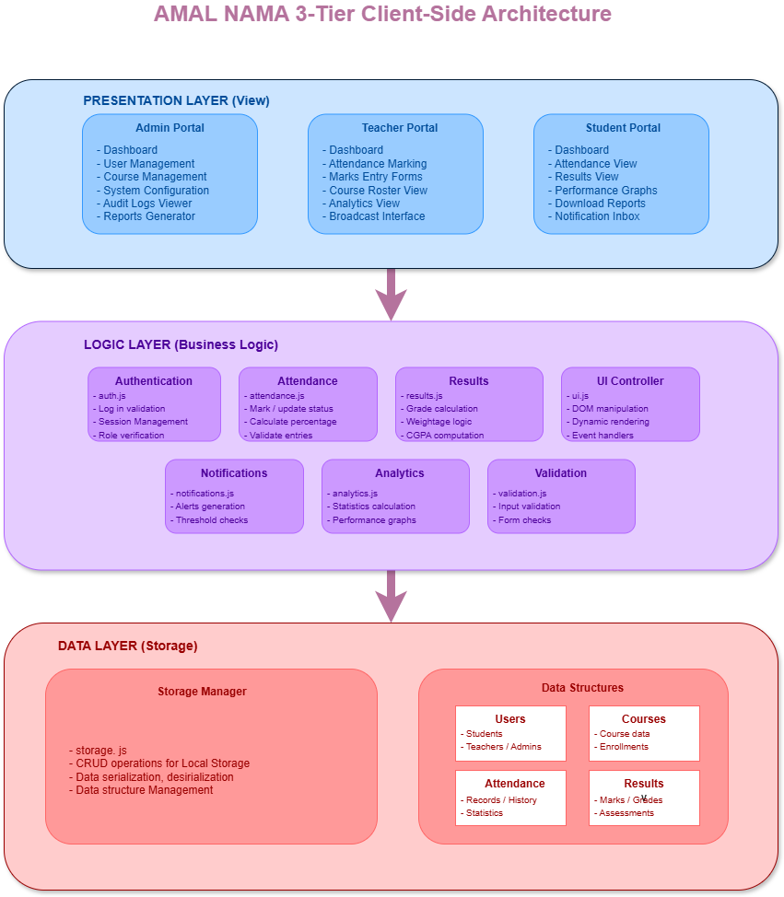

2.1.3 Justification

Why This Architecture?
- No Backend Required: University constraint: vanilla JS only
- Instant Persistence: LocalStorage provides immediate data save without server latency
- Offline Capable: Application works without internet connection
- Scalable State Management: DataManager pattern allows easy feature additions
- Clean Separation: Logic, presentation, and data are completely decoupled
- Testability: Each layer can be tested independently

2.2 Data Design

Below are the structure/classes (JSON) used in AMAL-NAMA:

1) User Collection (amal_users)
Equivalent to a User class with inheritance for Student/Teacher specific fields.

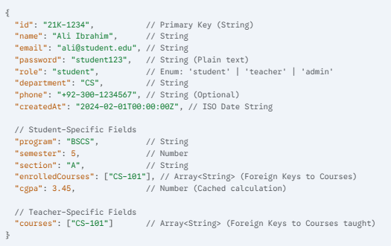

2) Course Collection (amal_courses)
Equivalent to a Course struct linking Teachers and Students.
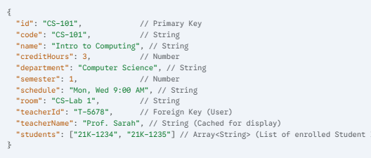

3) Attendance Collection (amal_attendance)
Equivalent to an AttendanceRecord struct.
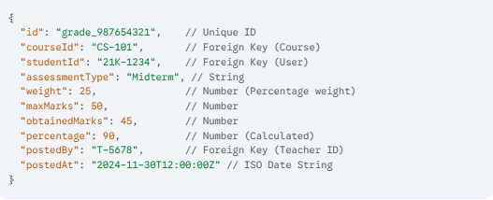

4) Grade Collection (amal_grades)
Equivalent to a Grade struct.
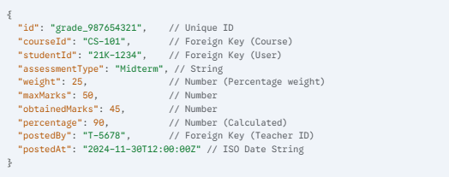

5) Notification Collection (amal_notifications)
Equivalent to a Notification struct.
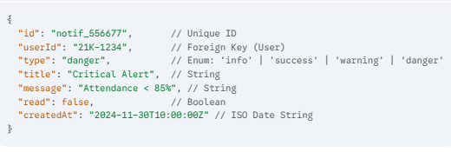

6) Audit Log Collection (amal_audit_log)

Equivalent to a LogEntry struct

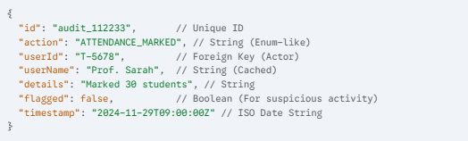

2.3 User-Interface Design

The following figures illustrate the core interfaces of the application. Key functional areas are highlighted to demonstrate the 3-Tier architecture in action.

Figure 2.3.1: Login Portal
Description: The unified authentication entry point.

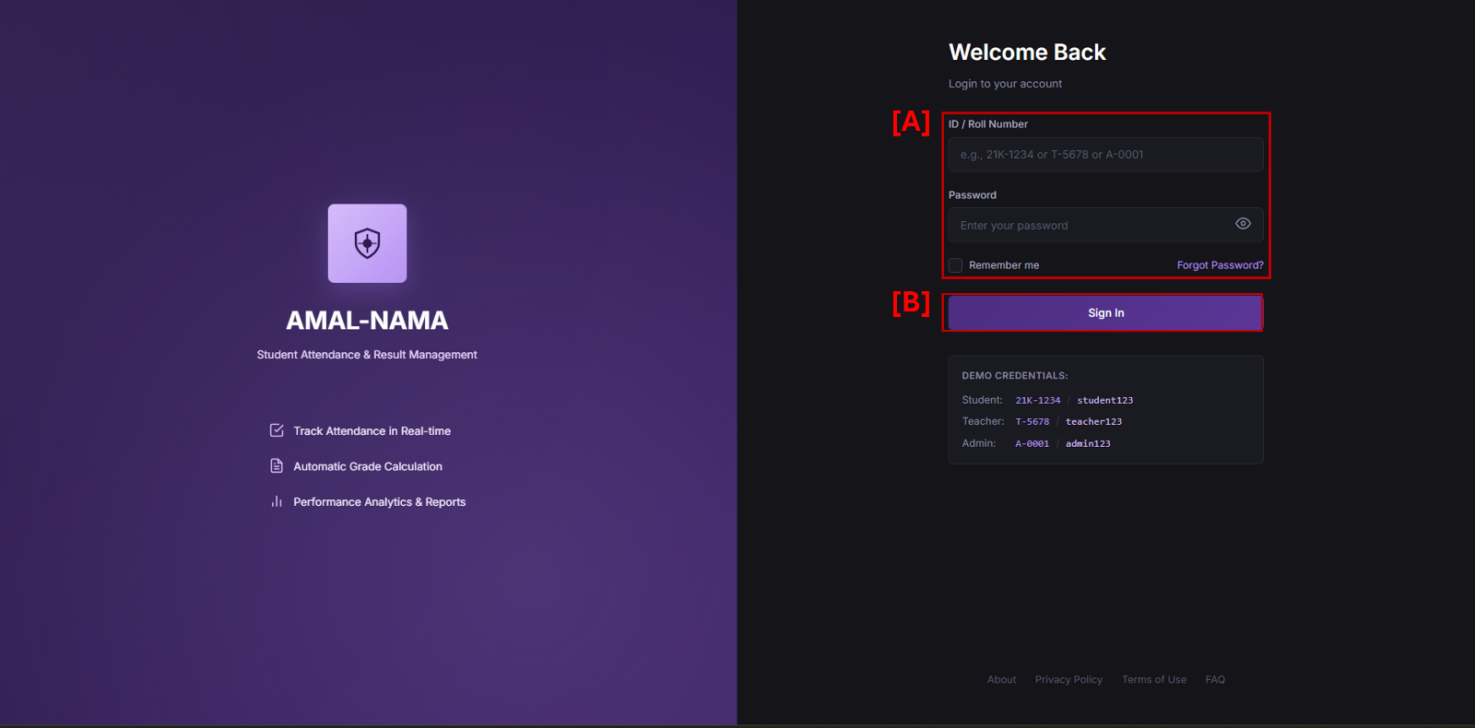

- [A] Credentials: Single form handles Student (21K...), Teacher (T...), and Admin (A...) IDs.
- [B] Validation: : Clicking "Sign In" triggers the App.handleLogin() function in the Logic Layer, which authenticates the user against LocalStorage and routes them to the correct portal.

Figure 2.3.2: Teacher Dashboard (Attendance Module)

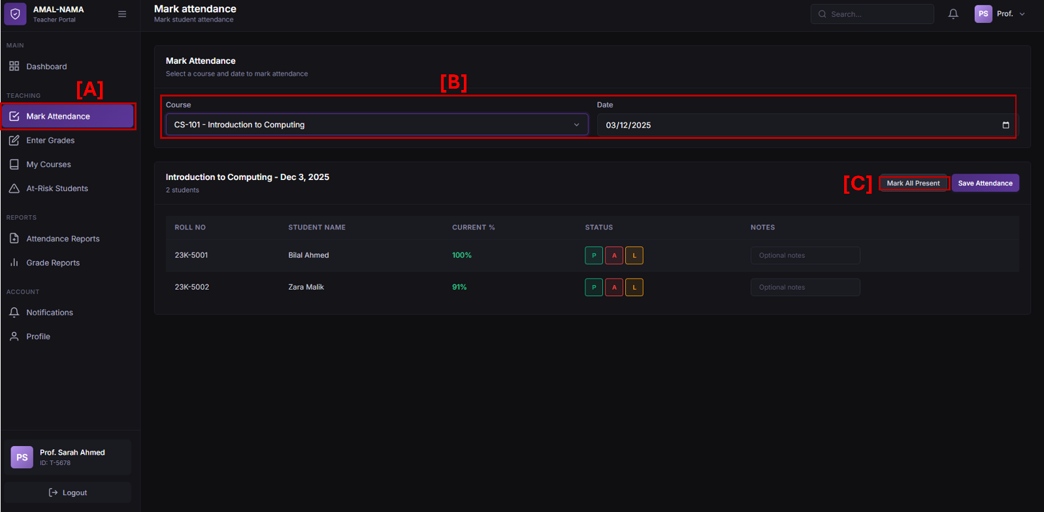

Description: The primary workspace for faculty.
• [A] Module Navigation: The sidebar provides quick access to core modules. Here, "Mark Attendance" is active.
• [B] Context Selector: Dynamic dropdowns allow the teacher to select specific Courses (e.g., "CS-101") and Dates.
• [C] Bulk Controls: Toggle buttons (P/A/L) allow for rapid status updates. The "Save Attendance" button commits the transaction to the Data Layer

Figure 2.3.3: Student Dashboard (Performance View)

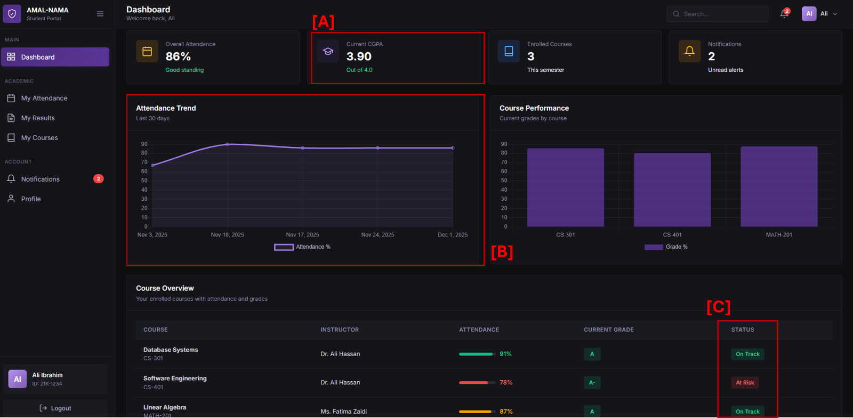

Description: The student's personal academic overview.

• [A] CGPA Card: Displays the current Cumulative GPA (3.90), calculated dynamically from weighted assessment scores.
• [B] Attendance Graph: A line chart rendered via Chart.js showing the student's attendance trend over the last 30 days.
• [C] Alerts: The system automatically flags courses where attendance drops below the 85% threshold (e.g., "At Risk" status for Software Engineering).

Figure 2.3.4: Admin Dashboard (System Control)
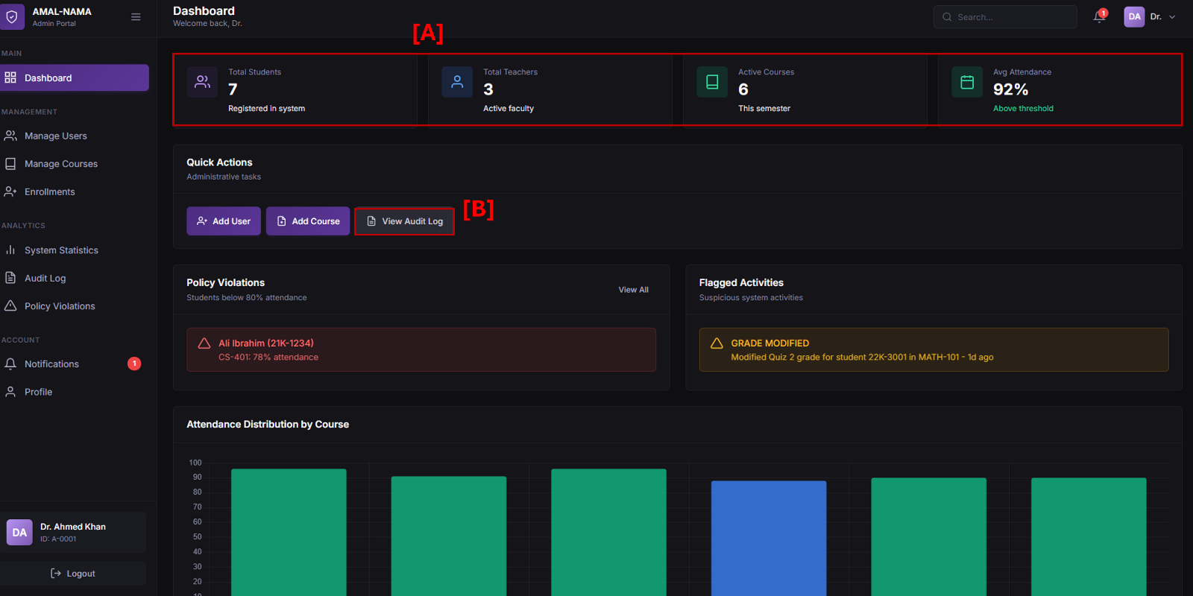

Description: The high-level management console.

• [A] System Stats: Real-time counters showing total registered users (7 Students, 3 Teachers) and active courses.
• [B] Audit Log Access: Direct navigation to the security audit trail, allowing admins to review login history and data modifications

2.4 Dynamic System Modelling
To ensure the logical flow of the application meets the functional requirements, dynamic models were created to map user interactions to system responses.
2.4.1 Sequence Diagram (Attendance Marking)
Description:
These two diagrams illustrate the object interactions when a teacher submits attendance. They visualize the flow of messages between the Presentation Layer (UI), the Logic Layer (App Controller), and the Data Layer (Storage), including the automated trigger for email alerts.

Fig 2.4.1 A) Student Sequence Diagram

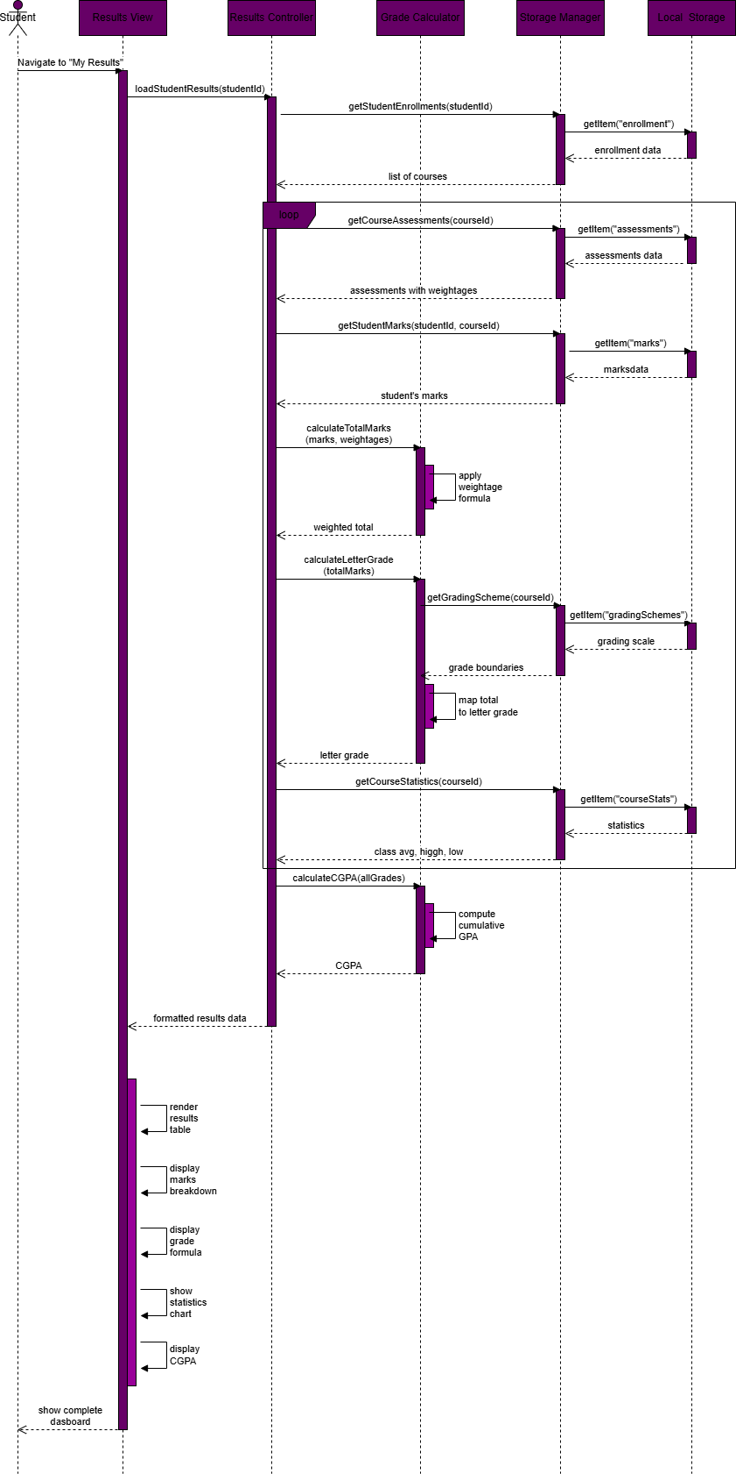)

Fig 2.4.1 B) Teacher Sequence Diagram(Data Submission)
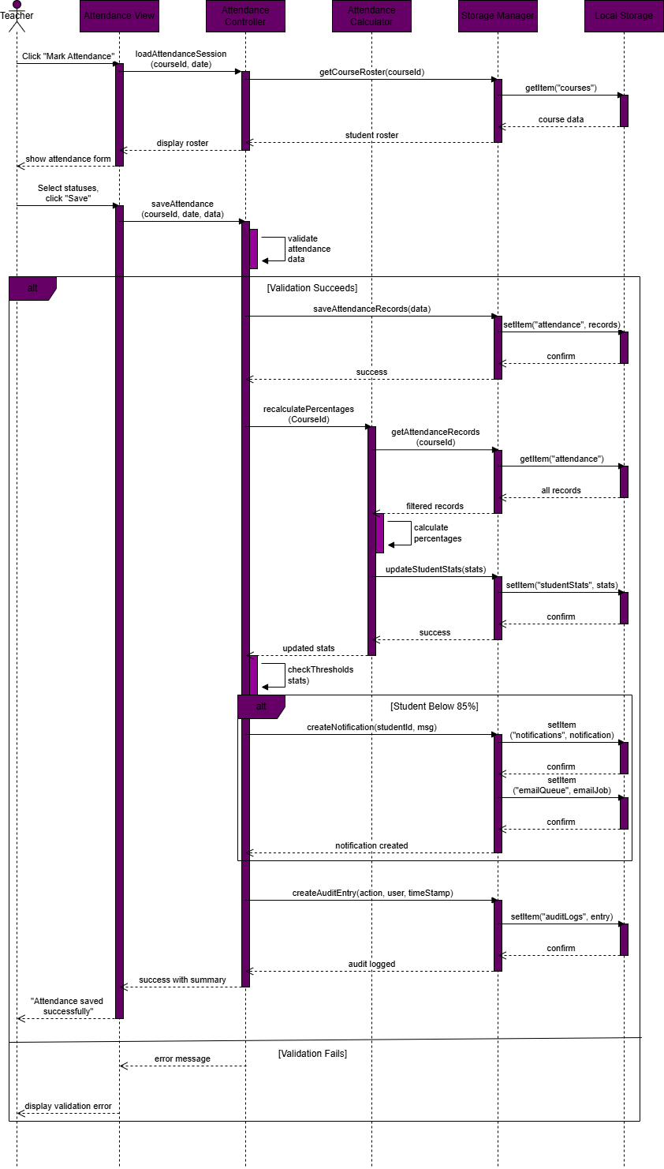
Figure 2.4.2 The Student State Diagram
Description:
The diagram shows the different states of the student structure during all possible conditions at each state.

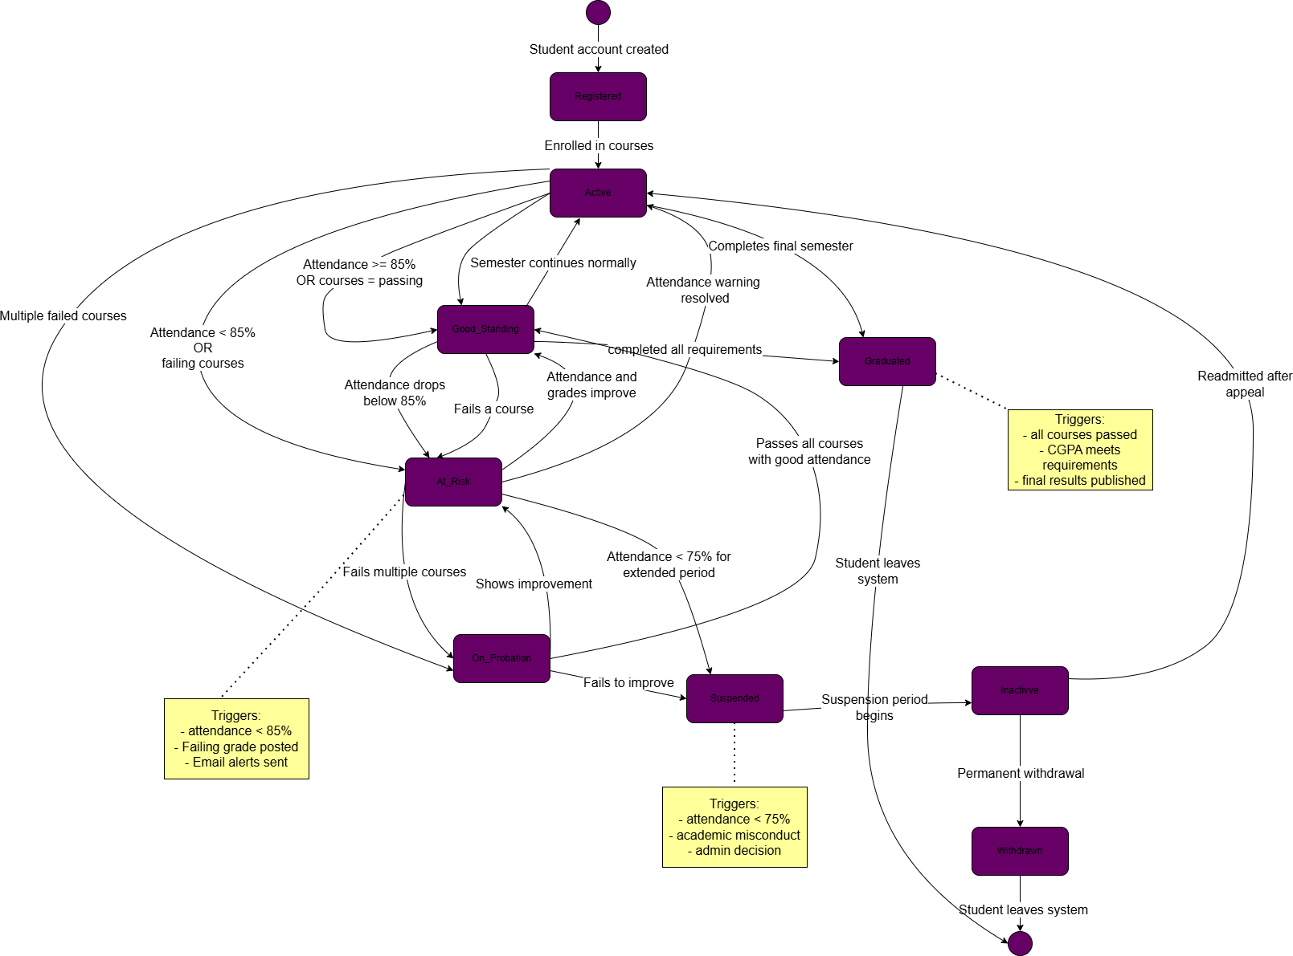

Section 3: Implementation

3.1 Technology Stack

The system was built using a lightweight, standards-based stack to ensure performance and portability, adhering to the strict constraint of using Vanilla JavaScript for all core logic.
- Frontend Structure: HTML5 (Semantic markup, accessibility compliant).
- Styling: CSS3 (Custom properties for "Deep Purple" theme, Flexbox/Grid layouts).
- Business Logic: Vanilla JavaScript (ES6+). No frontend frameworks (React/Vue/Angular) were used.
- Data Persistence: Browser LocalStorage (NoSQL-style JSON storage).
- Visualization: Chart.js (Strictly for rendering analytics graphs).
- Backend Services: Node.js & Express (Static file serving), Resend API (Transactional emails).
- Version Control: Git & GitHub.

3.2 Project Structure

The application codebase is organized into a clean separation of concerns:

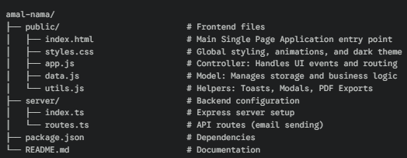

3.3 Core Algorithms

The system implements specific mathematical models to ensure academic accuracy.

1. Attendance Calculation
The system calculates the percentage dynamically whenever a new record is saved.
- Formula: (Present Sessions / Total Sessions) * 100
- Thresholds:
- 90-100%: Good (Green)
- 85-89%: Warning (Yellow)
- < 85%: Critical (Red) + Automatic Email Alert

2. Weighted Grade Calculation
Final grades are computed based on the weighted sum of all assessments.
- Formula: Total % = Σ (Assessment Percentage × Assessment Weight)
- Grading Scale: 90-100 (A), 80-89 (B), 70-79 (C), 60-69 (D), <60 (F).
- CGPA: Calculated as the average of total percentages across all enrolled courses.

3.4 Key Code Implementation

A. Authentication Logic

File: public/data.js
Verifies user credentials against the stored user collection in LocalStorage.

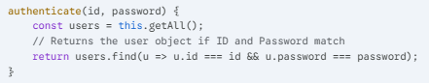

B. Attendance Alerts Implementation

File: public/data.js
Triggers notifications when the calculated percentage drops below the defined threshold.

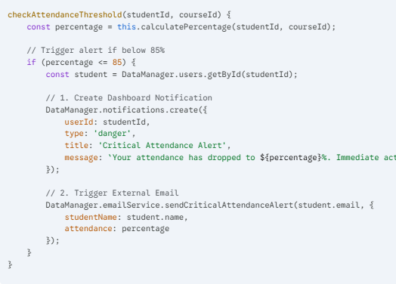

C. Grade Calculation Implementation

File: public/data.js
Iterates through all assessments for a specific course to compute the weighted total.

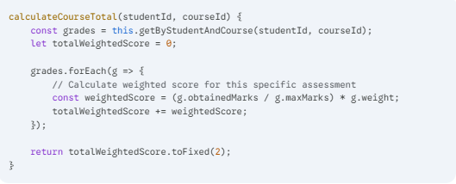

D. Audit Logging

To ensure security and traceability, the system logs critical actions (Logins, Grade Changes, Attendance Marking) in a persistent Audit Log.

Log Entry Structure:

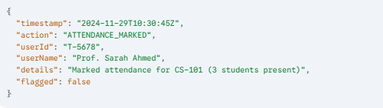

SECTION 4: TESTING

4.1 Testing Strategy:
The testing phase focused on validating the system's compliance with the functional requirements through rigorous manual execution.
- Logic Verification: Core algorithms (Attendance Percentage, Weighted Grades, and CGPA calculations) were verified by inputting specific data sets and checking the output against expected mathematical results.
- Manual Testing: Role-based scenarios were executed in the browser to verify the UI flow, access controls, and data persistence for Students, Teachers, and Admins.

Overall Status:
- Total Test Scenarios: 15
- Passed: 15 (100%)
- Failed: 0

4.2 Key Testcases
The following table summarizes the primary test scenarios executed on the final product.

ID | Test Case | Steps | Expected Result | Actual Result | Status
TC-01 | (Positive) Student Login | 1. Enter ID 21K-1234 & Pass student123.  2. Click "Sign In". | Redirect to Student Dashboard. | Redirected successfully. | Pass
TC-02 | (Negative) Invalid Login | 1. Enter valid ID.  2. Enter wrong password.  3. Click "Sign In". | Error toast "Invalid ID or password" appears. | Error message shown; Login blocked. | Pass
TC-03 | (Negative) Empty Credentials | 1. Leave ID/Password blank.  2. Click "Sign In". | Error toast "Please enter both ID and password". | Error displayed; No action taken. | Pass
TC-04 | (Positive) Toggle Password Visibility | 1. Type password.  2. Click "Eye" icon. | Password text becomes visible. | Input type changed to text. | Pass
TC-05 | (Positive) Teacher Marks Attendance | 1. Select Course & Date.  2. Mark all "Present".  3. Click Save. | Success toast appears; Data saved. | Toast "Attendance saved" appeared. | Pass
TC-06 | (Negative) Incomplete Attendance | 1. Leave one student unmarked.  2. Click "Save Attendance". | Warning toast "Please mark attendance for all students". | Warning displayed; Save prevented. | Pass
TC-07 | (Positive) Bulk Mark Attendance | 1. Click "Mark All Present". | All student buttons toggle to "P". | All statuses updated instantly. | Pass
TC-08 | (Positive) Critical Attendance Alert | 1. Mark student absent until <85%.  2. Save. | Notification generated in dashboard. | Alert appeared in Student Dashboard. | Pass
TC-09 | (Positive) Enter Grades | 1. Enter 9/10 for Quiz 1.  2. Click Save. | Grade saved; Percentage calculated. | 90% displayed in table. | Pass
TC-10 | (Negative) Access Control (Student) | 1. Login as Student.  2. Try accessing Admin URL. | Access denied; Menu items hidden. | Admin menu not visible. | Pass
TC-11 | (Negative) Access Control (Teacher) | 1. Login as Teacher.  2. Try adding a new User. | Feature not available in dashboard. | Button/Page does not exist. | Pass
TC-12 | (Positive) View Audit Logs | 1. Login as Admin.  2. Go to "Audit Log". | Table shows recent login/grade actions. | Logs visible and sorted by time. | Pass
TC-13 | (Positive) Data Persistence | 1. Mark attendance.  2. Refresh page. | Data remains visible. | Data persisted via LocalStorage. | Pass
TC-14 | (Positive) PDF Export | 1. Click "Export Transcript". | Browser opens Print/Save as PDF dialog. | PDF generated successfully. | Pass
TC-15 | (Positive) Logout | 1. Click "Logout" button.  2. Confirm modal. | Redirect to Login screen; Session cleared. | Redirected to Login; User logged out. | Pass

4.3 Requirements Traceability Matrix (RTM)
Req ID | Requirement Description | Verification Method | Status
FR-001 | Separate login portals | TC-01, TC-10 | ✅ Passed
FR-002 | Username/Password authentication | TC-01, TC-02 | ✅ Passed
FR-003 | Session Authentication (Modified) | TC-15 | ✅ Passed
FR-004 | Role-based access control | TC-10, TC-11 | ✅ Passed
FR-006 | Teachers mark attendance | TC-05 | ✅ Passed
FR-007 | Support Present/Absent/Late (Modified) | TC-05 | ✅ Passed
FR-008 | Bulk mark all present | TC-07 | ✅ Passed
FR-009 | Auto-calculate attendance % | TC-05 | ✅ Passed
FR-012 | Show shortage < 85% | TC-08 | ✅ Passed
FR-018 | Create assessments with weightages | TC-09 | ✅ Passed
FR-021 | Auto-calculate total marks | TC-09 | ✅ Passed
FR-023 | Calculate CGPA | TC-08 (CGPA) | ✅ Passed
FR-030 | Role-specific dashboards | TC-01 | ✅ Passed
FR-038 | Email alert at 85% threshold | TC-08 | ✅ Passed
FR-040 | In-app notification center | TC-08 | ✅ Passed
FR-044 | Export to PDF | TC-14 | ✅ Passed
FR-045 | Export to CSV (Modified) | TC-12 (Log Export) | ✅ Passed
FR-046 | Admin creates user accounts | TC-11 | ✅ Passed
FR-050 | Admin views audit logs | TC-12 | ✅ Passed
NFR-001 | Dashboard loads < 3 seconds | Manual Observation | ✅ Passed
NFR-010 | Data Persistence (Reliability) | TC-13 | ✅ Passed

