

**Software Requirements Specifications**

**Mina Electric E-commerce Website**

GROUP MEMBERS:

AZKA SAHAR SHAIKH    22K-4493

SUMAIYA WAHEED          22K-4201

MUHAMMAD SUDAIS      22K-4364

**Table of Contents**

**1** **Introduction 4**

*1.1* *Purpose of Document 4*

*1.2* *Scope 4*

*1.3* *Abbreviations 4*

*1.4* *Intended Audience and Reading Suggestions 4*

*1.5* *Project Plan 5*

*1.6**Technical Feasibility 6*

*1.7* *Incremental Model 8*

*1.8* *Homogenization Process 9*

*1.9* *References 10*

**2** **Overall Descriptions 10**

*2.1* *Product Perspective 10*

*2.2* *Product Features 10*

*2.3**User Classes and Characteristics 11*

*2.4**Operating Environment 11*

*2.5**Assumptions and Dependencies 12*

*2.6**Risks and Volatile Areas 12*

**3** **Specific Requirements 13**

*3.1* *Functional Requirements 13*

*3.2* *Non Functional Requirements 13*

*3.3 Data base Requirements 13*

**4** **System Models 14**

*4.1* *Use Case Diagram 14*

*4.2* *Class Diagram 14*

*4.3 Activity Diagram 16*

*4.4**Sequence Diagram*  *21*

*4.5**Collaboration Diagram*  *26*

*4.6**Component Diagram*  *28*

*4.7 State Chart Diagram 29*

*4.8 Deployment Diagram 30*

**5** **Appendicies 31**

*A.**Prototype 31*

# Introduction

***1.1. Purpose of Document***

The purpose of this document is to define the software requirements for the e-commerce web application for Mina Electric. This application aims to digitalize the wholesale business by providing an online platform for product browsing, ordering, and customer management while ensuring efficiency, scalability, and user-friendliness.

***1.2. Scope***

The project involves developing a database-driven e-commerce web application for Mina Electric, a wholesale business specializing in lighting products. The application will allow customers and small retailers to browse products, place orders, and manage their profiles. An admin panel will enable the business to manage products, orders, and customers efficiently. The system uses React.js for the frontend, Node.js with Express.js for the backend, and MySQL as the database, hosted on Supabase.

***1.3 Abbreviations***

*This section provides a list of abbreviations and acronyms used throughout the document to facilitate clarity and understanding:*

* *CRUD : Create, Read, Update , Delete*
* *ERD : Entity-Relationship Diagram*
* *SQL : Structured Query Language*
* *JWT : JSON Web Token*

***1.4 Indented Audience and Reading Suggestions***

This SRS document is intended for the following audience:

1. **Developers**:  
   To understand the functional and non-functional requirements of the system, database design, and technical specifications.
   * Suggested Sections: 2. Overall Description, 3. Specific Requirements, 4. System Models.
2. **Project Managers**:  
   To track project scope, features, and dependencies to ensure timely delivery and alignment with business goals.
   * Suggested Sections: 1. Introduction, 2. Overall Description, 3. Specific Requirements.
3. **Testers**:  
   To design test cases based on functional requirements and ensure system reliability and performance.
   * Suggested Sections: 3. Specific Requirements, 4. System Models.
4. **Marketing Staff**:  
   To understand the scope and features of the system for communication with clients and stakeholders.
   * Suggested Sections: 1. Introduction, 2. Overall Description.
5. **Users**:  
   To gain a high-level understanding of the application and its capabilities.
   * Suggested Sections: 1. Introduction, 2. Overall Description.
6. **Documentation Writers**:  
   To create user manuals, installation guides, and training materials.
   * Suggested Sections: 1. Introduction, 3. Specific Requirements.

***1.5 Project Plan***

|  |  |  |  |  |
| --- | --- | --- | --- | --- |
| **Phase** | **Task/Subtask** | **Assigned To** | **Timeline(Semester weeks)** | **Milestone** |
| Phase 1: Planning & Design | Gather Requirements | Sudais k224364 | Week 4 | Requirements Finalized |
|  | Define Technical Specifications | Sumaiya k224201 | Week 4 | Technical Specs Completed |
| Phase 2: Database Design | Create Database Schema | Azka k224493 | Week 5 - Week 6 | Database Setup Completed |
|  | Implement Relationships & Foreign Keys | Azka k224493 | Week 5 - Week 6 | Schema & Relationships OK |
| Phase 3: Development | Build User Authentication | Sudais k224364 | Week 7 - Week 8 | Auth System Developed |
|  | Develop Product Catalog Page | Sudais k224364 | Week 7 - Week 8 | Catalog Page Live |
|  | Implement Cart & Checkout | Sudais k224364 | Week 9 - Week 10 | Cart & Checkout Ready |
|  | Develop Admin Management Pages | Azka k224493 | Week 9 - Week 10 | Admin Pages Developed |
| Phase 4: Testing | Perform Unit Testing | Sumaiya k224201 | Week 11 | Unit Testing Complete |
|  | Integration Testing | Sumaiya k224201 | Week 12 | Integration Complete |

***1.6 Technical Feasibility***

**Technology Stack**

The proposed technology stack is modern, scalable, and aligns with the project requirements:

* **Frontend:** React.js for building a responsive and interactive user interface.
* **Backend:** Node.js (Express.js) with RESTful APIs for efficient and scalable server-side processing.
* **Database:** MySQL to securely store customer data, orders, and product information.

**Resource Requirements**

#### 1. Hardware Resources

### Development Systems: Each team member will require a laptop or desktop with the following specifications:

### Processor: Intel Core i5 or equivalent (quad-core).

### RAM: 8 GB (16 GB recommended for better performance).

### Storage: 256 GB SSD or higher.

### Operating System: Windows 10/11, Linux (Ubuntu 20.04+), or macOS.

### Network:

### A stable internet connection for collaborative development and dependency management.

#### 2. Software Resources

### Programming Frameworks and Languages:

### Frontend: ReactJS for UI development.

### Backend: Node.js and Express.js for server-side scripting and API handling.

### Database: MySQL for data storage and management.

### Development Tools:

### Integrated Development Environment (IDE): Visual Studio Code or IntelliJ IDEA.

### Database Design and Management: MySQL Workbench or Oracle SQL Developer.

### API Testing: Postman.

### Documentation Tools:

### Microsoft Word for creating the SRS document.

### Lucidchart and Papyrus for system and process diagrams.

#### 3. Human Resources

### Team Roles:

### Frontend Developer: Responsible for UI/UX design and integrating frontend with backend services.

### Backend Developer: Manages server logic, API development, and integration with the database.

### Database Designer: Focuses on designing and managing the database schema.

### Mentor/Guide: A faculty advisor or industry professional to oversee progress and provide guidance.

### Tester: (Shared responsibility among team members) Writing and executing test cases to ensure quality assurance.

#### 4. Time and Financial Resources

### Development Timeframe: 10 weeks.

### Weeks 1–2: Planning and environment setup.

### Weeks 3–8: Incremental development of functionalities.

### Weeks 9–10: Testing, final integration, and presentation preparation.

### Costs:

### Most tools and frameworks used are open-source and free.

#### **Scalability**

* The system will be designed to handle up to 50,000 concurrent users, with scalable components like caching mechanisms (Redis) and load balancers.
* Future enhancements could include expanding to domains such as:
  + **Electronics:** Mobile phones, laptops, and accessories.
  + **Fashion:** Apparel, shoes, and accessories.
  + **Home Decor:** Furniture, lighting, and decorative items.

### **1.7 Incremental Model**

### Phases and Increments

#### Increment 1: User Authentication & Product Browsing

* Goal: Set up the foundation of the E- Commerce platform.
* Features:
  + User registration and login functionality (email, password, validation).
  + Product listing page with search and filtering options.
* Database Integration:
  + Create tables for users and products with essential fields.
  + Use MySQL to store and retrieve user credentials and product data.
* Testing: Validate user authentication against the database and ensure proper display of product data.

#### Increment 2: Shopping Cart & Checkout

* Goal: Enable users to add products to their cart and proceed to checkout.
* Features:
  + Shopping cart functionality (add, remove, update quantities).
  + Checkout process with address entry and payment summary.
* Database Integration:
  + Add tables for cart and orders.
  + Implement relationships between users, products, and cart tables (e.g., foreign keys for user_id and product_id).
  + Store order details with status tracking in the database.
* Testing: Test cart functionality for multiple scenarios and validate database updates for cart and order data.

#### Increment 3: Admin Panel

* Goal: Provide admin users with the ability to manage the system.
* Features:
  + Product management (add, update, delete products).
  + Category management.
  + View and process customer orders.
* Database Integration:
  + Expand the products table to include categories and inventory.
  + Create a categories table for classification.
  + Add admin roles and permissions in the users table.
* Testing: Verify database CRUD operations for products, categories, and orders.

#### Increment 4: Wishlist & User Reviews

* Goal: Enhance user experience with personalized features.
* Features:
  + Wishlist functionality (allow users to save products for later).
  + User reviews and ratings for products.
  + Notifications for wishlist updates or price changes.
* Database Integration:
  + Add wishlist and reviews tables.
  + Implement many-to-many relationships between users and products for wishlist and reviews.
  + Store and retrieve review ratings and comments.
* Testing: Check database consistency for wishlist items and reviews.

#### Increment 5: Analytics & Advanced Features

* Goal: Add advanced functionalities and optimize the platform.
* Features:
  + Analytics dashboard for admin (sales reports, user activity).
  + Personalized product recommendations.
  + Optimize website performance (loading speed, responsive design).
* Database Integration:
  + Add a table for logging user activity and generating analytics.
  + Implement data aggregation queries for sales and user engagement reports.
  + Ensure database indexing for faster query execution.
* Testing: Validate analytics generation and database performance under load.

***1.8 Homogenization Process***

To ensure consistency and maintain quality across all increments, the following homogenization practices are followed:

1. User Interface:
   * Use a unified design language and consistent layout for all pages.
   * Ensure UI/UX principles are maintained for an intuitive user experience.
2. Data Flow:
   * Standardize APIs for frontend-backend communication.
   * Validate and sanitize data at all stages of processing.
3. Database Management:
   * Apply normalization techniques to minimize redundancy.
   * Use consistent naming conventions for tables and columns (e.g., user_id, product_id).
4. Coding Standards:
   * Follow industry-standard coding practices and conventions.
   * Implement modular code for maintainability and scalability.
5. Testing and Quality Assurance:
   * Perform rigorous testing for each increment, including unit and integration tests.
   * Automate repetitive testing tasks for efficiency.
6. Version Control:
   * Conduct code reviews before merging changes into the main branch.

***1.9 References***

* IEEE SRS Template
* Documentation for React.js, Node.js, and MySQL
* Mina Electric business workflow documentation

# Overall Description

*This section outlines crucial factors to consider when designing the pharmacy management system, ensuring a robust and adaptable solution for the Pharmacy Management System.*

## **2.1 Product Perspective**

The e-commerce platform for Mina Electric is a digital transformation of its traditional, physical business operations. As a wholesaling business with a strong presence in Karachi's Electric Market since 1985, the platform aims to leverage technology to enhance accessibility and convenience for customers and retailers. By shifting to an online model, Mina Electric can expand its customer base, streamline order management, and provide a seamless shopping experience. The platform integrates various modern tools and technologies to support scalability, security, and user-friendliness. It serves as a bridge to connect the business with customers who prefer online shopping and those unable to visit the physical store.

## **2.2 Product Features**

The e-commerce platform is designed with a range of features to meet the needs of customers, retailers, and admins:

1. **Product Management**:
   * Allows admins to manage product listings with CRUD (Create, Read, Update, Delete) operations.
   * Includes attributes like product title, description, price, stock status, and images to provide comprehensive product details.
   * Ensures products are updated regularly for accurate inventory tracking and customer satisfaction.
2. **Category Management**:
   * Enables organization of products into categories for easier navigation and improved user experience.
   * Admins can create, edit, and delete categories to reflect the inventory structure effectively.
3. **User Management**:
   * Provides registration and login functionality for customers and retailers.
   * Users can create and update their profiles, manage account details, and view order history.
   * Retailers are offered a tailored registration process to accommodate their business needs.
4. **Order Management**:
   * Allows customers to add products to their carts, proceed to checkout, and place orders.
   * Includes order tracking functionality to provide real-time updates on the order status.
5. **Search**:
   * Facilitates efficient product discovery through a robust search feature.
6. **Wish-list**:
   * Enables customers to save favorite products for future reference or purchase.
   * Encourages customer retention by allowing them to revisit and purchase saved items later.
7. **Admin Panel**:
   * A centralized dashboard for admins to oversee platform operations.
   * Includes tools for managing products, categories, orders, customers, and reviews.
   * Provides reporting and analytics for business insights and decision-making.

.

## **2.3 User Classes and Characteristics**

The e-commerce platform has two primary user classes, each with specific roles and characteristics:

1. Admin:
   * Role: Manages the platform, including products, categories, orders, and reviews.
   * Responsibilities: Perform CRUD operations on products, update inventory, manage customer orders, and moderate reviews.
   * Characteristics: Has full access to the admin panel and is responsible for platform operations.
2. Customer:
   * Role: Browses products, adds to cart, places orders, and leaves reviews.
   * Responsibilities: Create accounts, browse products, checkout, and manage orders and reviews.
   * Characteristics: Seeks an intuitive shopping experience with secure login and payment options.

## **2.4 Operating Environment**

* Frontend:
  + Technology: React.js
  + Purpose: Provides a responsive and user-friendly interface for customers and admins to interact with the platform.
* Backend:
  + Technology: Node.js with Express.js
  + Purpose: Handles the server-side logic, API requests, and data processing, ensuring smooth communication between the frontend and database.
* Database:
  + Technology: MySQL hosted on Supabase
  + Purpose: Stores and manages product, order, user, and other essential data, ensuring efficient querying and data retrieval.

## **2.5 Assumptions and Dependencies**

Users will have internet access and a modern web browser, and the application will use JWT for secure authentication.

## **2.6 Risks and Volatile Areas**

To ensure the successful development and deployment of the Mina Electric e-commerce system, potential risks and volatile areas have been identified:

1. System Downtime and Performance Issues:
   * Unexpected system outages or slow load times could impact user experience and order fulfillment.
   * Mitigation: Employ failover mechanisms, load balancers, and multiple backups.
2. Integration Challenges:
   * Difficulty in integrating the system with shipping services, or inventory management tools.
   * Mitigation: Test APIs thoroughly, document dependencies, and maintain collaboration with third-party service providers.
3. Scalability and Growth:
   * Risk of the system failing to accommodate increasing user traffic, product listings, and order volume as the business grows.
   * Mitigation: Use scalable database and server architectures, and perform load testing regularly.
4. User Adoption and Training:
   * Customers or admin users may struggle with unfamiliar features or interfaces, leading to a poor user experience.
   * Mitigation: Provide intuitive interfaces, offer user guides, and support onboarding sessions.
5. Technological Risks:
   * Rapid advancements in web technologies or vulnerabilities in existing frameworks could necessitate frequent updates.
   * Mitigation: Stay updated on technology trends, perform routine system updates, and have contingency plans for framework migrations.
6. Changing Market Trends:
   * New customer preferences or competitive trends could require modifications in features, product categories, or pricing strategies.
   * Mitigation: Conduct regular market research and maintain a flexible system design to accommodate changes.
7. Disaster Recovery and Business Continuity:

* Risks such as server crashes, data loss, or natural disasters could disrupt operations.
* Mitigation: Set up regular data backups, cloud storage, and disaster recovery protocols.

# Specific Requirements

This section outlines the specific requirements of the e-commerce platform for Mina Electric, detailing the key functional and non-functional requirements, database specifications, and performance expectations.

## **3.1 Functional Requirements**

The e-commerce system will provide robust product management features, enabling admins to perform CRUD (Create, Read, Update, Delete) operations on products and categories. Each product will have attributes such as title, description, price, image, category, and stock levels, while categories will help organize products efficiently. Secure user authentication is essential, with a registration and login system that encrypts passwords before storage and enforces role-based access control to distinguish between admin and customer functionalities.

Customers will have the ability to add products to their cart, adjust quantities, and remove items as needed. During checkout, users will provide shipping details, select payment options, and review their orders before confirmation, receiving a unique order ID and summary. A robust search functionality will allow users to locate products quickly by searching based on attributes. Furthermore, the platform will support review management, enabling customers to submit product reviews and ratings. Admins can moderate reviews to maintain a professional environment.

## **3.2 Non-Functional Requirements**

Performance is critical for a seamless user experience. The system is designed to load pages in under 2 seconds under normal conditions and handle at least 100 simultaneous requests with minimal delays.

Scalability is also a priority. The system will accommodate a growing user base and expanding product catalog by leveraging database indexing and caching mechanisms to maintain performance. Additionally, usability will be emphasized through an intuitive interface that provides clear feedback for user actions, such as successful logins, order confirmations, and validation errors, ensuring the system is accessible even to non-technical users

## **3.3 Data Base Requirements**

The database design will follow normalization principles up to BCNF to minimize redundancy and ensure data integrity. Key entities include Customers, Products, Categories, Orders, Order Items, Reviews, and Admins, with well-defined relationships to support the system’s operations. Advanced SQL queries will facilitate complex data retrieval, such as joining multiple tables and performing aggregate operations. Transactions will ensure atomicity and consistency during critical processes like order placement, where updates to stock and order tables must be synchronized.

# System Models

## **4.1Use Case Diagram**

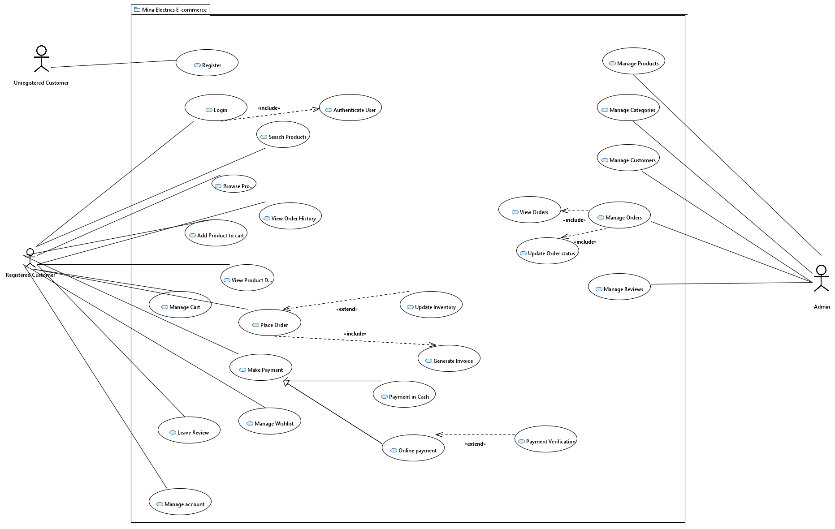

#### **4.2 Class Diagram**

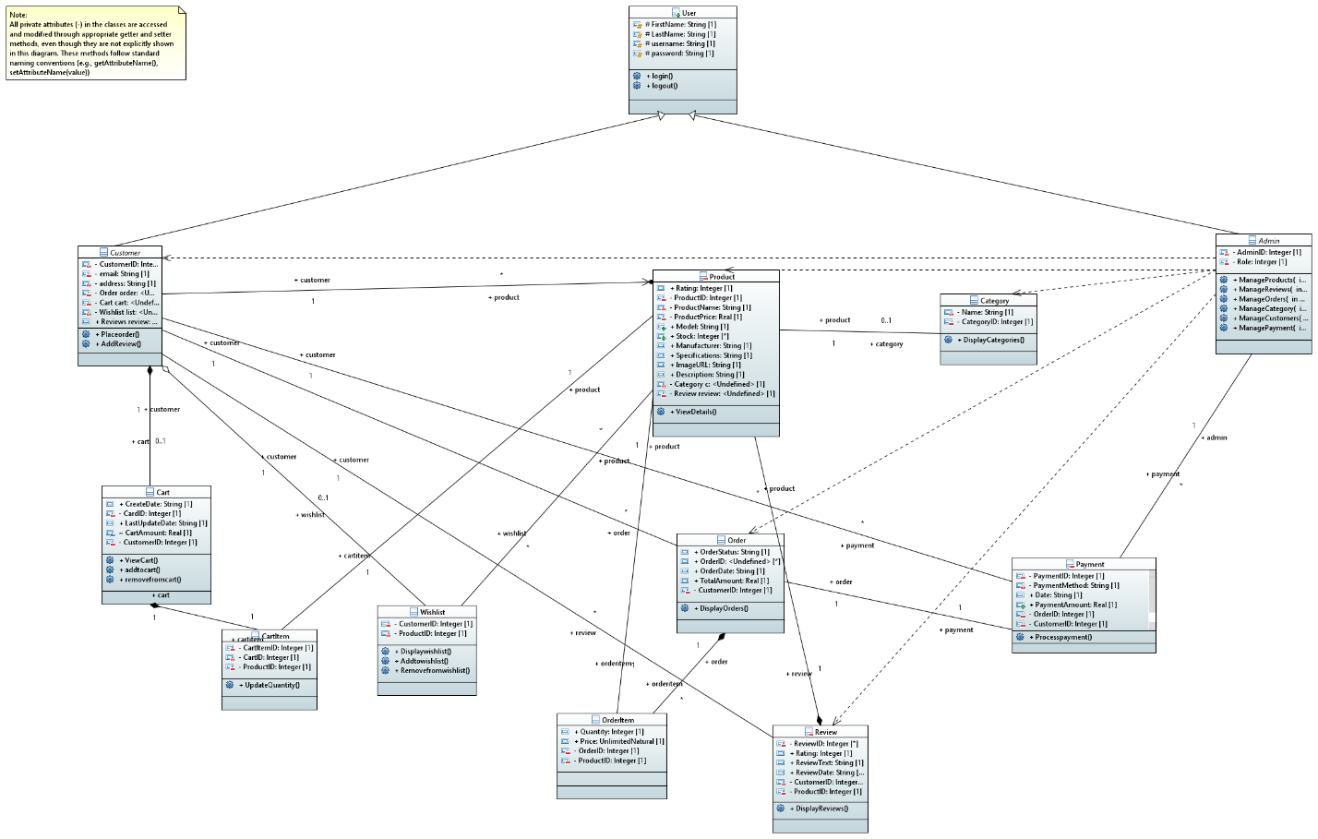

#### **4.3 Activity diagram**

* Admin controls

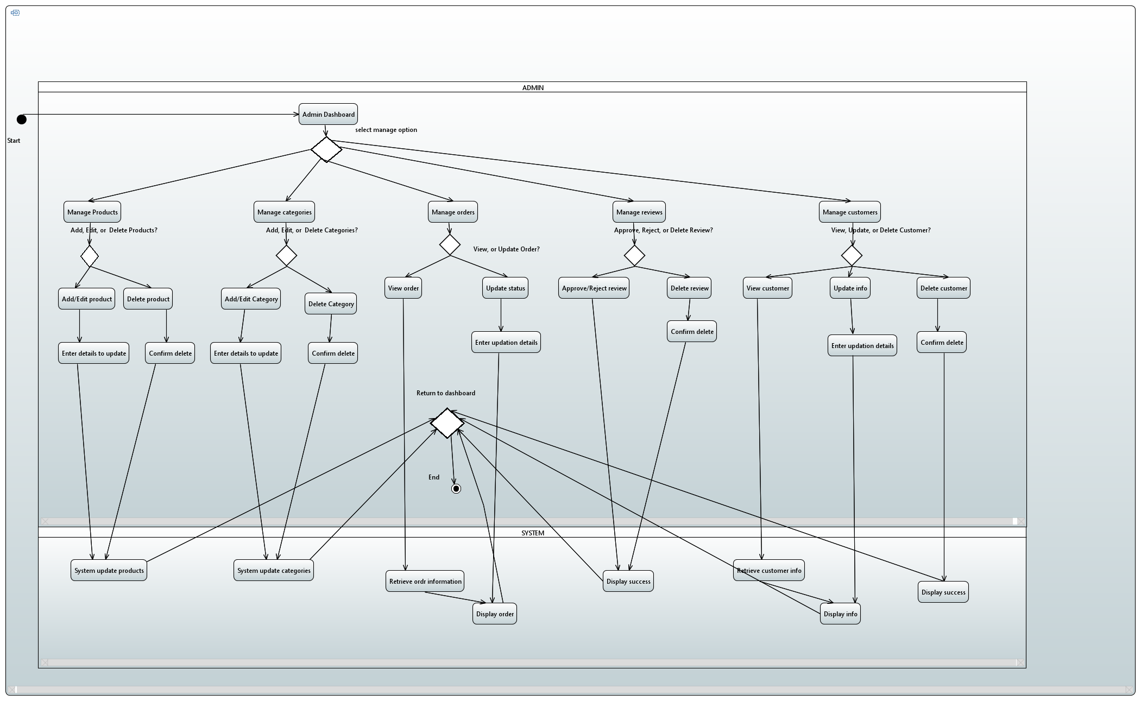

* User login feature

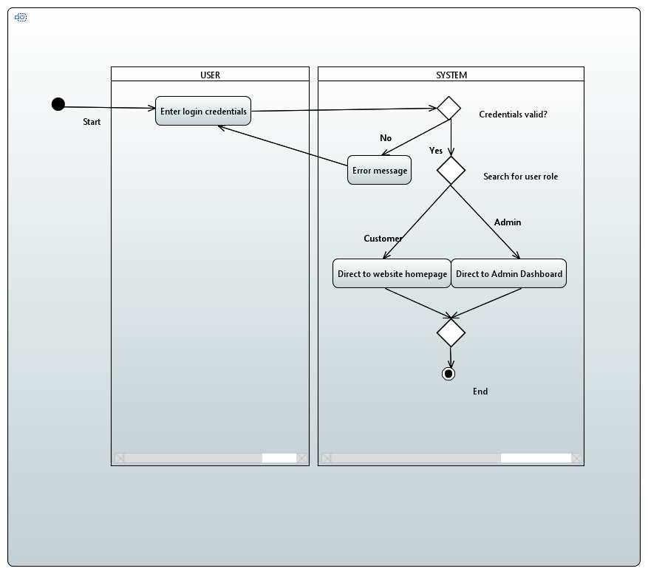

* 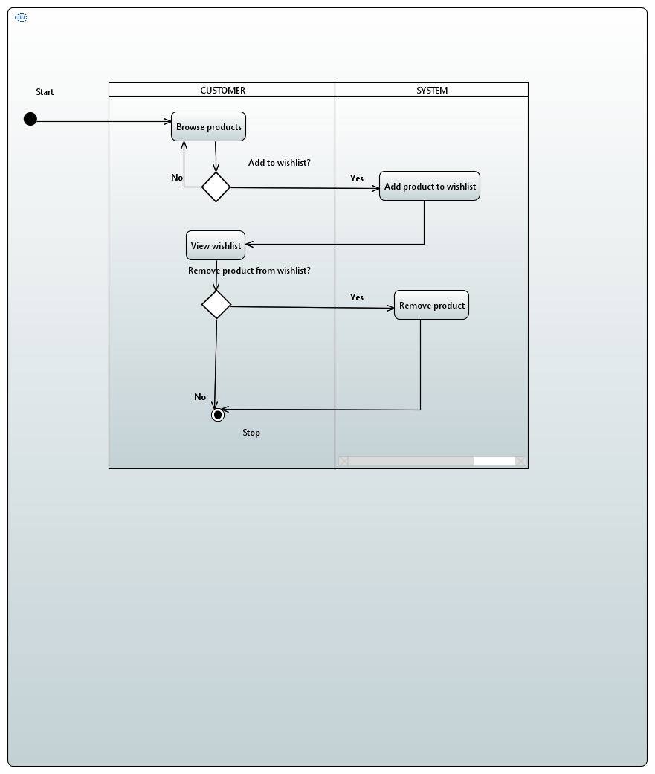Customer Add to Wish list
* Customer place order

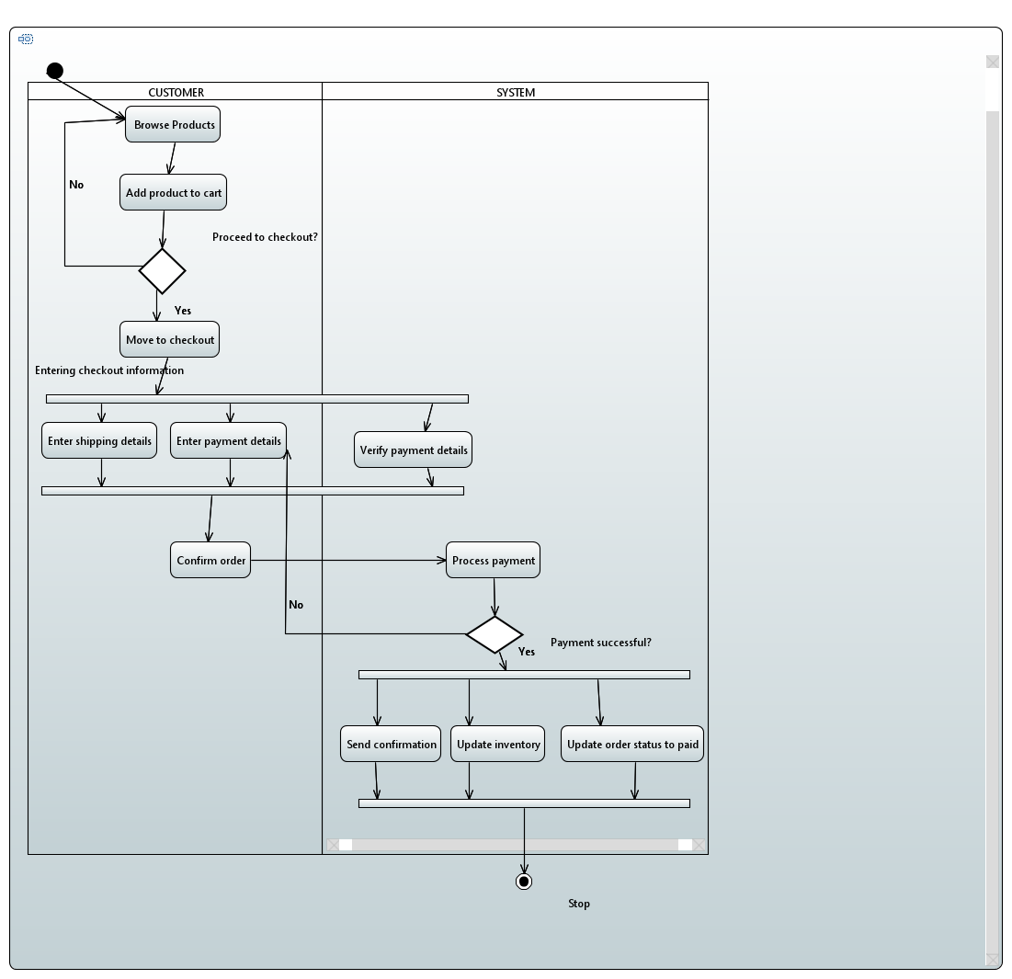

#### Customer Manage Profile

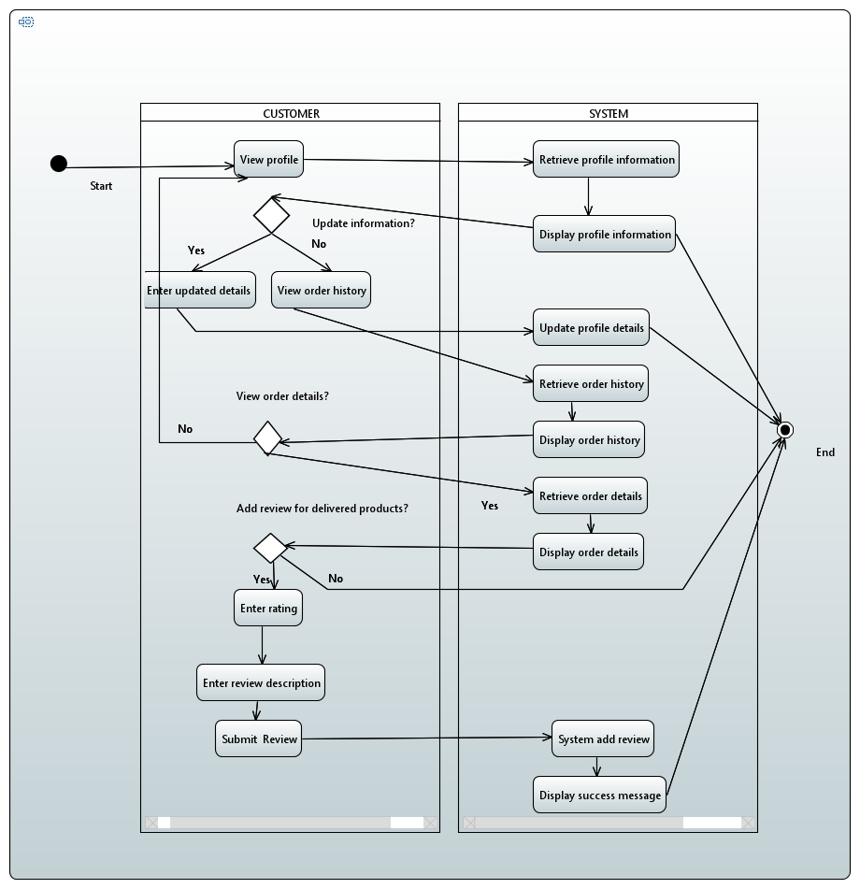

#### **4.4 Sequence Diagrams**

* Login Process

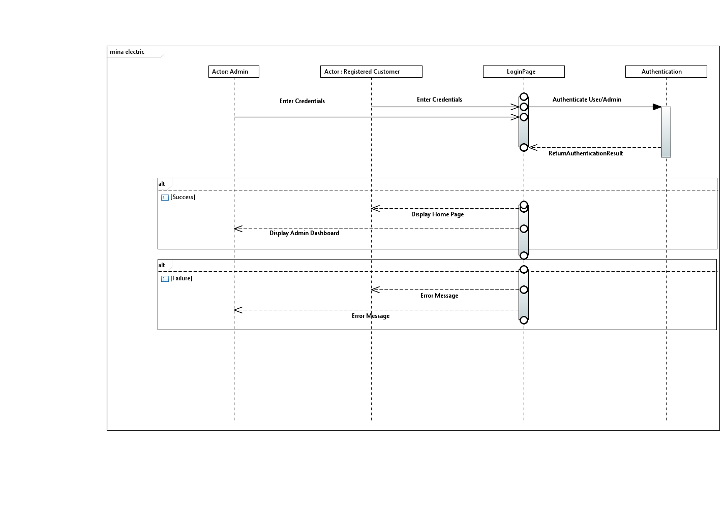

* Admin Actions

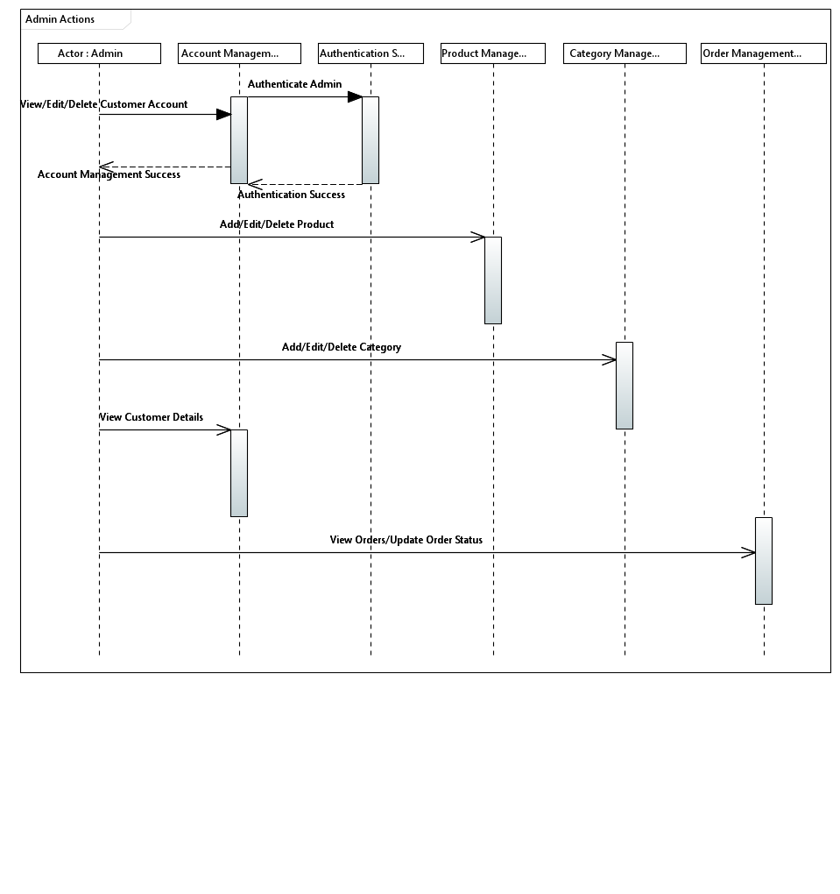

#### Registration Process

#### 

#### Product page

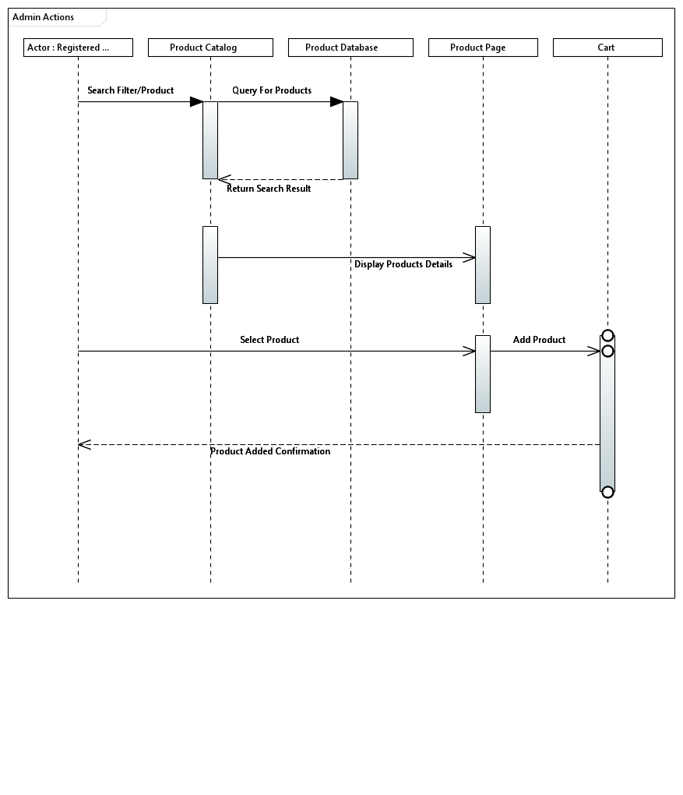

* Checkout process

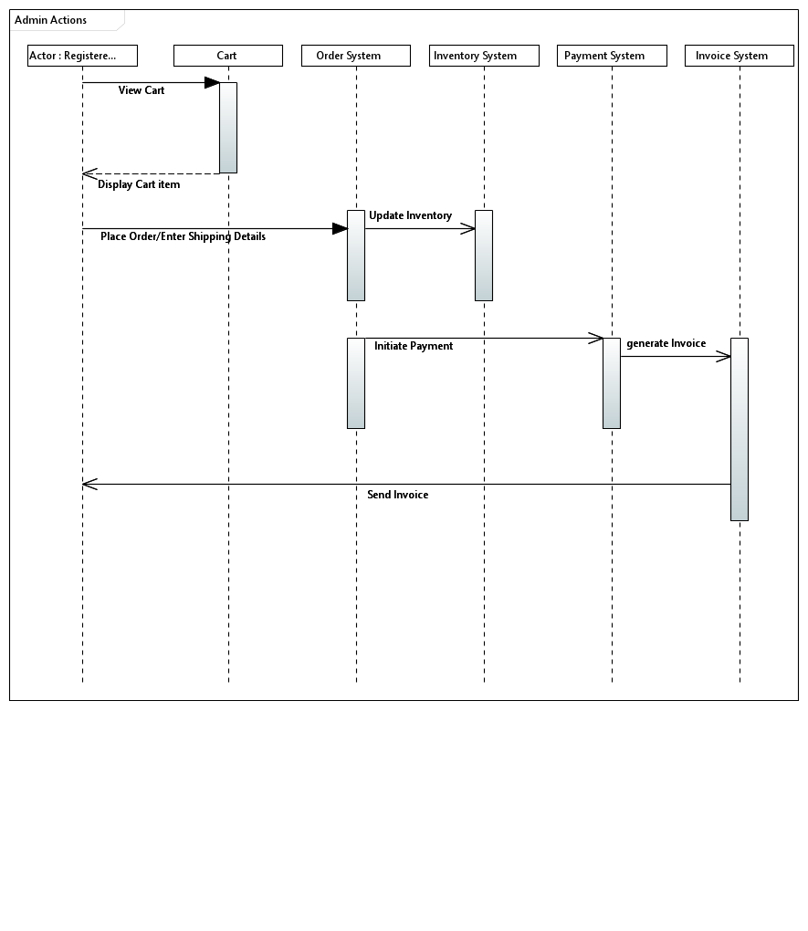

#### **4.5 Collaboration Diagrams**

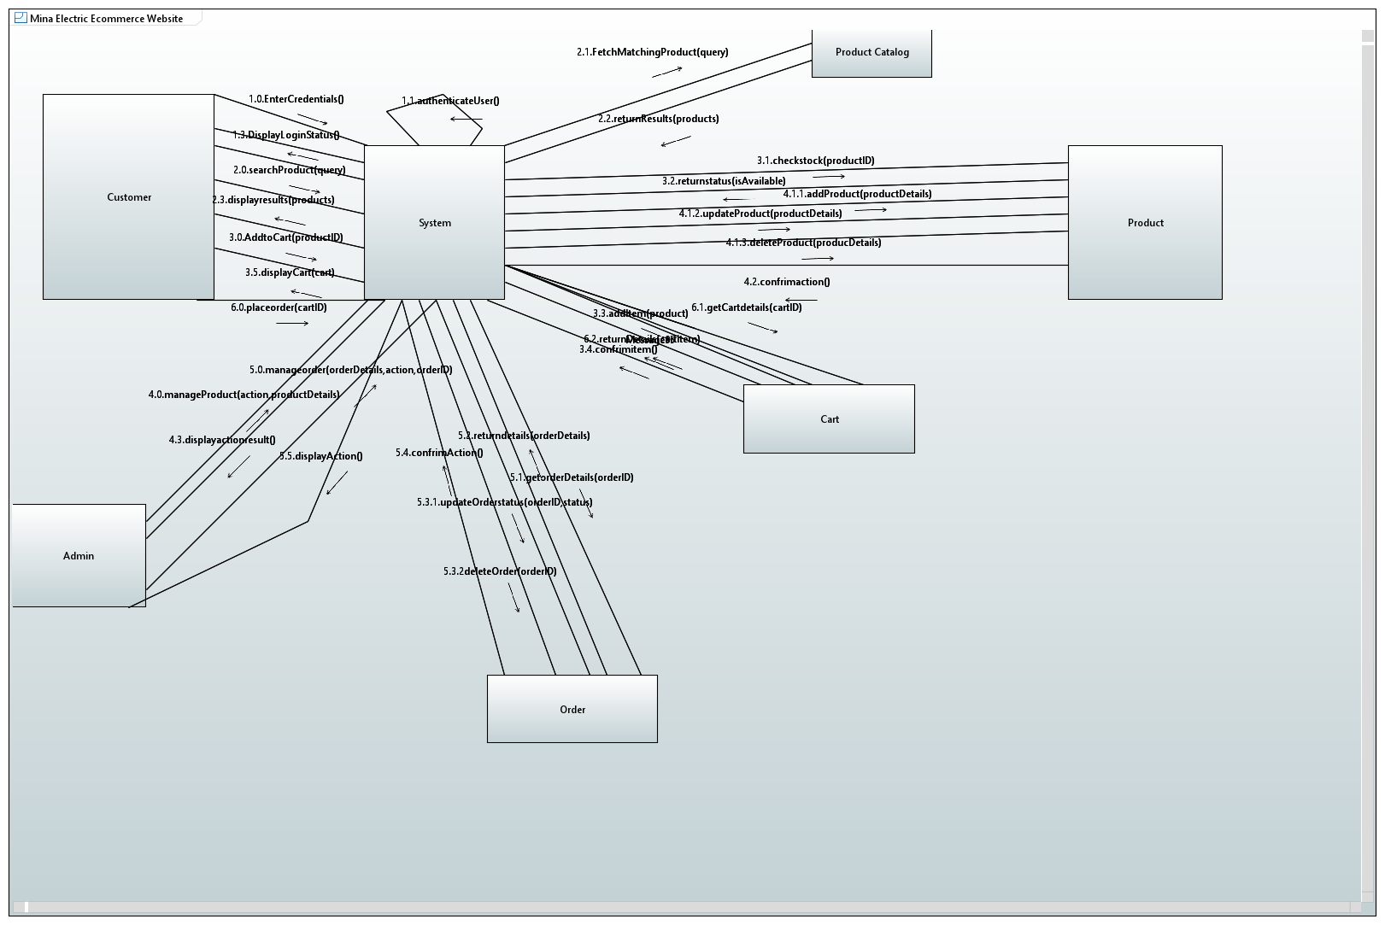

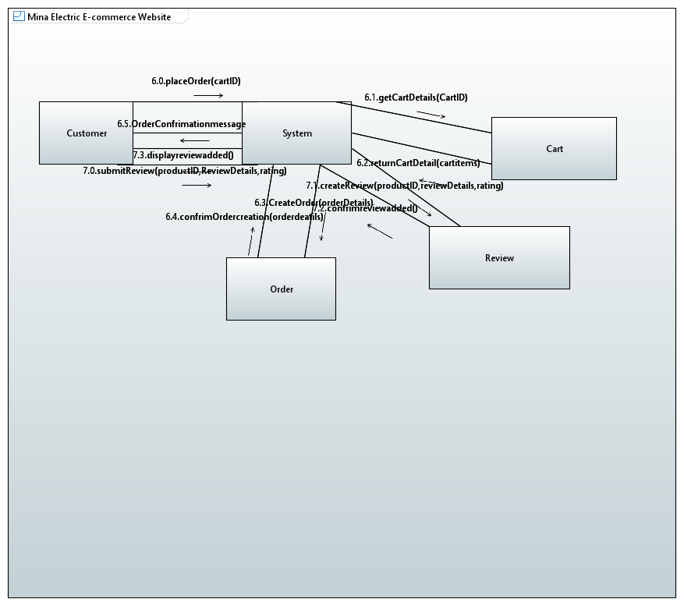

**4.6 Component Diagram**

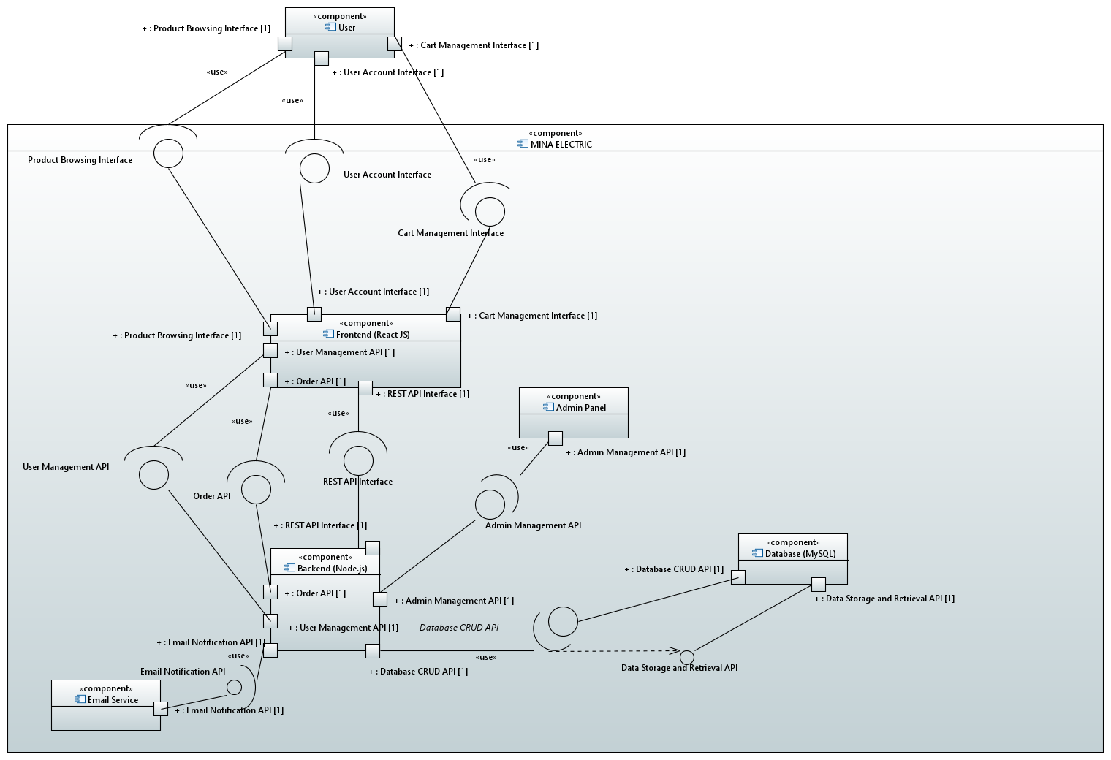

**4.7 State chart Diagram**

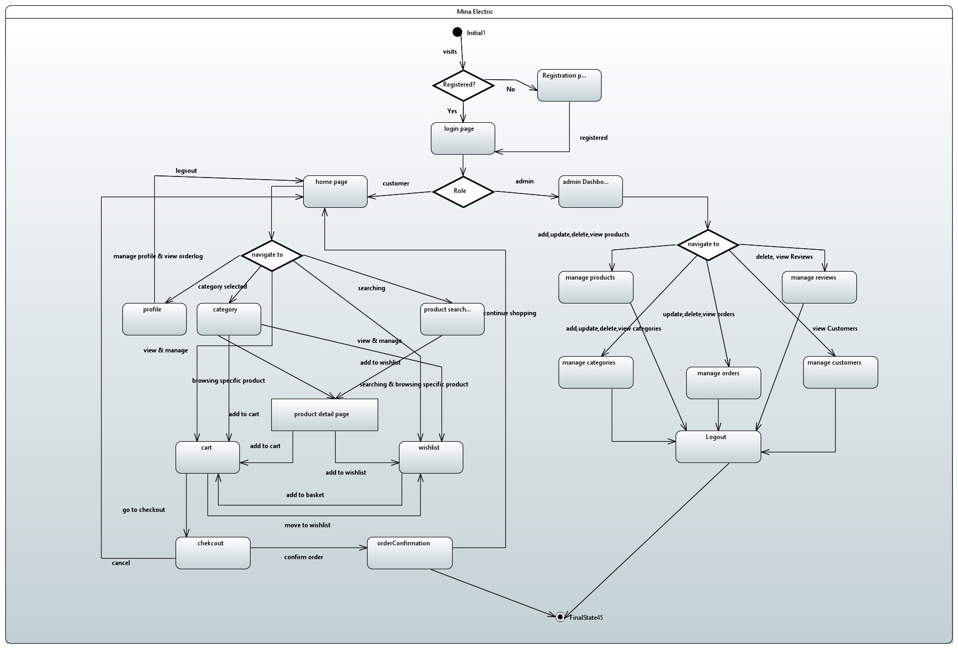

**4.8 Deployment diagram**

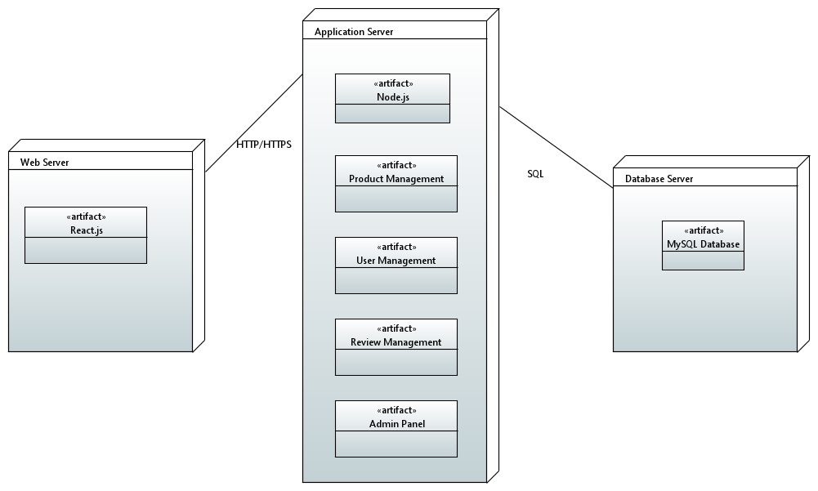

*.*

# Appendices

# **Appendix A: Prototype**

# Customer view:

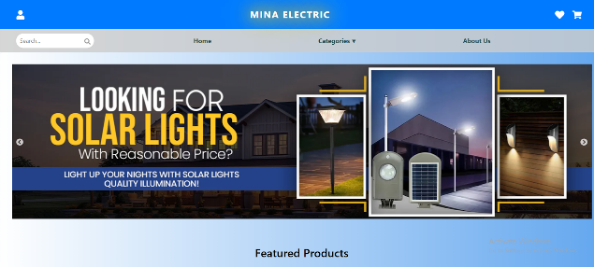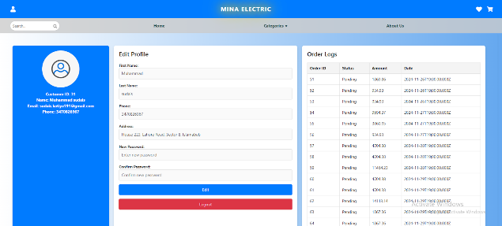

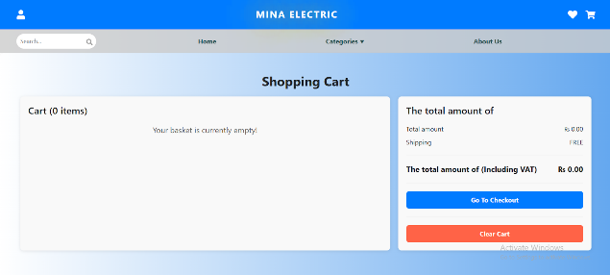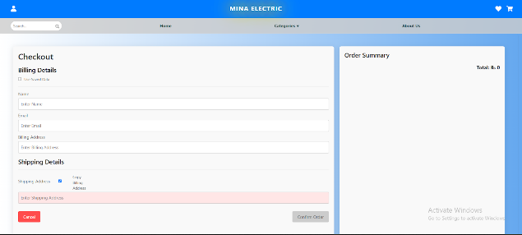

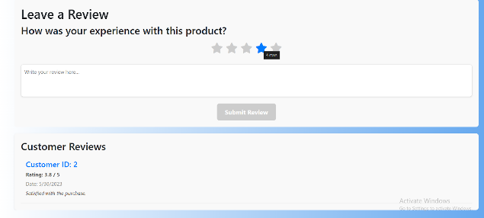

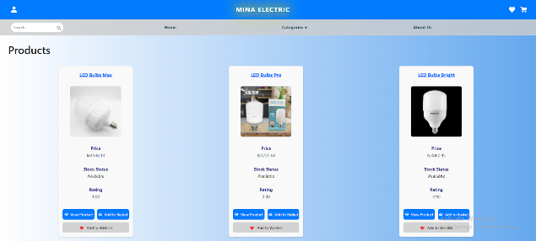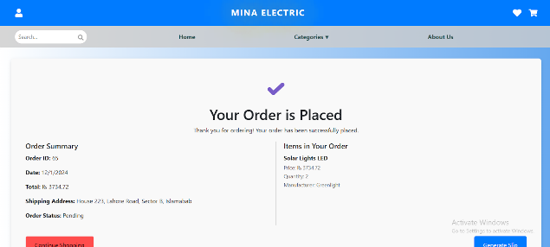

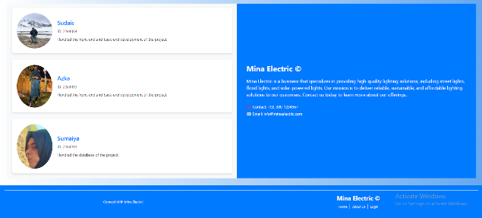

*Admin View*

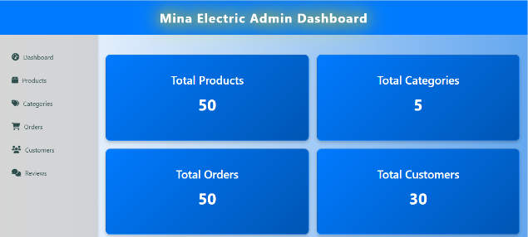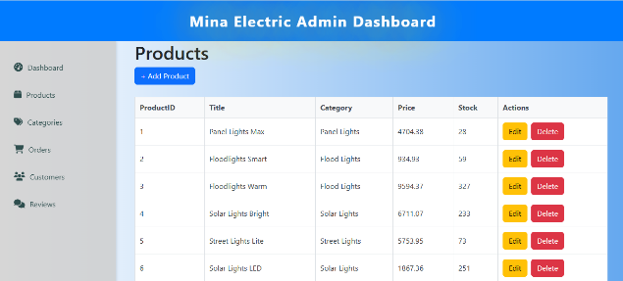

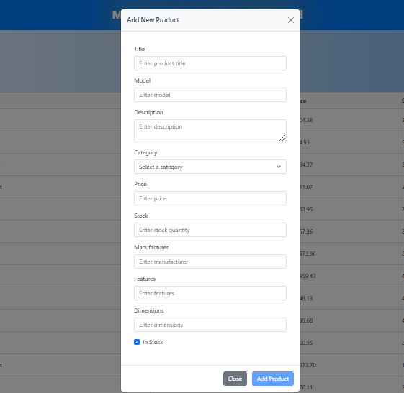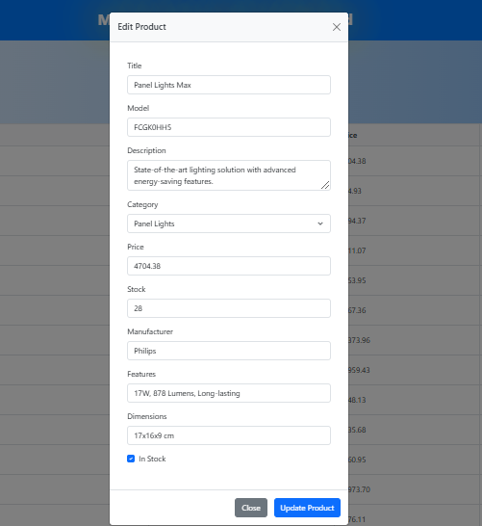

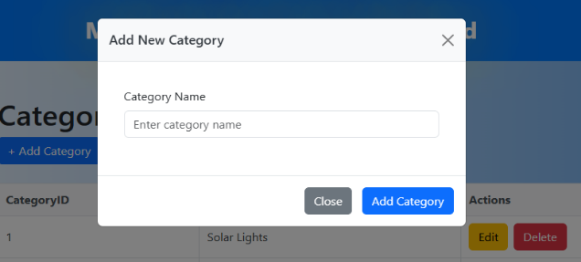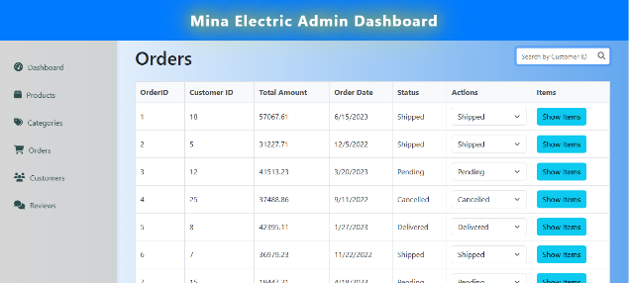

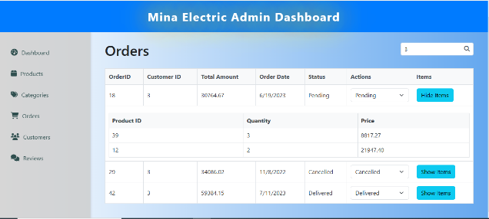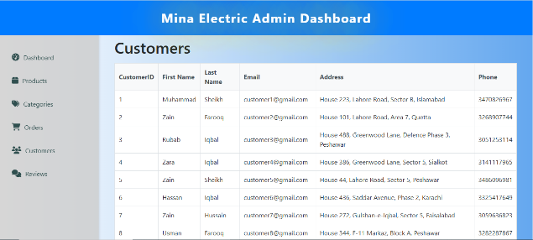

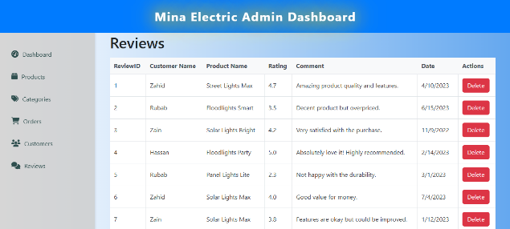

*THAT’S IT!*