Azlan Khan Mehsud, i26-3010, SE-A (F).

Prompt 1: Hello my name is Azlan Khan Mehsud, roll number 26i-3010 and I have been building a website. Take a look at these 3 files. I have made an initial bare-bones design for my test website. I want you to refine my home page, keep the theme consistent and in line with what I have already provided, in essence, the colour scheme. While you refine the homepage, I want you to add 2 more functional pages so that it is 3 pages in total. The 3 pages should be: Home, Places to Visit, Travel Tips. You may add as many entries as you see fit, but they should not exceed five countries. In the home page, right hand side to the table, there should be a suitable image which I will leave at your discretion. (Attached styles.css, index.html and script.js).
Return: Received three html files, index.html, tips.html and places.html, along with the edited styles.css and a functional script.js. Theme was kept consistent and I overall approve these amendments made.
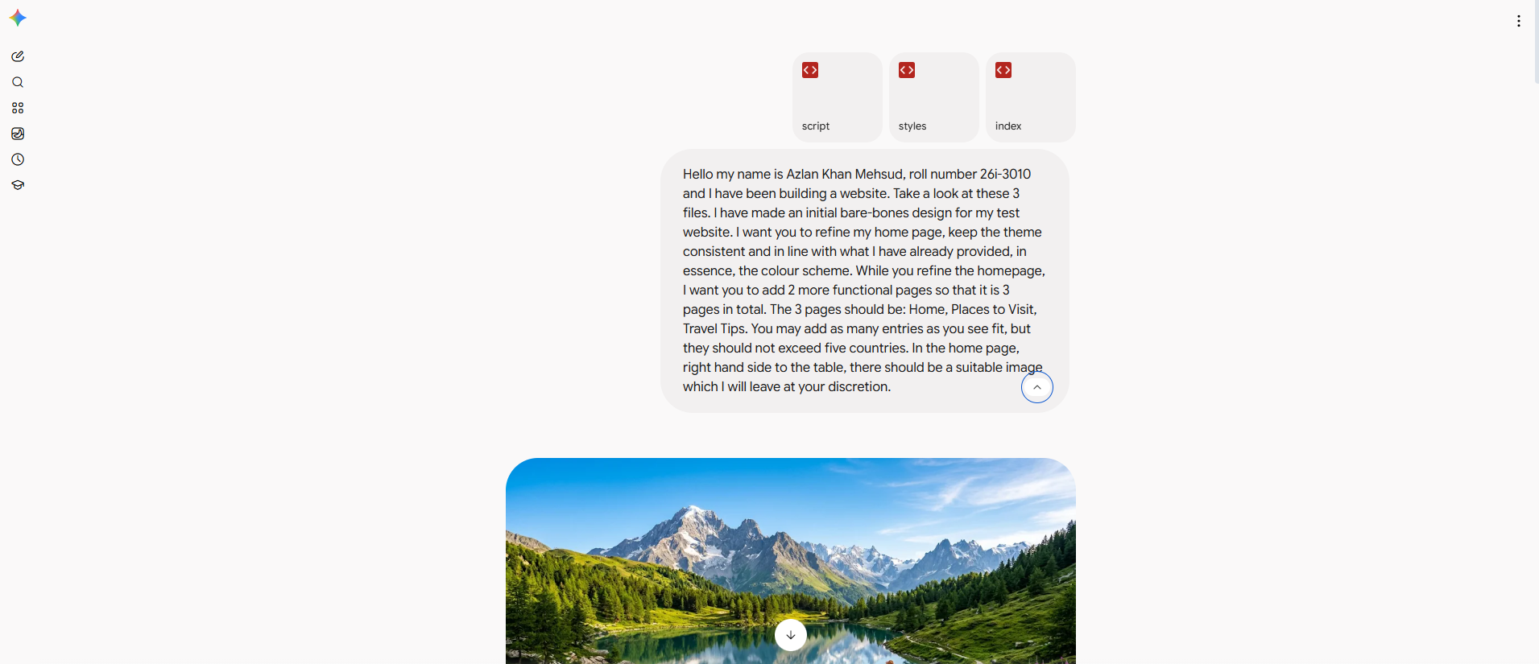
^Image for prompt 1.

Prompt 2: This is great so far. I would like to add a button to each of the pages with functionality added to it. Index.html already has a button so you need not to bother with that, however, the other two html pages could use one similar to index.html. It is up to you to what the buttons will do, as long as it is consistent with the website.
Return: An updated script.js along with the updated html files were returned. All consistent with the theme with functional buttons on each of the pages.


