AES: Automated Evaluation System for Southern Christian College using Django Framework



Judy Ann Ticar

John Rey Arapoc

AJ Lloyd Calixtro

April 2024

# Chapter 1

# Introduction

Student’s enrollment happens every school year in Southern Christian College, part of the enrollment process is the “evaluation”, it is a process that students’ progresses to undergo by it because on every department, there is a standard for students that will filter their eligibility for enrollment.

## Project Context

Evaluating students is an essential part of the process for enrolling on every school year or semester, there are requisites, there are set of standards they need to achieve before being verified to be enrolled on the next courses. Now, in Southern Christian College, enrollment is already automated, but process on evaluating students is not. On every department that Southern Christian College have, almost every dean on CCIS, CMAHS, CAS, CTE, Agriculture has been evaluating students manually under their department and large number of students undergoes by it. A lot of time is being spend because of manual evaluation, yet developer created a way for them to lessen the evaluation process and increase their productivity in a mean of time.

## Objectives

1. Turn the manual evaluation into automated
2. Increase a suggestion on decision making
3. Produce a printable output after an evaluation process

## Scope and Limitation

Input – Grades of every student on every department will be stored or synced in the database of the evaluation system.

Process – The stored grades of every student will be separated by department and will possess a primary key or what we call ID number that will help system separation of grades on its accordance. The point of helping the system on easing the time of the client on evaluating a student is that it will highlight the INC, the grade(s) that does not meet the standard of grading policy of a department and the blanked or zero grade on a course(s).

Output – The output of the system will show a display where students’ grades was recorded, from its previous school year or semesters, and this will suggest a decision of what are the possible action of an evaluator might do to a student’s profile or account after. Also, the displayed output will be available to be printed.

## Theoretical Framework

In their work, the developers choose to make use of the Automated Performance Evaluation System that Akhai, S., et al. (2017) introduced. They claim that the J48 method has the highest accuracy for efficiently identifying the cases, which is why they chose to utilize it. Figure 1 illustrates their system's logical flow. starting with the conversion and collecting of data, using the data in the Weka tool, training dataset, selecting attributes and preprocessing, testing dataset, and classifying the data, to analyzing the classification algorithm and forecasting the result.

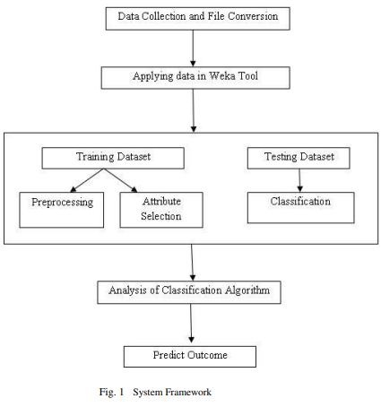

Figure 1. Theoretical Framework

## Conceptual Framework

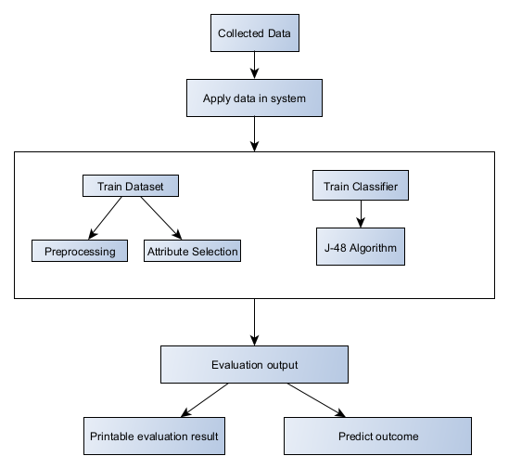

The J-48 algorithm is used by the developers to process the assessment process and provide a result that aids users in making decisions. This is in line with the Automated Performance Evaluation System idea. The J-48 algorithm decision tree, scikit-learn, web assembly application, and Python programming language were used in the construction of the AES system.

# Chapter 2

## Definition of Term

**Enrollment**: The process of officially registering and joining a school, program, or course.

**Requisites**: Necessary conditions or requirements that must be fulfilled or met.

**Automated**: Referring to a process or system that operates automatically, without requiring human intervention.

**Productivity**: The measure of efficiency and effectiveness in completing tasks and achieving goals.

**Inc**: An abbreviation for "Incomplete," indicating a grade that has not been fulfilled or finalized.

**Grading policy**: Guidelines and standards set by educational institutions for evaluating and assigning grades to students' academic work.

**Primary key**: In the context of databases, a unique identifier for each record or entry in a table.

**Logical flow**: The sequence or order in which steps or processes occur logically within a system or framework.

**Preprocessing**: The preparation and manipulation of data before it is used for analysis or other purposes.

**Algorithm**: A set of instructions or rules followed by a computer program to solve a problem or perform a task.

**Decision tree**: A graphical representation of a decision-making process, often used in machine learning and data mining.

**Scikit-learn**: A popular Python library used for machine learning tasks such as classification, regression, and clustering.

**Web assembly**: A binary instruction format for a stack-based virtual machine, designed for use on the web.

**Theoretical framework**: The underlying structure or model used to guide research or development, based on established theories or concepts.

**Conceptual framework**: A structure or system of ideas, theories, or concepts used to understand a specific phenomenon or problem.