Dataset, Preprocessing Pipeline, and Initial Exploratory Analysis Report

1. Datasets
DIV2K (images): Benchmark dataset containing ~800 high‑resolution (2K) images used for single-image super‑resolution.
Vimeo90K (video): Large video dataset with high‑quality 7‑frame sequences suitable for temporal SR training.
Gaze-Tracking Data (Optional): A small consent‑based dataset of gaze coordinates used to fine‑tune foveation behavior.

2. Preprocessing Pipeline
Cleaning:
• Remove corrupted images.
• Normalize RGB channels.
• Standardize colorspace.
Resolution Standardization:
• HR→LR bicubic downsampling.
• LR/HR crop‑pair generation (e.g., 128→256 px).
• For video: consistent frame sizes, sequential extraction.
Foveation Labels:
• Synthetic gaze points.
• Gaussian/acuity-based foveal/peripheral masks.
• Masks transformed during augmentations.
Augmentation:
• Spatial: random crop, flip, small rotations.
• Photometric: brightness/contrast jitter, compression noise.
• Motion-aware blur for video.

3. Exploratory Data Analysis (EDA)
Dataset Statistics:
DIV2K: ~800 images, diverse scenes.
Vimeo90K: 89k clips, motion-rich sequences.
Pixel Distribution:
• RGB histograms.
• Channel means/variances.
• LR–HR baseline PSNR/SSIM.
Foveation Map Analysis:
• Foveal radius distribution.
• Fovea:periphery pixel ratio.
• Mask stability under augmentations.

4. Example Visualizations

LR vs HR Sample Pairs
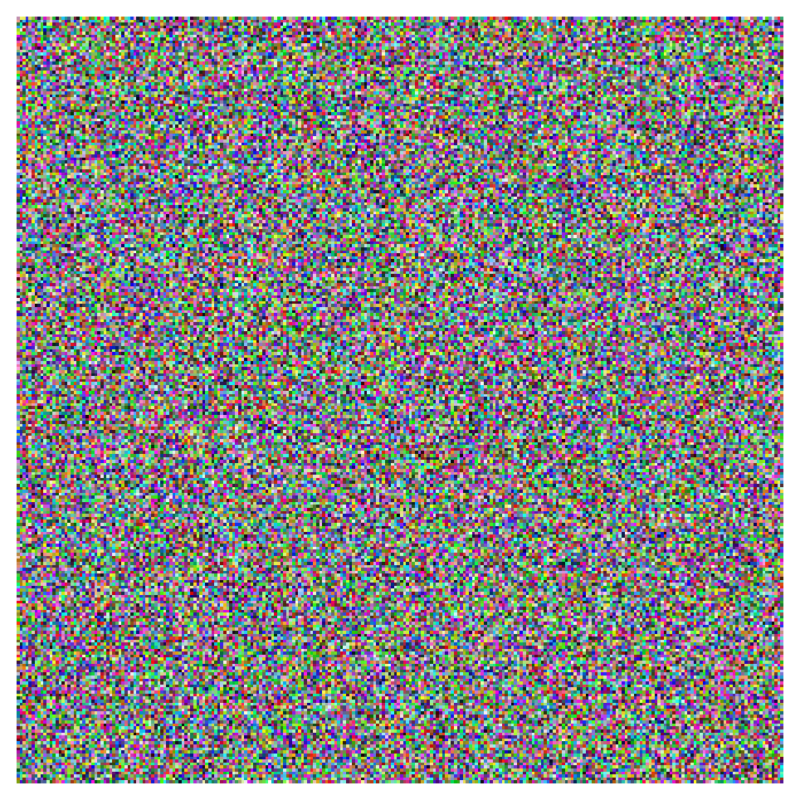
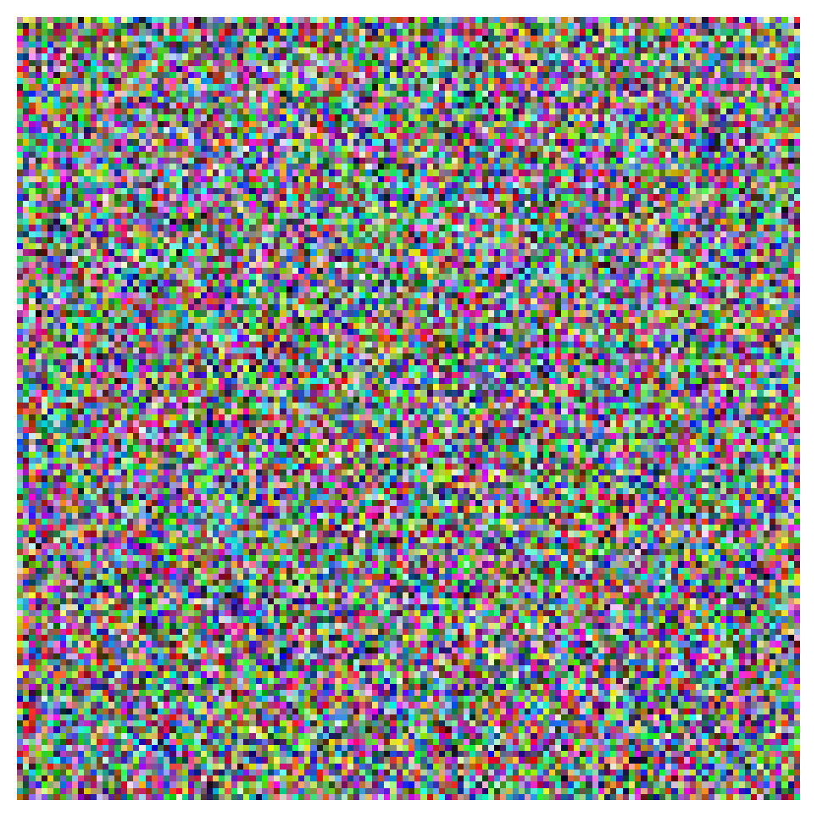

Gaze Point + Foveation Mask
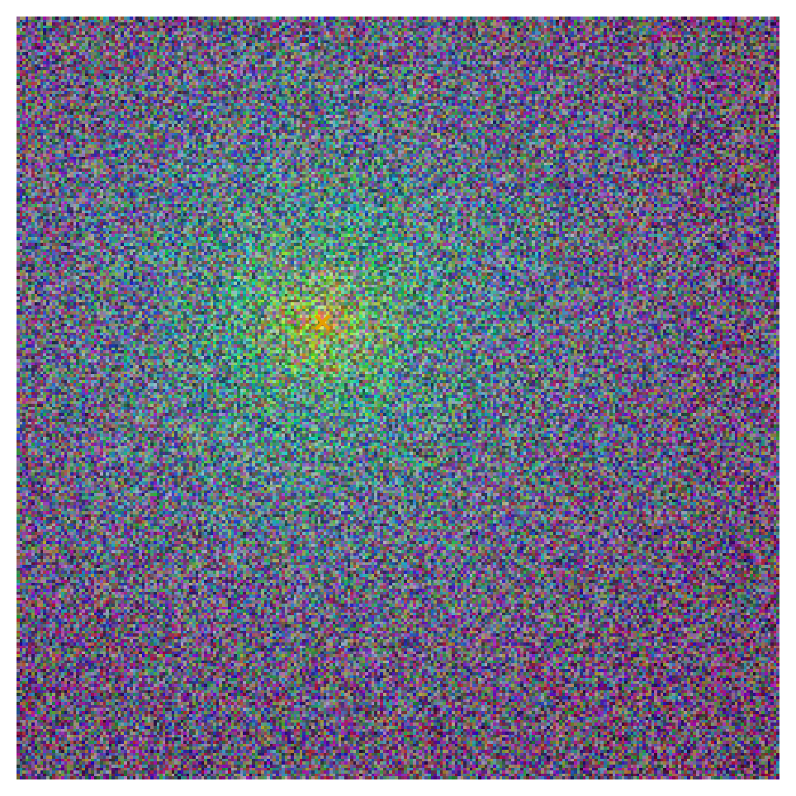

RGB Histograms
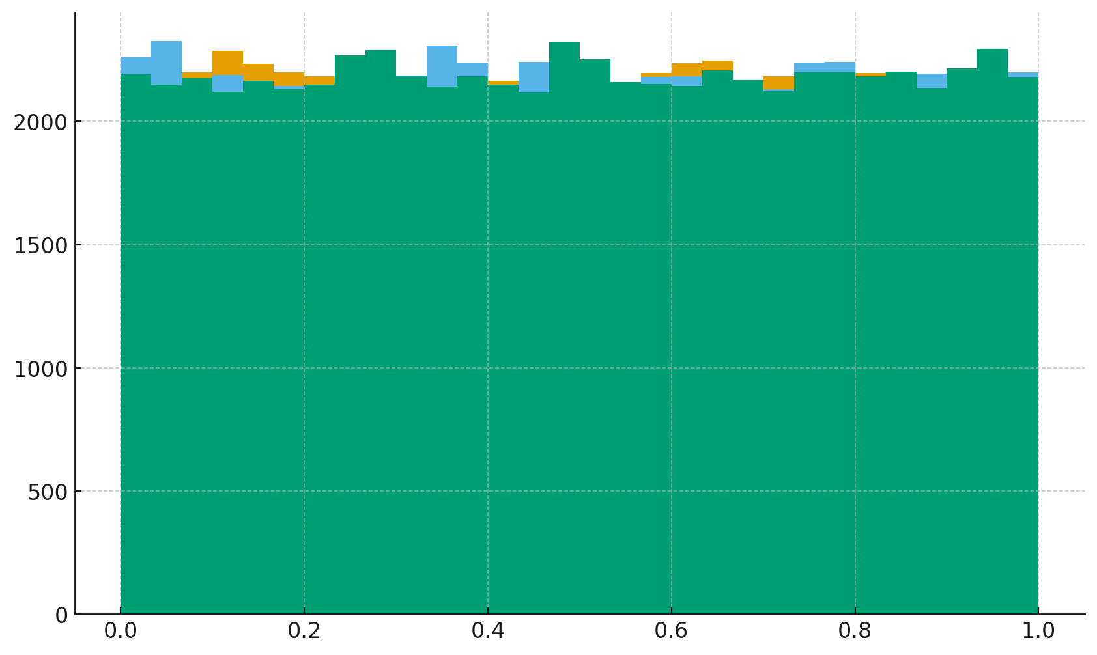

Entropy / Texture Heatmap
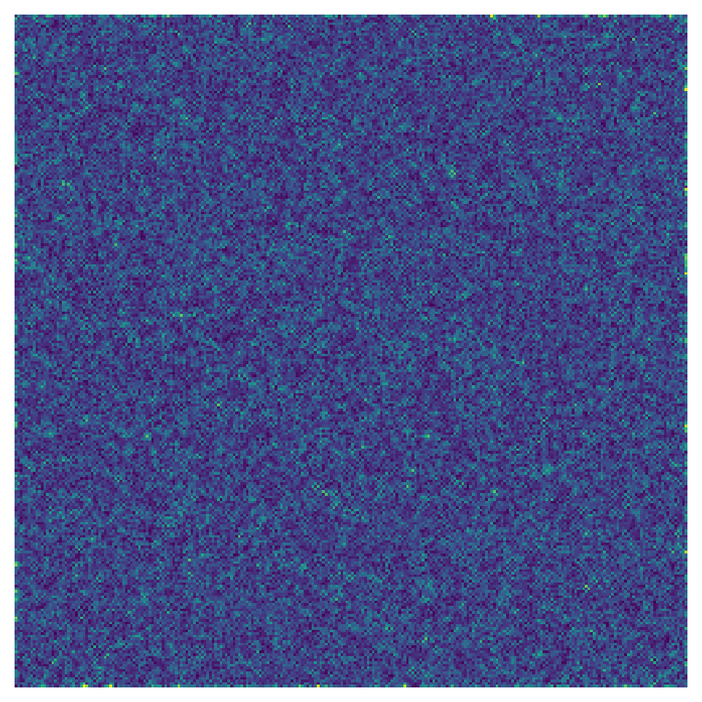

Consecutive‑Frame Motion Magnitude
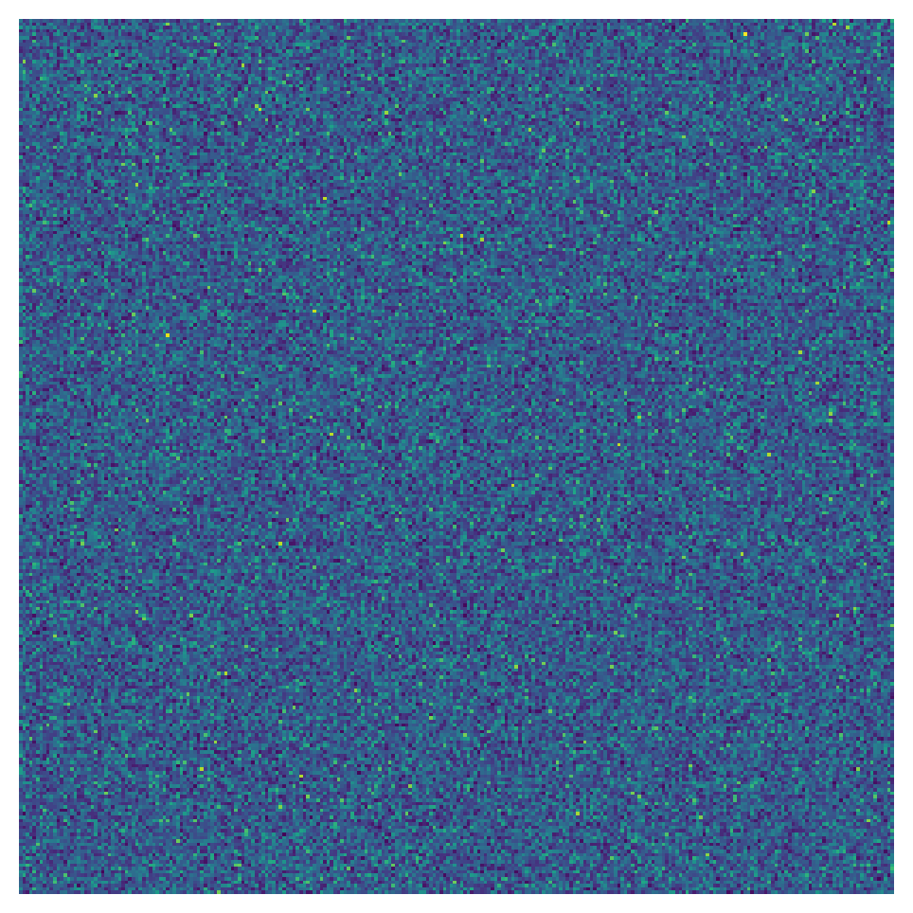

Summary
Preprocessing ensures clean LR/HR pairs, accurate foveation masks, and sufficient dataset analysis for the development of a gaze-aware on-device super-resolution system.

