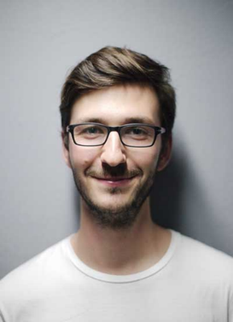

**L A N G U A G E S**

|  |  |
| --- | --- |
| * Bahasa Malaysia | * Hardworking |
| * English | * Teamwork |
|  | * Management * Resourceful |

**L A N G U A G E S**

* **Bahasa Malaysia**

Spoken

Written

Listening

* **English**

Spoken

Written

Listening

**S K I L L S**

|  |
| --- |
|  |
| * Microsoft Word |
| * Microsoft Excel * Microsoft PowerPoint * Microsoft Access |
|  |

**P E R S O N A L I T Y S K I L L S**

|  |
| --- |
| * Hardworking |
| * Teamwork |
| * Communication * Leadership |

**E D U C A T I O N**

**SMK Simpang Pulai**

2013 - 2015

Sijil Pelajaran Malaysia (SPM)

**SMK Simpang Pulai**

2015 – 2018

Diploma Kejuruteraan Elektrik Kuasa

**SK Taman Bersatu**

2005 – 2010

Ujian Pencapaian Sekolah Rendah (UPSR)

Experienced in handling various roles while maintaining focus on quality results. Enjoys improving systems, learning new skills, and staying organized. Known for reliability, calm decision-making, and team cooperation. Communicates clearly in both planning and execution. Values mutual respect and goal alignment. Works best in supportive environments that encourage growth, creativity, and continuous improvement in professional performance.

**E X P E R I E N C E**

**S.L. Ng Trading Agency**

Julai 2023 – Kini

Pembantu Pemandu

**Grab Malaysia**

April 2021 - Jun 2023

Penghantar Makanan

**Vape Pod Corner**

Januari 2021 - Mac 2021

Penyelia Talian, Operator Mesin

**Resident Evil**

Januari 2021 - Mac 2021

Penyelia Talian, Operator Mesin

**R E F E R E N C E S**

**RERF ERFERFERFERFERFEF**

RERFFEFERFREFEF

REFRFERFERFREF

**RREFREFREFERFER**

RERFERFEFERRF

REFERFERFERFERF

**R E F E R E N C E S**

**RERF ERFERFERFERFERFEF**

RERFFEFERFREFEF

REFRFERFERFREF

**RREFREFREFERFER**

RERFERFEFERRF

REFERFERFERFERF



ADDRESSSSSSSSSSSSSSSS

EMAILLLLLLLLLLLLLLLL

PHONEEEEEEEEEE

**C O N T A C T**

**A B O U T M E**

**Muhammad Raimi**

**Bin Rozainor**