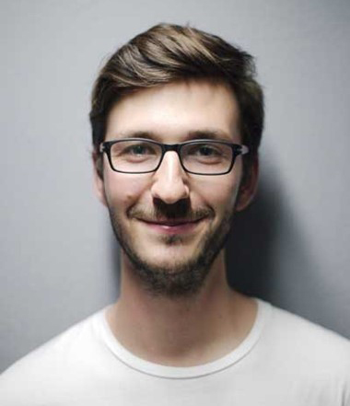

**Muhammad Raimi bin Rozainor**

**ABOUT ME**

Adaptable, calm, and focused in fast-moving work situations. Delivers consistent performance by combining structure with flexibility. Enjoys working closely with team members to solve problems and complete shared tasks. Communication is used as a tool to connect ideas and actions. Committed to learning, growing, and contributing positively to team efforts and long-term project success.

**PERSONAL SKILLS**

|  |
| --- |
| * Hardworking |
| * Teamwork |
| * Communication * Leadership |

**LANGUAGES**

* **Bahasa Malaysia**
* **English**

**LANGUAGES**

* **Bahasa Malaysia**

Spoken

Written

Listening

* **English**

Spoken

Written

Listening

**SKILLS**

|  |
| --- |
| * Microsoft Word |
| * Microsoft Excel |
| * Microsoft PowerPoint * Microsoft Access |

**REFERENCE**

**REF REFERFERFEFE**

ERFEFERFREFER

REFERFERFERFREF

ERFERFREFREFERF

**EFERFERFERFERREFERF**

REFERFERFERFE

ERFERFREFERFER

EFERFEFERFER

EXPERIENCE

**Nilai Harta Consultant Sdn. Bhd.**

29 Sep 2020 – Current

Assistant Valuer, Real Estate Agency

**Combat Electrical Engineering Sdn. Bhd.**

24 May 2019 – 24 December 2019

Assistant Chargeman, Supervisor

**Better Power Sdn. Bhd.**

15 June 2017 – 15 April 2018

Overhead Supervisor, Machine Operator

EDUCATION

**Institut Kemahiran MARA Kuala Lumpur**

2019 – 2020

Diploma in A4 Electrical Competency

**Kolej Kemahiran Tinggi Mara Pasir Mas**

2015 – 2018

Diploma in Electrical Engineering Power

**Royal Military College**

2013 – 2014

Sijil Pelajaran Malaysia



ADDRESSSSSSSS

PHONEEEEEEEEEE

EMAILLLLLLLLLL