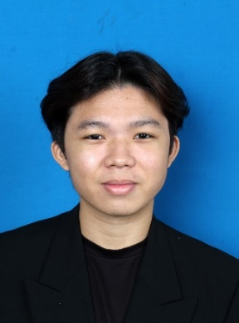

**MUHAMMAD RAIMI BIN ROZAINOR**

**Address**:

DDRESSSSSSSSSSSSSSSSSSSS

**Email**:

EMAILLLLLLLLLLLLLLLLLLLLLLL

**Phone Number**:

PHONEESSSee

Brings structure and teamwork into every task handled. Balances clarity, communication, and decision-making to ensure smooth progress. Enjoys seeing plans turn into results through shared effort and clear steps. Maintains energy during tight deadlines and changing priorities. Adjusts quickly without losing direction. Constantly looks for better ways to handle work and support those around.

**Objective Summary**

**Professional Experience**

**Health Jaya Nursing Care**

Jun 2022 - Sep 2023

Part-Time Administration And Marketing

* Developed a proactive and dependable approach to multitasking by efficiently managing and prioritizing diverse tasks. This involved honing strong organizational skills, ensuring that each responsibility was addressed with diligence and timeliness.
* Prioritized patient well-being by meticulously organizing daily basic care needs. This dedication to detail was not just about fulfilling routine tasks but also ensuring a personalized and comfortable environment for patients, contributing to an elevated standard of care.
* Collaborated effectively within the healthcare team, actively participating in discussions and decisions that shaped comprehensive patient care. This involvement extended beyond individual tasks, fostering a cooperative environment where collective insights and expertise contributed to optimal patient outcomes.
* Exhibited proficiency in written and verbal communication, serving as a strong asset in interactions with patients and their families. Effective communication not only ensured clarity in conveying information but also fostered positive and supportive relationships within the healthcare setting.
* Maintained meticulous attention to detail in managing patient records and reports. This commitment to accuracy and reliability in healthcare documentation was crucial in ensuring the quality of patient care and facilitating seamless collaboration among healthcare professionals.

UiTM Bandaraya Melaka

2022-2023

Degree in International Business

UiTM Alor Gajah, Melaka

2019-2022

Diploma in Accountancy

SMK Raja Jumaat, Port Dickson

2016-2018

Sijil Pelajaran Malaysia (SPM)

Result: 6A’s

**Educational Background**

Hardworking

Willing to Learn

Communication

Quickly Adaptable

Rolling Cinnamon Roll

Baking Cinnamon Roll

Multitask

Customer Service

**Technical & Personality Proficiency**

Hardworking

Willing to Learn

Communication

Quickly Adaptable

Rolling Cinnamon Roll

Baking Cinnamon Roll

Multitask

Customer Service

**Languages / Strengths**

**References**

Rolling Cinnamon Roll

Baking Cinnamon Roll

Multitask

Customer Service