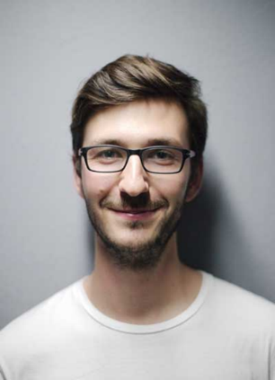

**MUHAMMAD RAIMI BIN ROZAINOR**

|  |
| --- |
| * Bahasa Malaysia |
| * English |
|  |

**LANGUAGES**

**SKILL**

**PERSONAL SKILL**

**REFERENCE**

|  |
| --- |
| * Hardworking |
| * Teamwork |
| * Communication * Leadership |

**PERSONALITY SKILLS**

**SKILL**

**PERSONAL SKILL**

**REFERENCE**

|  |
| --- |
| * Microsoft Word |
| * Microsoft Excel |
| * Microsoft PowerPoint * Microsoft Access |

**SKILLS**

**SKILL**

**PERSONAL SKILL**

**REFERENCE**

**Life Biopharma Sdn Bhd**

2017 - 2024

General Clerk

Maintained organized records, processed documents, and

**Perbadanan Perpustakaan Awam Negeri Sembilan**

2005 - 2013

Library Assistant

Assisted patrons with research, managed circulation desk, and

**EDUCATION**

**SKILL**

**PERSONAL SKILL**

**REFERENCE**

**Malvern Pathology Sdn Bhd**

July 2019 - Kini

Data Entry Executive

**Bank Kerjasama Rakyat Malaysia**

Oct 2018 - Apr 2019

BR Smart

**Beta Mutiara Corporation Berhad**

Sep 2017 - Mar 2018

Admin Assistant

**Yayasan Destini Anak Bangsa**

Feb 2017 - Mei 2017

subordinate officer

**EXPERIENCES**

**SKILL**

**PERSONAL SKILL**

**REFERENCE**

An enthusiastic, self-motivated, reliable, responsible, and hardworking individual with a mature approach to teamwork and adaptability to challenging situations. Demonstrates strong ability to work both independently and collaboratively, excelling under pressure and adhering to strict deadlines.

**ABOUT ME**

**SKILL**

**PERSONAL SKILL**

**REFERENCE**

**CONTACT**

**SKILL**

**PERSONAL SKILL**

**REFERENCE**

🖀

🖄

🏠

ADRESSSSSSSSSSSSSSSSS

PHONEEEEEEEEEEE

EMAILLLLLLLLLLLL

|  |
| --- |
| * **Bahasa Malaysia**   Spoken  Written  Listening |
| * **English**   Spoken  Written  Listening |
|  |

**LANGUAGES**

**SKILL**

**PERSONAL SKILL**

**REFERENCE**

**REFE FERFEFERFERFRFE**

REFERFERFERFEFEF

ERFERFERFERFREF

FERFERFEFF

**RFEFERFEFEFERFE**

RFEFERFEFEFE

RFERFERFEFEFERF

RFEFERFERFERFERF

**REFERENCES**

**SKILL**

**PERSONAL SKILL**

**REFERENCE**