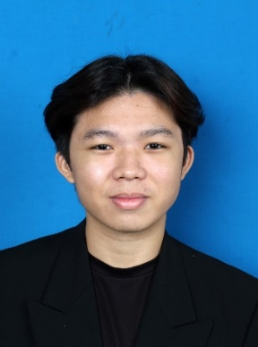

**MUHAMMAD RAIMI BIN ROZAINOR**

**Alamat**:

DDRESSSSSSSSSSSSSSSSSSSS

**E-mel**:

EMAILLLLLLLLLLLLLLLLLLLLLLL

**Nombor Telefon**:

PHONEESSSee

Minat dalam pembelajaran, penyelesaian masalah dan kerjasama pasukan. Membangunkan tabiat kerja melalui rutin dan koordinasi yang teliti. Menggunakan komunikasi untuk perjelas tugasan dan kekalkan semangat berpasukan. Mengalu-alukan perubahan demi penambahbaikan. Bekerja secara berkesan bila matlamat jelas, tugasan difahami, dan semua pihak menyumbang secara telus, konsisten dan penuh tanggungjawab.

**Objektif**

**Pengalaman Kerja**

**Health Jaya Nursing Care**

Jun 2022 - Sep 2023

Part-Time Administration And Marketing

* Developed a proactive and dependable approach to multitasking by efficiently managing and prioritizing diverse tasks. This involved honing strong organizational skills, ensuring that each responsibility was addressed with diligence and timeliness.
* Prioritized patient well-being by meticulously organizing daily basic care needs. This dedication to detail was not just about fulfilling routine tasks but also ensuring a personalized and comfortable environment for patients, contributing to an elevated standard of care.
* Collaborated effectively within the healthcare team, actively participating in discussions and decisions that shaped comprehensive patient care. This involvement extended beyond individual tasks, fostering a cooperative environment where collective insights and expertise contributed to optimal patient outcomes.
* Exhibited proficiency in written and verbal communication, serving as a strong asset in interactions with patients and their families. Effective communication not only ensured clarity in conveying information but also fostered positive and supportive relationships within the healthcare setting.
* Maintained meticulous attention to detail in managing patient records and reports. This commitment to accuracy and reliability in healthcare documentation was crucial in ensuring the quality of patient care and facilitating seamless collaboration among healthcare professionals.

UiTM Bandaraya Melaka

2022-2023

Degree in International Business

UiTM Alor Gajah, Melaka

2019-2022

Diploma in Accountancy

SMK Raja Jumaat, Port Dickson

2016-2018

Sijil Pelajaran Malaysia (SPM)

Result: 6A’s

**Latarbelakang Pendidikan**

Hardworking

Willing to Learn

Communication

Quickly Adaptable

Rolling Cinnamon Roll

Baking Cinnamon Roll

Multitask

Customer Service

**Kemahiran Teknikal & Personaliti**

**Rujukan**

Rolling Cinnamon Roll

Baking Cinnamon Roll

Multitask

Customer Service

Hardworking

Willing to Learn

Communication

Quickly Adaptable

Rolling Cinnamon Roll

Baking Cinnamon Roll

Multitask

Customer Service

**Bahasa & Kelebihan Diri**