Step by step guide for Installing Webtours

Contents
Download Webtours Zip 3
Installing Webtours 6

Web tours download and setup
- There will be a setup for ‘strawberry-perl’ and another zip file ‘WebTours’
- Install ‘strawberry-perl-5.10.1.0’ first. Double click on the icon to start the installation process.
- Check the License Agreement and click on Install

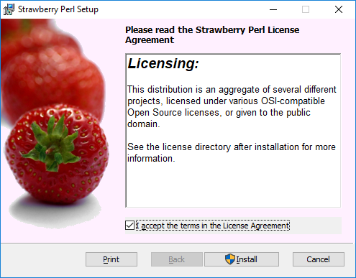

- After installation click on ‘Finish’

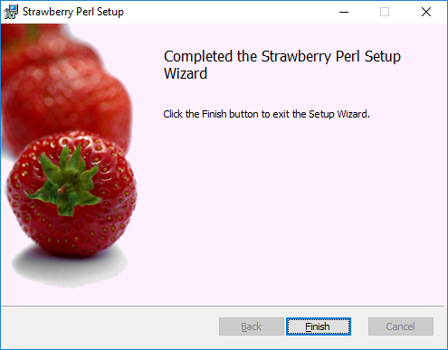

- Extract ‘WebTours.zip’
- Open the WebTours folder and click on Start Server or trigger the same via Command Prompt

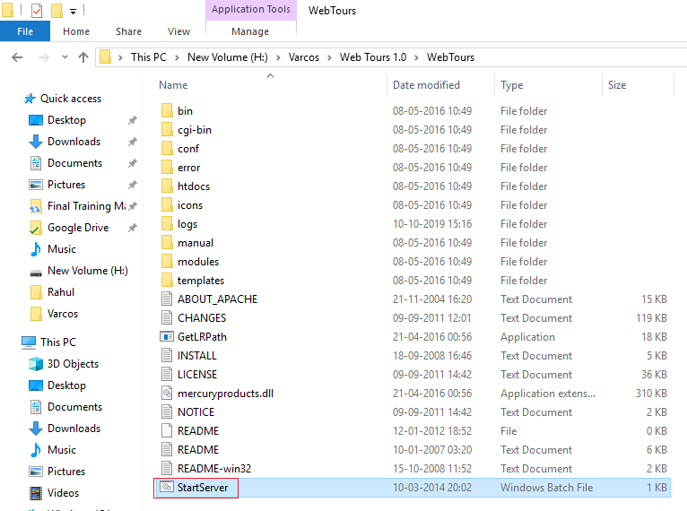

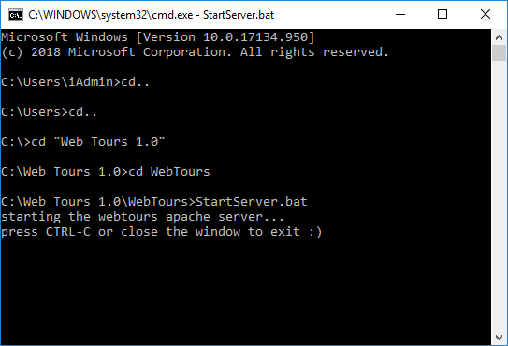

- When running the first time, you will be prompted with the Windows Security Alert. Check both the boxes and click on ‘Allow Access’

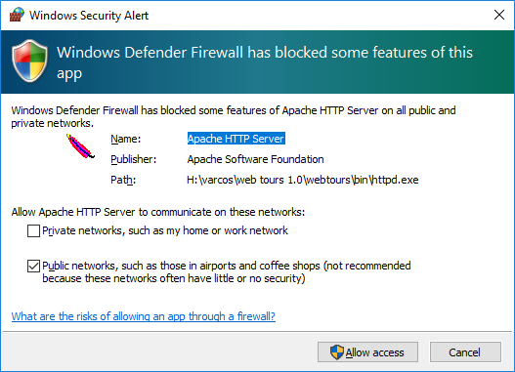

- Access the WebTours application by opening - http://localhost:1080/WebTours/
- Login: Username - jojo; password - bean

