

Introduction
Live classroom engagement tools such as Socrative and Kahoot show that timed questions, immediate feedback, and visible participation improve attention during lectures. Many course stacks, however, cannot assume WebSockets or a separate Node real-time layer. ClassPulse (Advanced Socrative Replica) addresses this gap with a Laravel-centered live quiz platform that uses short-interval HTTP polling, role-separated sessions, and automatic scoring.
Teachers create classrooms, share six-character room codes or QR links, author quizzes (multiple choice, true/false, and fill-in-the-blank), optionally generate questions with OpenAI, and run live sessions from a control room. Students join from another browser tab or device, answer under a server-synchronized timer, and review ranked results afterward. Administrators monitor users, activity, and application statistics.
The application follows a classical Laravel–Blade architecture. Laravel owns routing, validation, authorization, persistence, and service logic. Blade and Bootstrap render server-driven pages. Vanilla JavaScript modules poll JSON endpoints approximately every two to four seconds and resynchronize countdown timers from server timestamps, avoiding WebSocket infrastructure while remaining suitable for laboratory hosting (XAMPP / PHP built-in server).
Project objectives
- Provide secure multi-role authentication for admin, teacher, and student accounts.
- Allow teachers to manage classrooms with unique room codes and QR join links.
- Support quiz authoring for MCQ, true/false, and case-insensitive fill-in-the-blank items.
- Integrate optional AI-assisted question generation via the OpenAI API.
- Run teacher-paced live sessions with pause, reveal, next, timer controls, and auto-advance.
- Update students and teachers through Fetch-based polling rather than WebSockets.
- Score answers automatically with speed-weighted points and maintain live leaderboards.
- Expose session analytics, CSV export, student history, and admin oversight tools.
- Keep student and teacher browser sessions isolated so both roles can stay logged in simultaneously.
System Data Model
Entity–Relationship Diagram
The domain model is centered on users, classrooms, quizzes, questions, live quiz sessions, and session responses. A teacher owns classrooms; students enroll through a membership pivot (classroom_student). Quizzes belong to a classroom and contain ordered questions with optional answer choices. Starting a live session creates a quiz_sessions row that tracks status, the current question, timer fields, and reveal state. Each student answer is stored once per (session, question, student) combination in session_responses. Supporting tables store in-app notifications and activity logs.
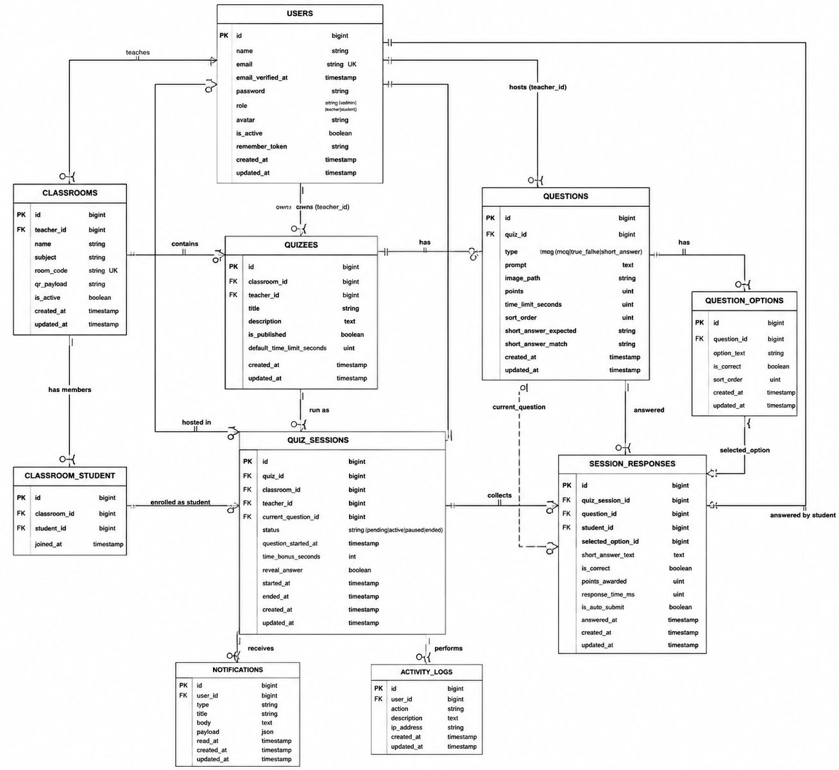
Figure 1. Entity–Relationship diagram of ClassPulse.
Database Schema 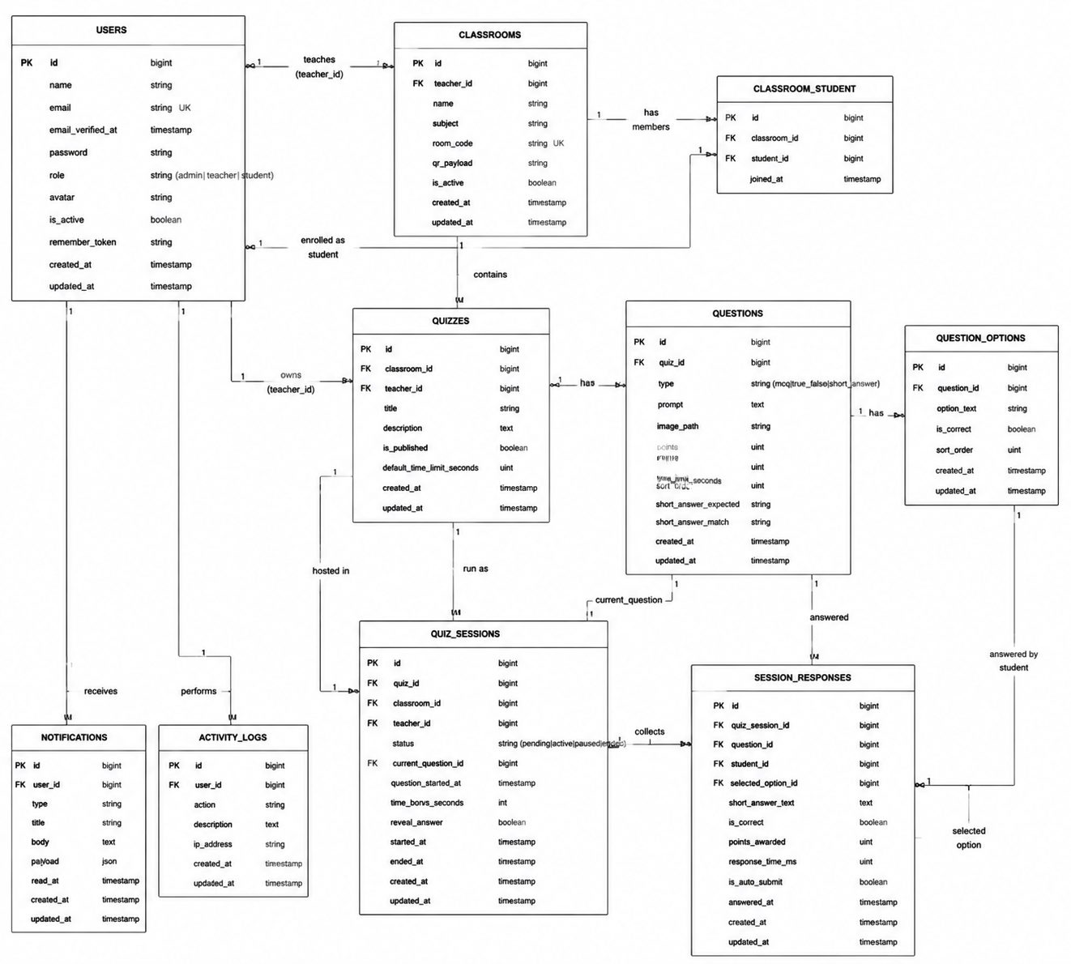
Figure 2. Relational schema diagram (tables, keys, and relationships).
Important database behavior includes foreign-key constraints with cascading deletes where child records must not outlive their owners, a unique constraint preventing duplicate live answers, indexes that support leaderboard aggregation by (quiz_session_id, student_id), and nullable option or short-answer fields depending on question type. Migrations live under database/migrations/, and Eloquent relationships are defined in app/Models/.

Technology Stack and Architecture
ClassPulse uses an integrated full-stack layout: Laravel remains the source of truth for security and data, while Blade pages and small JavaScript modules provide interactive live behavior without a separate SPA framework.
Layer | Technology | Responsibility
Backend | PHP 8.2+ and Laravel 12 | Routes, controllers, validation, Eloquent, services, middleware
Frontend | Blade + Bootstrap 5.3 | Server-rendered UI, responsive layouts, Icons
Client logic | Vanilla JavaScript (Fetch) | Live polling, timers, answer submission, theme toggle
Styling | Custom CSS (classpulse.css) | Student/teacher visual themes, live tiles, control room
Database | MySQL | Relational persistence via Laravel migrations
Live updates | HTTP polling (2–4 s) | Session state, counters, leaderboard, notifications
AI integration | OpenAI Chat Completions API | Topic-based generation of MCQ / T/F / fill-blank items
QR codes | simplesoftwareio/simple-qrcode | Classroom join QR payload rendering
Charts | Chart.js (CDN) | Session analytics visualizations
Testing | PHPUnit 11 | Feature tests for auth, live flow, zones, scoring

Authentication, Roles, and Zone Sessions
User capabilities
- Register as a teacher or student; administrators are provisioned separately.
- Log in, log out, remember a session, and recover access through password reset links.
- Remain logged in as teacher and student in two browser tabs without session collision.
Implementation
Authentication uses Laravel’s session guard with hashed passwords and CSRF-protected forms. After a successful login, ZoneAuth hands the user into a role-specific session cookie (teacher, student, or admin) through a short-lived claim token. This isolates cookies so a teacher control room and a student answer page can coexist on the same machine—an essential demonstration pattern for live quizzes.
Role middleware (TeacherMiddleware, StudentMiddleware, AdminMiddleware) and an active-account check guard dashboard routes. Suspended users cannot continue into protected areas.
Snippet — role zone handoff after login (ZoneAuth)
$zone = match ($user->role) {
'admin' => 'admin',
'teacher' => 'teacher',
default => 'student',
};
$token = Str::random(64);
Cache::put('cp_zone_claim:'.$token, [
'user_id' => $user->id,
'role' => $user->role,
'destination' => $destination,
], now()->addMinutes(3));
return redirect()->route('zone.claim', ['zone' => $zone, 'token' => $token]);

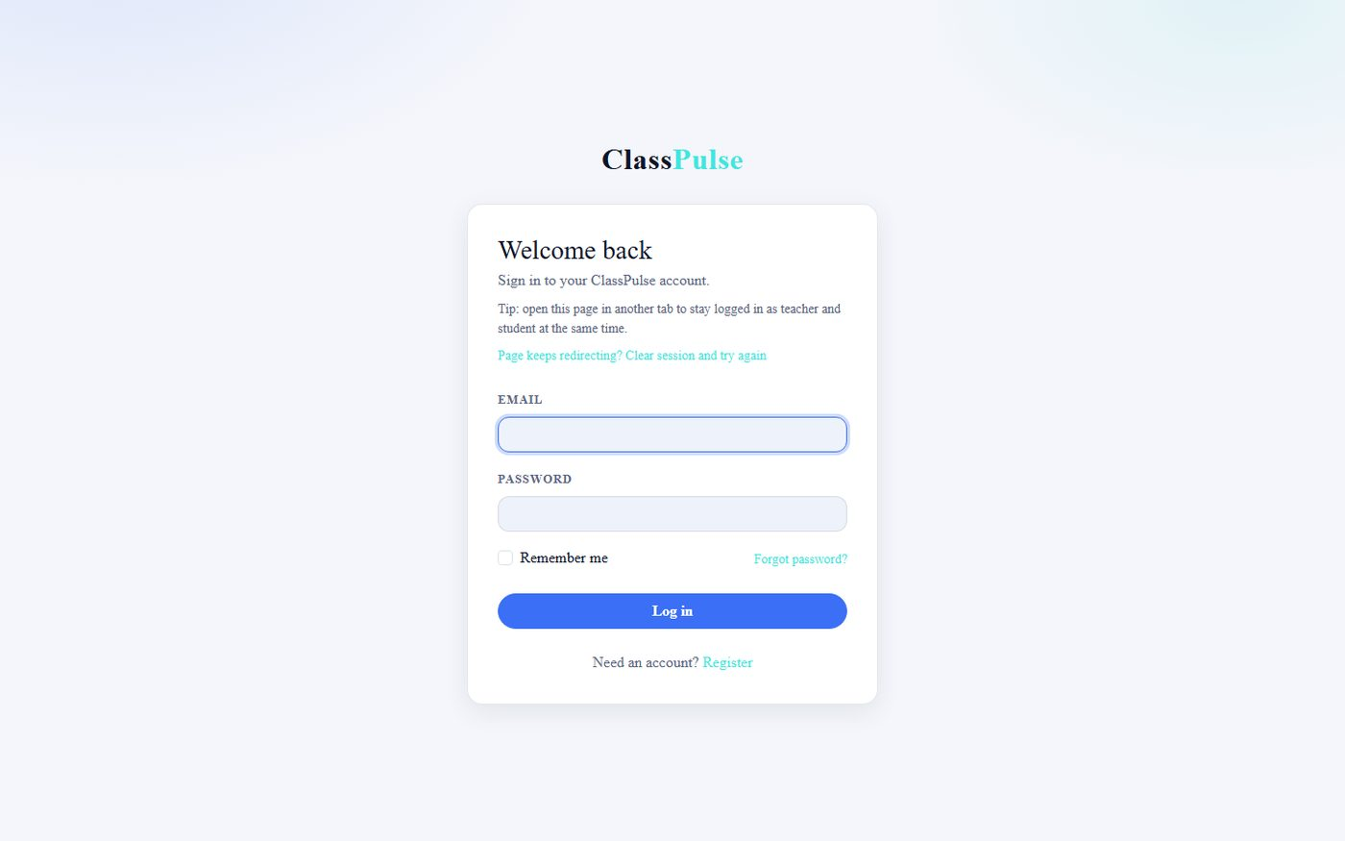
Figure 3. Login page.
Relevant files: app/Support/ZoneAuth.php; app/Http/Controllers/Auth/; app/Http/Middleware/; routes/web.php; resources/views/auth/.
Classroom Management and Student Join
User capabilities
- Teachers create, edit, and deactivate classrooms.
- Each classroom receives a unique six-character room code and a QR payload URL.
- Students join by entering the code (or scanning the QR) and then see the classroom on their dashboard.
Implementation
Room codes are generated through a dedicated service that rejects collisions. The classroom show page presents the code prominently and renders a QR image for projection. Enrollment is stored in classroom_student with a joined_at timestamp. Students cannot enter live sessions for classrooms they have not joined.
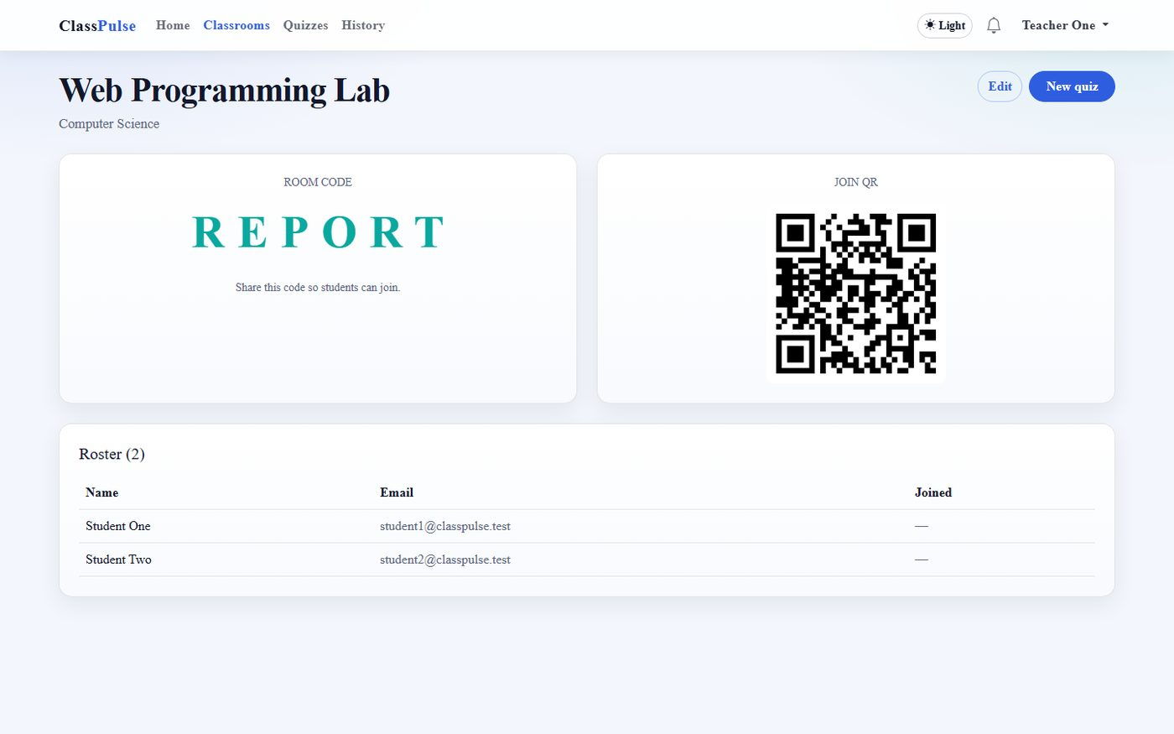
Figure 4. Classroom detail with room code and QR.
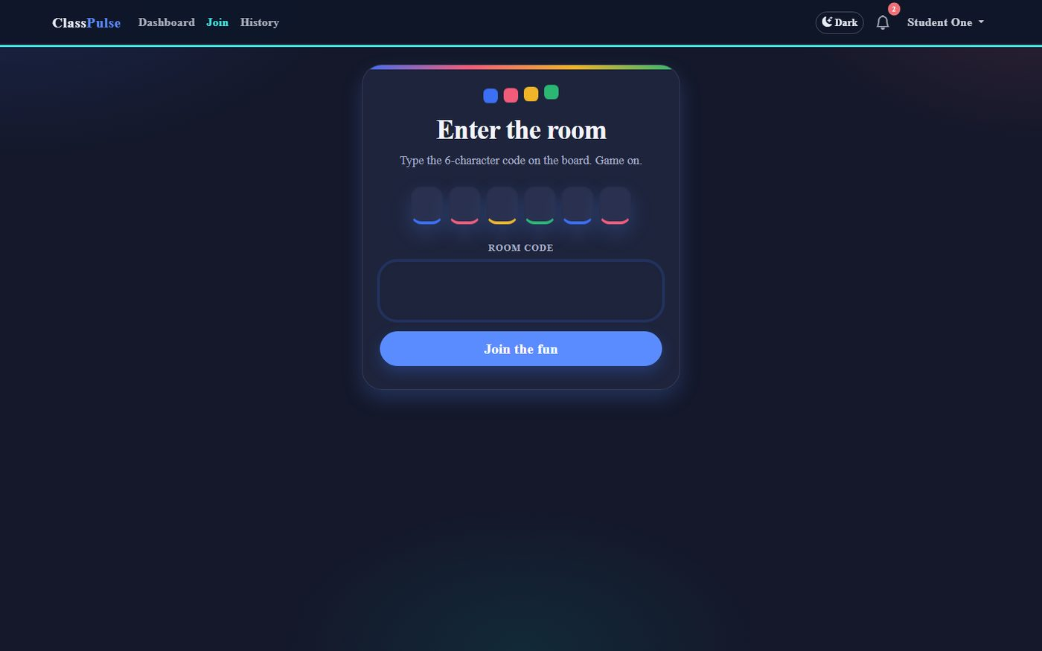
Figure 5. Student join-with-code screen.
Relevant files: app/Models/Classroom.php; app/Services/RoomCodeService.php; app/Services/QrCodeService.php; Teacher/ClassroomController; Student/JoinClassroomController; related Blade views.
Quiz Builder and Question Types
User capabilities
- Create quizzes inside a classroom, publish them, and open them for live play.
- Add multiple-choice items (exactly four options, one correct), true/false items, and fill-in-the-blank items.
- Configure points, per-question timers, and ordering.
Implementation
Form requests enforce type-specific rules (for example, four MCQ choices). Questions and options are persisted inside a database transaction so a failed option write cannot leave an incomplete question. Fill-in answers are graded case-insensitively after trimming surrounding whitespace, which keeps classroom scoring fair without accepting free-form paraphrases.
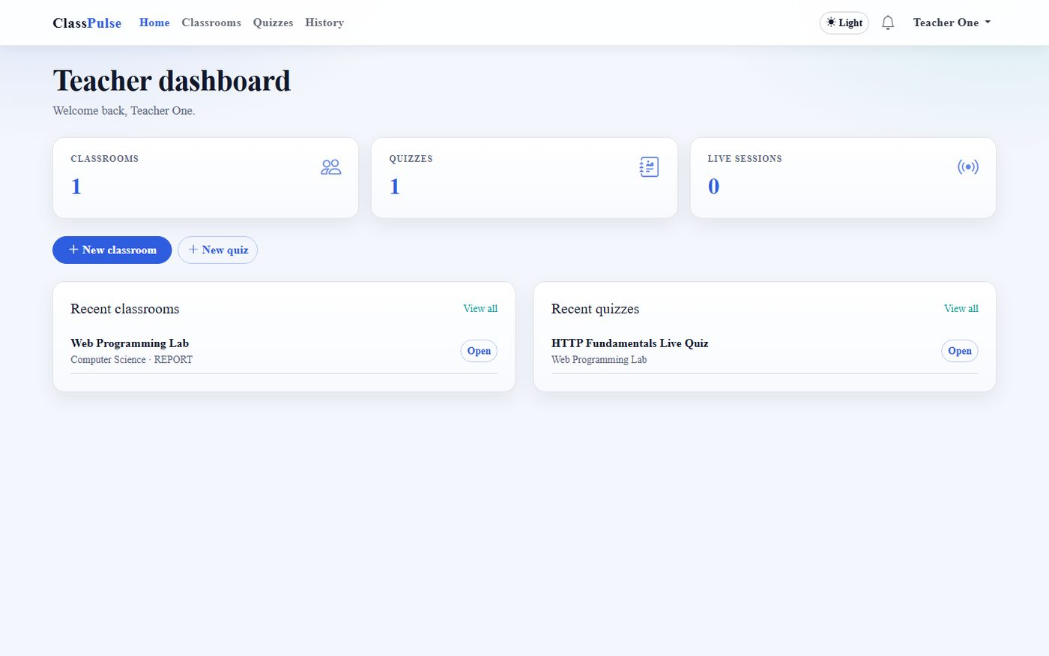
Figure 6. Teacher dashboard.
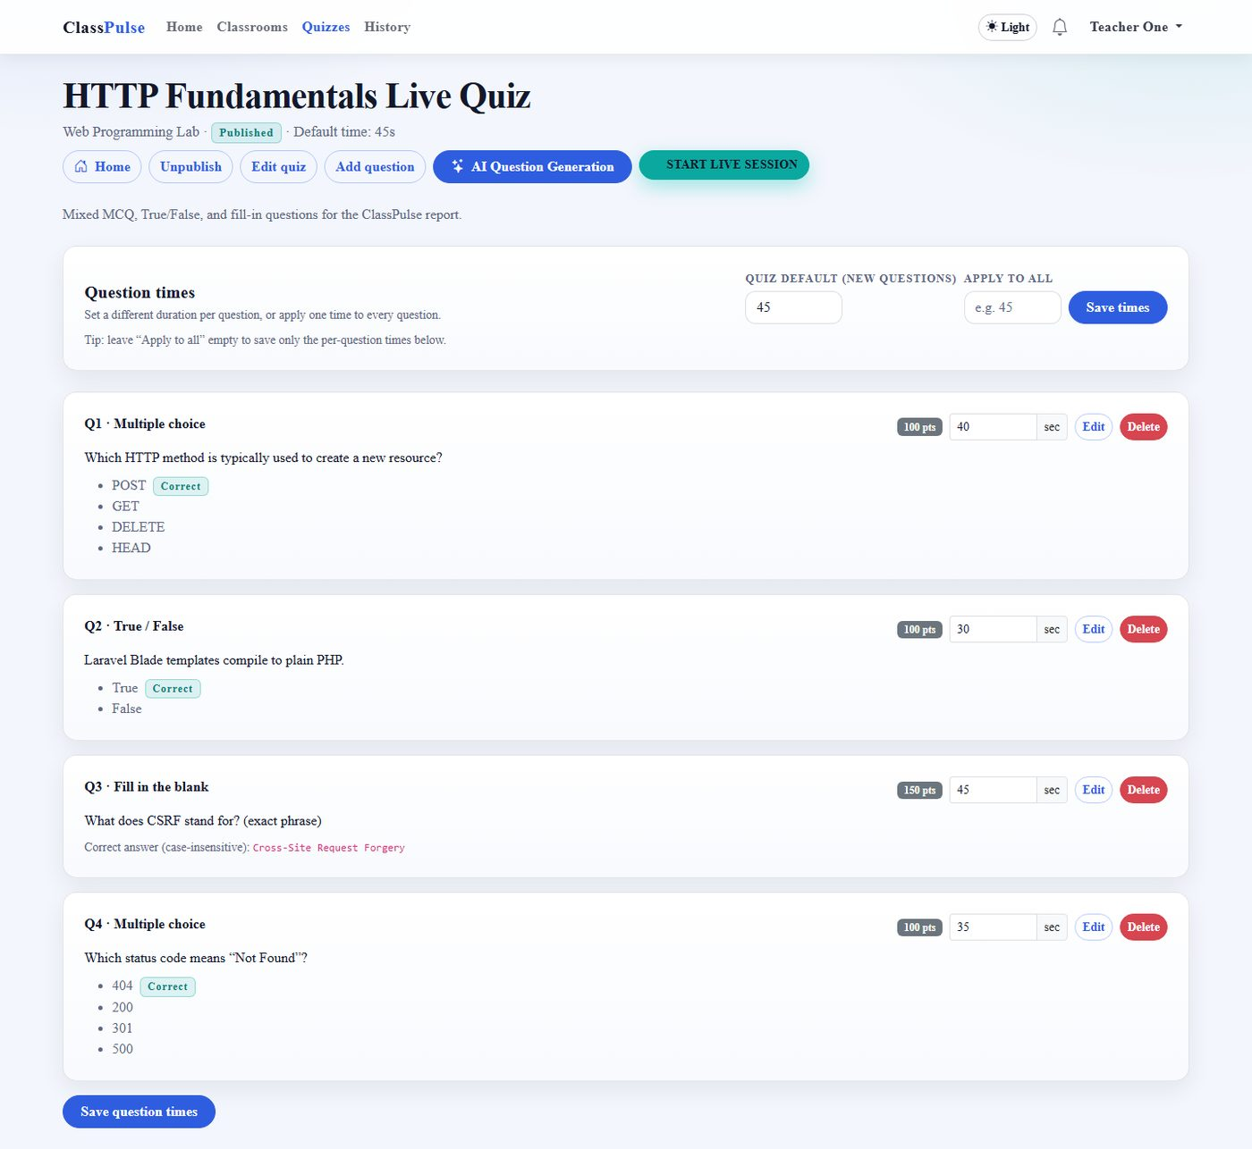
Figure 7. Quiz detail with mixed question types.
AI-Assisted Question Generation
User capabilities
- From a quiz page, open the AI generator, enter a topic, choose difficulty and count, and request questions.
- Review generated items before they become part of the live quiz.
Implementation
AiQuestionGeneratorService calls the OpenAI Chat Completions API with a strict JSON schema prompt. The service never returns the API key to the browser; failures surface as a generic user-facing message while details are logged server-side. Generated payloads are normalized into ClassPulse question rows (MCQ / true-false / short answer) with safe defaults for points and timers.
Snippet — constrained generation prompt (excerpt)
Rules:
- Allowed types ONLY: mcq, true_false, short_answer.
- MCQ: exactly 4 options, exactly one is_correct true.
- true_false: options "True" / "False", exactly one correct.
- short_answer: options [], set short_answer_expected.
- Matching is case-insensitive and trims surrounding spaces.

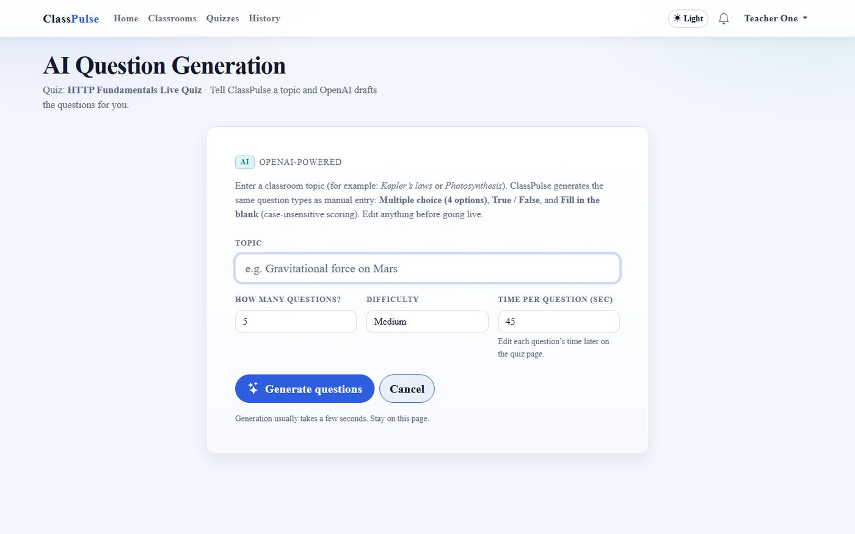
Figure 8. AI question generator form.
Relevant files: app/Services/AiQuestionGeneratorService.php; Teacher/AiQuestionController.php; config/services.php; resources/views/teacher/questions/ai-generate.blade.php.
Live Session Control Room
User capabilities
- Start a live session from a published quiz (draft quizzes can auto-publish on start).
- Pause and resume accepting answers; reveal the correct option; advance or skip questions.
- Adjust the remaining time (including shortening below the base limit) and end the session.
- Open a projector-friendly leaderboard view.
Implementation
Starting live creates an active quiz_sessions row and notifies enrolled students. Starting a new session ends any unfinished sessions for that teacher so dashboards never show stale LIVE banners. The control room polls response counters, answer distributions, and leaderboard JSON. LiveSessionAdvanceService can also auto-advance when the timer expires or when every student who actually joined the live room has answered—absent classmates are not waited on indefinitely.
Snippet — auto-advance when present players finish (excerpt)
$activeIds = $this->participants->activeStudentIds($session);
$answered = SessionResponse::query()
->where('quiz_session_id', $session->id)
->where('question_id', $question->id)
->whereIn('student_id', $activeIds)
->count();
return $answered >= count($activeIds) && count($activeIds) >= 1;

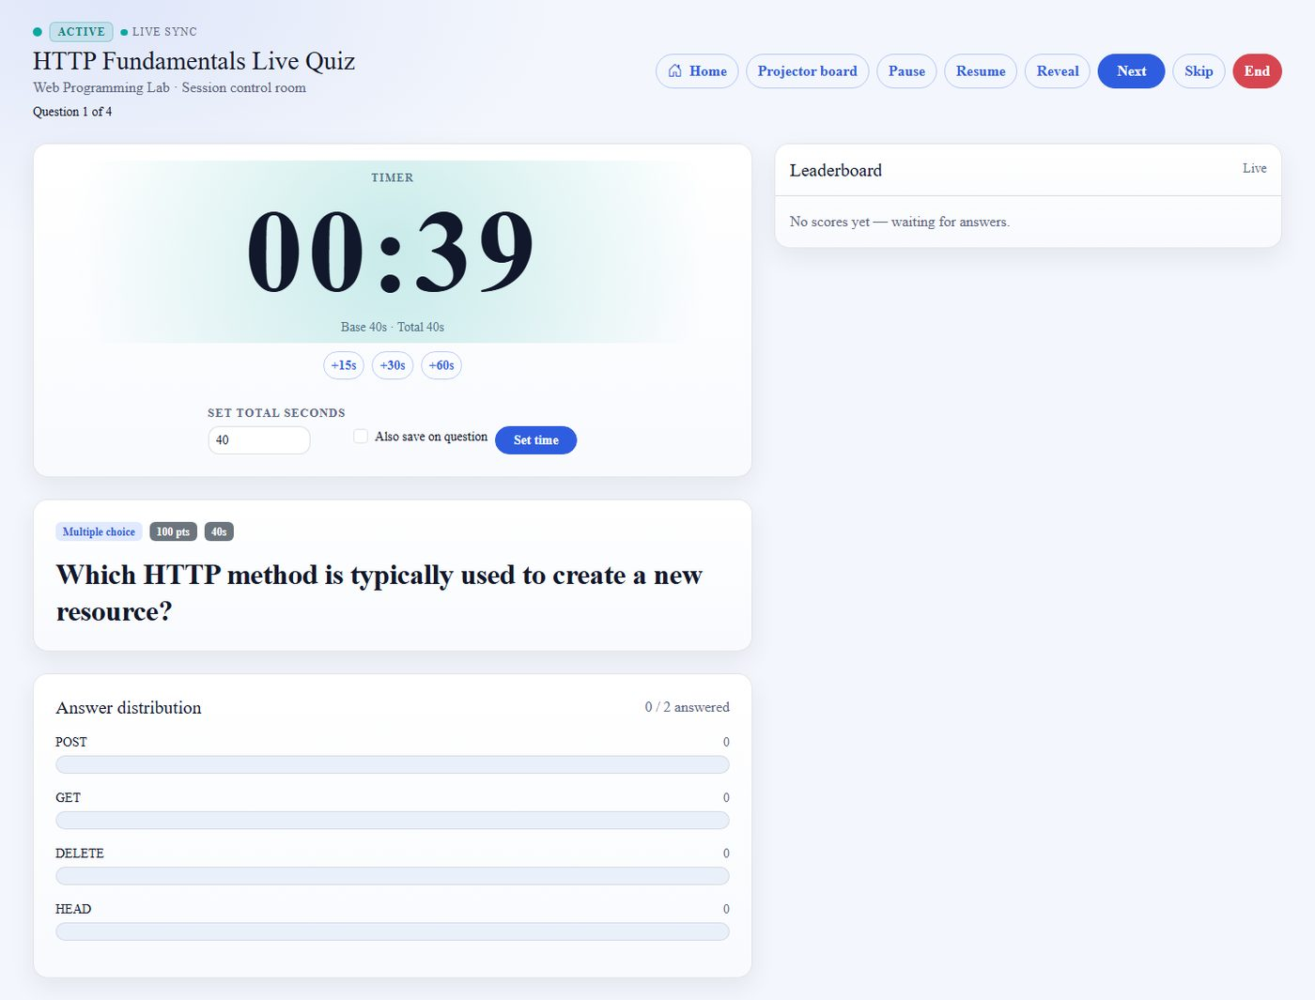
Figure 9. Teacher live control room.
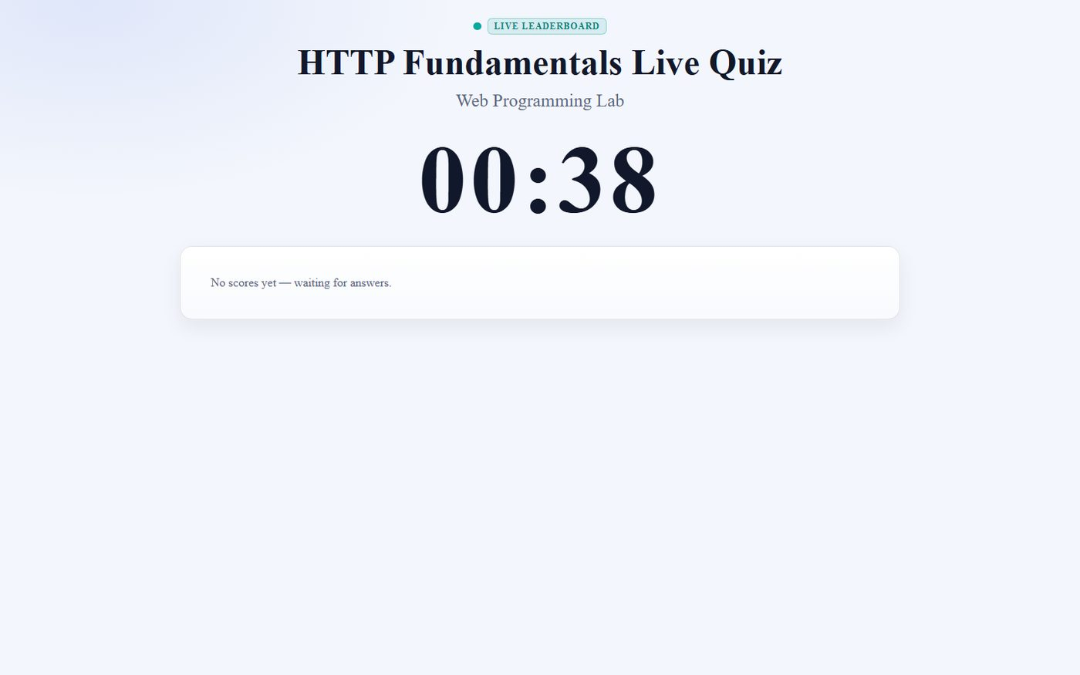
Figure 10. Projector leaderboard.
Relevant files: Teacher/LiveSessionController; LiveSessionAdvanceService; LiveParticipationService; public/js/live-session-teacher.js; teacher live Blade views.
Student Live Answering and Polling
User capabilities
- See a LIVE banner when the teacher starts a session and jump into the answer UI.
- Select colored option tiles (with clear selected-state feedback) or type a fill-in answer.
- Lock an answer before the deadline; late submissions score zero on the server.
- Follow question changes automatically as the teacher advances or auto-advance fires.
Implementation
Students do not receive WebSocket pushes. Instead, ClassPulsePoller repeatedly requests session state JSON containing the current question, timer anchors (question_started_at, server_now), answered flags, and reveal state. Client timers countdown locally but resync from the server to limit drift. Correctness and points stay hidden until the teacher reveals answers, matching Socrative-style pacing.
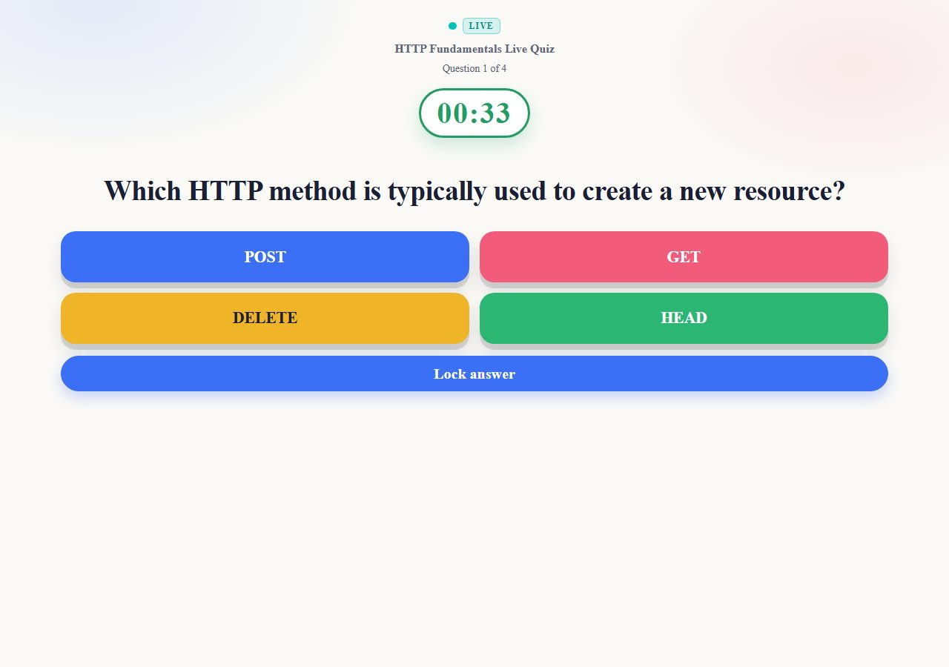
Figure 11. Student answering a live MCQ.
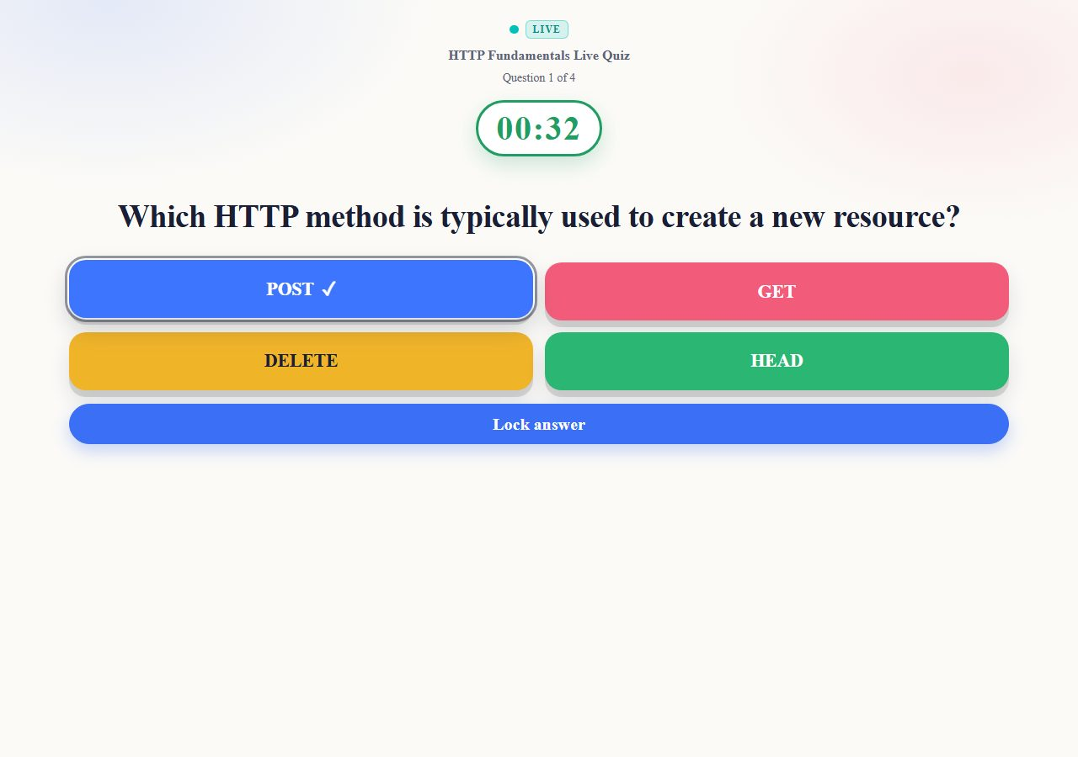
Figure 12. Selected option border / checkmark feedback.
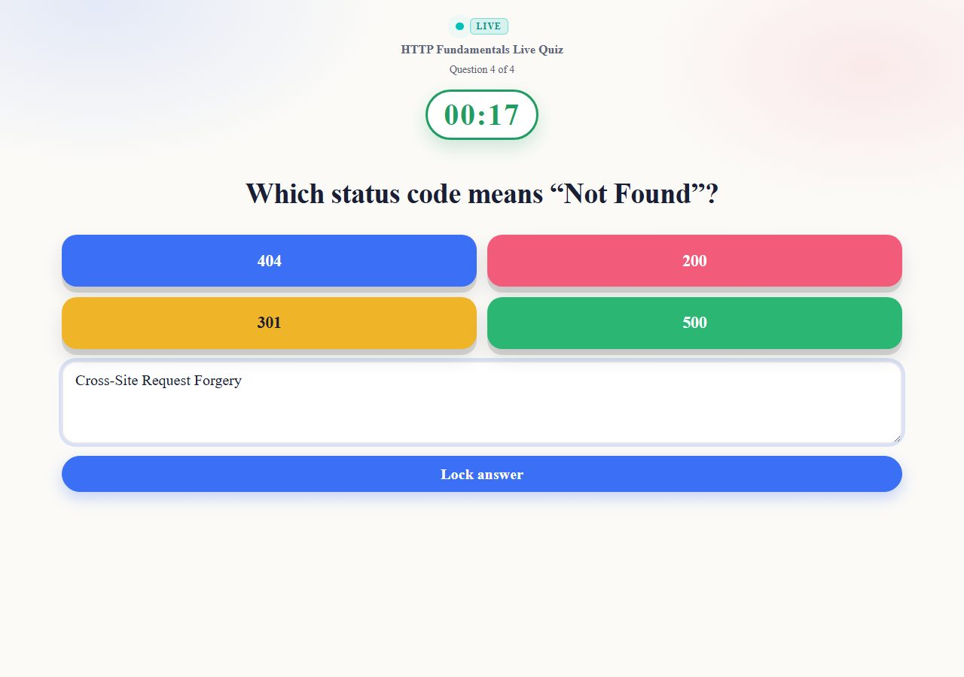
Figure 13. Fill-in-the-blank response during a live session.
Relevant files: Student/LiveAnswerController; Api/PollController; public/js/live-session-student.js; public/js/classpulse-poll.js; public/js/live-timer.js.
Scoring and Leaderboards
User capabilities
- Receive automatic grading for MCQ, true/false, and fill-in answers.
- Earn higher points for faster correct responses within the time window.
- View ranks on the live leaderboard and on post-session results.
Implementation
ScoringService evaluates correctness, then applies a Kahoot-inspired curve: a correct answer earns between 50% and 100% of base points depending on response time. Incorrect or late answers earn zero. Leaderboards are derived with GROUP BY over session_responses rather than a separate ranks table, which keeps totals consistent with stored awards.
Snippet — speed-weighted points (ScoringService)
$factor = 1 - (($clampedMs / $limitMs) * 0.5);
$score = (int) round($base * $factor);
$min = (int) round($base * 0.5);
return max($min, min($base, $score));

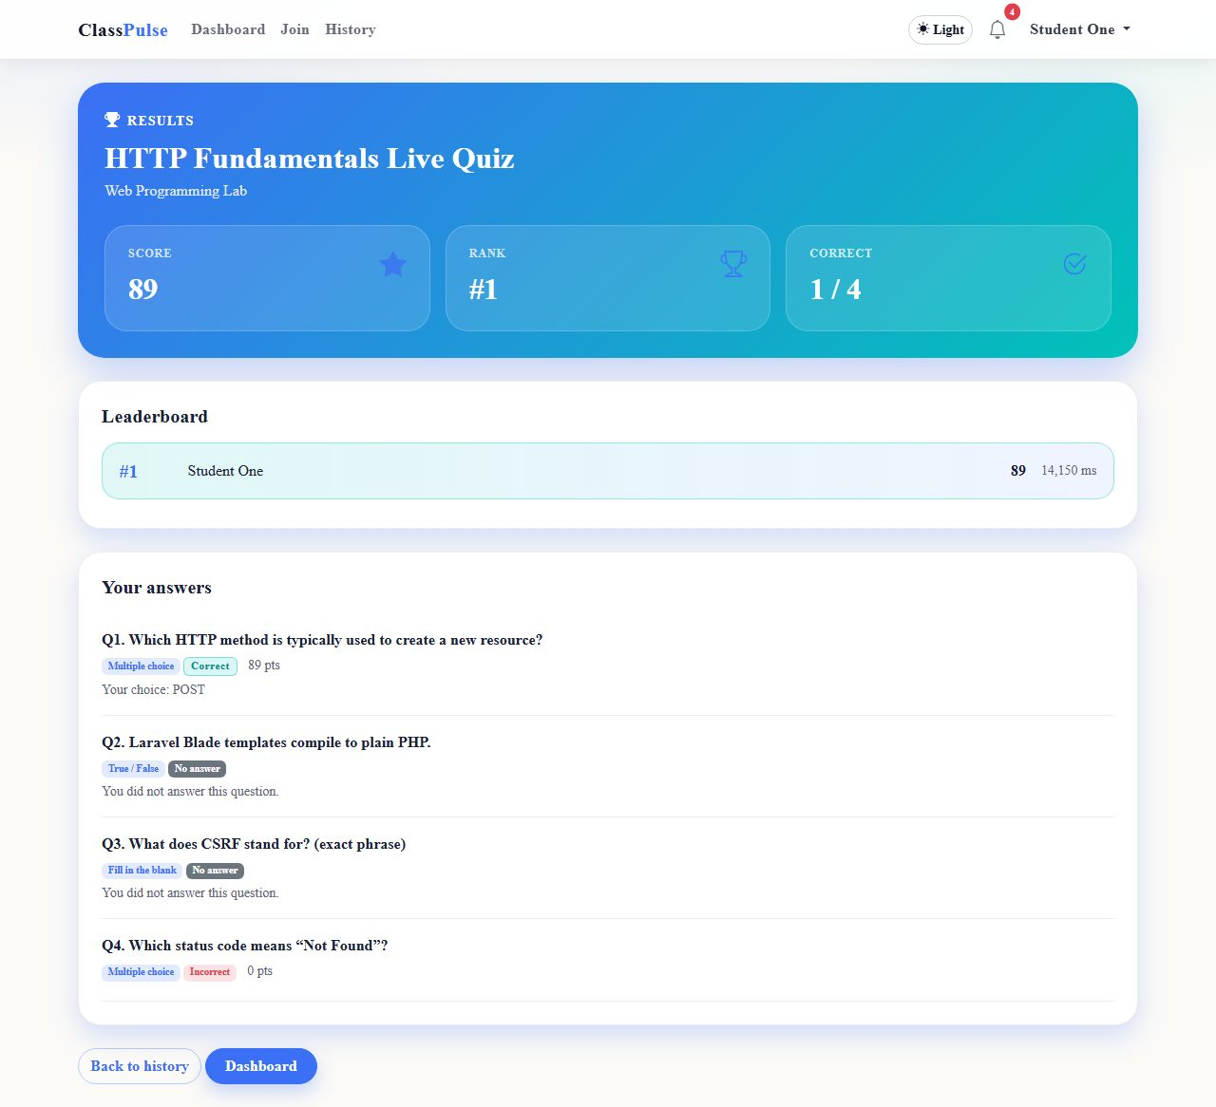
Figure 14. Student session result summary.
Relevant files: app/Services/ScoringService.php; app/Services/LeaderboardService.php; PollController leaderboard endpoint; student result views.
Analytics, History, and Export
User capabilities
- Teachers open per-session analytics with participation and item-level insight.
- Export response data as CSV for archival or marking records.
- Students and teachers browse history of past live sessions.
Implementation
Analytics controllers aggregate responses into structures consumed by Blade and Chart.js. CSV export streams tabular rows for the session. History indexes ended sessions for the authenticated teacher or the classrooms a student has joined.
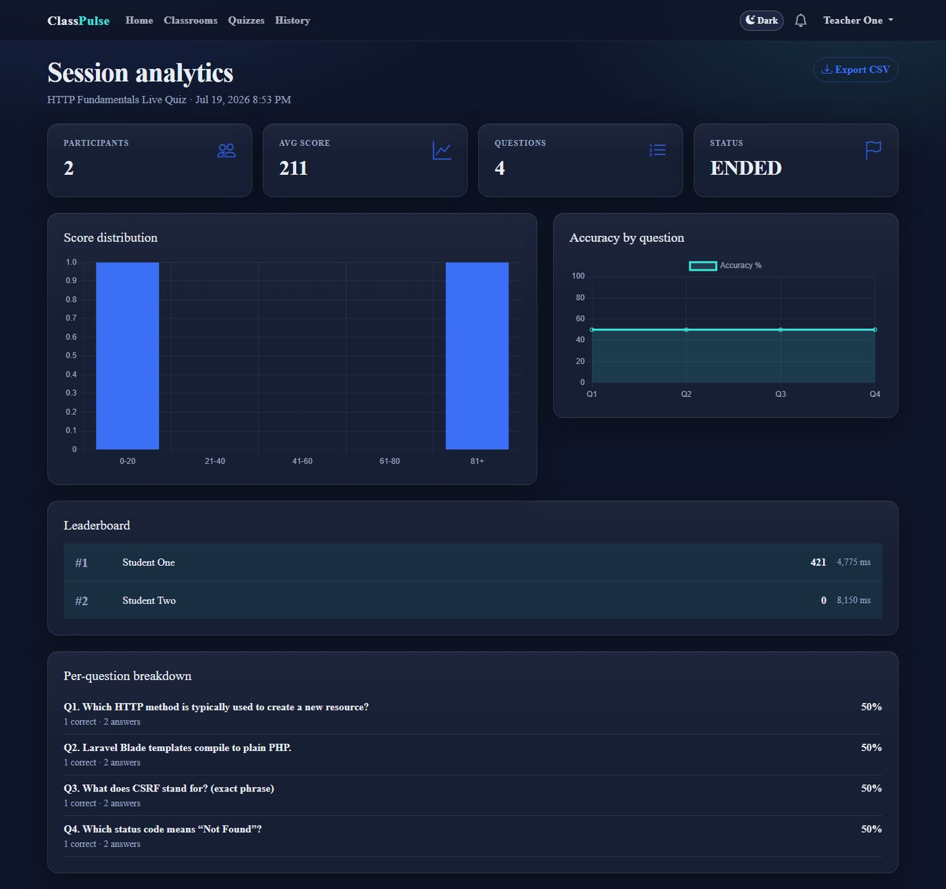
Figure 15. Teacher session analytics.
Relevant files: Teacher/SessionAnalyticsController; Teacher/HistoryController; Student/HistoryController; Student/SessionResultController; analytics Blade + Chart.js.
Administration and Notifications
User capabilities
- Administrators view platform statistics, search users, and suspend or activate accounts.
- Inspect an activity log of significant actions (login, session start/end, and similar events).
- All roles receive in-app notifications (for example, session started) with unread polling.
Implementation
Admin controllers scope privileged operations behind AdminMiddleware. ActivityLogService records structured actions with optional IP metadata. Notifications are persisted rows; the navbar bell polls an unread endpoint so new live-session alerts appear without a full refresh.
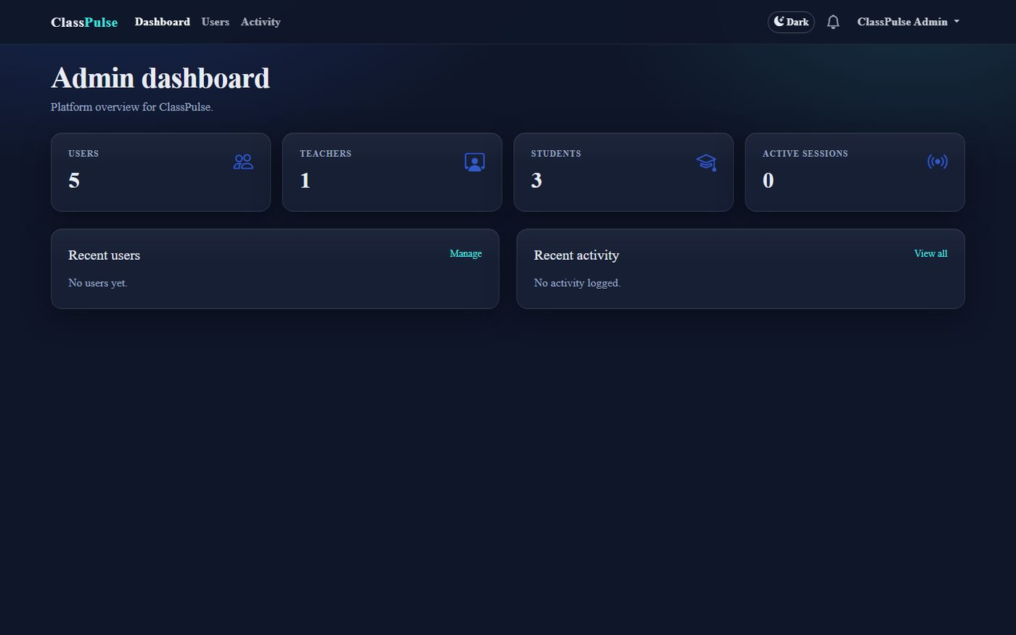
Figure 16. Admin dashboard.
Relevant files: Admin/* controllers; ActivityLogService; NotificationService; notifications views and JS.
Middleware, Authorization, and Request Security
Cross-cutting protection follows Laravel’s web stack: sessions, cookies, CSRF validation, route-model binding, authentication, guest restrictions, and throttling on sensitive routes including poll endpoints. Role middleware confines /teacher, /student, and /admin prefixes. Controller checks further confirm classroom membership or ownership before mutating quizzes or reading live session data. Poll JSON never exposes correctness flags until reveal_answer is true.
Relevant files: bootstrap/app.php; app/Http/Middleware/*; Form requests under app/Http/Requests/; routes/web.php.
Database Functionality and Data Integrity
The relational schema is responsible for durable ownership links and efficient live queries:
- Primary and foreign keys identify records and enforce teacher/classroom/quiz ownership.
- The classroom_student pivot implements many-to-many enrollment.
- Cascading foreign keys remove dependent questions, options, and responses when parents are deleted.
- A unique index on (quiz_session_id, question_id, student_id) prevents double answers under concurrent submit.
- Leaderboard-friendly indexes support aggregation during polling.
- Eloquent casts normalize booleans, timestamps, and related attributes for controllers and Blade.
Local development commonly uses SQLite; MySQL remains supported through the same migrations for XAMPP-style laboratory setups.
JavaScript Polling and Client Behavior
The frontend is intentionally modest: Blade delivers HTML, and focused scripts enhance live pages. ClassPulsePoller centralizes Fetch polling with CSRF and zone headers. Live timer modules compute remaining seconds from server timestamps. Student and teacher live scripts apply poll payloads to the DOM (question text, option tiles, counters, leaderboard rows) and submit answers as JSON. Client code never becomes the authority for scoring or authorization—every mutation is revalidated by Laravel.
Relevant files: public/js/classpulse-poll.js; live-session-student.js; live-session-teacher.js; live-timer.js; theme.js; notifications.js; public/css/classpulse.css.
Conclusion
ClassPulse demonstrates a complete live classroom quiz system suitable for a university web programming / database laboratory setting. Its main achievement is combining conventional course features—multi-role authentication, classrooms, quiz authoring, analytics, and administration—with technically meaningful live behavior: zone-isolated sessions, Fetch polling, server-trusted timers, speed-weighted scoring, auto-advance for present participants, and optional AI question generation—without requiring WebSockets.
The architecture assigns clear responsibilities. Laravel controls security, validation, persistence, and integrations; Blade renders role-appropriate interfaces; vanilla JavaScript supplies polling and interaction; and the relational database enforces integrity for enrollments, live answers, and historical analytics. The system is functional and extensible. Future work could include broader load testing of concurrent classrooms, richer accessibility reviews, and optional push transport if hosting constraints change.
Project repository / local application: ClassPulse (Laravel 12)
Submitted by: Azmaeen Nur Sajin | Roll: 2207113 | Section: B
Course: CSE 3100 — Database Systems Laboratory

