***Project Report***



Code : CSI_224

Title : {Database Mamagement System}

Course Teacher : Tanvir Rahman

**TEAM MEMBERS**

**1**

**Name :** **Hafiz Bin Azman Arnob**

**ID :** **CSE 069 08022**

**Batch No :** **69(B)**

**2**

**Name :** **HRidoy hasan nirob**

**ID :** **CSE 069 08025**

**Batch No :** **69(B)**

**3**

**Name :** **Farhan mahmud**

**ID :** **CSE 069 08016**

**Batch No :** **69(B)**

**INtroduction**

It is safe to say that now a days the vehicles increase day by day.When a driver management system is deployed, documents and training requirements can be managed more easily, ensuring compliance and safety. Technology can also help drivers optimize their working hours and routes, becoming more productive, but without overexerting themselves.

In our project, we will build a complete management system for an driver management system, creating an information-

sharing to the manager.This research work aims to provide a solution to the problem of driver management by designing a

user-friendly computerized system that will be compatible with the existing manual systems. The database to be developed will solve driver management's problem, thus helping to reduce issues associated with the manual driver management system.

**Scenario Description**

Answer:-

In an "Transport Management System," an Branch_office might appoint a manager. One Branch_office might appoint one manager and one manager manages only one branch.Every Branch has an unique id By which they were represented distinctly. the system stores Branch_id, Manager_id, MANAGER_NAME, ADDRESS, TRASPORT_ID. One Branch must manages exactly one TRASPORT, but sometimes one manager can manage multiple TRASPORT. Every Trasport has their own unique id.This system stores the T_ID, V_NAME, V_REGISTRATION, and D_ID. One Branch must need one but also can own more drives .A Transport can be driven by only one Driver but one Driver can assing to many Transport. This system also records D_ID, D_NAME ,L_NUM ,D_PHN. An D_id identifies every Drivers distictly.

**eR DIAGRAM**

Drive

Own

Has

Transport

Branch_Office

Drivers

TABLE CREATE

1.Branch_Office:-

SQL:-

CREATE TABLE Branch_Office(

branch_id Varchar(20),

Manager_id Varchar(20),

Manager_name Varchar(30),

Manager_Number Varchar(15),

Address Varchar(50),

Trasport_id Varchar(20),

primary key(branch_id ) ,

Unique(Manager_id ,Trasport_id,Manager_Number)

);

OUTPUT:-

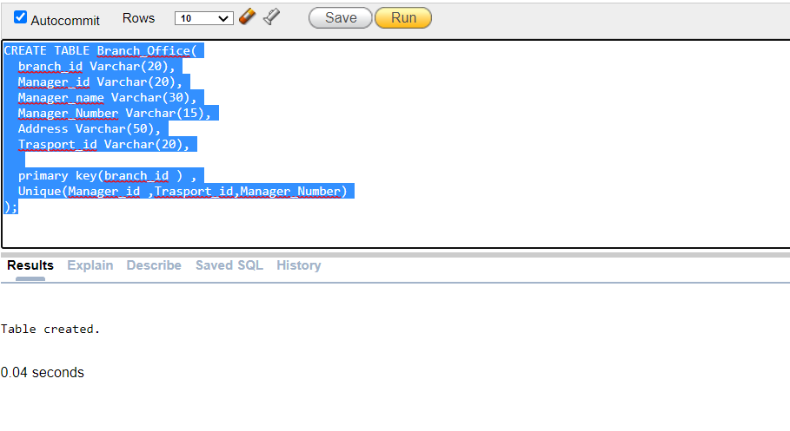

2.Transport:-

SQL:-

CREATE TABLE Transport(

t_id Varchar(20),

d_id Varchar(10),

v_registration Varchar(30),

v_name Varchar(15),

primary key(t_id) ,

Unique(d_id ,v_registration)

);

OUTPUT:-

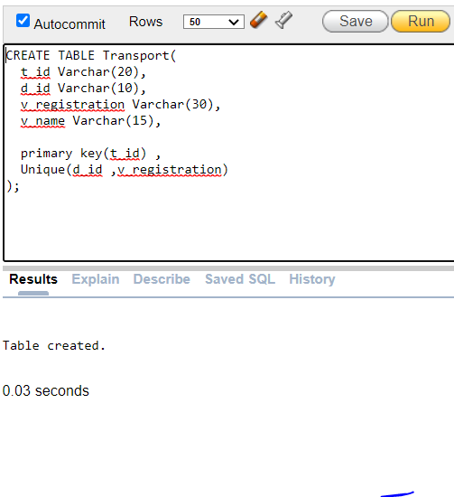

3.Drivers:-

SQL:-

create table drivers(

D_id varchar(10),

D_name varchar(30),

L_num varchar(10),

D_phn int,

primary key(D_id),

unique(L_num, D_phn)

);

OUTPUT:-

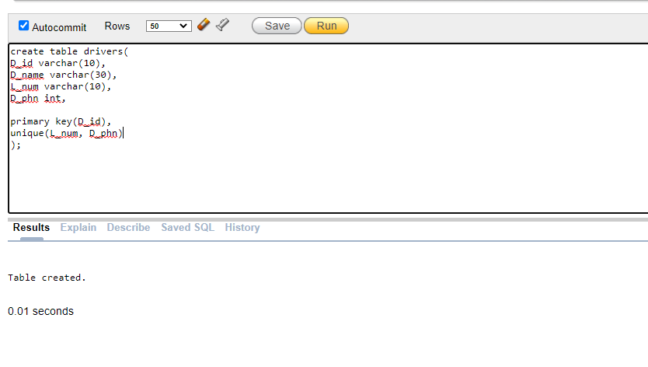

TABLE DATA INSERT

1.Branch_Office:-

SQL:-

1.insert into Branch_Office(branch_id ,Manager_id ,Manager_name ,Manager_Number ,Address ,Trasport_id ) values('br1','A1','Arnob','01234567899','Dhaka','tr101')

2.insert into Branch_Office(branch_id ,Manager_id ,Manager_name ,Manager_Number ,Address ,Trasport_id ) values('br2','A2','Azman','01234567999','Dhaka','tr102')

3.insert into Branch_Office(branch_id ,Manager_id ,Manager_name ,Manager_Number ,Address ,Trasport_id ) values('br3','B3','Hafiz','01234567990','Khulna','tr201')

4.insert into Branch_Office(branch_id ,Manager_id ,Manager_name ,Manager_Number ,Address ,Trasport_id ) values('br4','B4','tofayel','01234567880','Khulna','tr202')

5.insert into Branch_Office(branch_id ,Manager_id ,Manager_name ,Manager_Number ,Address ,Trasport_id ) values('br5','B5','topu','01234567680','Khulna','tr203')

6.insert into Branch_Office(branch_id ,Manager_id ,Manager_name ,Manager_Number ,Address ,Trasport_id ) values('br6','B6','Shanto','01234567870','Khulna','tr204')

7.insert into Branch_Office(branch_id ,Manager_id ,Manager_name ,Manager_Number ,Address ,Trasport_id ) values('br8','D7','Ria','01234577870','Cumilla','tr301')

8.insert into Branch_Office(branch_id ,Manager_id ,Manager_name ,Manager_Number ,Address ,Trasport_id ) values('br9','D8','Parvez','01236567870','Cumilla','tr302')

9.insert into Branch_Office(branch_id ,Manager_id ,Manager_name ,Manager_Number ,Address ,Trasport_id ) values('br10','A3','Porna','01336567870','Dhaka','tr103')

10.insert into Branch_Office(branch_id ,Manager_id ,Manager_name ,Manager_Number ,Address ,Trasport_id ) values('br7','D9','Dipon','01236667870','Cumilla','tr303')

11.insert into Branch_Office(branch_id ,Manager_id ,Manager_name ,Manager_Number ,Address ,Trasport_id ) values('br11','C1','Amir','01234567199','Chittagong','tr401')

12.insert into Branch_Office(branch_id ,Manager_id ,Manager_name ,Manager_Number ,Address ,Trasport_id ) values('br22','C2','Farhan','01234567299','Chittagong','tr402')

13.insert into Branch_Office(branch_id ,Manager_id ,Manager_name ,Manager_Number ,Address ,Trasport_id ) values('br13','E3','Moriom','01234567993','Barisal','tr501')

14.insert into Branch_Office(branch_id ,Manager_id ,Manager_name ,Manager_Number ,Address ,Trasport_id ) values('br14','E4','Tisha','01234567880','Barisal','tr502')

15.insert into Branch_Office(branch_id ,Manager_id ,Manager_name ,Manager_Number ,Address ,Trasport_id ) values('br15','E5','Amy','01234567680','Barisal','tr503')

16.insert into Branch_Office(branch_id ,Manager_id ,Manager_name ,Manager_Number ,Address ,Trasport_id ) values('br16','E6','Rownok','01234567870','Barisal','tr504')

17.insert into Branch_Office(branch_id ,Manager_id ,Manager_name ,Manager_Number ,Address ,Trasport_id ) values('br18','F7','Rumi','01234577770','Faridpur','tr601')

18.insert into Branch_Office(branch_id ,Manager_id ,Manager_name ,Manager_Number ,Address ,Trasport_id ) values('br19','F8','Polin','01236577870','Faridpur','tr602')

19.insert into Branch_Office(branch_id ,Manager_id ,Manager_name ,Manager_Number ,Address ,Trasport_id ) values('br20','C3','Porna','01336567870','Chittagong','tr403')

20.insert into Branch_Office(branch_id ,Manager_id ,Manager_name ,Manager_Number ,Address ,Trasport_id ) values('br27','F9','Nirob','01235677870','Faridpur','tr603')

21.insert into Branch_Office(branch_id ,Manager_id ,Manager_name ,Manager_Number ,Address ,Trasport_id ) values('br12','A4','Purob','01244567899','Dhaka','tr104')

22.insert into Branch_Office(branch_id ,Manager_id ,Manager_name ,Manager_Number ,Address ,Trasport_id ) values('br17','D2','Pius','01243667899','Cumilla','tr304')

23.insert into Branch_Office(branch_id ,Manager_id ,Manager_name ,Manager_Number ,Address ,Trasport_id ) values('br21','B1','Efty','01214567899','Khulna','tr205')

24.insert into Branch_Office(branch_id ,Manager_id ,Manager_name ,Manager_Number ,Address ,Trasport_id ) values('br23','B2','Isika','01114567899','Khulna','tr206')

25.insert into Branch_Office(branch_id ,Manager_id ,Manager_name ,Manager_Number ,Address ,Trasport_id ) values('br24','C4','Rakib','01014567899','Chittagong','tr404')

26.insert into Branch_Office(branch_id ,Manager_id ,Manager_name ,Manager_Number ,Address ,Trasport_id ) values('br26','A6','Robin','01014567299','Dhaka','tr106')

27.insert into Branch_Office(branch_id ,Manager_id ,Manager_name ,Manager_Number ,Address ,Trasport_id ) values('br25','C5','Robin','01014567899','Dhaka','tr405')

28.insert into Branch_Office(branch_id ,Manager_id ,Manager_name ,Manager_Number ,Address ,Trasport_id ) values('br28','A5','Rakib','01204567199','Dhaka','tr105')

29. insert into Branch_Office(branch_id ,Manager_id ,Manager_name ,Manager_Number ,Address,Trasport_id ) values('br29','A6','Robin','01014567299','Dhaka','tr106')

30.insert into Branch_Office(branch_id ,Manager_id ,Manager_name ,Manager_Number ,Address ,Trasport_id ) values('br30','E1','Sumon','01012567399','Barisal','tr505')

31.insert into Branch_Office(branch_id ,Manager_id ,Manager_name ,Manager_Number ,Address ,Trasport_id ) values('br31','E2','Samira','01230567499','Barisal','tr506')

32.insert into Branch_Office(branch_id ,Manager_id ,Manager_name ,Manager_Number ,Address ,Trasport_id ) values('br32','F2','Priti','01332567870','Faridpur','tr604')

33. insert into Branch_Office(branch_id ,Manager_id ,Manager_name ,Manager_Number ,Address,Trasport_id ) values('br33','D6','Rifat','01243997899','Cumilla','tr306')

34.insert into Branch_Office(branch_id ,Manager_id ,Manager_name ,Manager_Number ,Address ,Trasport_id ) values('br34','D5','Raju','01243977899','Cumilla','tr305')

35. insert into Branch_Office(branch_id ,Manager_id ,Manager_name ,Manager_Number ,Address,Trasport_id ) values('br35','F5','Punom','01332561770','Faridpur','tr605')

36. insert into Branch_Office(branch_id ,Manager_id ,Manager_name ,Manager_Number ,Address,Trasport_id ) values('br36','F6','Puja','01332562770','Faridpur','tr606')

37.insert into Branch_Office(branch_id ,Manager_id ,Manager_name ,Manager_Number ,Address ,Trasport_id ) values('br37','F3','Hanif','01332561777','Faridpur','tr607')

38.insert into Branch_Office(branch_id ,Manager_id ,Manager_name ,Manager_Number ,Address ,Trasport_id ) values('br38','F4','Habib','01332562778','Faridpur','tr608')

39.insert into Branch_Office(branch_id ,Manager_id ,Manager_name ,Manager_Number ,Address ,Trasport_id ) values('br39’,'E7','Qurashi','01230566899','Barisal','tr507')

40.insert into Branch_Office(branch_id ,Manager_id ,Manager_name ,Manager_Number ,Address ,Trasport_id ) values('br40','E8','Naruto','01230566999','Barisal','tr508')

41. insert into Branch_Office(branch_id ,Manager_id ,Manager_name ,Manager_Number ,Address,Trasport_id ) values('br41','D3','Akas','01221667899','Cumilla','tr307')

42. insert into Branch_Office(branch_id ,Manager_id ,Manager_name ,Manager_Number ,Address,Trasport_id ) values('br42','D4','Aveer','01222667899','Cumilla','tr308')

43. .insert into Branch_Office(branch_id ,Manager_id ,Manager_name ,Manager_Number ,Address,Trasport_id ) values('br43','C6','Shikha','01914567899', 'Chittagong','tr407')

44. .insert into Branch_Office(branch_id ,Manager_id ,Manager_name ,Manager_Number ,Address,Trasport_id ) values('br44','C7','Saima','01814567899', 'Chittagong','tr408')

45. insert into Branch_Office(branch_id ,Manager_id ,Manager_name ,Manager_Number ,Address,Trasport_id ) values('br45','A7','Sask','01934567899','Dhaka','tr107')

46. insert into Branch_Office(branch_id ,Manager_id ,Manager_name ,Manager_Number ,Address,Trasport_id ) values('br46','A8','Tanveer','01834567899','Dhaka','tr108')

47. insert into Branch_Office(branch_id ,Manager_id ,Manager_name ,Manager_Number ,Address,Trasport_id ) values('br47','A9','Siam','01734567899','Dhaka','tr109')

48. insert into Branch_Office(branch_id ,Manager_id ,Manager_name ,Manager_Number ,Address,Trasport_id ) values('br7','B7','Nafi','01734567870','Khulna','tr207')

49. insert into Branch_Office(branch_id ,Manager_id ,Manager_name ,Manager_Number ,Address,Trasport_id ) values('br8','B8','Raihan','01934567870','Khulna','tr208')

50. insert into Branch_Office(branch_id ,Manager_id ,Manager_name ,Manager_Number ,Address,Trasport_id ) values('br9','B9','Rashed','01834567870','Khulna','tr209')

Output:-

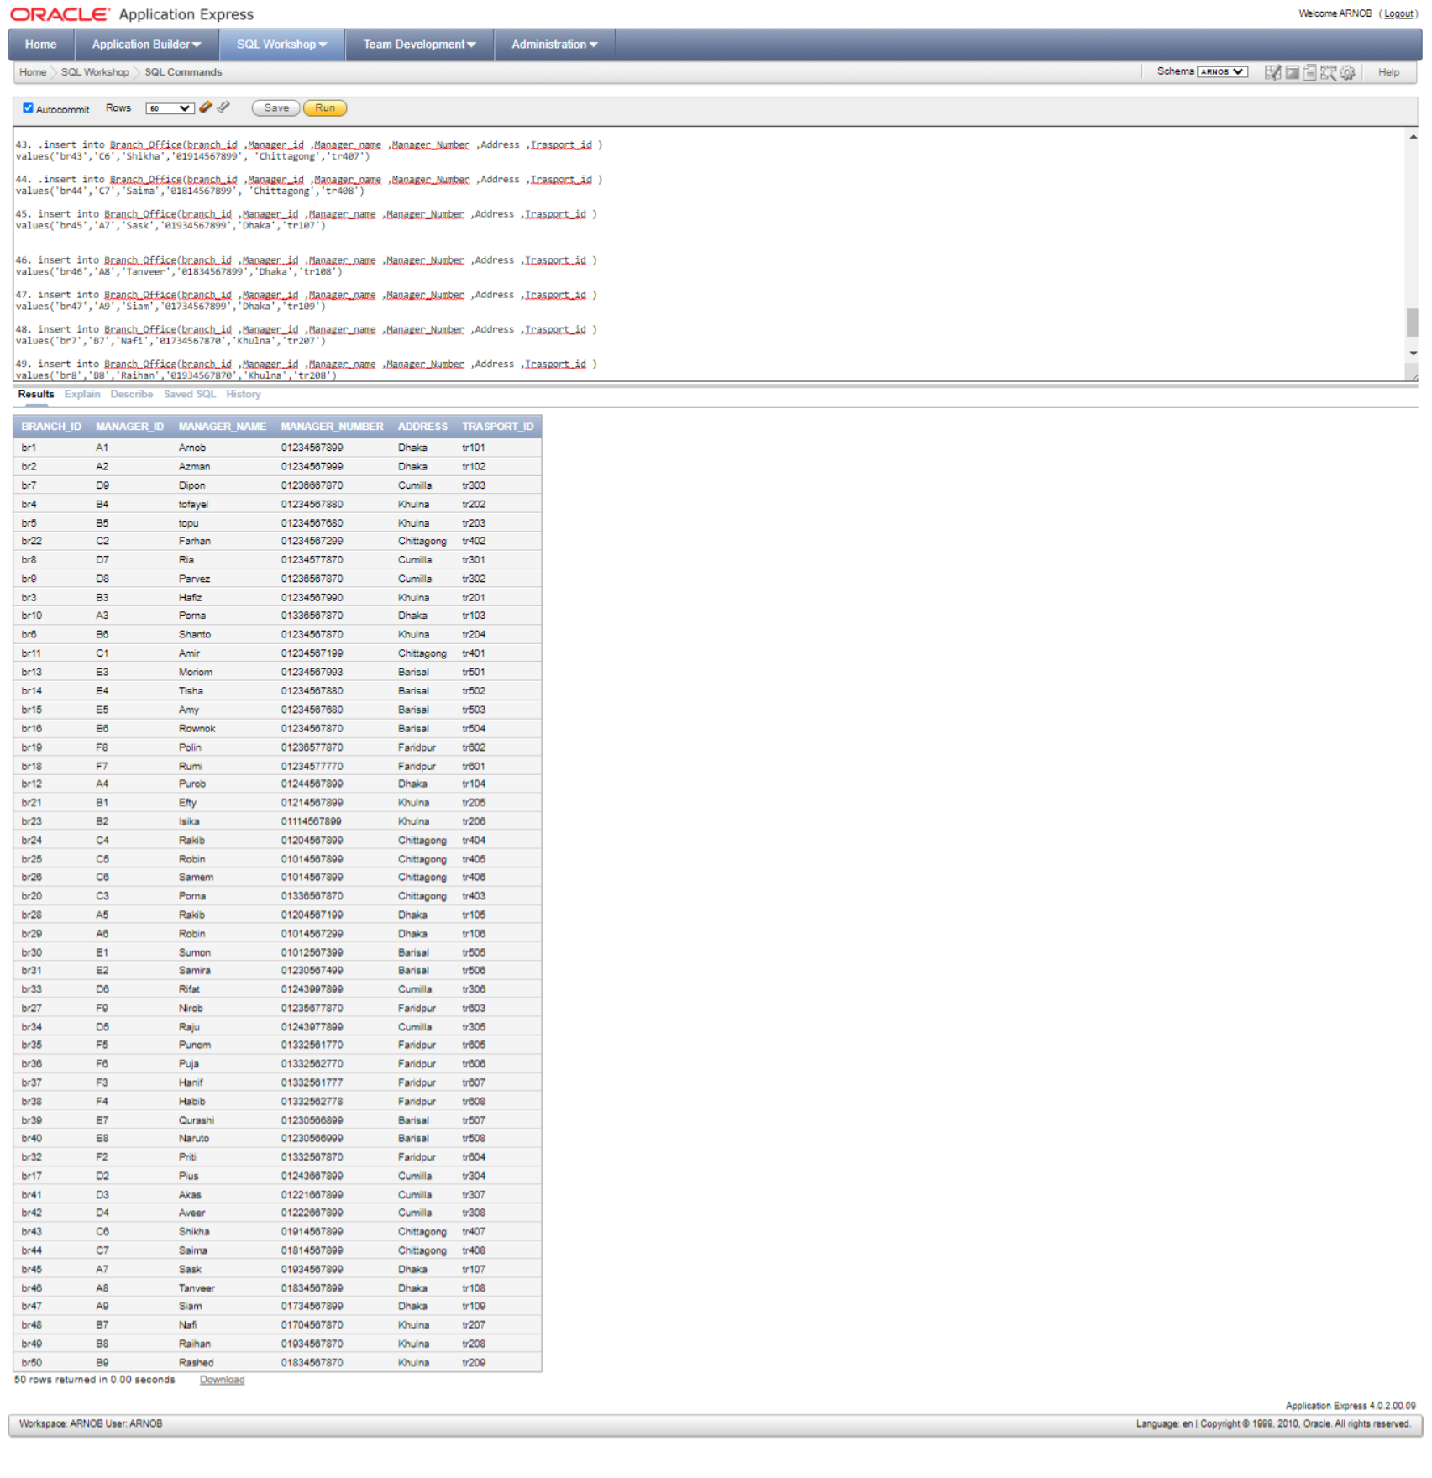

2. Transport:-

SQL:-

1.insert into Transport(t_id,d_id,v_registration,v_name) values('tr101','1001','23451','BUS')

2.insert into Transport(t_id,d_id,v_registration,v_name) values('tr102','1002','23452','BUS')

3.insert into Transport(t_id,d_id,v_registration,v_name) values('tr103','1003','23453','BUS')

4.insert into Transport(t_id,d_id,v_registration,v_name) values('tr104','1004','23454, 33454','BUS')

5.insert into Transport(t_id,d_id,v_registration,v_name) values('tr105','1005','23455, 33455','BUS')

6.insert into Transport(t_id,d_id,v_registration,v_name)values('tr106','10028','234528','Toyota')

7.insert into Transport(t_id,d_id,v_registration,v_name)values('tr107','10029','234529','Toyota')

8.insert into Transport(t_id,d_id,v_registration,v_name)values('tr108','10030','234530','Toyota')

9.insert into Transport(t_id,d_id,v_registration,v_name)values('tr109','10031','234531','Toyota')

10.insert into Transport(t_id,d_id,v_registration,v_name)values('tr201','1006','23456, 23457','BUS')

11.insert into Transport(t_id,d_id,v_registration,v_name)values('tr304','10013','234513','BUS')

12.insert into Transport(t_id,d_id,v_registration,v_name)values('tr202','1007','23457','BUS')

13.insert into Transport(t_id,d_id,v_registration,v_name)values('tr203','1008','23458','BUS')

14.insert into Transport(t_id,d_id,v_registration,v_name)values('tr204','1009','23459','BUS')

15.insert into Transport(t_id,d_id,v_registration,v_name)values('tr205','10000','23400','BUS')

16.insert into Transport(t_id,d_id,v_registration,v_name)values('tr206','10032','234532','Toyota')

17.insert into Transport(t_id,d_id,v_registration,v_name)values('tr207','10033','234533','Toyota')

18.insert into Transport(t_id,d_id,v_registration,v_name)values('tr208','10034','234534','Toyota')

19.insert into Transport(t_id,d_id,v_registration,v_name)values('tr209','10035','234535','Toyota')

20.insert into Transport(t_id,d_id,v_registration,v_name)values('tr301','10010','234510, 334510','BUS')

21.insert into Transport(t_id,d_id,v_registration,v_name)values('tr302','10011','234511 , 334511','BUS')

22.insert into Transport(t_id,d_id,v_registration,v_name)values('tr303','10012','234512,334512','BUS')

23.insert into Transport(t_id,d_id,v_registration,v_name)values('tr305','10014','234514','BUS')

24.insert into Transport(t_id,d_id,v_registration,v_name)values('tr306','10036','234536','Toyota')

25.insert into Transport(t_id,d_id,v_registration,v_name)values('tr307','10037','234537','Toyota')

26.insert into Transport(t_id,d_id,v_registration,v_name)values('tr308','10038','234538','Toyota')

27.insert into Transport(t_id,d_id,v_registration,v_name)values('tr401','100152','2345152','BUS')

28.insert into Transport(t_id,d_id,v_registration,v_name)values('tr402','100151','2345151','BUS')

29.insert into Transport(t_id,d_id,v_registration,v_name)values('tr403','10015','234515','BUS')

30.insert into Transport(t_id,d_id,v_registration,v_name)values('tr404','10016','234516','Corolla')

31.insert into Transport(t_id,d_id,v_registration,v_name)values('tr405','10017','234517','Corolla')

32.insert into Transport(t_id,d_id,v_registration,v_name)values('tr406','10039','234539','Premio')

33.insert into Transport(t_id,d_id,v_registration,v_name)values('tr407','10040','234540','Premio')

34.insert into Transport(t_id,d_id,v_registration,v_name)values('tr408','10041','234541','Premio')

35.insert into Transport(t_id,d_id,v_registration,v_name)values('tr501','10018','234518, 334518','Corolla')

36.insert into Transport(t_id,d_id,v_registration,v_name)values('tr502','10019','234519','Corolla')

37.insert into Transport(t_id,d_id,v_registration,v_name)values('tr503','10020','234520','Corolla')

38.insert into Transport(t_id,d_id,v_registration,v_name)values('tr504','10021','234521','Corolla')

39.insert into Transport(t_id,d_id,v_registration,v_name)values('tr505','10022','234522','Corolla')

40.insert into Transport(t_id,d_id,v_registration,v_name)values('tr506','10042','234542, 334542','Premio')

41.insert into Transport(t_id,d_id,v_registration,v_name)values('tr507','10043','234543','Premio')

42.insert into Transport(t_id,d_id,v_registration,v_name)values('tr508','10044','234544','Premio')

43.insert into Transport(t_id,d_id,v_registration,v_name)values('tr601','10023','234523','Corolla')

44.insert into Transport(t_id,d_id,v_registration,v_name)values('tr602','10024','234524','Corolla')

45.insert into Transport(t_id,d_id,v_registration,v_name)values('tr603','10025','234525','Corolla')

46.insert into Transport(t_id,d_id,v_registration,v_name)values('tr604','10026','234526','Corolla')

47.insert into Transport(t_id,d_id,v_registration,v_name)values('tr605','10027','234527','Corolla')

48.insert into Transport(t_id,d_id,v_registration,v_name)values('tr606','10045','234545','Premio')

49.insert into Transport(t_id,d_id,v_registration,v_name)values('tr607','10046','234546','Premio')

50.insert into Transport(t_id,d_id,v_registration,v_name)values('tr608','10047','234547, 33457','Premio')

OUTPUT:-

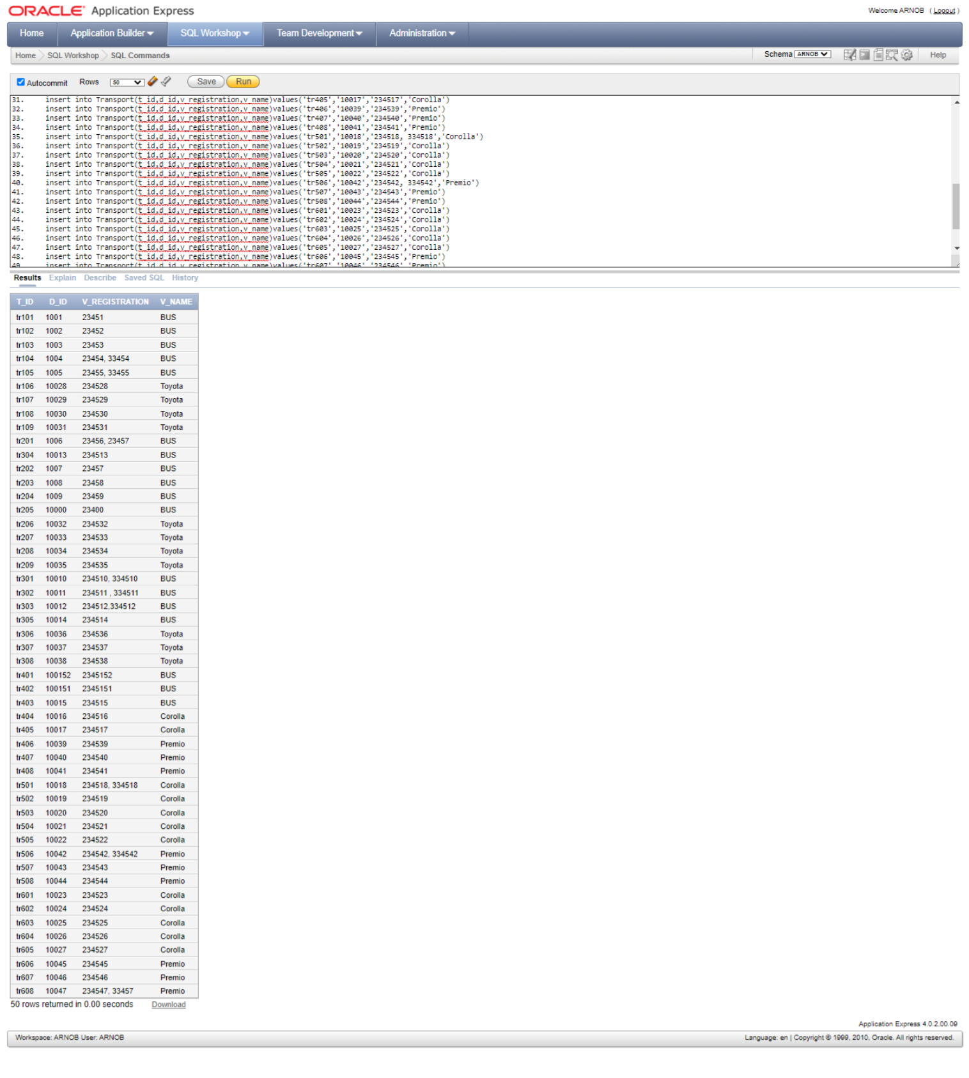

**3.Drivers:-**

**SQL:-**

1. insert into drivers(d_id,d_name,l_num,d_phn) values('1001','Arnob','11221',01714321451)
2. insert into drivers(d_id,d_name,l_num,d_phn) values('1002','Nirob','11222',01714321452)
3. insert into drivers(d_id,d_name,l_num,d_phn) values('1003','Farhan','11223',01714321453)
4. insert into drivers(d_id,d_name,l_num,d_phn) values('1004','shameem','11224',01714321454)
5. insert into drivers(d_id,d_name,l_num,d_phn) values('1005','rakib','11225',01714321455)
6. insert into drivers(d_id,d_name,l_num,d_phn) values('1006','polin','11226',01714321456)
7. insert into drivers(d_id,d_name,l_num,d_phn) values('1007','shanto','11227',01714321457)
8. insert into drivers(d_id,d_name,l_num,d_phn) values('1008','dipon','11228',01714321458)
9. insert into drivers(d_id,d_name,l_num,d_phn) values('1009','topu','11229',01714321459)
10. insert into drivers(d_id,d_name,l_num,d_phn) values('1010','robin','11230',01714321460)
11. insert into drivers(d_id,d_name,l_num,d_phn) values('1011','hamza','11231',01714321461)
12. insert into drivers(d_id,d_name,l_num,d_phn) values('1012','reed','11232',01714321462)
13. insert into drivers(d_id,d_name,l_num,d_phn) values('1013','mahbub','11233',01714321463)
14. insert into drivers(d_id,d_name,l_num,d_phn) values('1014','Arnob','11234',01714321464)
15. insert into drivers(d_id,d_name,l_num,d_phn) values('1015','dipon','11235',01714321465)
16. insert into drivers(d_id,d_name,l_num,d_phn) values('1016','parbez','11236',01714321466)
17. insert into drivers(d_id,d_name,l_num,d_phn) values('1017','imon','11237',01714321467)
18. insert into drivers(d_id,d_name,l_num,d_phn) values('1018','nirob','11238',01714321468)
19. insert into drivers(d_id,d_name,l_num,d_phn) values('1019','farhan','11239',01714321469)
20. insert into drivers(d_id,d_name,l_num,d_phn) values('1020','polin','11240',01714321470)
21. insert into drivers(d_id,d_name,l_num,d_phn) values('1021','rakibul','11241',01714321471)
22. insert into drivers(d_id,d_name,l_num,d_phn) values('1022','pranto','11242',01714321472)
23. insert into drivers(d_id,d_name,l_num,d_phn) values('1023','alhaz','11243',01714321473)
24. insert into drivers(d_id,d_name,l_num,d_phn) values('1024','ashik','11244',01714321474)
25. insert into drivers(d_id,d_name,l_num,d_phn) values('1025','jahid','11245',01714321475)
26. insert into drivers(d_id,d_name,l_num,d_phn) values('1026','abir','11246',01714321476)
27. insert into drivers(d_id,d_name,l_num,d_phn) values('1027','nishat','11247',01714321477)
28. insert into drivers(d_id,d_name,l_num,d_phn) values('1028','dipon','11248',01714321478)
29. insert into drivers(d_id,d_name,l_num,d_phn) values('1029','topu','11249',01714321479)
30. insert into drivers(d_id,d_name,l_num,d_phn) values('1030','robin','11250',01714321480)
31. insert into drivers(d_id,d_name,l_num,d_phn) values('1031','monir','11251',01714321481)
32. insert into drivers(d_id,d_name,l_num,d_phn) values('1032','arif','11252',01714321482)
33. insert into drivers(d_id,d_name,l_num,d_phn) values('1033','ali','11253',01714321483)
34. insert into drivers(d_id,d_name,l_num,d_phn) values('1034','Arnob','11254',01714321484)
35. insert into drivers(d_id,d_name,l_num,d_phn) values('1035','farid','11255',01714321485)
36. insert into drivers(d_id,d_name,l_num,d_phn) values('1036','parbez','11256',01714321486)
37. insert into drivers(d_id,d_name,l_num,d_phn) values('1037','imon','11257',01714321487)
38. insert into drivers(d_id,d_name,l_num,d_phn) values('1038','polash','11258',01714321488)
39. insert into drivers(d_id,d_name,l_num,d_phn) values('1039','farhan','11259',01714321489)
40. insert into drivers(d_id,d_name,l_num,d_phn) values('1040','amin','11260',01714321490)
41. insert into drivers(d_id,d_name,l_num,d_phn) values('1041','monir','11261',01714321491)
42. insert into drivers(d_id,d_name,l_num,d_phn) values('1042','arif','11262',01714321492)
43. insert into drivers(d_id,d_name,l_num,d_phn) values('1043','ali','11263',01714321493)
44. insert into drivers(d_id,d_name,l_num,d_phn) values('1044','Arnob','11264',01714321494)
45. insert into drivers(d_id,d_name,l_num,d_phn) values('1045','farid','11265',01714321495)
46. insert into drivers(d_id,d_name,l_num,d_phn) values('1046','parbez','11266',01714321496)
47. insert into drivers(d_id,d_name,l_num,d_phn) values('1047','imon','11267',01714321497)
48. insert into drivers(d_id,d_name,l_num,d_phn) values('1048','polash','11268',01714321498)
49. insert into drivers(d_id,d_name,l_num,d_phn) values('1049','farhan','11269',01714321499)
50. insert into drivers(d_id,d_name,l_num,d_phn) values('1050','amin','11270',01714321500)

OUTPUT:-

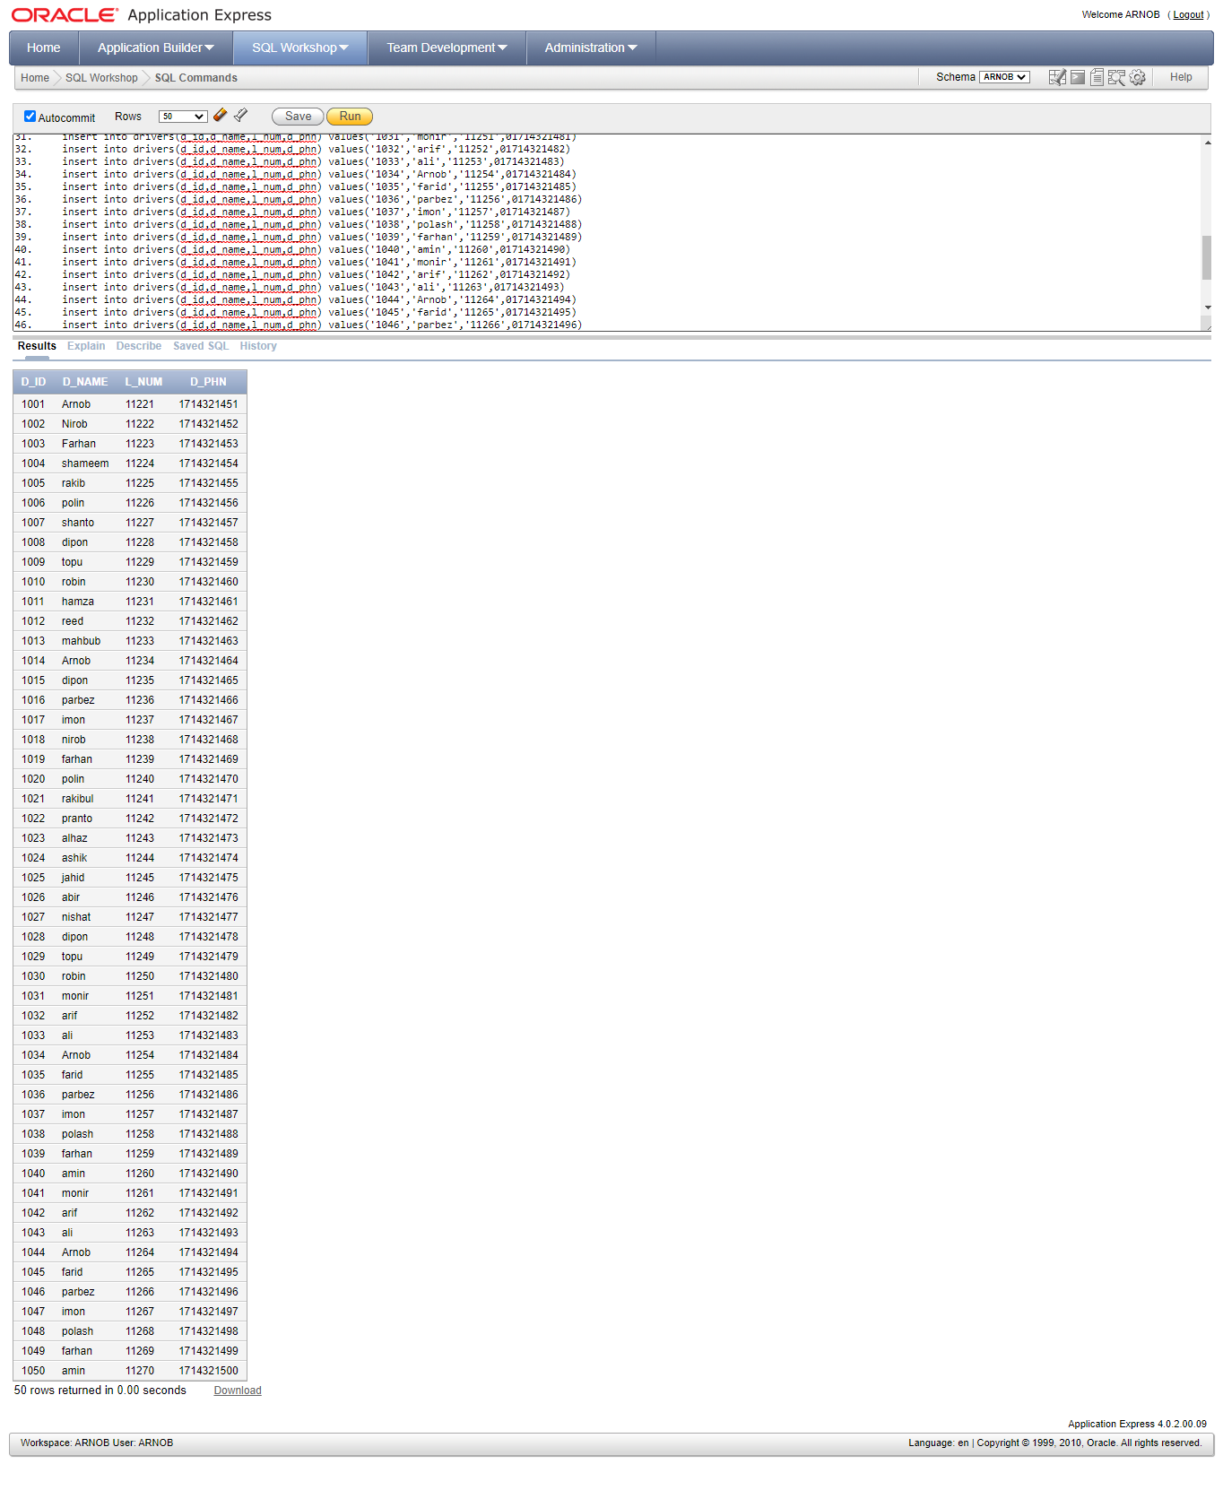

Query WRITTING

Query;-

1.

select BRANCH_ID,MANAGER_ID,TRASPORT_ID

from Branch_office

where ADDRESS='Khulna'

output:-

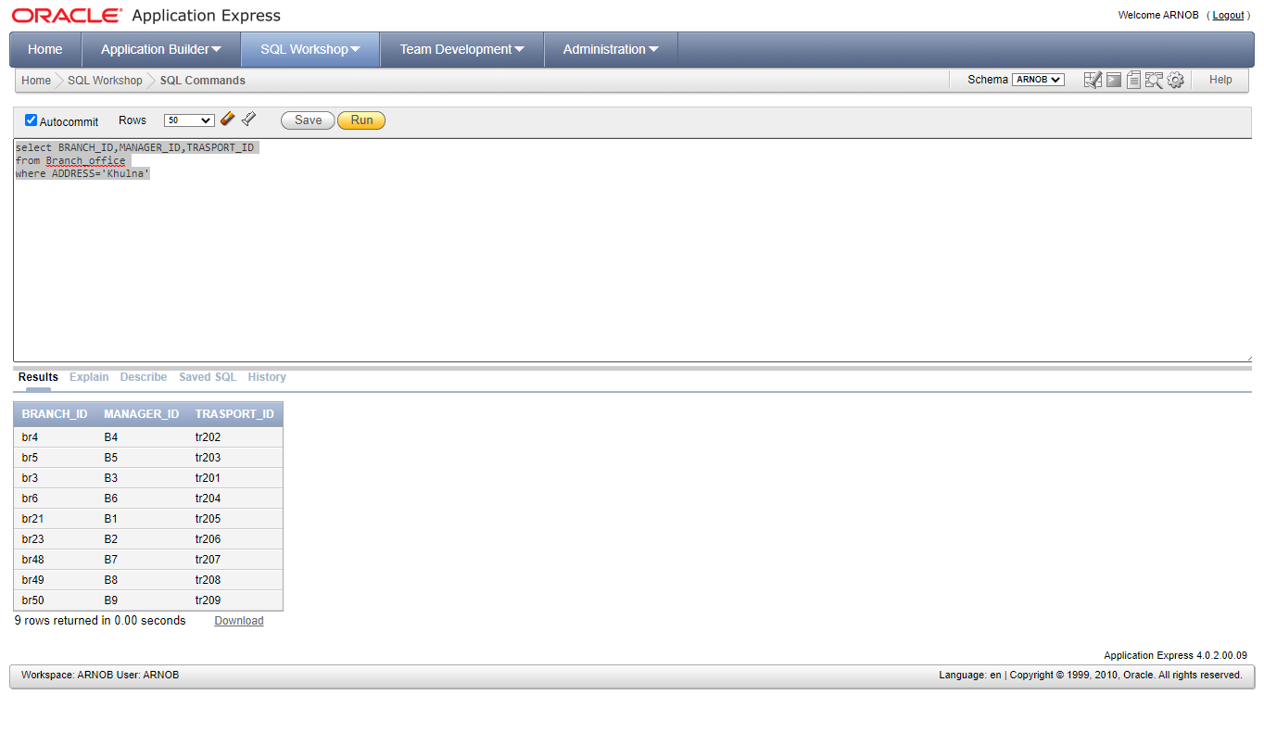

ORDER BY:-

2.

select BRANCH_ID,MANAGER_ID,MANAGER_NAME

from Branch_office

order by MANAGER_ID asc

Output;-

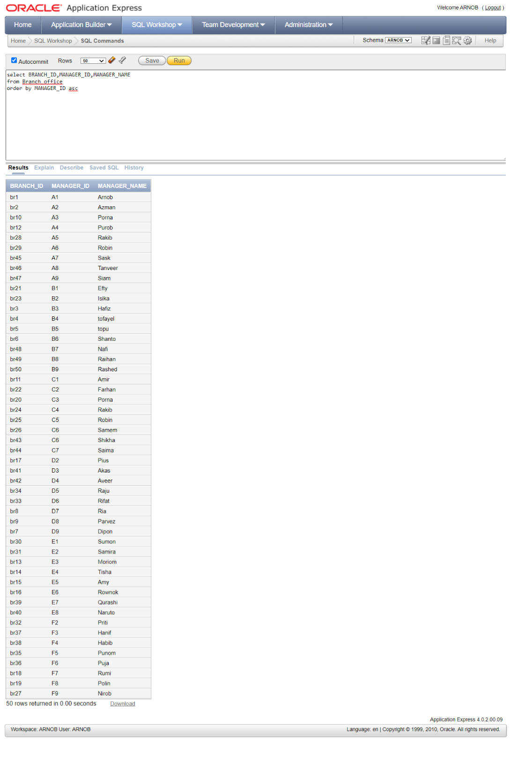

GROUP BY:-

3.

select V_NAME,count(T_ID) as TR_Number

from Transport

group by V_NAME

Output:-

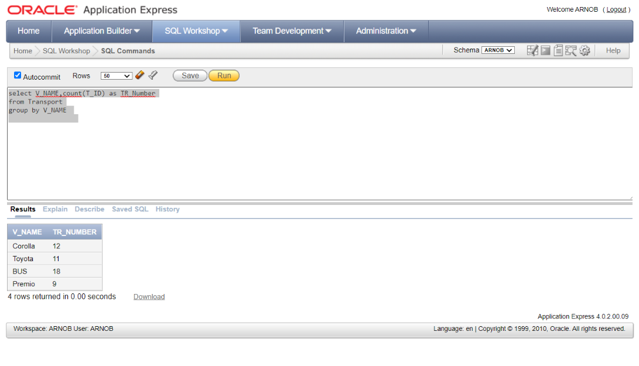

STRING OPARATION;-

4.

select D_ID,L_NUM,D_NAME

from drivers

where D_NAME like '%Arn%'

output;-

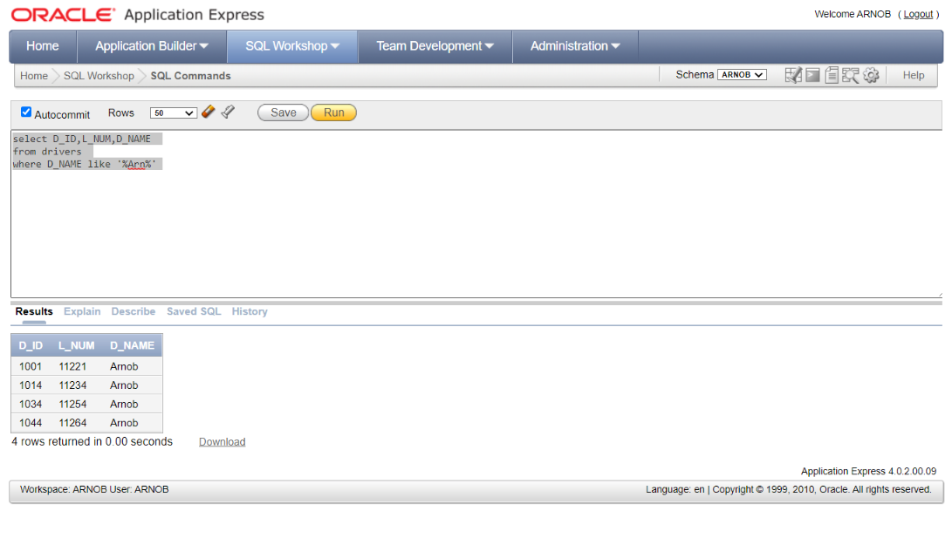

DELETION:-

5.

delete Branch_office

where BRANCH_ID='br7' and MANAGER_NAME='Dipon'

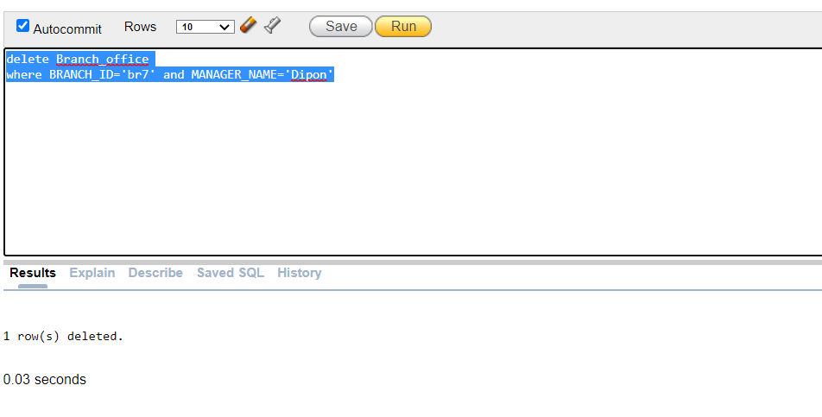

BEFOR DELETE;-

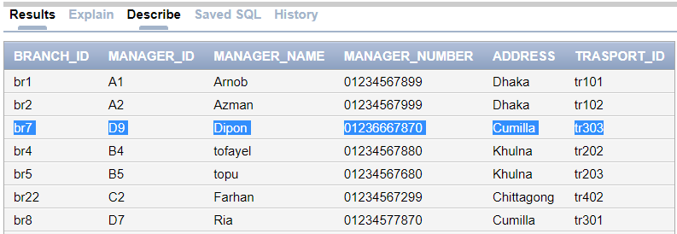

AFTER DELETE;-

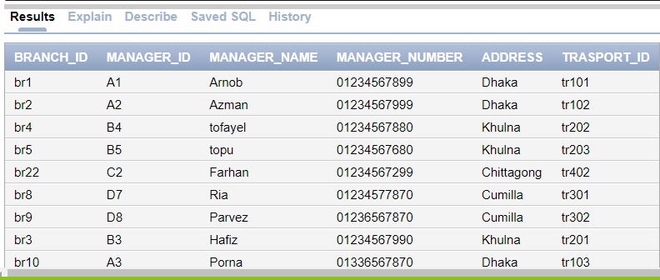

UPDATE:-

6.

update Transport

set V_NAME='Mini-Van'

where T_ID='tr106' and D_ID='10028'

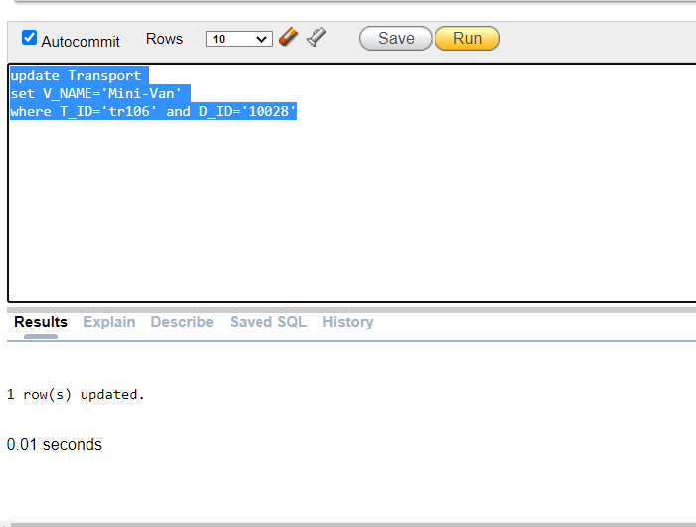

BEFORE UPDATE;-

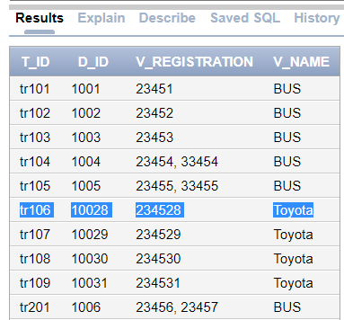

AFTER UPDATE:-

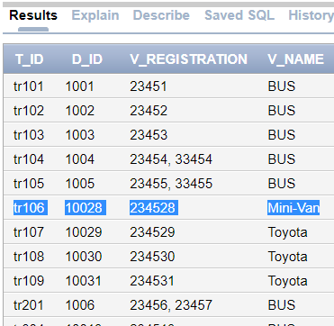

NESTED QUERY;-

7.

select T_id, name from Transport

where T_id in(select trasport_id

from Branch_office

where adddress='Dhaka' )

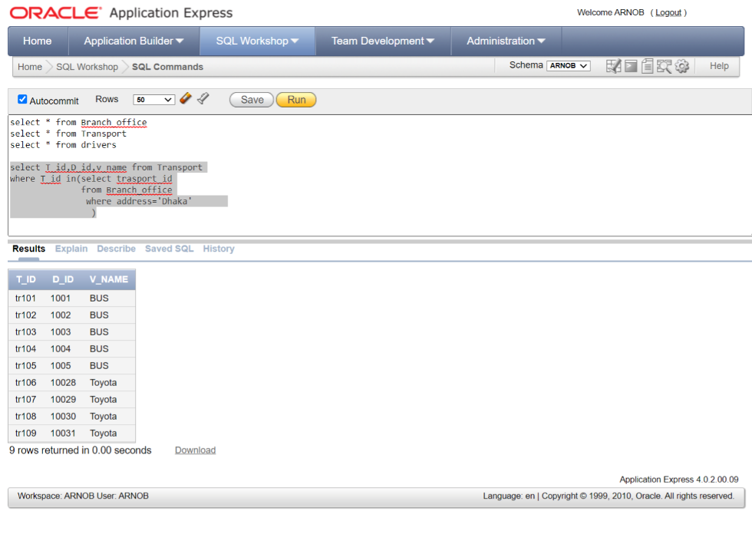

8.

select T_id,D_id,v_name from Transport

where v_name='Corolla' or

T_id in(select trasport_id

from Branch_office

where address='Cumilla' )

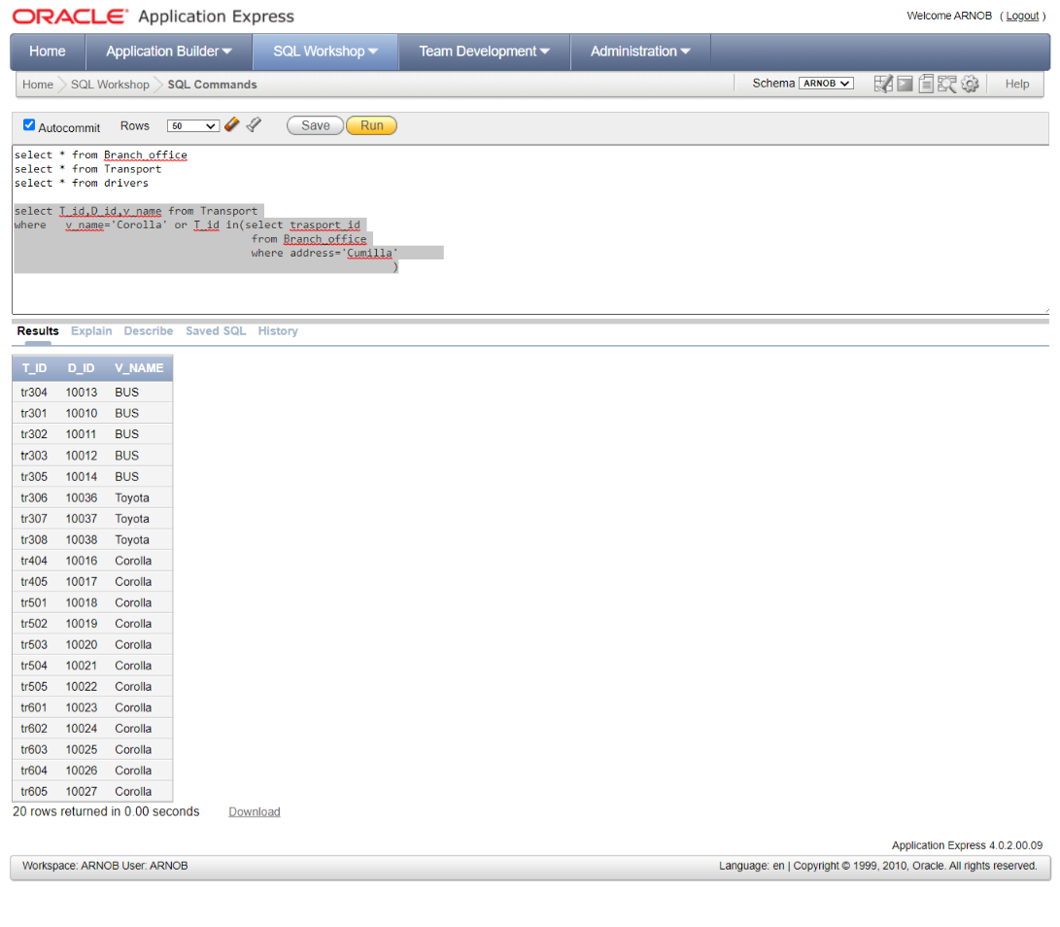

9.

select BRANCH_ID, MANAGER_ID,MANAGER_NAME

from Branch_office

where ADDRESS='Dhaka' and

TRASPORT_ID in(select T_ID

from Transport where V_REGISTRATION='23453' and D_id in(

select D_ID

from drivers

where L_NUM='11223'))

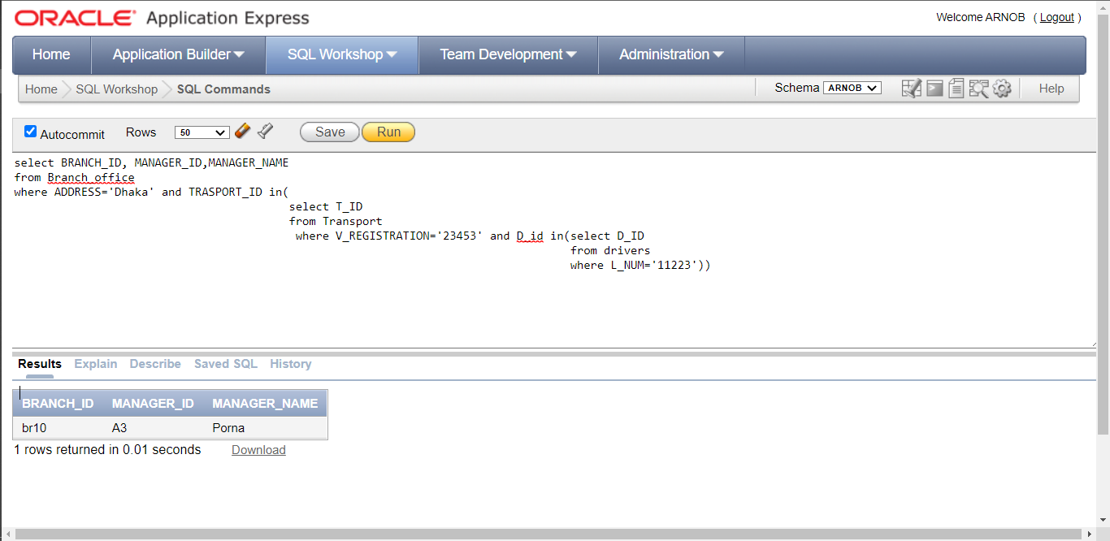

JOIN:-

FULL JOIN:-

10.

select MANAGER_ID,D_ID,V_NAME

from Branch_office,Transport

where Banch_office.TRASPORT_ID=Transport.T_ID

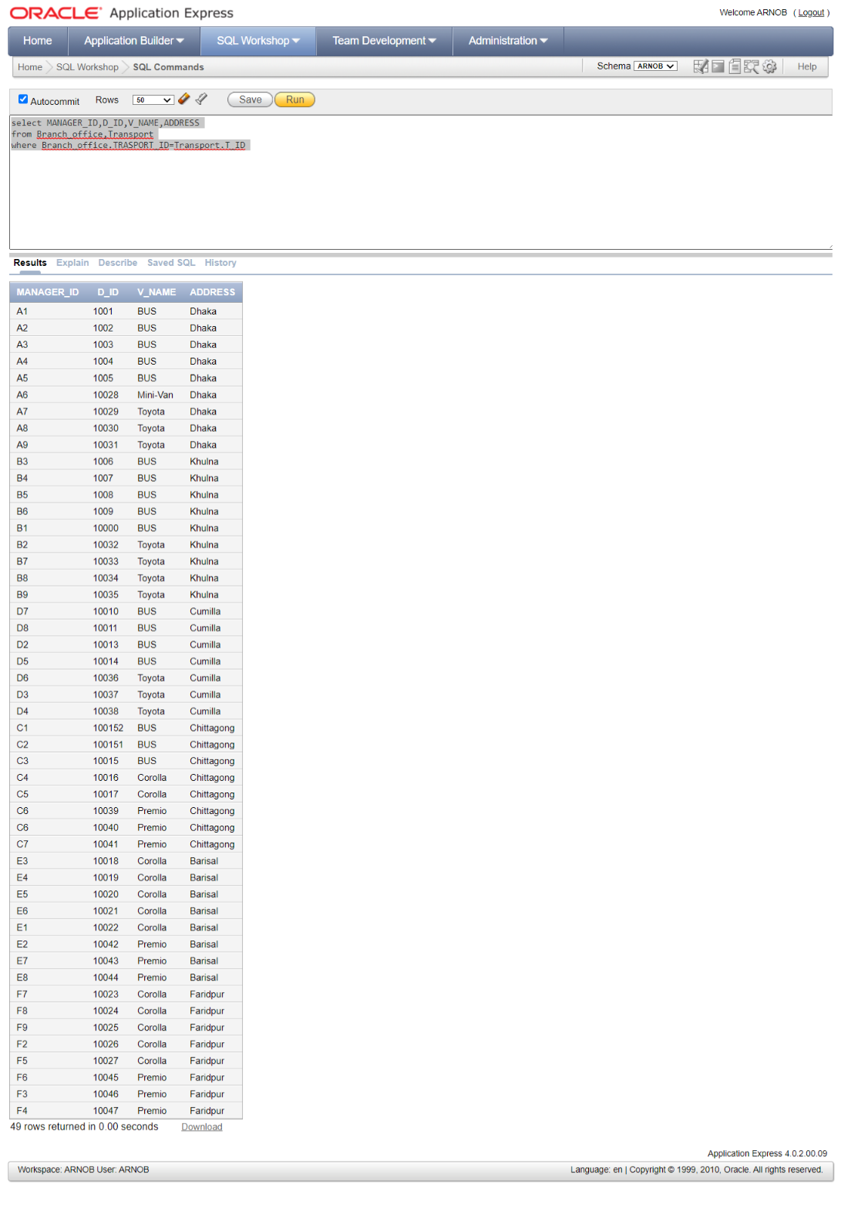

CONDITIONAL JOIN:-

11.

select MANAGER_ID,D_ID,V_NAME,ADDRESS

from Branch_office,Transport

where Branch_office.TRASPORT_ID=Transport.T_ID and ADDRESS='Dhaka'

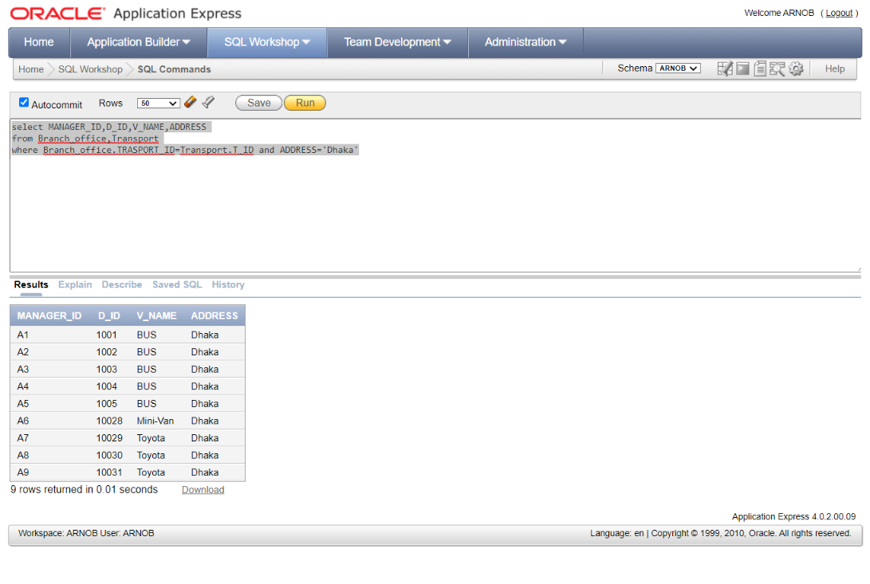

VIEW:-

CREATE VIEW:-

12.

Create View Dhaka As

select BRANCH_ID,MANAGER_ID,MANAGER_NAME,TRASPORT_ID,D_NAME

from Branch_office,drivers,Transport

where Transport.T_ID=Branch_office.TRASPORT_ID and Transport.D_ID=drivers.D_ID

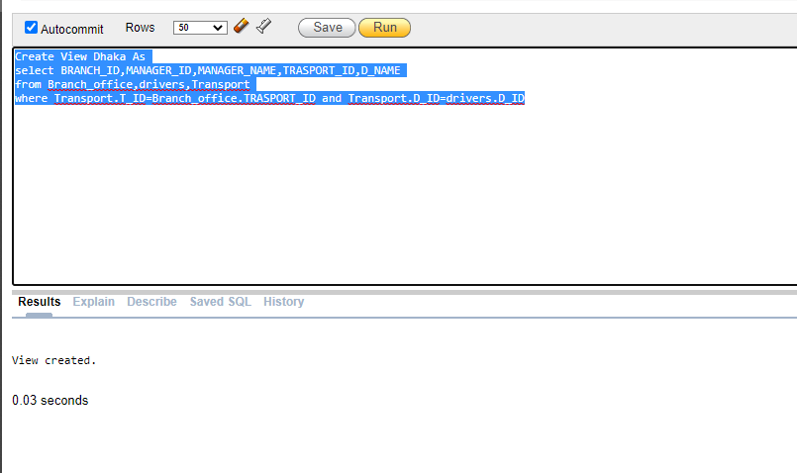

SHOW VIEW:-

13.

select * from Dhaka

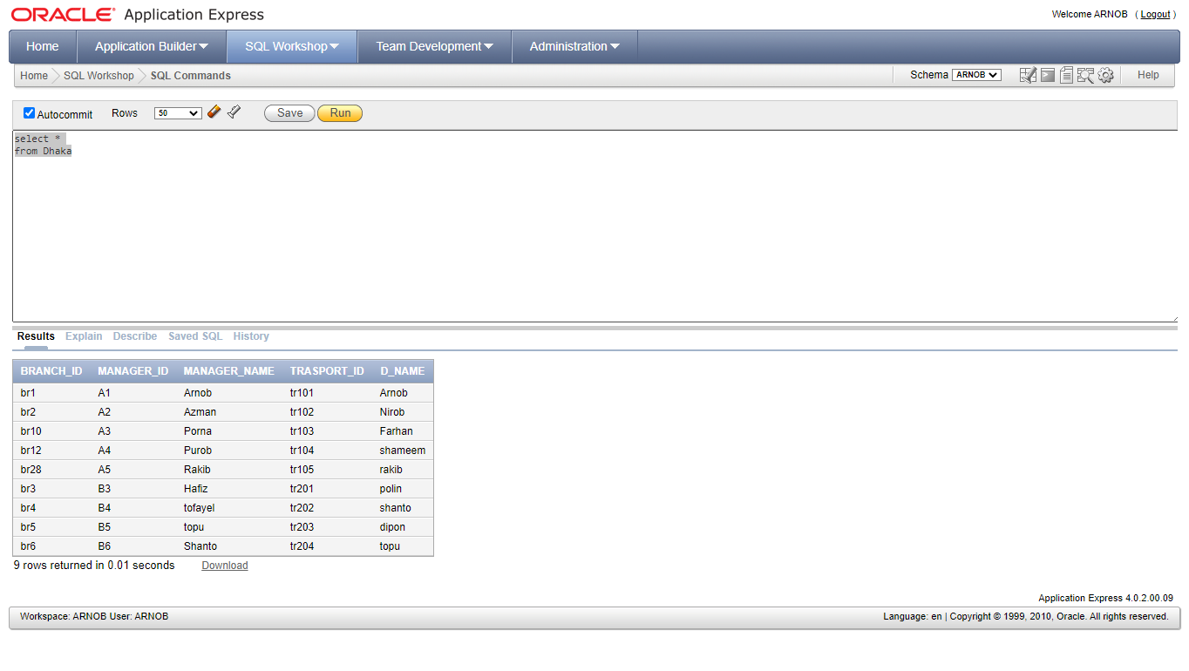

RElational Algebra

1. Find Manger Name who are work in ‘Dhaka’?

=> π Manager_name(ℓ Address=’Dhaka’(Branch_office))

2.Find the Branch ID where Manager Name is ‘Arnob’ and located in ‘Dhaka’?

=> π Branch_ID(ℓ Manager_name=’Arnob’ ^ Address=’Dhaka’ (Branch_office))

3. Find Those Manager who only Manages ‘Bus’?

=> π Manager_ID,Manager_Name( π TRASPORT_ID((Branch_office) ⋈( π Tr_ID (ℓ V_name=’Bus’ (Transport) ) ) )

4.Find The Driver Who’s Licences is 11227 or Name is ‘Shanto’?

=> π D_Id,D_Name ( ℓ L_Num=’11227’ v D_Name=’Shanto’(Drivers))

5.Find The Driver who only drive’s bus?

=> π D_ID, D_Name ( π D-ID ( ℓ V_Name=”Bus” (Transfort)) ⋈ (Drivers))

6.Find the Branch_ID and Manager name who manage “Premio” and Driver name is “Nirob”?

=> π Branch_ID,manager_Name ( π Transfort_ID (Branch_Office)) ⋈ ( π Tr_id ( π D_ID ( ℓ V_Name=”Premio” (Transfort)) )⋈ ( π D-ID ( ℓ D_name=”Nirob” (Drivers)))

7.Find All the Registration no. For Bus?

=> π V_Registration( ℓ V_Name=’Bus’ (Transport) )

8.Find the Name Of drivers’s who’s D_ID is between 1001 to 1009?

=> π D_Name ( ℓ D_ID > 1000 and D_ID<1010 (drivers))

9.Find the manager Id who only manage “Toyota” Drivers?

=> (π Manager_ID, D_ID (Branch_office))/ ( π D_ID( ℓ V_Name =”Toyoto”(Drivers))

10.Find D_ID and Name who drivers Bus and Also Registration No is not 23452 ?

=> π D_ID, Name (( π D_ID (Drivers)) ⋈ ( π D_ID ( ℓ V_Registration ≠ 23452 ^ V_name =”Bus” (Transfort)))

Normalization

**Branch_OFFICE Table:-**

***1NF:-***

The official qualification for 1NF are:

1.Each attribute name must be unique.

2.Each attribute value must be single.

3.Each row must be unique.

4.There is no repeating groups.

Example:

|  |  |  |  |  |  |
| --- | --- | --- | --- | --- | --- |
| BRANCE_ID | M_ID | M_NAME | M_NUM | ADDRESS | TRANSPORT_ID |
| br1 | A1 | Arnob | 0123456899 | dhaka | Tr101 |
| Br2 | A2 | Azman | 0123456999 | dhaka | Tr102 |

IN my table there is no repeating name,attributes,row & group.It has already 1NF.

***2NF:-***

The official qualification for 2NF are:

1.The table already in 1NF.

2.All nonkey attributes are fully dependent on the primary key.

3.All partial dependencies are remove to place in another table.

|  |  |  |
| --- | --- | --- |
| M_ID | ADDRESS | S_no |
| A1 | dhaka | 1 |
| A2 | dhaka | 2 |
| D9 | Cumilla | 3 |
| B4 | khulna | 4 |
| B5 | khulna | 5 |
| C2 | chittagong | 6 |
| D7 | Cumilla | 7 |
| D8 | Cumilla | 8 |
| B3 | khulna | 9 |

|  |  |  |  |  |
| --- | --- | --- | --- | --- |
| BRANCE_ID | M_NUM | M_NUM | TRANSPORT_ID | S_no |
| br1 | 01234567899 | 01234567899 | Tr101 | 1 |
| Br2 | 01234567999 | 01234567999 | Tr102 | 2 |
| Br7 | 01236667870 | 01236667870 | Tr303 | 3 |
| Br4 | 01234567880 | 01234567880 | Tr202 | 4 |
| Br5 | 01234567670 | 01234567670 | Tr203 | 5 |
| Br22 | 01234567299 | 01234567299 | Tr402 | 6 |
| Br8 | 01234567870 | 01234567870 | Tr301 | 7 |
| Br9 | 01236567870 | 01236567870 | Tr 302 | 8 |
| Br3 | 01234567990 | 01234567990 | Tr201 | 9 |

***3NF:-***

The official qualification for 3NF are:

1.The table already in 2NF.

2.Nonprimary key attributes do not depends on other nonprimary key attributes.

3.All transitive dependencies are remove to place in another table.

|  |  |  |  |
| --- | --- | --- | --- |
| M_ID | M_NUM | TRANSPORT_ID | S_no |
| A1 | 01234567899 | Tr101 | 1 |
| A2 | 01234567999 | Tr102 | 2 |
| D9 | 01236667870 | Tr303 | 3 |
| B4 | 01234567880 | Tr202 | 4 |
| B5 | 01234567670 | Tr203 | 5 |
| C2 | 01234567299 | Tr402 | 6 |
| D7 | 01234567870 | Tr301 | 7 |
| D8 | 01236567870 | Tr 302 | 8 |
| B3 | 01234567990 | Tr201 | 9 |

|  |  |  |  |
| --- | --- | --- | --- |
| BRANCE_ID | M_NAME | ADDRESS | S_no |
| br1 | Arnob | dhaka | 1 |
| Br2 | Azman | dhaka | 2 |
| Br7 | dipon | Cumilla | 3 |
| Br4 | tofayel | khulna | 4 |
| Br5 | topu | khulna | 5 |
| Br22 | farhan | chittagong | 6 |
| Br8 | ria | Cumilla | 7 |
| Br9 | parvez | Cumilla | 8 |
| Br3 | hafiz | khulna | 9 |

**Drivers Table:-**

***1NF***

The official qualification for 1NF are:

1. Each attribute name must be unique.
2. Each attribute value must be single.
3. Each row must be unique.
4. There is no repeating groups.

Example:

|  |  |  |  |
| --- | --- | --- | --- |
| D_id | D_name | L_id | D_phn |
| 1001 | arnob | 11221 | 01714311451 |
| 1002 | nirob | 11222 | 01714311452 |

IN my table there is no repeating name,attributes,row & group.It has already 1NF.

***2NF***

The official qualification for 2NF are:

1. The table already in 1NF.
2. All nonkey attributes are fully dependent on the primary key.
3. All partial dependencies are remove to place in another table.

|  |  |  |  |
| --- | --- | --- | --- |
| D_ID | D_NAME | L_NUM | D_PHN |
| 1001 | Arnob | 112211 | 1714321451 |
| 1002 | Nirob | 112212 | 1714321452 |
| 1003 | Farhan | 112213 | 1714321453 |
| 1004 | shameem | 112214 | 1714321454 |
| 1005 | rakib | 112215 | 1714321455 |
| 1006 | polin | 112216 | 1714321456 |
| 1007 | Shanto | 112217 | 1714321457 |
| 1008 | Dipon | 112218 | 1714321458 |
| 1009 | topu | 112219 | 1714321459 |

IN this table All nonkey attributes are fully dependent on the primary key and there has no partial dependencies…So this table already in 2NF.

***3NF***

The official qualification for 3NF are:

1. The table already in 2NF.
2. Nonprimary key attributes do not depends on other nonprimary key attributes.
3. All transitive dependencies are remove to place in another table.

|  |  |  |
| --- | --- | --- |
| L_NUM | D_PHN | S_no |
| 112211 | 1714321451 | 1 |
| 112212 | 1714321452 | 2 |
| 112213 | 1714321453 | 3 |
| 112214 | 1714321454 | 4 |
| 112215 | 1714321455 | 5 |
| 112216 | 1714321456 | 6 |
| 112217 | 1714321457 | 7 |
| 112218 | 1714321456 | 8 |
| 112219 | 1714321459 | 9 |

|  |  |  |
| --- | --- | --- |
| D_ID | D_NAME | S_no |
| 1001 | Arnob | 1 |
| 1002 | Nirob | 2 |
| 1003 | Farhan | 3 |
| 1004 | shameem | 4 |
| 1005 | rakib | 5 |
| 1006 | polin | 6 |
| 1007 | Shanto | 7 |
| 1008 | Dipon | 8 |
| 1009 | topu | 9 |

**Transport Table:-**

***1NF***

* + In 1NF Attributes value must be single
  + But we got double value in (t_id- tr301, tr302, tr303, tr501, tr104, tr905, tr1005, tr105, tr201)’s rows from our Transport table (attribute name: v_registration)
  + Then we have separated those double value and made individual row for each attribute value
  + Then all attributes value looks single

**Example:**

|  |  |  |  |
| --- | --- | --- | --- |
| T_id | D_id | V_Reregistration | V_name |
| tr301 | 10010 | 234510,334510 | BUS |

|  |  |  |  |
| --- | --- | --- | --- |
| T_id | D_id | V_Reregistration | V_name |
| Tr301 | 10010 | 234510 | BUS |
| Tr301 | 10010 | 334510 | BUS |

***2NF***

The official qualification for 2NF are:

1. The table already in 1NF.
2. All nonkey attributes are fully dependent on the primary key.
3. All partial dependencies are remove to place in another table.

|  |  |  |  |
| --- | --- | --- | --- |
| **T_id** | **D_id** | **V_Reregistration** | **V_name** |
| tr101 | 1001 | 23451 | 1 |
| tr102 | 1002 | 23452 | 1 |
| tr103 | 1003 | 23452 | 1 |
| tr104 | 1004 | 23453 | 1 |
| tr104 | 1004 | 33454 | 1 |
| tr201 | 1006 | 23456 | 1 |
| tr201 | 1006 | 33457 | 1 |
| Tr202 | 10010 | 23457 | 1 |
| Tr502 | 10019 | 234519 | 2 |
| Tr503 | 10020 | 234520 | 2 |
| Tr701 | 10028 | 234528 | 3 |
| Tr702 | 10029 | 234529 | 3 |

|  |  |
| --- | --- |
| **S_NO** | **V_Name** |
| 1 | Bus |
| 2 | Corolla |
| 3 | Toyota |

***3NF***

The official qualification for 3NF are:

1. The table already in 2NF.
2. Nonprimary key attributes do not depends on other nonprimary key attributes.
3. All transitive dependencies are remove to place in another table.

|  |  |  |  |
| --- | --- | --- | --- |
| **T_id** | **D_id** | **V_Reregistration** | **V_name** |
| tr101 | 1001 | 23451 | 1 |
| tr102 | 1002 | 23452 | 1 |
| tr103 | 1003 | 23452 | 1 |
| tr104 | 1004 | 23453 | 1 |
| tr104 | 1004 | 33454 | 1 |
| tr201 | 1006 | 23456 | 1 |
| tr201 | 1006 | 33457 | 1 |
| Tr202 | 10010 | 23457 | 1 |
| Tr502 | 10019 | 234519 | 2 |
| Tr503 | 10020 | 234520 | 2 |
| Tr701 | 10028 | 234528 | 3 |
| Tr702 | 10029 | 234529 | 3 |

**Conclusion**

This project is relatively simple to understand and implement. It fulfills all the current

requirements of a local **Transport management company**. The system is very user-friendly; a

person with basic computer skills can easily use this system.

Queries of this project, **" Transport System"** are run in 'Oracle 10g’ In our project, we have mentioned the queries and inserted screenshots of the tables we created

using those queries. The normalization process makes this project simpler.

**Difficulties & Problems**

* + - Personal information of Transport managers and members may leak by Vehicle drivers
    - We are not expert in providing security so we have some lacings in security. Due to lack of proper security, this system can be easily hacked.

**Future Development**

* + - Increasing the system's security will eliminate the risk of data leakage and hacking.
    - We will add more features for developing our Transport System
    - In future the database must gather a large amount of data and Information for one or more features making system upgrades and data storage extremely expensive. We will focus on making pricing easier in the future.

If these issues are resolved, it is expected that this system will become more efficient, user-

friendly, and convenient in the future. We may add, modify, update, or delete something at any time.