(CO2)
Q1. You should show the proper units for all the questions, detailed calculations, and/or formulas.
Attributes | Average Size (bytes)
Name | 2
Id | 2
Address | 4
SSN | 4
Email | 7
Designation | 8
Mobile | 9
Salary | 13

- Find the Record Size in bits. [2]

- The system's overhead will be 0.3. Calculate the Total Record Size in bits. [2]

- The initial table size is 50,000. Calculate the Initial Table Volume in bits. [2]

- Calculate the Final Table Volume in bits after 36 months; quarterly growth is 3000. [4]

(CO2)
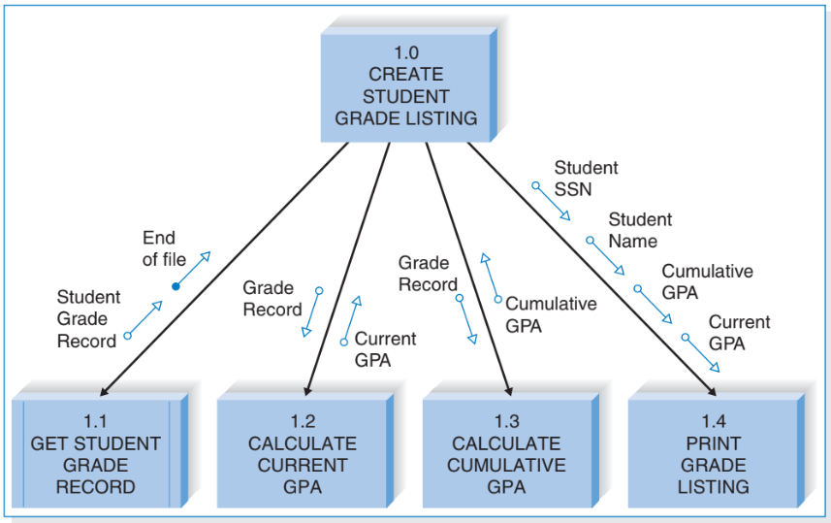
Q2.

- How many control and subordinate modules are there? [2]
- What kind of module is 1.1? [2]
- Which unique control and data couples do you see? [2]
- What are the fan-in and fan-out numbers for 1.2 and 1.3? [2]
- How many methods should the module 1.0 call at max? [2]

