Data Store Design & Program Design (CO2)
Q1. You should show the proper units for all the questions, detailed calculations, and/or formulas.
Attributes | Average Size (bytes)
Name | 2
Id | 2
Address | 4
SSN | 4
Email | 7
Designation | 8
Mobile | 9
Salary | 13

- Find the Record Size in bits. [2]

Record Size = Summation of all the attributes’ average size
= ((2 + 2 + 4 + 4 + 7 + 8 + 9 + 13) * 8) bits
= 392 bits

- The system's overhead will be 0.3. Calculate the Total Record Size in bits. [2]

Total Record Size = Record Size + (Record Size * overhead)
= 392 + (392 * 0.3) bits
= 509.6 bits

- The initial table size is 50,000. Calculate the Initial Table Volume in bits. [2]

Initial Table Volume = Initial Table Size * Total Record Size
= 50000 * 509.6 bits
= 25,480,000 bits

- Calculate the Final Table Volume in bits after 36 months; quarterly growth is 3000. [4]

Final Table Volume = Initial Table Volume + (Growth per unit * Total Record Size * total time)
= (25,480,000 + (1000 * 509.6 * 36)) bits
= 43,825,600 bits

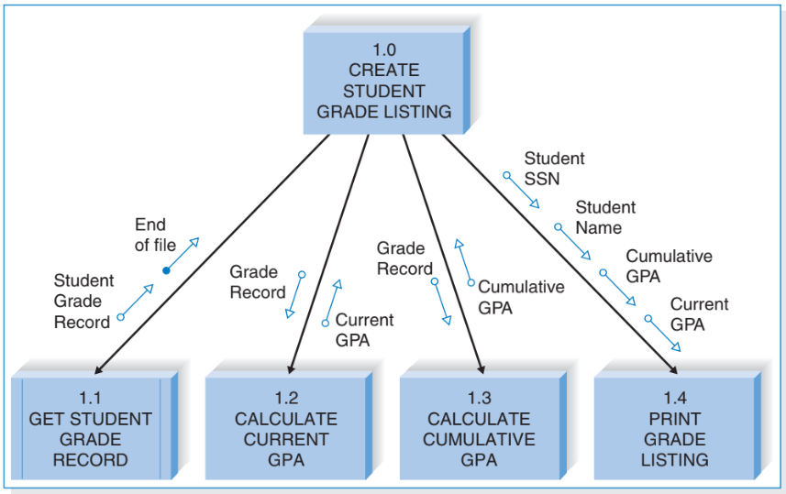
Q2.

- How many control and subordinate modules are there? [2]
Ans: Control – 1, Subordinate - 4
- What kind of module is 1.1? [2]
Ans: Library
- Which unique control and data couples do you see? [2]
* Unique means appearing only once [Student Grade Record = Grade Record]
Ans: Control – End of file, Data – Student SSN, Student name.
- What are the fan-in and fan-out numbers for 1.2 and 1.3? [2]
Ans: 1.2 – Fan-in: 1, Fan-out: 0, 1.3 - Fan-in: 1, Fan-out: 0
- How many methods should the module 1.0 call at max? [2]
Ans: 7

