(CO2)
Q1. You should show the proper units for all the questions, detailed calculations, and/or formulas.
Attributes | Average Size (bits)
TAX | 16
VAT | 104
Reg No. | 16
TIN | 72
Bill No. | 32
Transaction ID | 32
SSN | 64
Expiry | 56

- Find the Record Size in bytes. [2]

- The system's overhead will be 0.3. Calculate the Total Record Size in bytes. [2]

- The Initial Table Size is 50,000. Calculate the Initial Table Volume in bytes. [2]

- Calculate the Final Table Volume in bytes after 36 months; quarterly growth is 3000. [4]

(CO2)
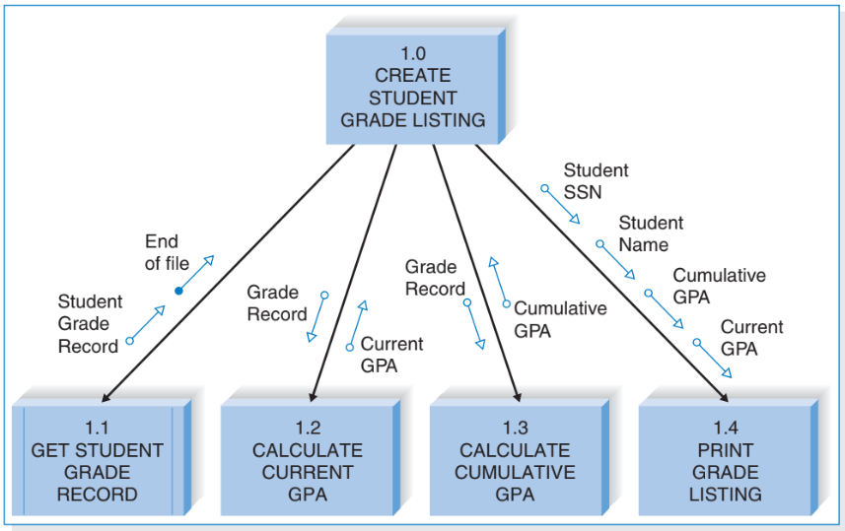
Q2.

- How many distinct data and control couples are there? [2]
- What kind of module is 1.0? [2]
- Which subordinate modules do you see? [2]
- What are the fan-in and fan-out numbers for 1.1 and 1.4? [2]
- How many modules can call 1.0 at max? [2]

