Data Store Design & Program Design (CO2)
Q1. You should show the proper units for all the questions, detailed calculations, and/or formulas.
Attributes | Average Size (bits)
TAX | 16
VAT | 104
Reg No. | 16
TIN | 72
Bill No. | 32
Transaction ID | 32
SSN | 64
Expiry | 56

- Find the Record Size in bytes. [2]

Record Size = Summation of all the attributes’ average size
= ((16 + 104 + 16 + 72 + 32 + 32 + 64 + 56) / 8) bytes
= 49 bytes

- The system's overhead will be 0.3. Calculate the Total Record Size in bytes. [2]

Total Record Size = Record Size + (Record Size * overhead)
= 49 + (49 * 0.3) bytes
= 63.7 bytes

- The Initial Table Size is 50,000. Calculate the Initial Table Volume in bytes. [2]

Initial Table Volume = Initial Table Size * Total Record Size
= (50,000 * 63.7) bytes
= 3,185,000 bytes

- Calculate the Final Table Volume in bytes after 36 months; quarterly growth is 3000. [4]

Final Table Volume = Initial Table Volume + (Growth per unit * Total Record Size * total time)

= (3,185,000 + (1000 * 63.7 * 36)) bytes
= 5,478,200 bytes

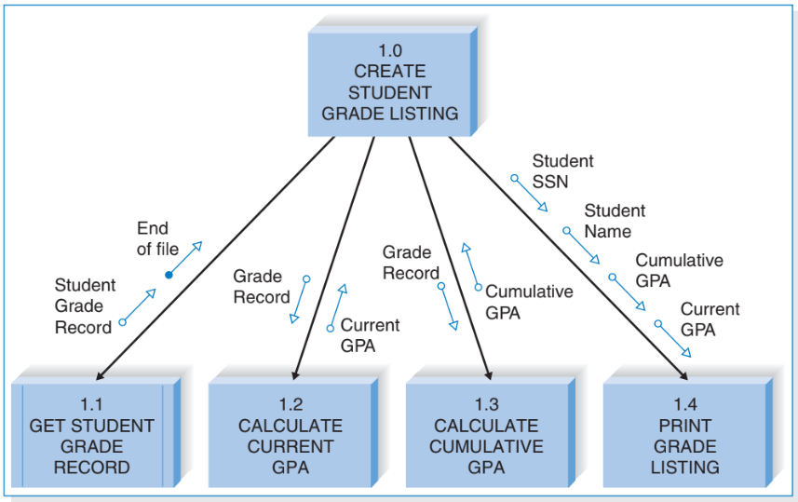
Q2.

- How many distinct data and control couples are there? [2]
* Distinct means different types [Student Grade Record = Grade Record]
Ans: Data – 5, Control - 1
- What kind of module is 1.0? [2]
Ans: Control module
- Which subordinate modules do you see? [2]
Ans: 1.1(Get Student Grade Record), 1.2 (Calculate Current GPA), 1.3 (Calculate Cumulative GPA), 1.4 (Print Grade Listing)
- What are the fan-in and fan-out numbers for 1.1 and 1.4? [2]
Ans: 1.1 – Fan-in: 1, Fan-out: 0, 1.4 – Fan-in: 1, Fan-out: 0
- How many modules can call 1.0 at max? [2]
Ans: 1

