(CO2)
Q1. You should show the proper units for all the questions, detailed calculations, and/or formulas.
Attributes | Average Size (bytes)
Name | 11
Id | 8
Address | 3
SSN | 5
Email | 11
Designation | 8
Mobile | 8
Salary | 12

- Find the Record Size in bits. [2]

- The system's overhead will be 0.25. Calculate the Total Record Size in bits. [2]

- The initial table size is 45,000. Calculate the Initial Table Volume in bits. [2]

- Calculate the Final Table Volume in bits after 48 months; quarterly growth is 2500. [4]

(CO2)
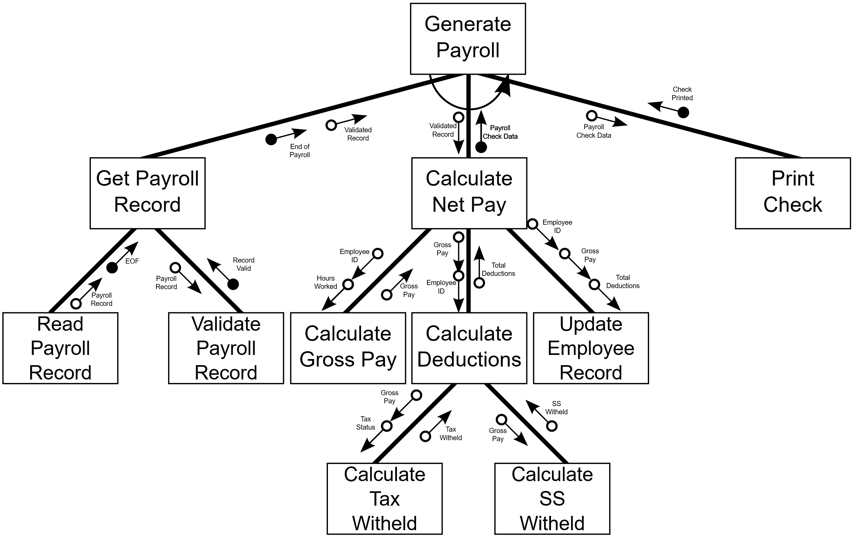
Q2.

Generate Payroll is numbered as 1.0.
- How many subordinate modules are there for Calculate Net Pay? [2]
- What kind of module is 1.3? [2]
- Which control couples do you see? [2]
- What are the fan-in and fan-out numbers for 1.2? [2]
- What type of cohesion is in the Update Employee Record? [2]

