(CO2)
Q1. You should show the proper units for all the questions, detailed calculations, and/or formulas.
Attributes | Average Size (bytes)
Name | 11
Id | 8
Address | 3
SSN | 5
Email | 11
Designation | 8
Mobile | 8
Salary | 12

- Find the Record Size in bits. [2]

Record Size = Summation of all the attribute’s average size
= ((11 + 8 + 3 + 5 + 11 + 8 + 8 +12) * 8) bits
= 528 bits

- The system's overhead will be 0.25. Calculate the Total Record Size in bits. [2]

Total Record Size = Record Size + (Record Size * overhead)
= 528 + (528 * 0.25) bits
= 660 bits

- The initial table size is 45,000. Calculate the Initial Table Volume in bits. [2]

Initial Table Volume = Initial Table Size * Total Record Size
= 45000 * 660 bits
= 29,700,000 bits

- Calculate the Final Table Volume in bits after 48 months; quarterly growth is 2500. [4]

Final Table Volume = Initial Table Volume + (Growth per unit * Total Record Size * total time)
= (29,700,000 + ((2500/3) * 660 * 48)) bits
= 56,100,000 bits

(CO2)
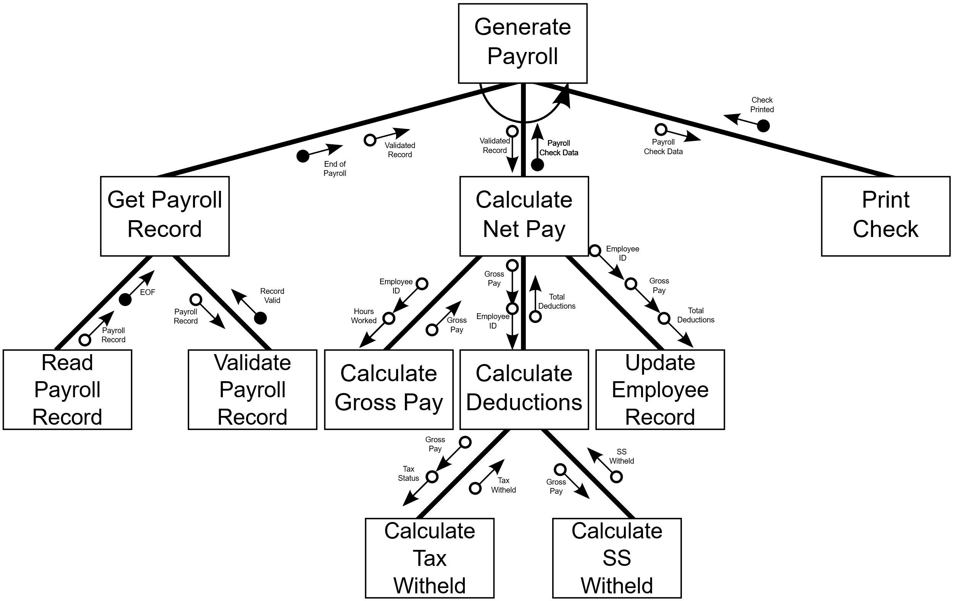
Q2.

Generate Payroll is numbered as 1.0.
- How many subordinate modules are there for Calculate Net Pay? [2]
Ans: 3
- What kind of module is 1.3? [2]
Ans: Subordinate
- Which control couples do you see? [2]
Ans: EOF, Record Valid, End of Payroll, Payroll Check Data, Check Printed
- What are the fan-in and fan-out numbers for 1.2? [2]
Ans: Fan-in: 1, fan-out: 3
- What type of cohesion Update Employee Record is in? [2]
Ans: Functional

