(CO2)
Q1. You should show the proper units for all the questions, detailed calculations, and/or formulas.
Attributes | Average Size (bytes)
Name | 11
Id | 7
Address | 3
SSN | 5
Email | 9
Designation | 4
Mobile | 11
Salary | 6

- Find the Record Size in bits. [2]

Record Size = Summation of all the attribute’s average size
= ((11 + 7 + 3 + 5 + 9 + 4 + 11 +6) * 8) bits
= 448 bits

- The system's overhead will be 0.25. Calculate the Total Record Size in bits. [2]

Total Record Size = Record Size + (Record Size * overhead)
= 528 + (448 * 0.25) bits
= 560 bits

- The initial table size is 45,000. Calculate the Initial Table Volume in bits. [2]

Initial Table Volume = Initial Table Size * Total Record Size
= 45000 * 560 bits
= 25,200,000 bits

- Calculate the Final Table Volume in bits after 48 months; quarterly growth is 2500. [4]

Final Table Volume = Initial Table Volume + (Growth per unit * Total Record Size * total time)
= (25,200,000 + ((2500/3) * 560 * 48)) bits
= 47,600,000 bits

(CO2)
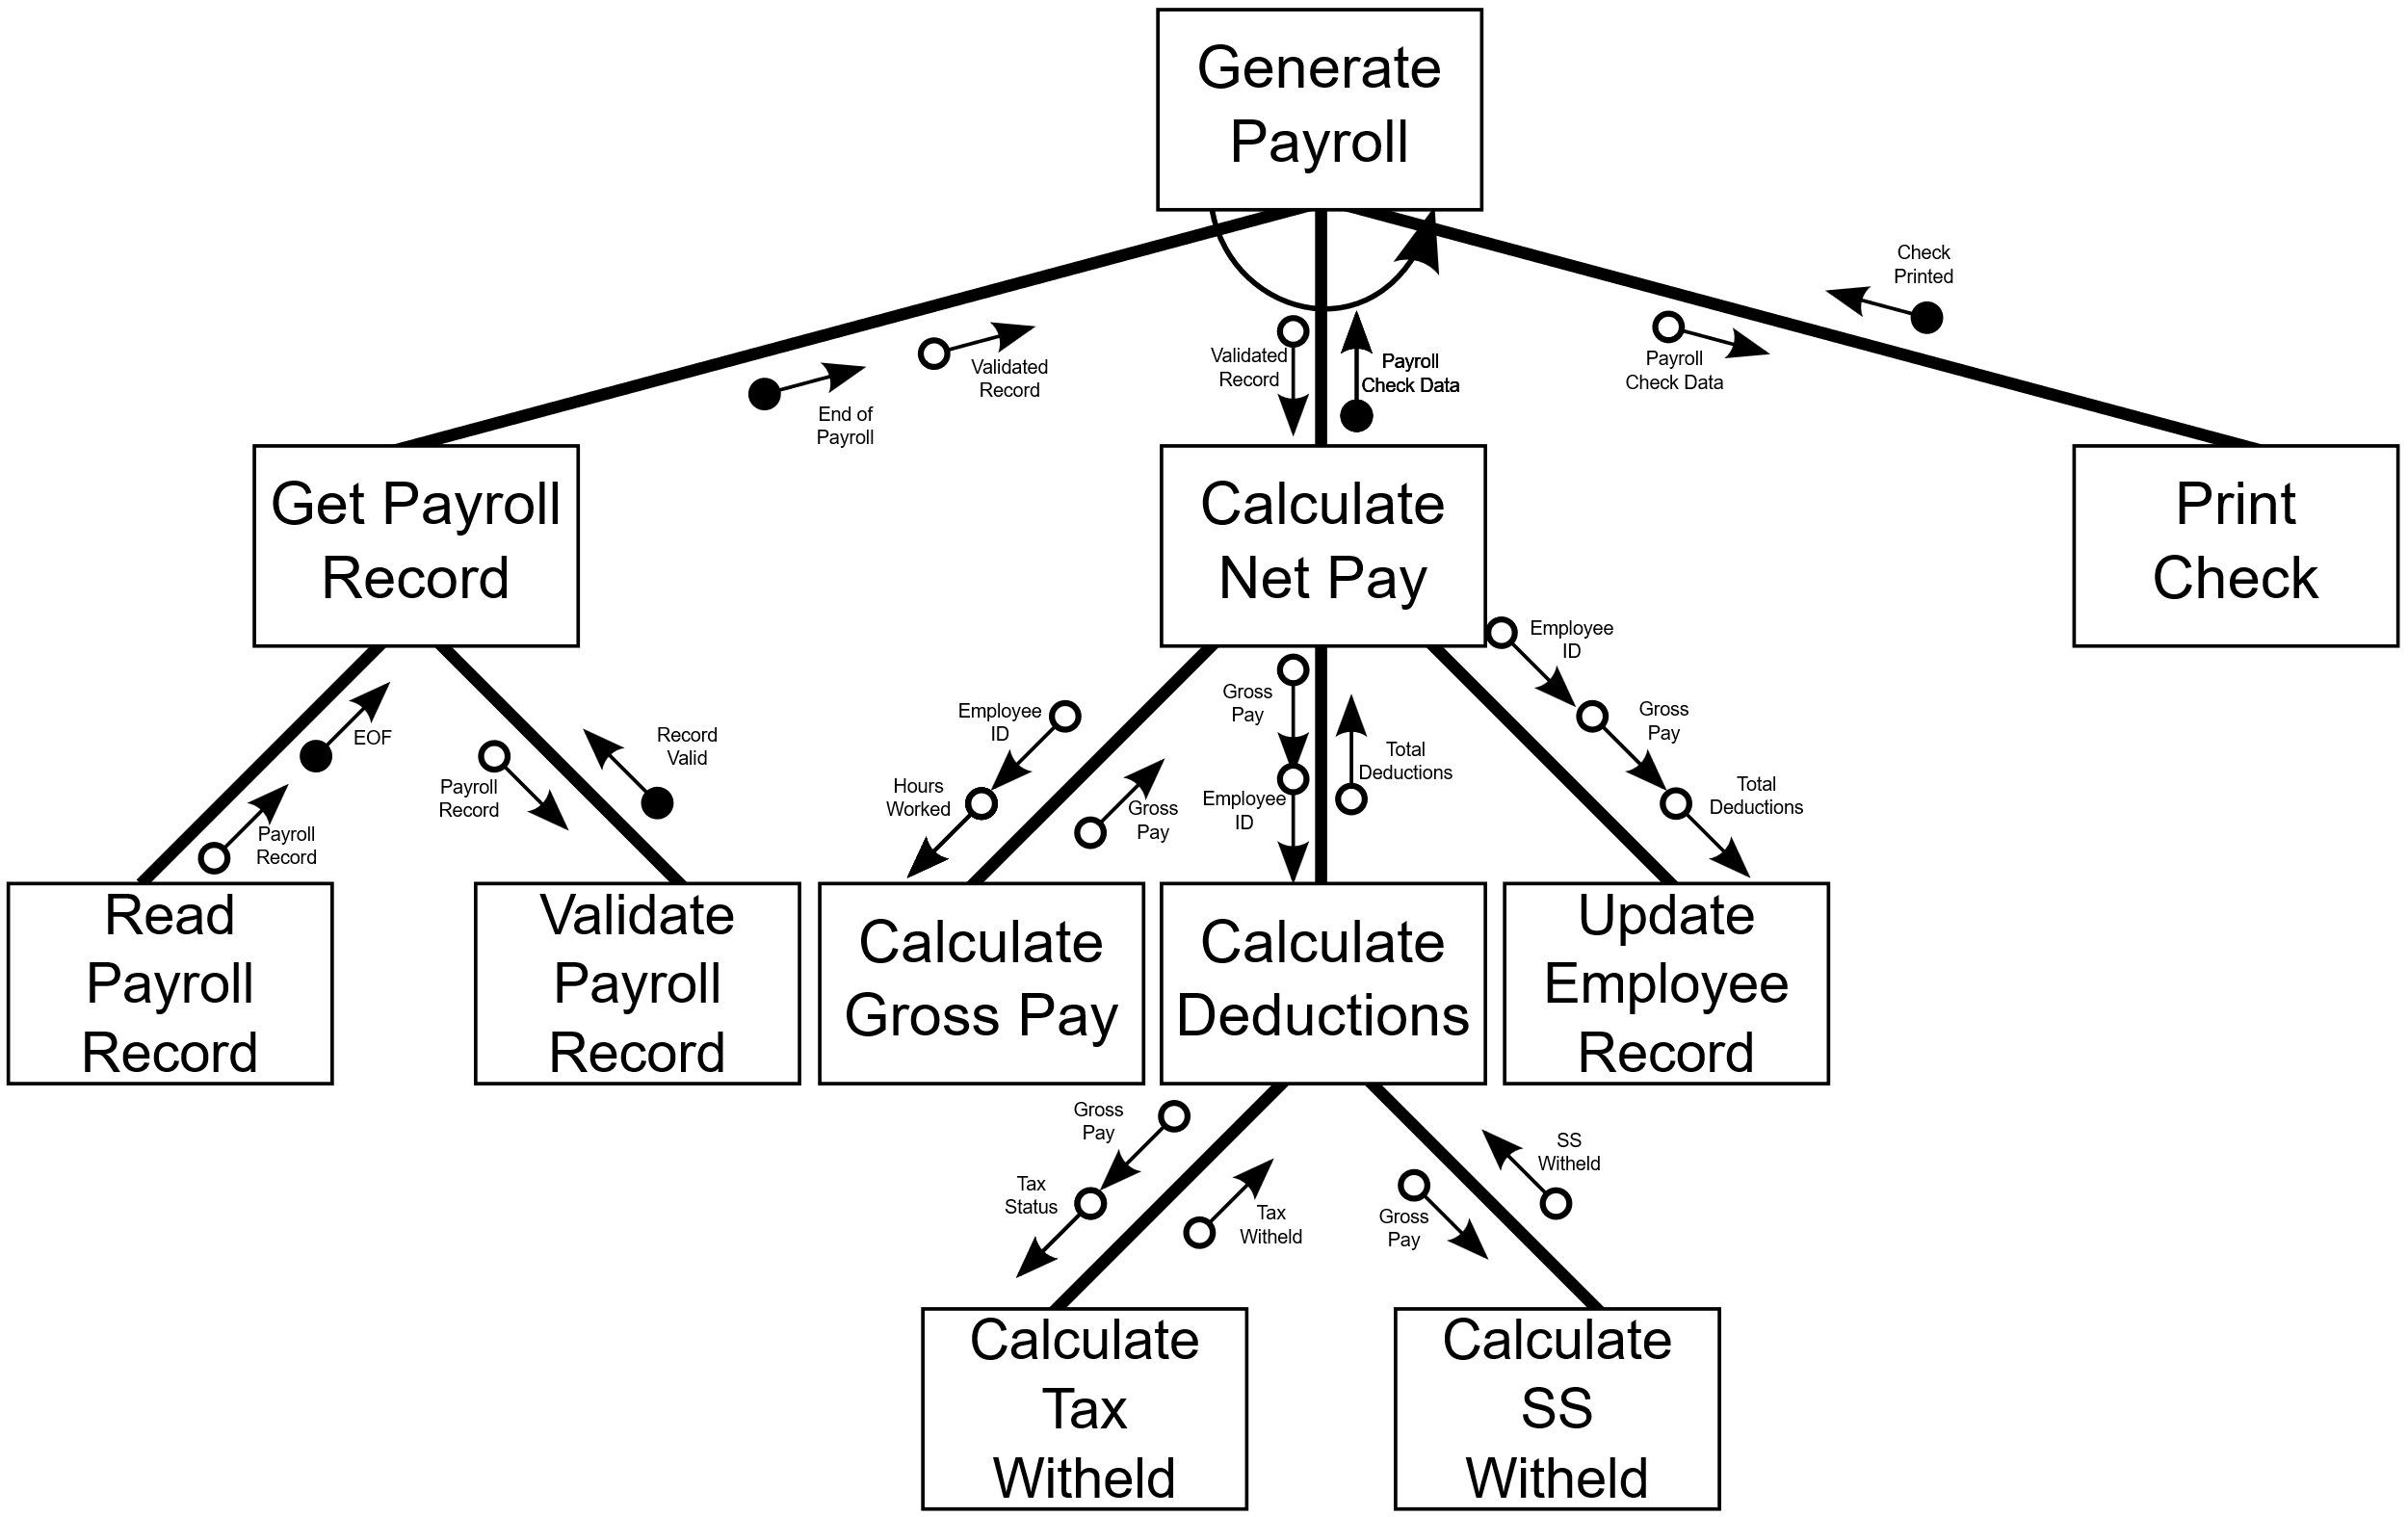
Q2.

Generate Payroll is numbered as 1.0.
- How many subordinate modules are there for Calculate Net Pay? [2]
Ans: 3
- What kind of module is 1.3? [2]
Ans: Subordinate
- Which data couples are sent down by module 1.2? [2]
Ans: Employee ID, Hours Worked, Gross Pay, Total Deductions
- What are the fan-in and fan-out numbers for 1.2.2? [2]
Ans: Fan-in: 1, Fan-out: 2
- What type of cohesion Update Employee Record is in? [2]
Ans: Functional

