Introduction:

Tic-tac-toe (also known as nougats and crosses or X s and O s) is a game for two players, one assigned the symbol X (goes first) and one assigned the symbol O, who take turns marking the spaces in a 3x3 grid. The game either ends in a win, when one player gets three marks in a row (horizontal, vertical, or diagonal), or a draw, when the board is filled up.

Requirements:

A two-player tic tac toe game having user friendly interface and should not accept wrong inputs so that players will use it easily. Allow the players to mark their moves (desired box) in the form of numbers (1-9) only and output the winner of the game.

Specifications:

1. The program takes input in the form of numbers (1-9) to place your mark to the corresponding box
2. Checks conditions for win and draw
3. Home screen including options (Play, Help, About, Rules, Controls and Quit)
4. Produces sound (beep) on every input, error and at the end of the game
5. Validates user input for wrong choices
6. Output winner’s name or “Draw” at the end of the game

Program flow:

1. Shows main menu
2. Input names of players
3. Input move from player
4. Make sure that desired box hasn’t been previously picked up
5. Move is added to the board, visually and in memory
6. Board is checked for win or draw conditions
7. If any of the players wins, print his/her name
8. Else go to step 3
9. Process repeats until game ends

Hierarchy chart:

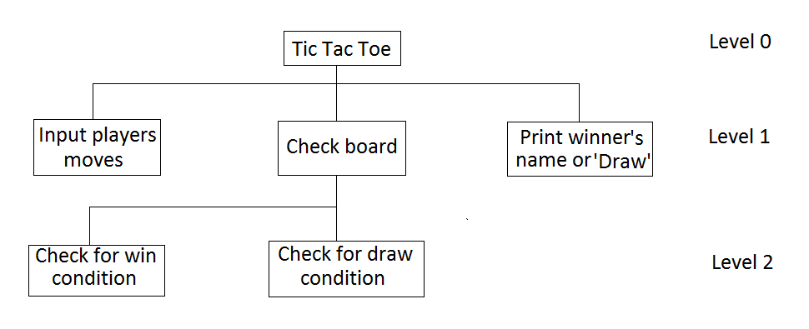

Testing and integration:

Program was tested for different use cases. It was noticed that the program was not able to handle wrong inputs as, whenever user tried to enter character in integer type variable instead of integer the program crashes and stops working. In order to resolve this bug, some IF/ELSE checks have been added to the code.