PMSM Parameter Identification Experiment Plan

Base Parameters
Motor speed constant | $$K_{V}$$ | $$210\frac{rpm}{V}$$
Pole pairs | $$p$$ | $$14$$
Line-to-line resistance | $$R_{LL}$$ | $$42.5 mΩ$$
Stator radius | $$r_{1}$$ | $$31mm$$
Motor radius | $$r_{2}$$ | $$34,4mm$$
Motor mass | $$m_{motor}$$ | 331g

A: Identification Phase Resistance

$$R_{s}=\frac{R_{LL}}{2}=\frac{42.5 }{2} mΩ=21.25 mΩ$$

B: Identification Flux Linkage
- Calculate torque constant.

$$K_{t}=\frac{60}{2∙π∙K_{V}}=\frac{60}{2⋅π⋅210\frac{rpm}{V}}= 0,04547\frac{Nm}{A}$$

- Calculate flux linkage.

$$ψ_{PM}=\frac{K_{t}}{1.5⋅p}=\frac{0,04547\frac{Nm}{A}}{1.5⋅14}=2.165 mWb$$

C: Identification Stator Inductance
- Measure line to line inductance.

$$L_{LL,ab}= 40,27uH$$
$$L_{LL,ac}=31,78uH$$
$$L_{LL,ac}=32,80uH$$

$$\overline{L_{LL}}=34,95uH$$
- Calculate stator inductance.
$$L_{s}=\frac{\overline{L_{LL}}}{2}=17,475uH$$

D: Identification Rotor Inertia
- Obtain rotor geometry.
$$r_{1}=31mm, r_{2}=34,4mm,$$
$$m=120g (≈36\%⋅m_{motor}, assumption)$$
- Calculate rotor inertia.
$$J=\frac{1}{2}m\left(r_{1}^{2}+r_{2}^{2}\right)=1,29×{10}^{-4}kg⋅m^{2}$$

E: Identification Viscous Friction Coefficient
- Leave all phases open and connect oscilloscope.
- Externally spin motor.
- Measure back-EMF line-to-line voltage during deceleration.
- Convert back-EMF to rotor speed.
$$ω\left(t\right)=\frac{2π}{60}⋅K_{v}⋅V_{LL}(t)$$
- Find maxima and minima.
- Decide which are better suited for fit.
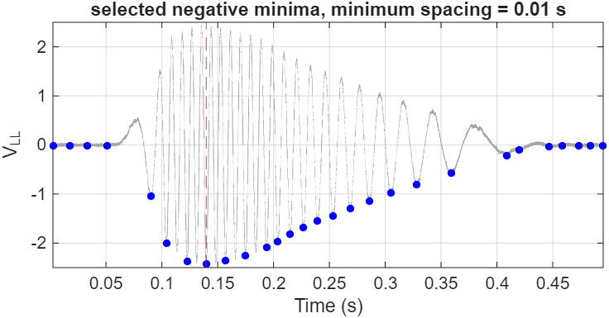
- Take log and fit straight line.

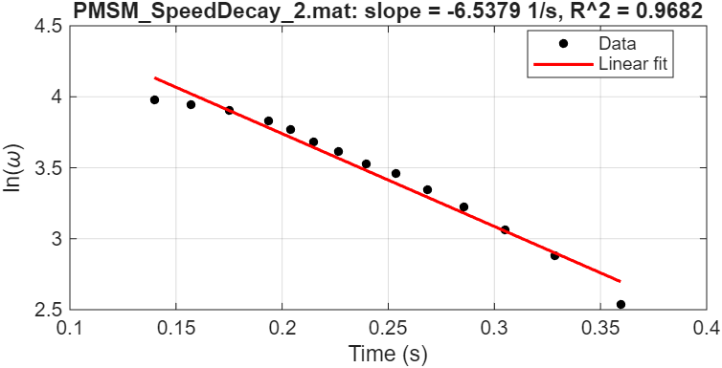

- Determine slope.
$$\frac{B}{J}= -slope= 6.67786\frac{1}{s}$$
- Calculate viscous friction coefficient.
$$B=J⋅\left(\frac{B}{J}\right)= 0.000861444\frac{Nms}{rad}$$

Final Parameter Set
Parameter | Value
Rs | 21.25 mOhm
Ls | 17.475 uH
psi_pm | 2.165 mWb
J | 1.29*10^-4 kg*m^2
B | 0.000861444 Nms/rad

