**Digital Image Processing CSE3226**

**EXERCISE 1**

1. ­­A data file was given to read in matlab by using the command ‘fread’ which consisted of unsigned int 8 bits in size and it was to converted into matlab image format having length 580 pixels and width 435 pixels. The image was the displayed.

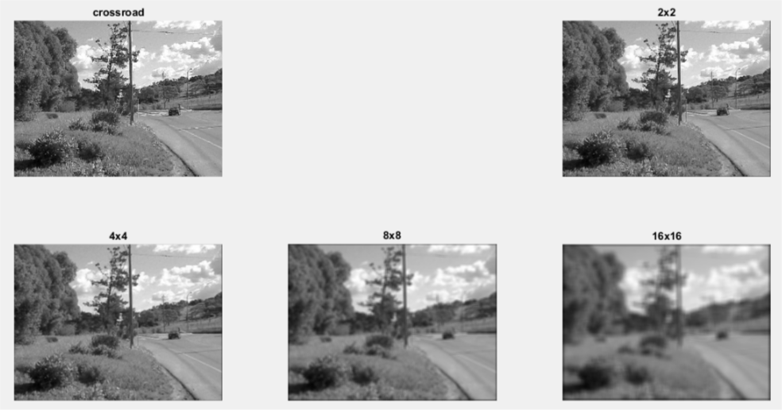

1. The resolution of the image used in (i) was to then changed by assign box 2 pixels which should be equal to 1 pixel of the previous image. This was done by using the ‘imfilter’ command. Then with the same procedure for box 4,8 and 16 pixels.

When using box 2 pixels there were not very change in the image- some small details were missing and the sharpness went down a little.

For box 4 pixels more details were missing as the image started to blur.

For box 8 pixels the image became even more blurry and the quality was far worse.

For box 16 pixels the image became more blur and even the biggest objects became hard to distinguish.

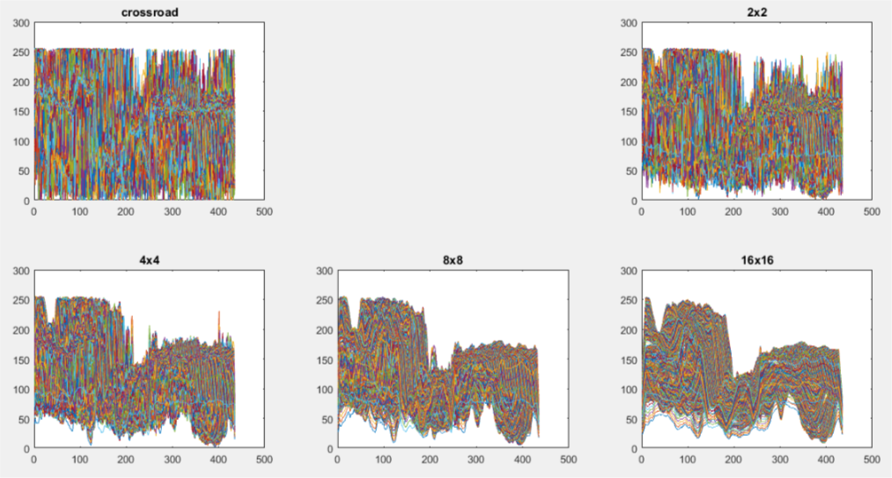

1. The obvious structure of the image was to observe and by plotting all a huge difference was seen as the box number increased the more level of details were missing out from the figure.

**Procedure with Code**

% importing the .dat file

I = fopen('E:\Third Year\3 2\DIP\DIP LAB\assignment\crossroad.dat');

% converting the .dat file to matlab readable image format

I = fread(I,[580 435],'*uint8');

% rotating the image to get a nice view

I = imrotate(I,270);

% displaying the image

figure;

subplot(2,3,1),imshow(I),title('crossroad');

% generating image with box 2 pixels

h2 = ones(2,2)/4;

I2 = imfilter(I,h2);

subplot(2,3,3),imshow(I2),title('2x2');

% generating image with box 4 pixels

h4 = ones(4,4)/16;

I4 = imfilter(I,h4);

subplot(2,3,4),imshow(I4),title('4x4');

% generating image with box 8 pixels

h8 = ones(8,8)/64;

I8 = imfilter(I,h8);

subplot(2,3,5),imshow(I8),title('8x8');

% generating image with box 16 pixels

h16 = ones(16,16)/256;

I16 = imfilter(I,h16);

subplot(2,3,6),imshow(I16),title('16x16');

% checking the structure

figure;

subplot(2,3,1),plot(I),title('crossroad');

subplot(2,3,3),plot(I2),title('2x2');

subplot(2,3,4),plot(I4),title('4x4');

subplot(2,3,5),plot(I8),title('8x8');

subplot(2,3,6),plot(I16),title('16x16');

**Exercise 2**