**Digital Image Processing Sessional 2**

**Exercise 1**

In this problem, we were told to show difference between to arbitrary BW images. Then after that we were told to show another example where image arithmetic is useful.

For first part we read to images and after that the difference between the images were marked by using **imshowpair()** function. The same thing can also be done with **imabsdiff()** function also.

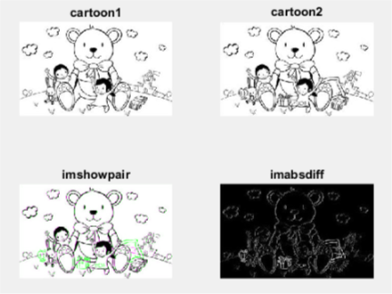

For the second part to show example of image arithmetic, an image was read and then as image arithmetic **imcomplement()** function was used to negate the image. In some medical imaging this is useful to find tumor cells.

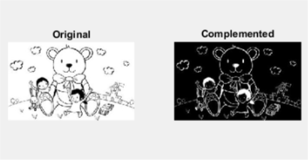

**Exercise 2**

This problem was to enhance image using intensity transformations.

1. In this one the implementation of the log transformation was asked. After reading the image the log transformation was implemented. We used **s = clog(1+r)** where c is a constant, s is the processed image, r is the given image. By observing the result, it was seen that for a certain value of the constant c the image was mostly clear.

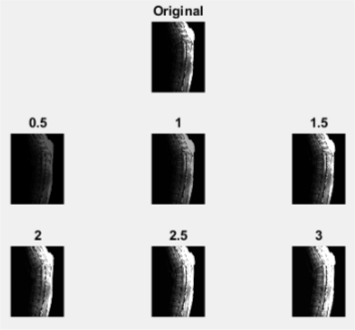

1. Then it was asked to implement power law transform. The equation **s = cr**γ used. Now giving both c and r for a certain combination of those gave a better image.

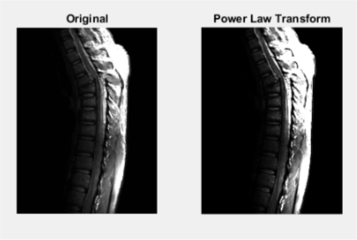

**Exercise 3**

This problem told to understand Histogram Equalization and use histogram equalization and enhance image using Contrast-Limited Histogram Equalization.

1. This told to read the documentation regarding Histogram Equalization and Contrast-Limited histogram equalization.
2. Now taking the image ‘spine.jpg’ it was equalized using **hiseq()** and the difference was seen.
3. To enhance the image using Contrast-Limited Histogram Equalization **adapthiseq()** function was used. Using this the quality of the image was enhanced and it was clear. The estimation of ‘tiles’ for a subjective enhancement was not understood so it was not used.

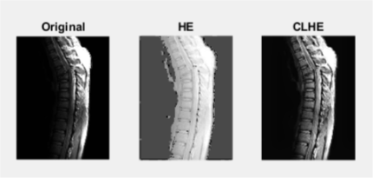

**Exercise 4**

1. Reading the image ‘rocks.jpg’ it was then converted to RGB and then all the 3 color planes were equalized differently and then they were added to get the full image. This made the picture more sharp and colors were seemed bright and clear.
2. Could not do the average.

