**BE 1 Exercises**

**Exercise 1 (Network inspect)**

**o What is the url ?**

https://www.youtube.com/

**o What is the IP address of the server host?**

[2a00:1450:4006:80e::200e]:443

**o How many http(s) request were made?**

81

**o What are the different types returned from all of the requests?**

Script , stylesheet, webp, xhr, x-icon, text/html

**o What was the largest file returned?**

Data:application/json

**o How many ms did it take?**

6ms

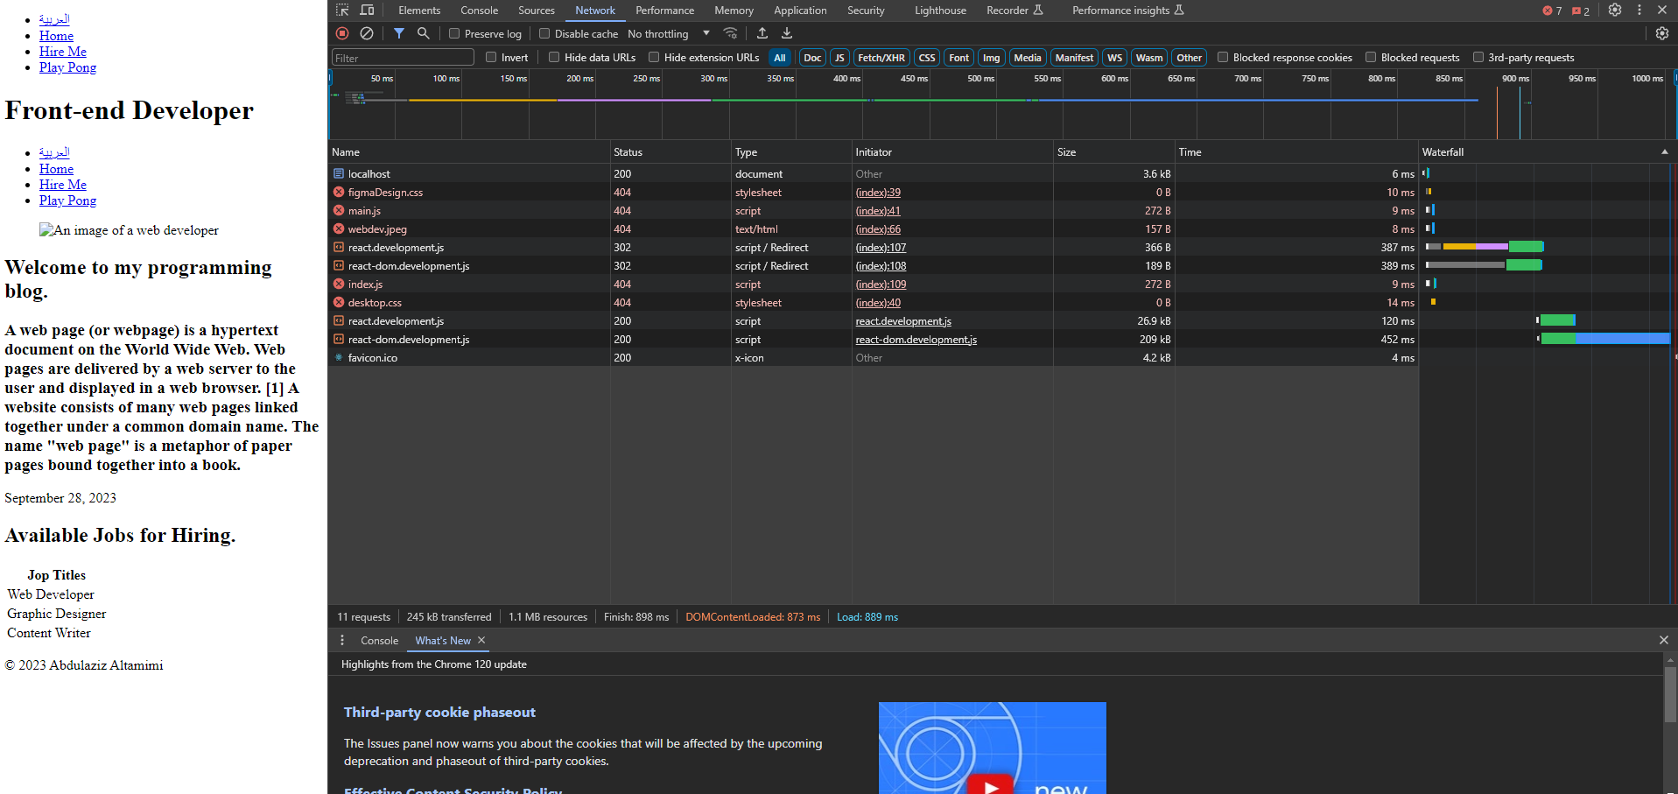

**- Go to GoDaddy.com**

- Find a domain name for your

