**FACULTY TABLE**

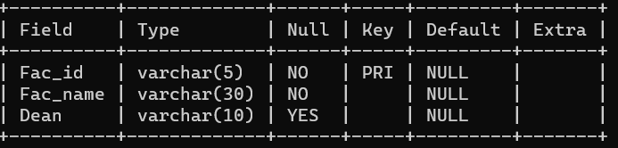

**Note Dean is the Foreign key .**

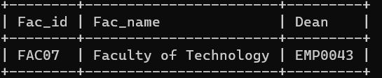

**DEPARTMENT TABLE**

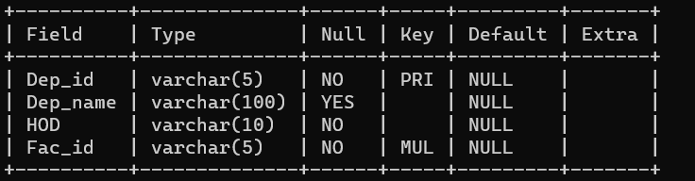

**Note HOD is the Foreign key of the lecturer table.**

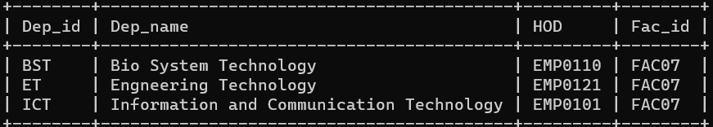

**ACADEMIC_STAFF TABLE**

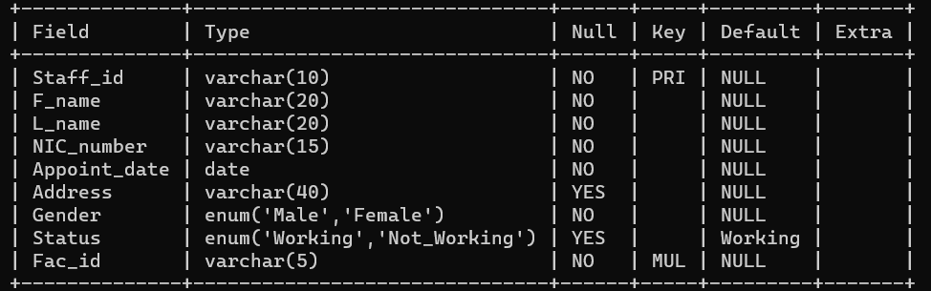

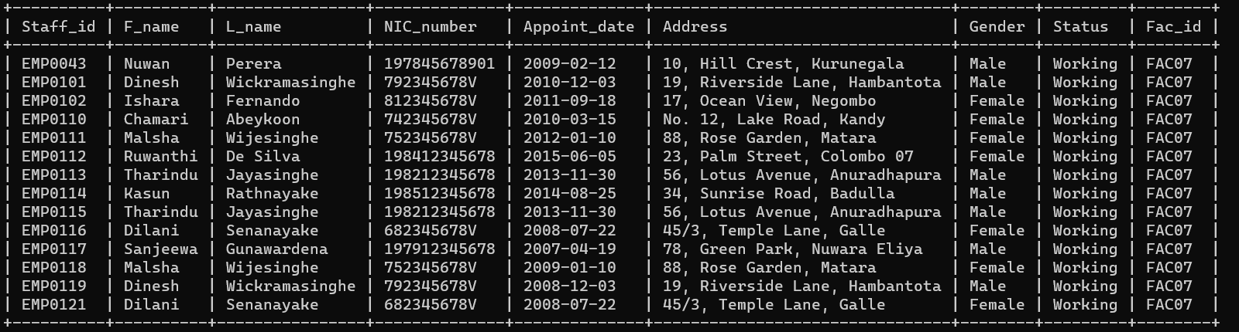

**LECTURER TABLE**

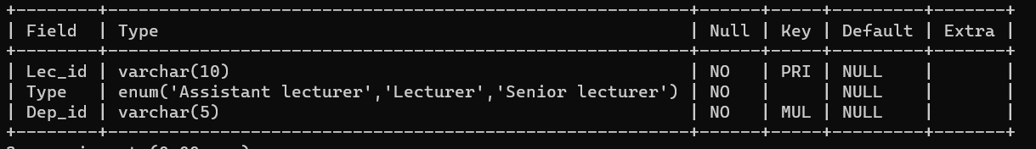

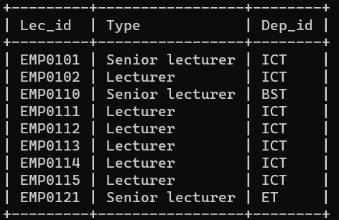

**DEAN TABLE**

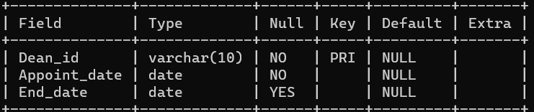

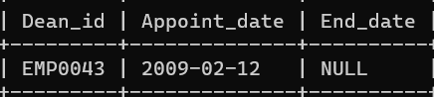

**DEMONSTRATOR TABLE**

