# Guidelines for Reporting

## Donations

Donations of money or material from unit treasury, personal accounts or business accounts used to support the project (e.g. nails, gravel, supplies, etc.). Report the monetary value.

Do not include fuel costs for travel or stock hauling. These costs are accounted for in the per mile rate for these categories.

 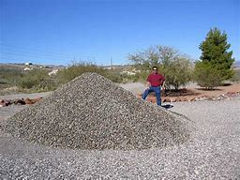

* + Chainsaw fuel, oil and blades should be counted as cash donations.
  + Rental fees and fuel for heavy equipment should be counted under cash donations.