# Guidelines for Reporting

## Community Service

### Education & LNT:

* Educational Clinics open to the public (e.g. Horsemanship and packing skills).
* Leave No Trace (LNT) Education. Record LNT education projects under the agency “L and other Educational projects under the agency “E”.

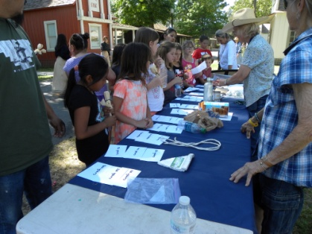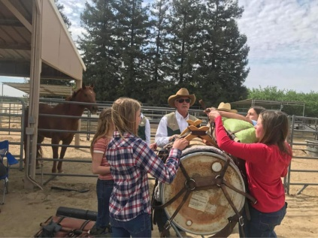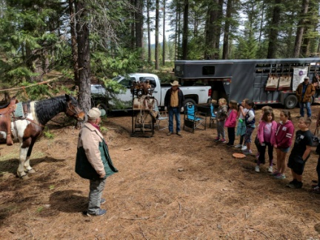 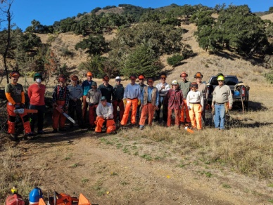 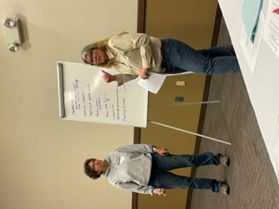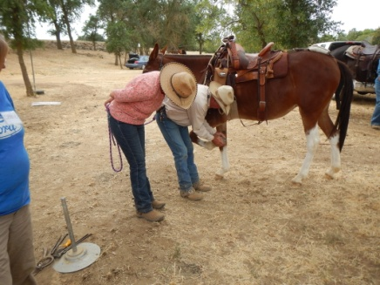

### What Counts for Education and LNT:

* + Clinics, Seminars, Rendezvous – Planning and facilitation by the teacher.
  + Clinics, Seminars, Rendezvous – Hosting (working, judging and setup) clinics put on for the public benefit (Packing clinics etc...). Do not include attendance time as student unless needed for future classes/seminar as an instructor/demonstrator.
  + Presentations and/or writing articles regarding LNT or other educational topics. (record hours spent in preparation of article)
  + Teaching – Clinics, Seminars and Presentations to the public.
  + Education Booths – Public display or representation of the BCHC interaction with the public.
  + Chain Saw certification.
  + Hosting an informational clinic for your Unit or speaking at another organization.
  + Youth camp - Planning and hosting camp is under (E) code. LNT classes are under agency (L) code.
  + Youth Program leaders planning, preparing, teaching educational projects, public service events, work projects involving youth activities.