# Guidelines for Reporting

## Equipment

Log the hours that heavy equipment is used.

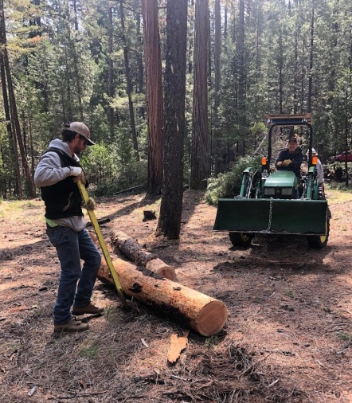 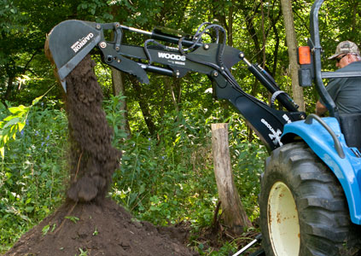

### Heavy Equipment:

* Trailers, dump trucks, saw mills etc.
* Tractors, dozers, graders etc.
  + Prepping heavy equipment and loading it before you use it counts as skilled labor.
  + Rental fees and fuel for heavy equipment should be counted under cash donations.