# Guidelines for Reporting

### Travel Time/Miles

### Travel Time:

* Actual hours spent by participants going to and from projects, educational events and meetings.

All time is recorded in increments of 1 Hour

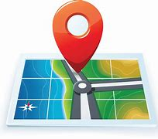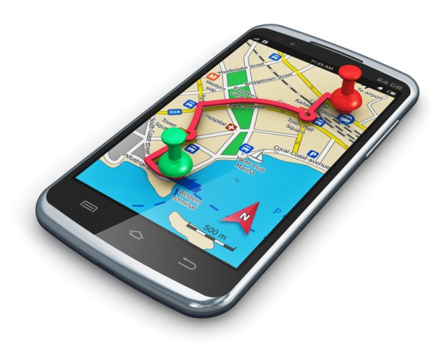

### Vehicle Miles:

* Miles driven to and from the volunteer location in a personal vehicle.
* Only the driver records the personal vehicle miles (others record as travel time)
* If your are hauling stock, hauling heavy equipment, or a trailer of some sort, record your miles under stock hauling. You should only record your miles under one or the other, not both.
  + If you drive ten miles to the barn and pick up your trailer and horses then drive 20 miles to the site you would then record 20 miles personal, and 40 miles stock hauling (round trip). If you are using your vehicle as a means to take crews to and from work points, count the miles that you drive to get your crew to their locations and back.