ASSIGNMENT-11
Name: Azra Farheen
Enrollment Number: 2505B04211
Course: M. Tech (Embedded Systems)
SCHOOL OF COMPUTER SCIENCE AND ARTIFICIAL INTELLIGENCE |  |  |  |  | DEPARTMENTOF COMPUTER SCIENCE ENGINEERING
ProgramName:M. Tech/MCA/MSC |  |  |  | AssignmentType: Lab |  |  | AcademicYear:2025-2026
CourseCoordinatorName |  |  |  | Venkataramana Veeramsetty
CourseCode |  |  |  | CourseTitle |  | AI Assisted Problem Solving Using Python
Year/Sem |  |  | II/I | Regulation |  | R24
DateandDay  of Assignment |  |  | Week5- Monday | Time(s)
Duration |  |  | 2 Hours | Applicableto  Batches
AssignmentNumber:11.3(Presentassignmentnumber)/24(Totalnumberofassignments)
 | Q.No. | Question |  |  |  |  |  | ExpectedTime  to complete
 | 1 | Lab 11 – Data Structures with AI: Implementing Fundamental Structures  Lab Objectives  - To implement fundamental data structures with the assistance of AI tools.  - To understand how AI suggests different implementations and optimizations.  - To analyze the readability, correctness, and performance of AI-generated code.  - To reinforce problem-solving skills using AI-powered coding assistance.  Learning Outcomes  After completing this lab, students will be able to:  - Implement stack, queue, and linked list using Python with AI support.  - Use AI tools to optimize and refactor basic data structure operations.  - Compare multiple AI-suggested implementations for the same structure.  - Apply AI assistance to generate test cases for verifying data structure behavior.  - Demonstrate understanding of trade-offs in AI-generated solutions.  Task Description #1 – Stack class implementation  Task: Ask AI to implement a stack class with push(), pop(), peek() and is_empty() methods  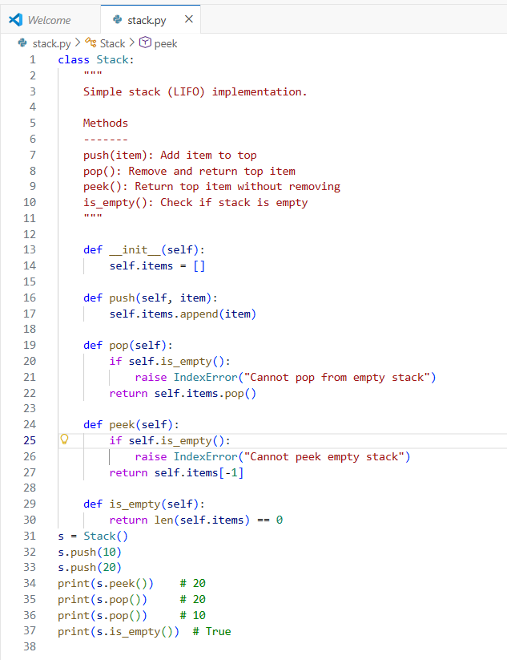  Fig 11.1(a) Python implementation of a Stack data structure using the LIFO (Last In First Out) principle. The class includes methods for pushing, popping, peeking, and checking whether the stack is empty  CODE EXPLANATION:  Class Definition + Docstring  class Stack:  """  Simple stack (LIFO) implementation.  Methods  -------  push(item): Add item to top  pop(): Remove and return top item  peek(): Return top item without removing  is_empty(): Check if stack is empty  """  Explanation:  - A class named Stack is created.  - The docstring explains that this is a LIFO (Last In First Out) data structure.  - It also lists all supported methods:  - push()  - pop()  - peek()  - is_empty()  Constructor  def __init__(self):  self.items = []  Explanation:  - The constructor runs when the Stack object is created.  - It initializes an empty Python list called items.  - This list is used to store all elements of the stack.  - The top of the stack will be the last element in this list.  push() Method  def push(self, item):  self.items.append(item)  Explanation:  - push() adds a new element to the top of the stack.  - append() inserts the item at the end of the list.  - This correctly maintains the LIFO order.  pop() Method  def pop(self):  if self.is_empty():  raise IndexError("Cannot pop from empty stack")  return self.items.pop()  Explanation:  - pop() removes and returns the top element of the stack.  - First, it checks if the stack is empty using is_empty().  - If empty → it raises an IndexError to prevent invalid popping.  - If not empty → it removes the last element using pop().  - This follows LIFO: last inserted item is removed first.  peek() Method  def peek(self):  if self.is_empty():  raise IndexError("Cannot peek empty stack")  return self.items[-1]  Explanation:  - peek() returns the top element without removing it.  - Again, it checks if the stack is empty.  - If not empty → returns the last element of the list using items[-1].  is_empty() Method  def is_empty(self):  return len(self.items) == 0  Explanation:  - Returns True if the stack contains no items.  - Returns False otherwise.  - Used for safety checks in pop() and peek().  OUTPUT:  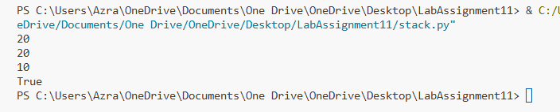  Fig 11.1(b) Output showing stack operations. The top element (20) is viewed using peek(), followed by two pop() operations that remove elements in LIFO order. Finally, is_empty() returns True, indicating the stack is empty  Task Description #2 – Queue Implementation  Task: Use AI to generate a Queue class with enqueue(), dequeue(), and is_empty().  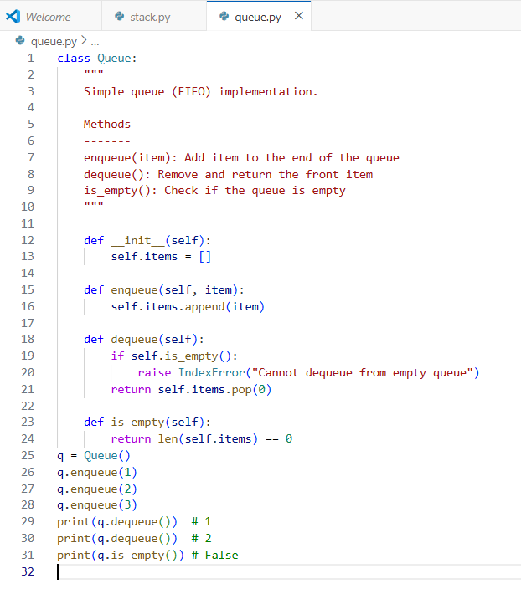  Fig 11.2(a) Python implementation of a Queue using the FIFO (First In First Out) principle, featuring enqueue, dequeue, and is_empty operations.  CODE EXPLANATION:  1) Class and docstring  Defines a Queue class that follows FIFO (First In First Out).  Lists available methods: enqueue, dequeue, is_empty.  2) Constructor  self.items = []  Creates an empty list to store queue elements.  Front of the queue = index 0.  New items are added at the end.  3) enqueue()  self.items.append(item)  Adds an item to the end of the queue.  Maintains FIFO order.  4) dequeue()  return self.items.pop(0)  Removes and returns the first element.  If empty → raises an error to prevent invalid removal.  5) is_empty()  return len(self.items) == 0  Returns True if queue contains no elements, otherwise False.  OUTPUT:  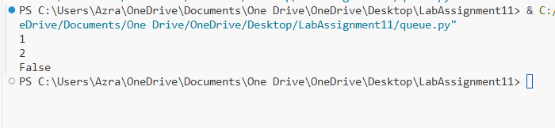  Fig 11.2(b) Output demonstrates queue behavior: elements are removed in the same order they were inserted, confirming FIFO operation.  Task Description #3 – Linked List Implementation  Task: Ask AI to create a singly linked list with insert_at_end(), insert_at_beginning(), and display().  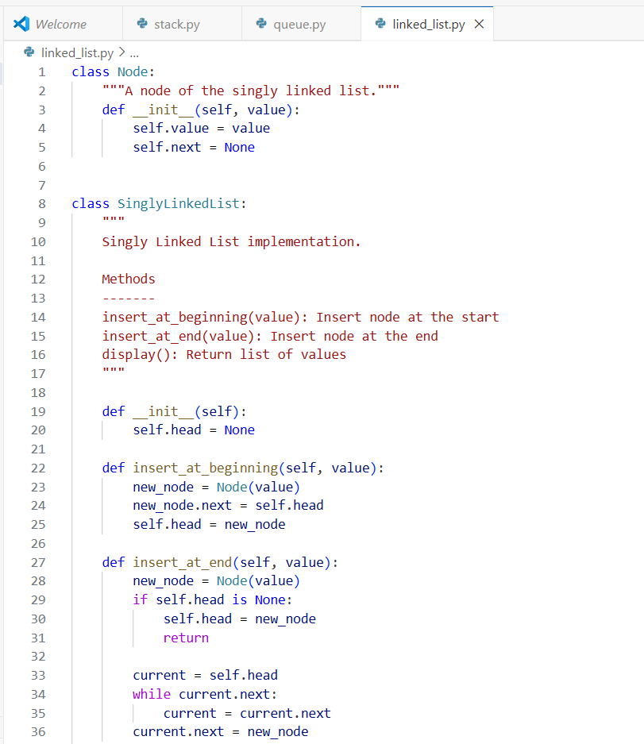  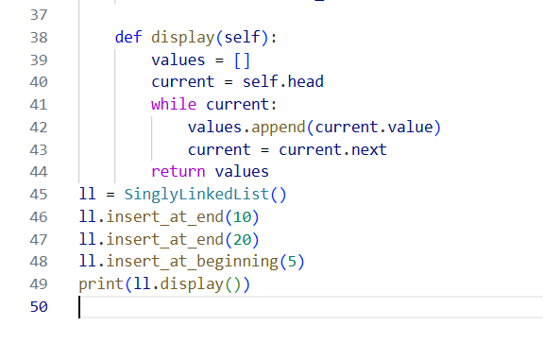  Fig 11.3(a) Python implementation of a singly linked list supporting insertion at the beginning, insertion at the end, and display operations.  CODE EXPLANATION:  Node Class  class Node:  Represents a single node in the linked list.  self.value = value  self.next = None  - value: stores data  - next: points to the next node in the list  Linked List Class  Constructor  self.head = None  - The list is empty initially.  - head stores the first node.  insert_at_beginning()  new_node.next = self.head  self.head = new_node  - Creates a new node.  - Connects new node to old head.  - Updates head to the new node.  - Works in O(1) time.  insert_at_end()  if self.head is None:  self.head = new_node  If list is empty → new node becomes head.  while current.next:  current = current.next  current.next = new_node  - Travels to the last node.  - Links the new node at the end.  - Works in O(n) time since it must traverse.  display()  values.append(current.value)  current = current.next  - Traverses each node from head to end.  - Collects values in a Python list.  - Returns the list for printing.  OUTPUT:  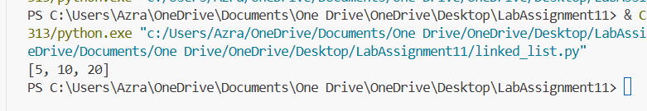  Fig 11.3(b) Output shows the linked list values in order after performing insertions at both beginning and end.  Task Description #4 – Binary Search Tree (BST)  Task: Ask AI to generate a simple BST with insert() and inorder_traversal().  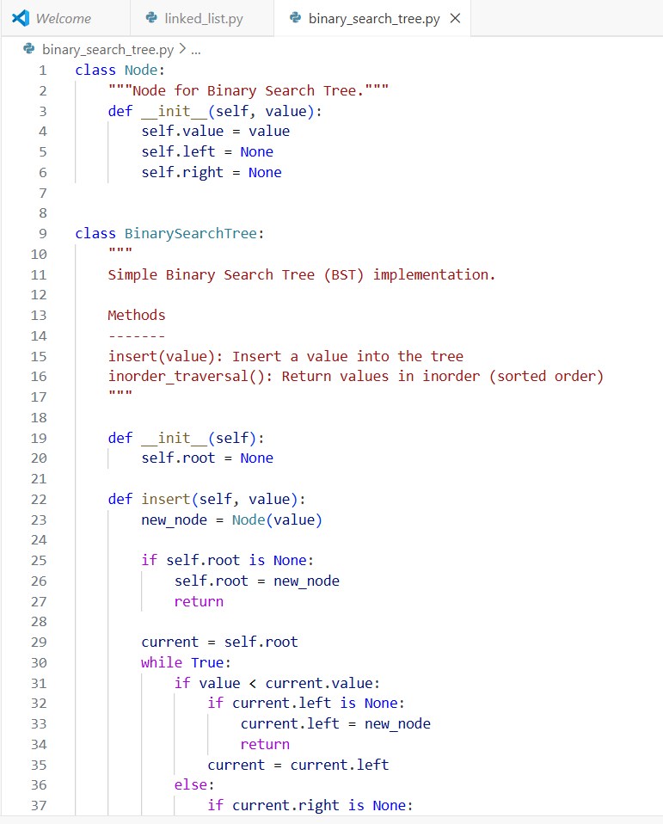  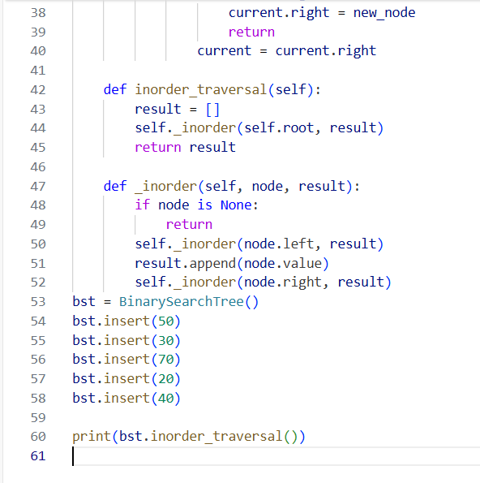  Fig 11.4(a) Python implementation of a Binary Search Tree supporting insertion of values and inorder traversal to return sorted elements.  CODE EXPLANATION:  1) Node Class  class Node:  Represents a single node in the BST.  self.value = value  self.left = None  self.right = None  - Stores data  - left: subtree with smaller values  - right: subtree with larger values  2) BinarySearchTree Constructor  self.root = None  Tree starts empty.  root points to the topmost node.  3) insert() Method  if self.root is None:  self.root = new_node  return  - If tree is empty → new node becomes root.  Traversal for inserting  if value < current.value:  go left  else:  go right  - Smaller values are placed in the left subtree.  - Larger or equal values go to the right subtree.  - Continues until an empty position is found.  This maintains Binary Search Tree property.  4) inorder_traversal()  self._inorder(self.root, result)  - Inorder traversal = Left → Root → Right  - In a BST, inorder traversal always returns sorted values.  5) _inorder() Helper Function  This function recursively:  - Visits left subtree  - Adds current node value  - Visits right subtree  OUTPUT:  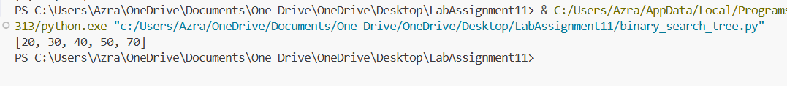  Fig 11.4(b) The inorder traversal prints values in ascending order, demonstrating correct BST structure. |  |  |  |  |  | Week5 - Monday

