SCHOOLOFCOMPUTER SCIENCE AND ARTIFICIAL INTELLIGENCE |  |  |  |  | DEPARTMENTOFCOMPUTER SCIENCE ENGINEERING
Program Name: M. Tech/MCA/MSC |  |  |  | Assignment Type: Lab |  |  | AcademicYear:2025-2026
Course Coordinator Name |  |  |  | Venkataramana Veeramsetty
Course Code |  |  | 24CS002PC215 | Course Title |  | AI Assisted Problem Solving Using Python
Year/Sem |  |  | II/I | Regulation |  | R24
Date and Day  of Assignment |  |  | Week5- Tuesday | Time(s)
Duration |  |  | 2 Hours | Applicable to  Batches
AssignmentNumber:13.3(Presentassignmentnumber)/24(Totalnumberofassignments)
 | Q.No. | Question |  |  |  |  |  | ExpectedTime  to complete
 | 1 | Lab 13 – Code Refactoring: Improving Legacy Code with AI Suggestions  Lab Objectives  - To introduce the concept of code refactoring and why it matters (readability, maintainability, performance).  - To practice using AI tools for identifying and suggesting improvements in legacy code.  - To evaluate the before vs. after versions for clarity, performance, and correctness.  - To reinforce responsible AI-assisted coding practices (avoiding over-reliance, validating outputs).  Learning Outcomes  After completing this lab, students will be able to:  - Use AI to analyze and refactor poorly written Python code.  - Improve code readability, efficiency, and error handling.  - Document AI-suggested improvements through comments and explanations.  - Apply refactoring strategies without changing functionality.  - Critically reflect on AI’s refactoring suggestions.  Task Description #1 – Remove Repetition  Task: Provide AI with the following redundant code and ask it to refactor  Python Code  def calculate_area(shape, x, y=0):  if shape == "rectangle":  return x * y  elif shape == "square":  return x * x  elif shape == "circle":  return 3.14 * x * x  Expected Output  - Refactored version with dictionary-based dispatch or separate functions.  - Cleaner and modular design.  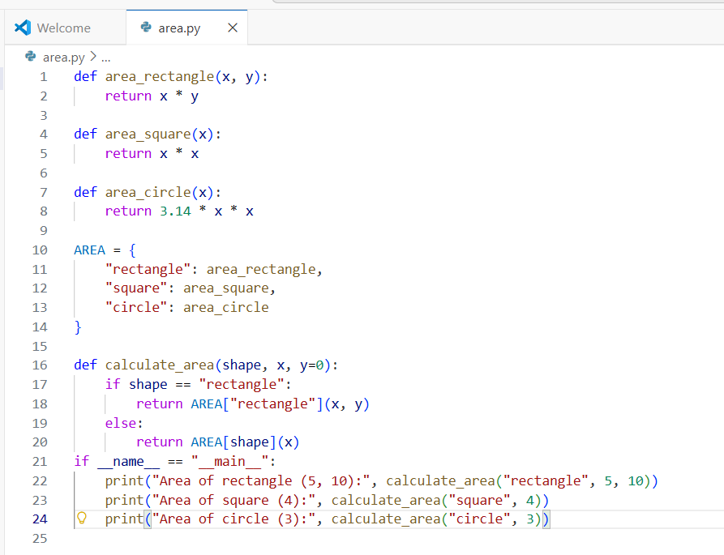  Fig 13.1(a) Refactored area calculation program using modular functions and a dictionary to remove repetition.  CODE EXPLANATION:  - Three separate functions (area_rectangle, area_square, area_circle) are created to calculate the area of each shape.  - A dictionary named AREA stores the mapping between shape names and their corresponding functions.  - The calculate_area() function uses this dictionary to select the correct shape function and return the area.  - This removes repeated code and makes the program cleaner, modular, and easy to extend.  - The main block (if __name__ == "__main__":) tests the function by printing areas of rectangle, square, and circle.  OUTPUT:  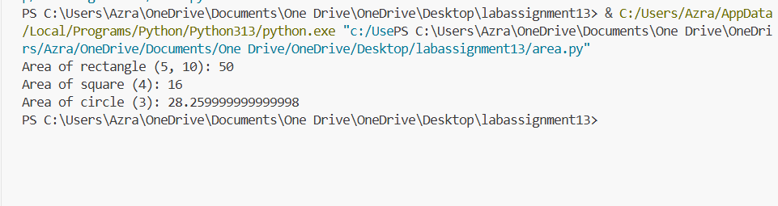  Fig 13.1 (b) Program output showing correct area calculations for rectangle, square, and circle using the refactored modular design.  Task Description #2 – Error Handling in Legacy Code  Task: Legacy function without proper error handling  Python Code  def read_file(filename):  f = open(filename, "r")  data = f.read()  f.close()  return data  Expected Output:  AI refactors with with open() and try-except:  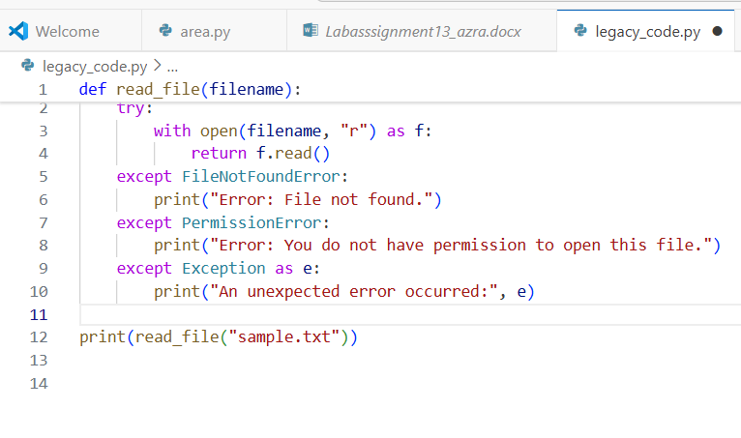  Fig 13.2(a) Refactored file-reading function using with open() and try-except for safe error handling.  CODE EXPLANATION:  1. The old function opened the file manually and had no error handling, which could make the program crash.  2. The refactored version uses with open(), which automatically closes the file, even if an error happens.  3. try-except blocks are used to catch common errors such as:  - File not found  - No permission  - Any unexpected error  4. This makes the function safer, cleaner, and more reliable.  5. At the bottom, print(read_file("sample.txt")) is used to display the file contents or show an error message.  OUTPUT:  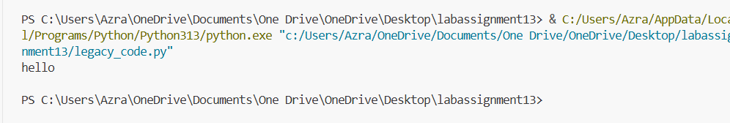  Fig 13.2(b) Program successfully reads the content of the file and prints ‘hello’, showing correct execution of the refactored file-reading function  Task Description #3 – Complex Refactoring  Task: Provide this legacy class to AI for readability and modularity improvements:  Python Code  class Student:  def __init__(self, n, a, m1, m2, m3):  self.n = n  self.a = a  self.m1 = m1  self.m2 = m2  self.m3 = m3  def details(self):  print("Name:", self.n, "Age:", self.a)  def total(self):  return self.m1+self.m2+self.m3  Expected Output:  - AI improves naming (name, age, marks).  - Adds docstrings.  - Improves print readability.  - Possibly uses sum(self.marks) if marks stored in a list.  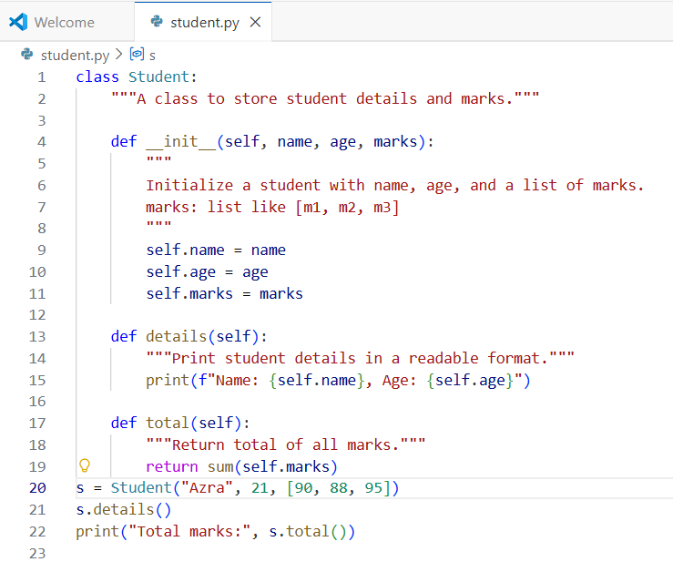  Fig 13.3(a) Refactored Student class with improved naming, modular marks list, and added docstrings for clarity.  CODE EXPLANATION:  - The original class used short, unclear variable names (n, a, m1, m2, m3).  - The refactored version improves readability by using name, age, and a marks list.  - marks is stored as a list, so calculating the total is easy using sum(self.marks).  - Added docstrings for the class and each method, explaining their purpose.  - The details() method now uses an f-string to print clean, readable output.  - This version is more modular, easier to extend, and easier to understand.  OUTPUT:  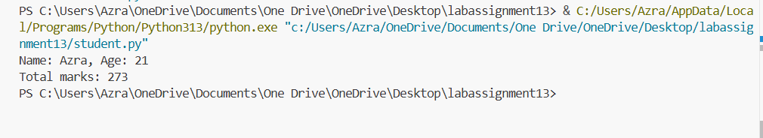  Fig 13.3(b) Output displaying student details and total marks computed using the refactored Student class.  Task Description #4 – Inefficient Loop Refactoring  Task: Refactor this inefficient loop with AI help  Python Code  nums = [1,2,3,4,5,6,7,8,9,10]  squares = []  for i in nums:  squares.append(i * i)  Expected Output: AI suggested a list comprehension  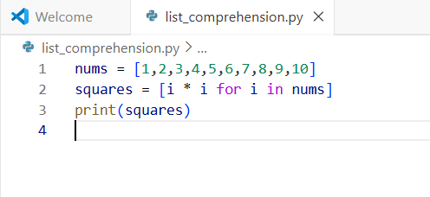  Fig 13.4(a) Refactored loop using Python list comprehension to generate squares in a clean and efficient way.  CODE EXPLANATION:  - The list nums contains numbers from 1 to 10.  - Instead of using a long for loop and .append(), a list comprehension is used.  - [i * i for i in nums] creates a new list where each i from nums is squared.  - The result is stored in squares and printed.  OUTPUT:  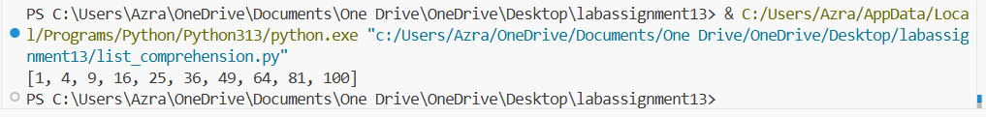  Fig 13.4(b) Output displays the list of squared values generated using list comprehension. |  |  |  |  |  | Week5- Tuesday

