ASSIGNMENT-15
Name: Azra Farheen
Enrollment Number: 2505B04211
Course: M. Tech (Embedded Systems)

SCHOOL OF COMPUTER SCIENCE AND ARTIFICIAL INTELLIGENCE |  |  |  |  | DEPARTMENT OF COMPUTER SCIENCE ENGINEERING
Program Name: M.Tech/MSC/MCA |  |  |  | Assignment Type: Lab |  |  | Academic Year:2025-2026
Course Coordinator Name |  |  |  | Venkataramana Veeramsetty
Course Code |  |  |  | Course Title |  | AI Assisted Problem Solving Using Python
Year/Sem |  |  |  | Regulation |  | R25
Date and Day  of Assignment |  |  | Week5 - Tuesday | Time(s)
Duration |  |  | 2 Hours | Applicable to  Batches
AssignmentNumber:15.4(Present assignment number)/24(Total number of assignments)
 | Q.No. | Question |  |  |  |  |  | Expected Time  to complete
 | 1 | Lab 18 – API Integration: Connecting to External Services with Error Handling  Lab Objectives:  - Learn how to integrate Python programs with external REST APIs.  - Understand API request/response handling using requests or similar libraries.  - Implement proper error handling for failed API calls (timeouts, invalid responses, rate limits).  - Practice extracting and displaying meaningful information from API responses.  Task 1: Connect to a Public API  - Instructions:  - Use Python (or Node.js/JavaScript) to connect to a public API (e.g., OpenWeatherMap or JSONPlaceholder).  - Send a simple GET request to retrieve data.  - Display the response in a readable format (pretty JSON).  - Expected Output:  - Program prints API response (e.g., weather data or posts from JSONPlaceholder).  - Output should be properly formatted JSON (not raw).  Prompt: write a python function that display weather details of a city using weather api without error handling. Display weather details as JSON output  To use this code:  - First, you'll need to sign up for a free API key at Open Weather Map: https://openweathermap.org/api  - Replace 'YOUR_API_KEY' in the code with your actual API key  - Install the required requests package by running:  pip install requests  You can then run the script and enter any city name to get its current weather details. The output will look something like this:  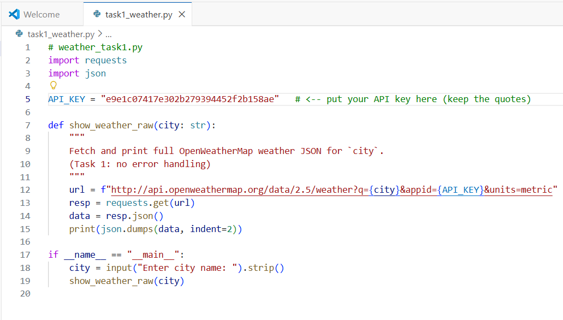  Fig 15.1(a) Python program to fetch and display complete weather details for a given city using the OpenWeatherMap API without error handling. The output is printed in formatted JSON.  CODE EXPLANATION:  Line 1–3: Importing required modules  import requests  import json  - requests → used for making the API call (GET request).  - json → used to pretty-print the API response.  Line 5: API Key Setup  API_KEY = "your_api_key"  - Stores your OpenWeatherMap API key.  - Required to authenticate your request.  Line 7–15: Function to fetch and display weather JSON  def show_weather_raw(city: str):  Defines a function that accepts a city name as input.  Inside the function:  url = f"http://api.openweathermap.org/data/2.5/weather?q={city}&appid={API_KEY}&units=metric"  - This creates the complete API URL using:  - city name  - your API_KEY  - units=metric (to get temperature in °C)  resp = requests.get(url)  - Sends the GET request to the API.  data = resp.json()  - Converts the API response into a Python dictionary.  print(json.dumps(data, indent=2))  - Pretty-prints the JSON output in a clear, readable format.  Line 17–20: Program starts here  if __name__ == "__main__":  - Ensures this part runs only when the script is executed directly.  city = input("Enter city name: ").strip()  - Reads city name from user.  show_weather_raw(city)  - Calls the function and prints the weather JSON.  OUTPUT:  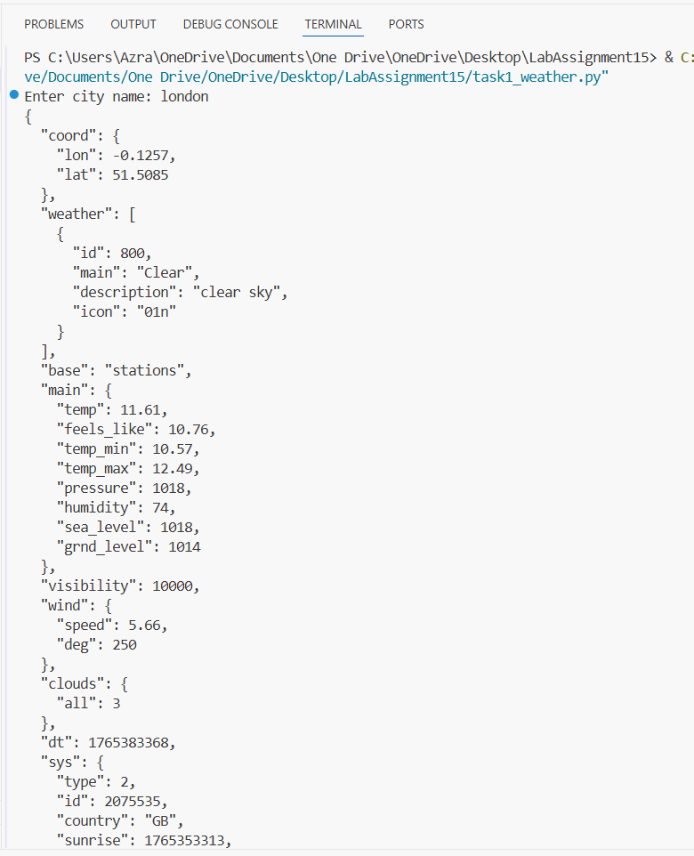  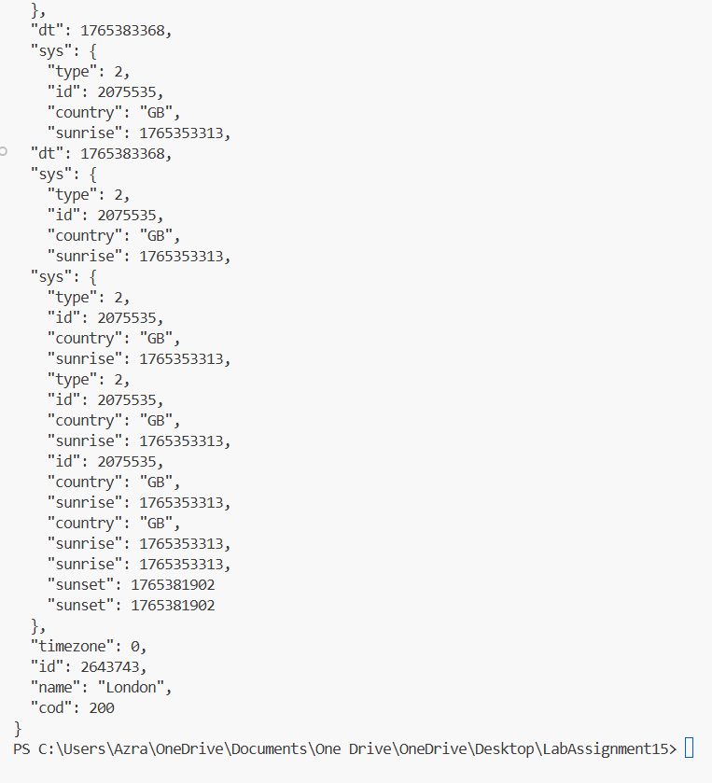  Fig 15.1(b) Output showing the complete JSON response returned by the OpenWeatherMap API for the entered city (“London”). The program successfully fetches live weather data and prints it in a readable, pretty-formatted JSON structure.  Task 2: Add Error Handling for Invalid API Calls  - Instructions:  - Modify your code from Task 1 to handle errors.  - Include try/except (Python) or try/catch (JavaScript) blocks.  - Handle cases like:  - Invalid URL  - Network timeout  - Wrong API key (if required)  - Print user-friendly error messages.  - Expected Output:  - If the API works, the result is shown as in Task 1.  - If there’s an error, output:  Error: Could not connect to API. Check your API key or network connection.  Prompt: write a python function that display weather details of a city using weather api with error handling. Display weather details as JSON output  To use this code:  - First, you'll need to sign up for a free API key at Open Weather Map: https://openweathermap.org/api  - Replace 'YOUR_API_KEY' in the code with your actual API key  - Install the required requests package by running:  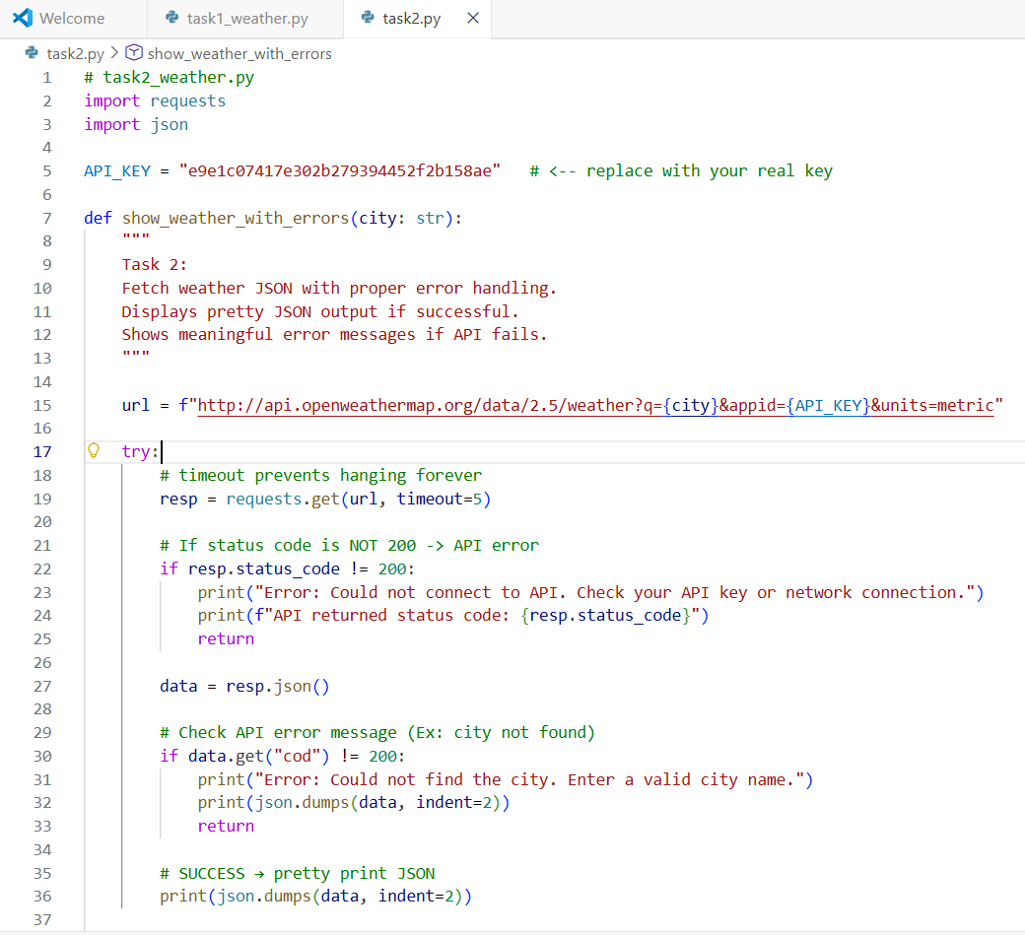  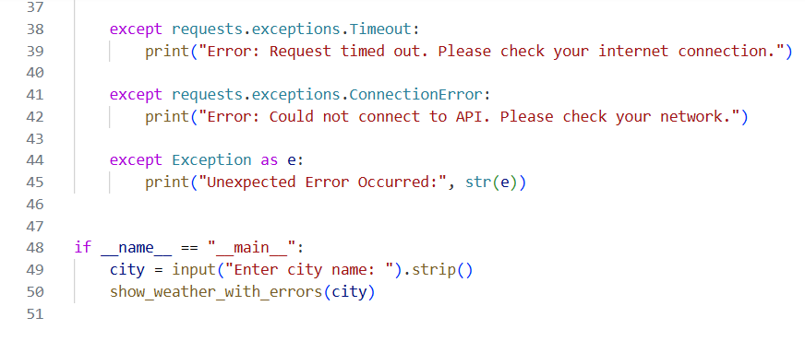 Fig 15.2(a) Python program that fetches weather details from the OpenWeatherMap API with full error handling. The script uses try/except blocks to manage invalid API calls, wrong API keys, timeouts, and network issues, while printing weather data in formatted JSON when successful.  What This Code Handles  - Wrong city name  Shows:  Error: Could not find the city. Enter a valid city name.  - Wrong API KEY / expired key  Shows:  Error: Could not connect to API. Check your API key or network connection.  - No internet / API down  Shows:  Error: Could not connect to API. Please check your network.  - Timeout  Shows:  Error: Request timed out.  - Success (same as Task 1)  Pretty JSON prints normally.  Expected Lab Output  If valid city:  Pretty formatted JSON (same as Task 1).  If wrong API key:  Error: Could not connect to API. Check your API key or network connection.  If city not found:  Error: Could not find the city. Enter a valid city name.  OUTPUT:  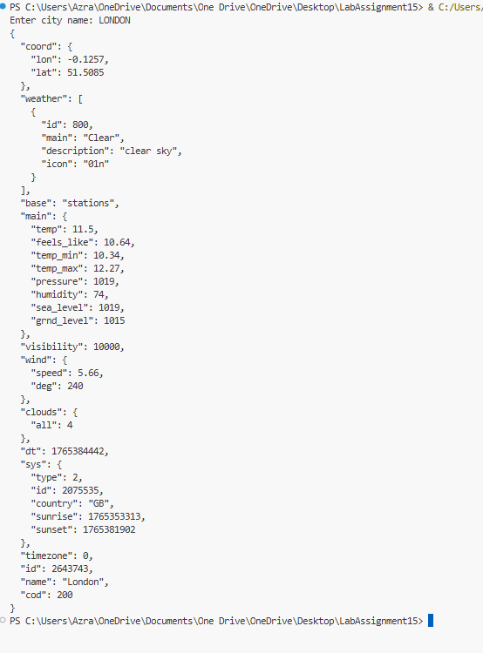  Fig 15.2(b) Output showing the weather details returned by the API in pretty-formatted JSON when a valid city is entered. If an error occurs—such as an invalid city name, wrong API key, or network failure—the program prints a clear user-friendly error message.  Task 3: Extract and Display Specific Data  - Instructions:  - From the API response (e.g., weather API), extract specific fields (temperature, humidity, description).  - Display them in a user-friendly format (not raw JSON).  - Expected Output:  - City: London  - Temperature: 18°C  - Humidity: 60%  Weather: Clear sky  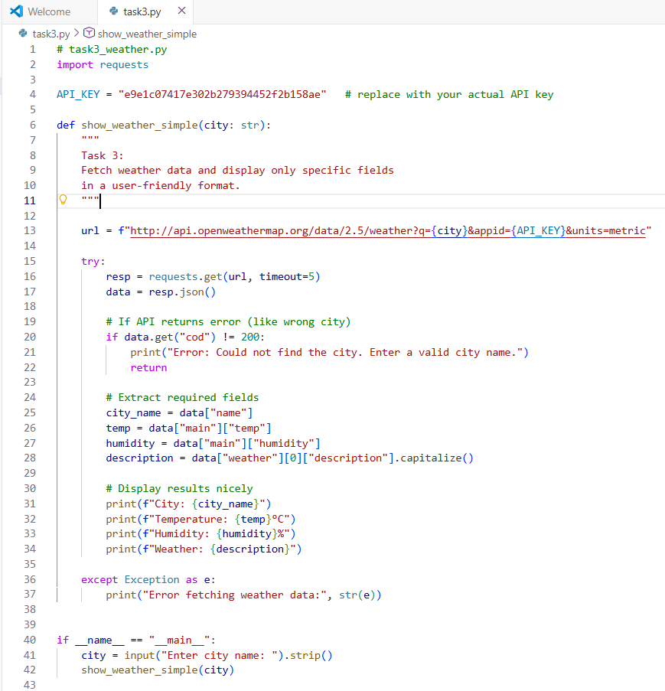  Fig 15.3(a) Python program that retrieves weather details from the OpenWeatherMap API and extracts only specific fields—city name, temperature, humidity, and weather description. The output is displayed in a clean, user-friendly format instead of raw JSON.  CODE EXPLANATION:  1. Importing modules  import requests  - requests is used to send the API request.  2. Storing the API key  API_KEY = "your_api_key"  - Holds the OpenWeatherMap API key required to authenticate the request.  3. Defining the function  def show_weather_simple(city: str):  - Takes a city name as input.  - Fetches and displays selected weather details.  4. Creating the API URL  url = f"http://api.openweathermap.org/data/2.5/weather?q={city}&appid={API_KEY}&units=metric"  - Combines the base URL with the city name and API key.  - units=metric returns temperature in °C.  5. Sending the GET request  resp = requests.get(url, timeout=5)  data = resp.json()  - Sends the request with a timeout of 5 seconds.  - Converts the response into JSON format.  6. Handling API errors  if data.get("cod") != 200:  print("Error: Could not find the city. Enter a valid city name.")  return  - If the API returns an error (like wrong city name), a friendly message is shown.  7. Extracting required fields  city_name = data["name"]  temp = data["main"]["temp"]  humidity = data["main"]["humidity"]  description = data["weather"][0]["description"].capitalize()  Extracts:  - City name  - Temperature  - Humidity  - Weather description (capitalized for readability)  8. Printing output (User-friendly format)  print(f"City: {city_name}")  print(f"Temperature: {temp}°C")  print(f"Humidity: {humidity}%")  print(f"Weather: {description}")  - Displays the selected weather details clearly and neatly.  9. Handling unexpected exceptions  except Exception as e:  print("Error fetching weather data:", str(e))  - Catches unexpected errors (like network issues).  10. Calling the function  city = input("Enter city name: ").strip()  show_weather_simple(city)  - Takes user input and runs the weather function.  OUTPUT:  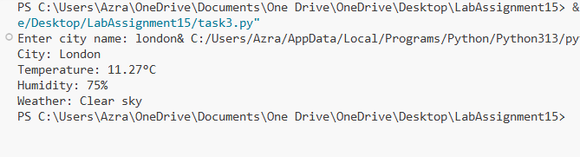  Fig 15.3(b) Output showing the extracted weather details for the entered city. Instead of displaying the full raw JSON response, the program prints only the required fields—city name, temperature, humidity, and weather description—in a clean and user-friendly format.  Task 4: Build a Function with Parameters  - Instructions:  - Write a function that accepts a parameter (e.g., city name for weather API).  - The function should call the API dynamically based on user input.  - Include error handling if the city is invalid.  - Expected Output:  - Input: "New York"  - Output:  - City: New York  - Temperature: 22°C  - Humidity: 55%  - Weather: Few clouds  - Input: "xyz123"  - Output:  Error: City not found. Please enter a valid city.  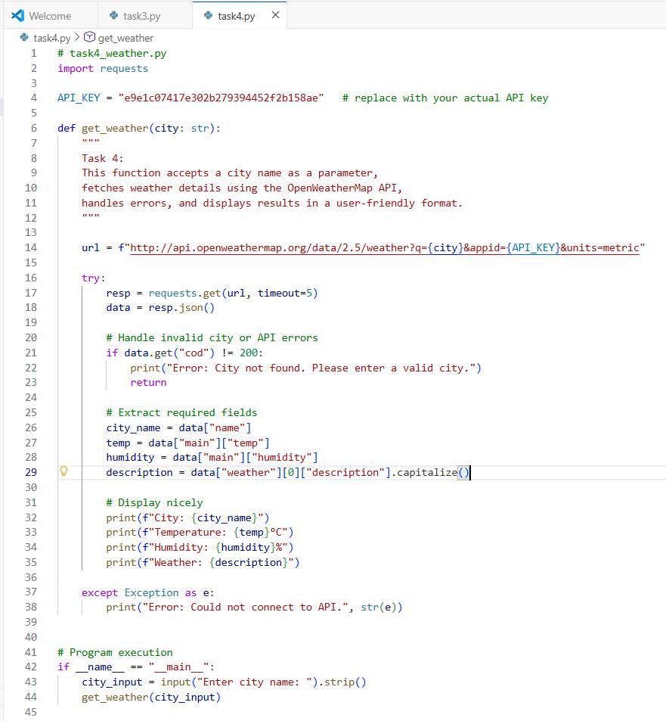  Fig 15.4(a) Python function that accepts a city name as a parameter, calls the OpenWeatherMap API dynamically, handles invalid inputs using error handling, and displays the weather details in a clean, user-friendly format.  CODE EXPLANATION:  1. Importing Required Module  import requests  requests is used to send GET requests to the API.  2. Storing the API Key  API_KEY = "your_api_key"  Holds the API key needed to authenticate requests.  3. Defining the Weather Function  def get_weather(city: str):  The function takes city name as a parameter.  This allows the API call to be made dynamically based on user input.  4. Creating the API Request URL  url = f"http://api.openweathermap.org/data/2.5/weather?q={city}&appid={API_KEY}&units=metric"  Builds the complete URL using:  City name  API key  Unit as metric (temperature in °C)  5. Sending API Request and Reading JSON  resp = requests.get(url, timeout=5)  data = resp.json()  Sends GET request with a timeout.  Converts API response into Python dictionary.  6. Handling Invalid City or API Errors  if data.get("cod") != 200:  print("Error: City not found. Please enter a valid city.")  return  If the API returns an error code (like 404), a friendly message is displayed.  Prevents the program from crashing.  7. Extracting Required Fields  city_name = data["name"]  temp = data["main"]["temp"]  humidity = data["main"]["humidity"]  description = data["weather"][0]["description"].capitalize()  Extracts:  City name  Temperature (°C)  Humidity (%)  Weather description  .capitalize() makes the description readable (e.g., "few clouds").  8. Displaying the Output Nicely  print(f"City: {city_name}")  print(f"Temperature: {temp}°C")  print(f"Humidity: {humidity}%")  print(f"Weather: {description}")  Shows weather details in clean and user-friendly formatting.  9. Handling Any Unexpected Errors  except Exception as e:  print("Error: Could not connect to API.", str(e))  Catches network errors or unexpected issues.  Prevents program crashes.  10. Getting User Input and Calling the Function  city_input = input("Enter city name: ").strip()  get_weather(city_input)  Takes city input from user.  Calls get_weather() with the provided city.  OUTPUT:  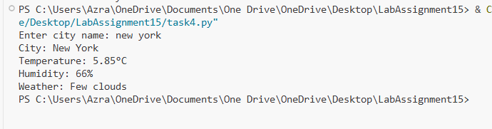  Fig 15.4(b) Output showing weather details retrieved for the user-entered city using a parameterized function. The program displays the city name, temperature, humidity, and weather description in a clear, user-friendly format. If the user enters an invalid city name, the program prints a meaningful error message indicating that the city was not found.  Task 5: Store API Results Locally  - Instructions:  - Extend your function from Task 4.  - Save the extracted API results into a local file (results.json or results.txt).  - Each new request should append results without overwriting old ones.  - Expected Output:  - Console still shows formatted output.  - A local file results.json is created/updated with stored responses like:  - [  - {"city": "London", "temp": 18, "humidity": 60, "weather": "Clear sky"},  - {"city": "New York", "temp": 22, "humidity": 55, "weather": "Few clouds"}  ]  Prompt: write a python function that display weather details of a city using weather api with error handling. Display weather details as JSON output. Store the weather details in current directory as text file, every run output will append  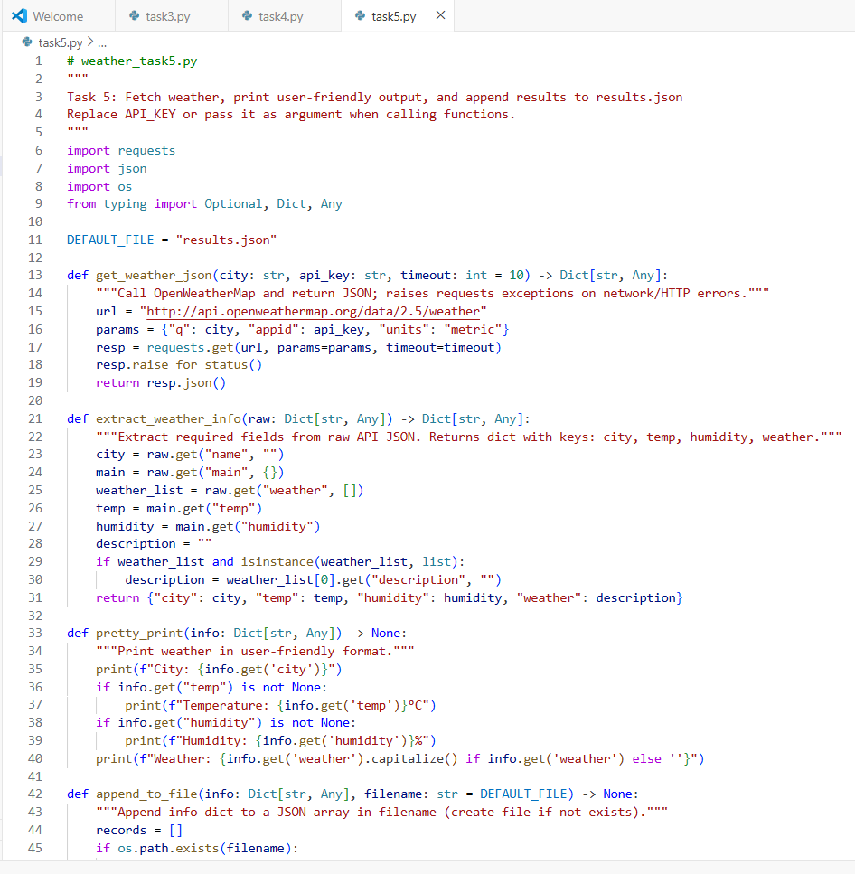  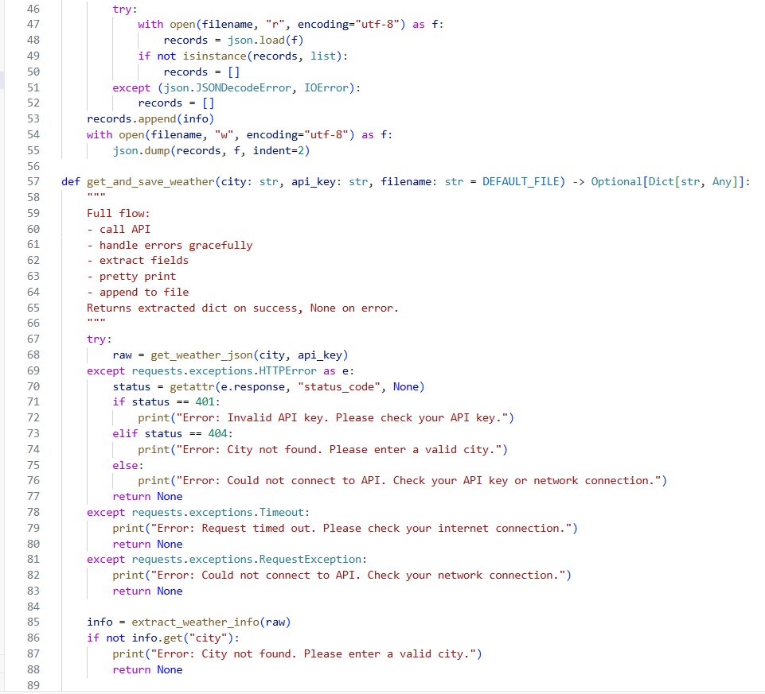  Fig 15.5(a) Python program that fetches weather details for a given city, displays the extracted fields (city, temperature, humidity, weather) in a user-friendly format, and appends the results to a local JSON file (results.json) so previous results are preserved.  CODE EXPLANATION:  - get_weather_json: calls API and returns JSON (raises HTTP/network exceptions if any).  - extract_weather_info: pulls city, temp, humidity, weather from API JSON.  - pretty_print: prints the extracted fields in a friendly format.  - append_to_file: safely reads existing results.json (if any), appends new record, and writes back. Handles corrupt files by resetting to empty list.  - get_and_save_weather: orchestrator — calls API, handles errors, prints output, saves the result; returns extracted dict on success, None on failure.  OUTPUT:  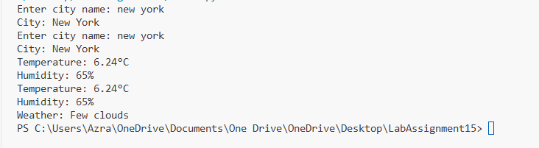  Fig 15.5(b): Console output displays the selected weather details (city, temperature, humidity, and weather). The results.json file in the working directory is updated to include the new record without overwriting previous entries.  ✅ Deliverables (For All Tasks)  - AI-generated prompts for code and test case generation.  - At least 3 assert test cases for each task.  - AI-generated initial code and execution screenshots.  - Analysis of whether code passes all tests.  - Improved final version with inline comments and explanation.  - Compiled report (Word/PDF) with prompts, test cases, assertions, code, and output. |  |  |  |  |  | Week5 - Tuesday

